**DatabaseConverter**

**Project Overview :**

The Database Converter project is a Spring Boot-based application that aims to convert data from CSV files into a database format. It provides functionality to read CSV files, create database tables dynamically based on the file's header, and insert the CSV data into the corresponding database tables.

**Pre-request**

* JDK ( Recommended Java 17)
* Install the IDE and ensure it is properly configured for Java development. (Recommended Intellij IDEA )
* MySQL DataBase
* Postman
* Git

Clone the project file from git repository –

Git clone “path”

MYSQL DataBase :

* Download the MySQL Community Line and install MySQL workbench or MySQL Shell.
* Setup a new Connection with user as root & password as root.
* Create a Database named DatabaseConverter.
* Else customize the Database name, username & password in Application.properties in project file ( DatabaseConverter/src/main/resources/application.properties )

**Task Explanation**

* I have created a SpringBoot project using Spring Initializr with required dependency and named as DatabaseConverter.
* Created a Controller layer for request mapping and Service layer to write Business logic
* Also, created Entity and repository to save the progress records like totalRecords, progressTime, failureRecords etc..
* Developed two endpoints, one for to upload the file, created a table dynamic with filename and inserted the dynamic values into the table ( http://localhost:9091/CSV/upload ). Another endpoint is used to fetch the progress of last record processing into the DB (http://localhost:9091/CSV/progress) .
* Implemented the Error handling technique with proper error message in case of failure and Thread for efficient usage.

**How to run a project**

* Open the project in IntelliJ IDEA or your preferred IDE.
* Run the Spring Boot application.
* The application will run on a local server, http://localhost:9091. Since I override the port number in application properties file.
* Once the application started the server, open the postman and upload the CSV file in the body and send the request via http://localhost:9091/CSV/upload url (POST Call).

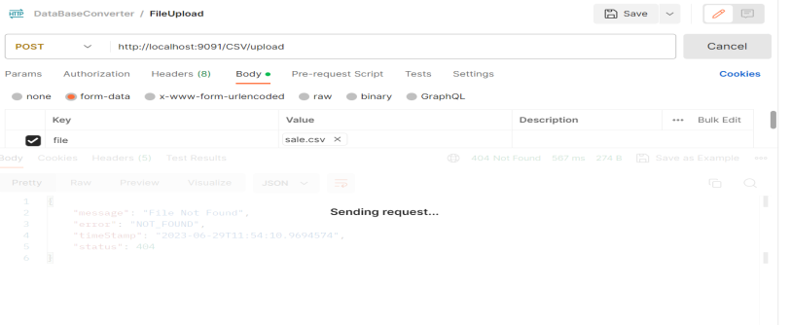

Sending the request

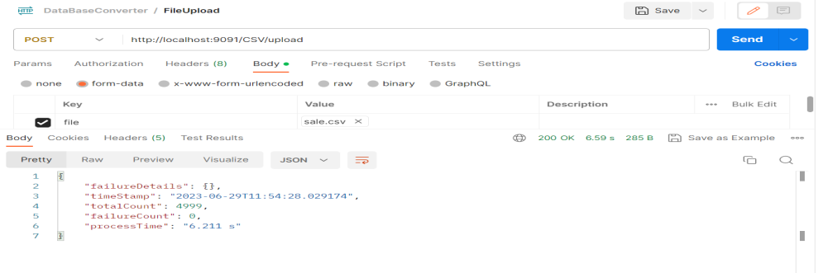

Response

* To check the progress record processing, send the request url http://localhost:9091/CSV/progress (GET Call)

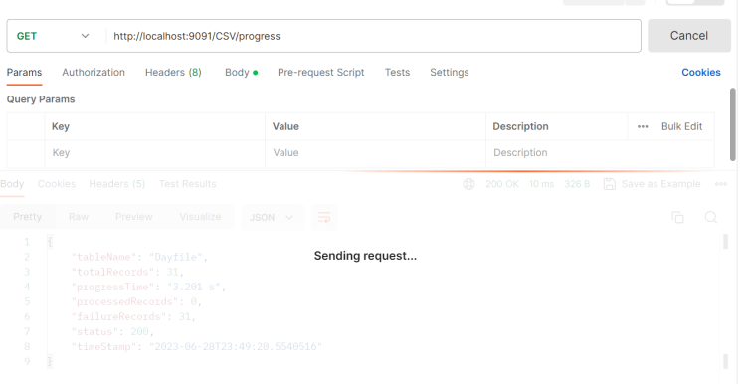

Sending Request

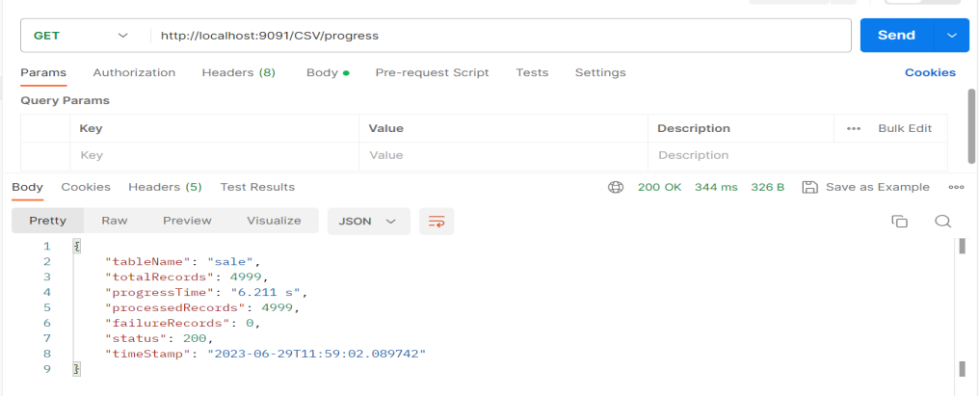

Response