To create a new branch without commiting on master , we should use
- Git checkout –b <branchName>
This will create a new brach , move the user to this branch
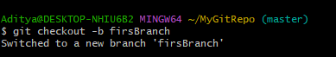

Next, create a file inside this branch , edit it & check the status using
Git status
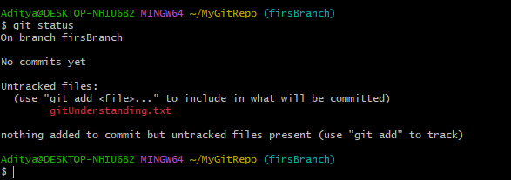
Now we will use git add to add this file to the “to be committed” list

Git add filename -> this will add the corresponding file
Git add. -> command with a wildcard-> this will add all the files in the current directory to the next commit.
Now lets try git status
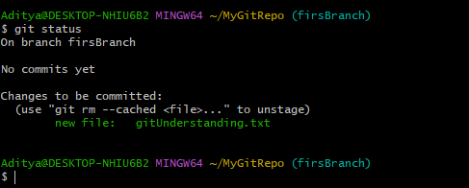

Now lets try git commit & git log
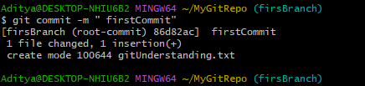

First we need to remote add & then push the changes

