“Beach Surfer” Game Design Document

**Single Player Campaign Mode –**

The story of Beach Surfer is based on Macho Man Manny, a casual surfer who’s precious sandals have been stolen by the leader of a group of thieves. Manny suffers a leg injury while surfing, removing his ability to jump. Macho Man Manny then decides to chase the group of thieves, to retrieve his most treasured pair of sandals.

**Goals & Mechanics –**

The goal of Beach Surfer is to retrieve your sandals from the group of thieves. The boss thief holds your sandals as the other thieves then single out one-by-one to attack and slow you down. You must defeat all thieves, as you (Macho Man Manny) chase after the main thief boss in pursuit of beating him and getting your sandals back.

The first core mechanic of Beach Surfer is the act of placing your surfboard down to create a bridge across to the other platforms. The player will use this mechanic whenever needing to move to another platform, because of his inability to jump, thus making the interaction extremely essential to progression in the game.

The second core mechanic of Beach Surfer is simply Macho Man Manny’s powerful punches, performed by using the attack function. The player will use this mechanic whenever encountering an enemy, as you cannot initially pass an enemy by jumping over them.

**Level Descriptions –**

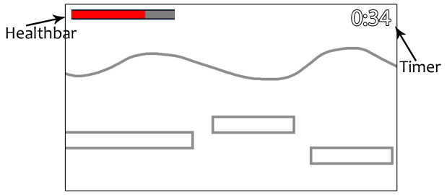The way to progress in Beach Surfer is by simply using the two core mechanics to move through the level from the left side of the screen (starting point) to the right side of the screen (ending point).

Each level has a type of thief who takes an appearance similar to the theme of the level. You can then finish the game by defeating the boss thief and retrieving your sandal.

The level is finished once you out-maneuver or fight all enemies in your path, and make it to the end. A portal will be open at the end of the level, where the player can go through and advance to the next level or finish the game, depending on which level they are on.

**Game Loop & Menu –**

Once the game application has been started, the main menu of the game will soon load in. Two options are available, one being to start the game at Level 1, and the other option being a Quit button to exit the application.

Upon starting Level 1, the game loop will commence and the player is tasked with reaching the end of the levels by jumping and/or punching his way through.

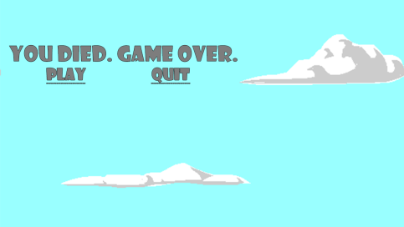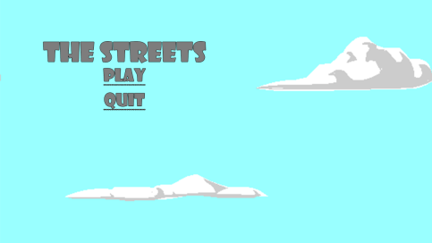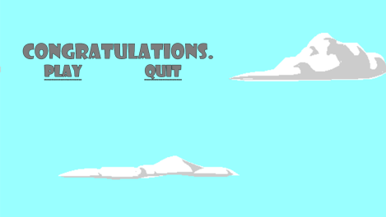The game loop is closed if the player dies or finishes all levels. When this loop is closed, the player is met with a menu. If the player dies, the menu will notify the player that the game is over… they are then free to retry or quit. If the player finishes all levels, the menu will congratulate the player on their victory, and they are then given an option to play again, or quit.

**Collectibles, Enemies, Powerups –**

‘Beach Surfer’ comes equipped with a respectable inventory of collectibles, enemies, and powerups.

There are a total of 3 collectible bottles of juices on each level. When the player makes physical contact with the bottles of juice, they are awarded 5000 score (which will be discussed in the ‘Scoring’ section).

Currently there are also a total of 3 enemy types, one themed for each level. These enemies get lightly more difficult to battle as each enemy gets a slightly bigger hitbox along with a more ranged animation for attack, allowing for easy collision with the player’s hitbox and thus causing death.

The list goes from left to right, starting with the Level 1 Enemy Prospect, equipped with nun chucks. The second enemy is the Level 2 Enemy Soldier, equipped with a baseball bat. The third enemy is the Level 3 Enemy Enforcer, equipped with throwing stars. The final enemy is the Level 3 Enemy Boss, equipped with amazing skill in taekwondo, and various other martial arts.

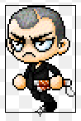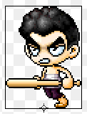

When the player successfully performs a double KO, they will be awarded with a powerup. The player can only hold up to 3 powerups at any given time. When using the powerup, the player’s fists will extend out during the next punch, allowing the player to stay further away from an enemy while attacking them at the same time.

**Death & Hitboxes –**

Upon collision with an enemy hitbox, the player’s death animation will instantly play and upon the animation finishing, the game loop closes and the game over menu will appear. Enemies’ hitboxes get bigger per level, with the boss having the biggest hitbox, thus increasing the difficulty of the game per level.

Besides enemies, falling off of the map on any corner of the map will result in a death, which again causes the game loop to close and the game over menu to appear.

**Scoring –**

The player can obtain a score for each level; between three gold stars, one star being the least favorable score and a result for minimum effort, and three stars being the most favorable score and a result for maximum effort.

Each enemy killed results in 2,500+ score. Bottled juice collectibles result in 5,000+ score. If the player’s score is between 0 and 10,000, then they receive a one star score, with their exact score also displayed to them. If the player’s score is between 10,001 and 16,000, then they receive a two star score, with their exact score also displayed to them. If the player’s score is above 16,001, then they receive a three star score, with their exact score also displayed to them.

**VGP121 – Lab 1 – Kermani, Kavian**