**Virtual Art Gallery**

CREATE DATABASE VirtualArtGallery;

USE VirtualArtGallery;

CREATE TABLE Artists (

ArtistID INT PRIMARY KEY NOT NULL,

Name VARCHAR(255) NOT NULL,

Biography TEXT,

Nationality VARCHAR(100)

);

CREATE TABLE Categories (

CategoryID INT PRIMARY KEY,

Name VARCHAR(100) NOT NULL

);

CREATE TABLE Artworks (

ArtworkID INT PRIMARY KEY,

Title VARCHAR(255) NOT NULL,

ArtistID INT,

CategoryID INT,

Year INT,

Description TEXT,

ImageURL VARCHAR(255),

FOREIGN KEY (ArtistID) REFERENCES Artists(ArtistID),

FOREIGN KEY (CategoryID) REFERENCES Categories(CategoryID)

);

CREATE TABLE Exhibitions (

ExhibitionID INT PRIMARY KEY,

Title VARCHAR(255) NOT NULL,

StartDate DATE,

EndDate DATE,

Description TEXT

);

CREATE TABLE ExhibitionArtworks (

ExhibitionID INT,

ArtworkID INT,

PRIMARY KEY (ExhibitionID, ArtworkID),

FOREIGN KEY (ExhibitionID) REFERENCES Exhibitions(ExhibitionID),

FOREIGN KEY (ArtworkID) REFERENCES Artworks(ArtworkID)

);

INSERT INTO Artists (ArtistID, Name, Biography, Nationality) VALUES

(1, 'Pablo Picasso', 'Renowned Spanish painter and sculptor.', 'Spanish'),

(2, 'Vincent van Gogh', 'Dutch post-impressionist painter.', 'Dutch'),

(3, 'Leonardo da Vinci', 'Italian polymath of the Renaissance.', 'Italian');

INSERT INTO Categories (CategoryID, Name) VALUES

(1, 'Painting'),

(2, 'Sculpture'),

(3, 'Photography');

INSERT INTO Artworks (ArtworkID, Title, ArtistID, CategoryID, Year, Description, ImageURL) VALUES

(1, 'Starry Night', 2, 1, 1889, 'A famous painting by Vincent van Gogh.', 'starry_night.jpg'),

(2, 'Mona Lisa', 3, 1, 1503, 'The iconic portrait by Leonardo da Vinci.', 'mona_lisa.jpg'),

(3, 'Guernica', 1, 1, 1937, 'Pablo Picasso''s powerful anti-war mural.', 'guernica.jpg');

INSERT INTO Exhibitions (ExhibitionID, Title, StartDate, EndDate, Description) VALUES

(1, 'Modern Art Masterpieces', '2023-01-01', '2023-03-01', 'A collection of modern art masterpieces.'),

(2, 'Renaissance Art', '2023-04-01', '2023-06-01', 'A showcase of Renaissance art treasures.');

INSERT INTO ExhibitionArtworks (ExhibitionID, ArtworkID) VALUES

(1, 1),

(1, 2),

(1, 3),

(2, 2);

-- 1. Retrieve the names of all artists along with the number of artworks they have in the gallery, and list them in descending order of the number of artworks.

SELECT Artists.Name, COUNT(Artworks.ArtworkID) AS TotalArtworks

FROM Artists

JOIN Artworks ON Artists.ArtistID = Artworks.ArtistID

GROUP BY Artists.Name

ORDER BY TotalArtworks DESC;

**Output:**

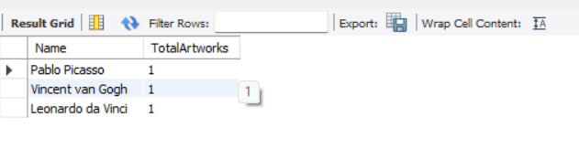

-- 2. List the titles of artworks created by artists from 'Spanish' and 'Dutch' nationalities, and order them by the year in ascending order.

SELECT Artworks.Title, Artists.Name, Artists.Nationality, Artworks.Year

FROM Artworks

JOIN Artists ON Artworks.ArtistID = Artists.ArtistID

WHERE Artists.Nationality IN ('Spanish', 'Dutch')

ORDER BY Artworks.Year ASC;

Output:

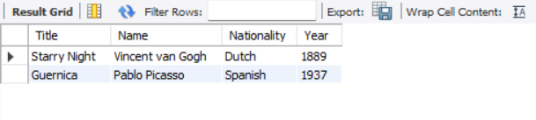

-- 3. Find the names of all artists who have artworks in the 'Painting' category, and the number of artworks they have in this category.

SELECT Artists.Name, COUNT(Artworks.ArtworkID) AS PaintingCount

FROM Artists

JOIN Artworks ON Artists.ArtistID = Artworks.ArtistID

JOIN Categories ON Artworks.CategoryID = Categories.CategoryID

WHERE Categories.Name = 'Painting'

GROUP BY Artists.Name;

**Output:**

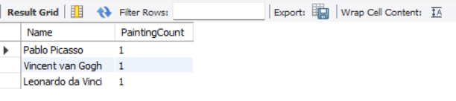

-- 4. List the names of artworks from the 'Modern Art Masterpieces' exhibition, along with their artists and categories.

SELECT Artworks.Title AS ArtworkTitle, Artists.Name AS ArtistName, Categories.Name AS CategoryName

FROM ExhibitionArtworks

JOIN Exhibitions ON ExhibitionArtworks.ExhibitionID = Exhibitions.ExhibitionID

JOIN Artworks ON ExhibitionArtworks.ArtworkID = Artworks.ArtworkID

JOIN Artists ON Artworks.ArtistID = Artists.ArtistID

JOIN Categories ON Artworks.CategoryID = Categories.CategoryID

WHERE Exhibitions.Title = 'Modern Art Masterpieces';

**Output**

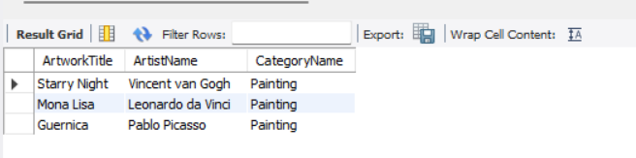

-- 5. Find the artists who have more than two artworks in the gallery.

SELECT Artists.Name, COUNT(Artworks.ArtworkID) AS ArtworkCount

FROM Artists

JOIN Artworks ON Artists.ArtistID = Artworks.ArtistID

GROUP BY Artists.Name

HAVING COUNT(Artworks.ArtworkID) > 2;

**Output**

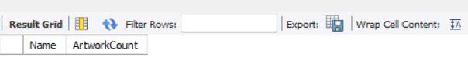

-- 6. Find the titles of artworks that were exhibited in both 'Modern Art Masterpieces' and 'Renaissance Art' exhibitions.

SELECT Artworks.Title

FROM Artworks

JOIN ExhibitionArtworks EA1 ON Artworks.ArtworkID = EA1.ArtworkID

JOIN ExhibitionArtworks EA2 ON Artworks.ArtworkID = EA2.ArtworkID

JOIN Exhibitions E1 ON EA1.ExhibitionID = E1.ExhibitionID

JOIN Exhibitions E2 ON EA2.ExhibitionID = E2.ExhibitionID

WHERE E1.Title = 'Modern Art Masterpieces'

AND E2.Title = 'Renaissance Art';

**Output**

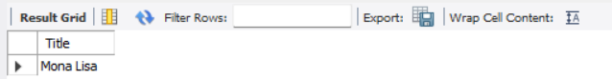

-- 7. Find the total number of artworks in each category.

SELECT Categories.Name AS CategoryName, COUNT(Artworks.ArtworkID) AS TotalArtworks

FROM Categories

LEFT JOIN Artworks ON Categories.CategoryID = Artworks.CategoryID

GROUP BY Categories.Name;

**Output**

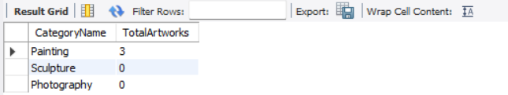

-- 8. List artists who have more than 3 artworks in the gallery.

SELECT Artists.Name, COUNT(Artworks.ArtworkID) AS TotalArtworks

FROM Artists

JOIN Artworks ON Artists.ArtistID = Artworks.ArtistID

GROUP BY Artists.Name

HAVING COUNT(Artworks.ArtworkID) > 3;

**Output**

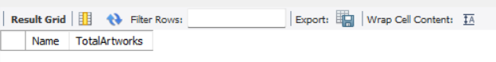

-- 9. Find the artworks created by artists from a specific nationality (e.g., Spanish).

SELECT Artworks.Title, Artists.Name, Artists.Nationality

FROM Artworks

JOIN Artists ON Artworks.ArtistID = Artists.ArtistID

WHERE Artists.Nationality = 'Spanish';

**Output**

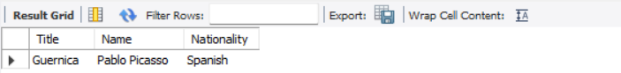

-- 10. List exhibitions that feature artwork by both Vincent van Gogh and Leonardo da Vinci.

SELECT Exhibitions.Title

FROM Exhibitions

JOIN ExhibitionArtworks EA1 ON Exhibitions.ExhibitionID = EA1.ExhibitionID

JOIN Artworks AR1 ON EA1.ArtworkID = AR1.ArtworkID

JOIN Artists A1 ON AR1.ArtistID = A1.ArtistID

JOIN ExhibitionArtworks EA2 ON Exhibitions.ExhibitionID = EA2.ExhibitionID

JOIN Artworks AR2 ON EA2.ArtworkID = AR2.ArtworkID

JOIN Artists A2 ON AR2.ArtistID = A2.ArtistID

WHERE A1.Name = 'Vincent van Gogh' AND A2.Name = 'Leonardo da Vinci'

GROUP BY Exhibitions.ExhibitionID

**Output**

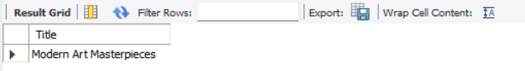

-- 11. Find all the artworks that have not been included in any exhibition.

SELECT Title

FROM Artworks

WHERE ArtworkID NOT IN (

SELECT ArtworkID

FROM ExhibitionArtworks

);

**Output**



-- 12. List artists who have created artworks in all available categories.

SELECT Artists.Name

FROM Artists

JOIN Artworks ON Artists.ArtistID = Artworks.ArtistID

GROUP BY Artists.Name

HAVING COUNT(DISTINCT Artworks.CategoryID) = (SELECT COUNT(*) FROM Categories);

**Output**



-- 13. List the total number of artworks in each category.

SELECT Categories.Name AS CategoryName, COUNT(Artworks.ArtworkID) AS TotalArtworks

FROM Categories

LEFT JOIN Artworks ON Categories.CategoryID = Artworks.CategoryID

GROUP BY Categories.Name;

**Output**

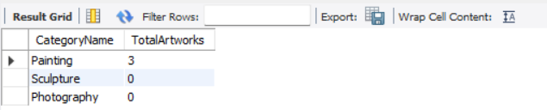

-- 14. Find the artists who have more than 2 artworks in the gallery.

SELECT Artists.Name, COUNT(Artworks.ArtworkID) AS TotalArtworks

FROM Artists

JOIN Artworks ON Artists.ArtistID = Artworks.ArtistID

GROUP BY Artists.Name

HAVING COUNT(Artworks.ArtworkID) > 2;

**Output**

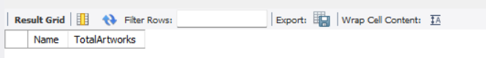

-- 15. List the categories with the average year of artworks they contain, only for categories with more than 1 artwork.

SELECT Categories.Name AS CategoryName, AVG(Artworks.Year) AS AverageYear

FROM Categories

JOIN Artworks ON Categories.CategoryID = Artworks.CategoryID

GROUP BY Categories.Name

HAVING COUNT(Artworks.ArtworkID) > 1;

**Output**

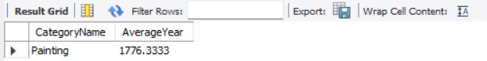

-- 16. Find the artworks that were exhibited in the 'Modern Art Masterpieces' exhibition.

SELECT Artworks.Title

FROM Artworks

JOIN ExhibitionArtworks ON Artworks.ArtworkID = ExhibitionArtworks.ArtworkID

JOIN Exhibitions ON ExhibitionArtworks.ExhibitionID = Exhibitions.ExhibitionID

WHERE Exhibitions.Title = 'Modern Art Masterpieces';

**Output**

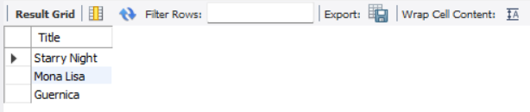

-- 17. Find the categories where the average year of artworks is greater than the average year of all artworks.

SELECT Categories.Name AS CategoryName, AVG(Artworks.Year) AS AverageYear

FROM Categories

JOIN Artworks ON Categories.CategoryID = Artworks.CategoryID

GROUP BY Categories.Name

HAVING AVG(Artworks.Year) > (

SELECT AVG(Year) FROM Artworks

);

**Output**

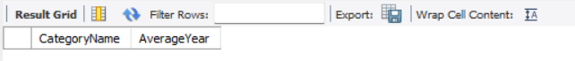

-- 18. List the artworks that were not exhibited in any exhibition.

SELECT Title

FROM Artworks

WHERE ArtworkID NOT IN (

SELECT ArtworkID

FROM ExhibitionArtworks

);

**Output**



-- 19. Show artists who have artworks in the same category as "Mona Lisa."

SELECT DISTINCT Artists.Name

FROM Artists

JOIN Artworks ON Artists.ArtistID = Artworks.ArtistID

WHERE Artworks.CategoryID = (

SELECT CategoryID

FROM Artworks

WHERE Title = 'Mona Lisa'

);

**Output**

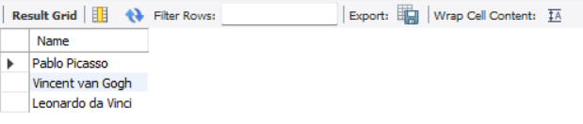

-- 20. List the names of artists and the number of artworks they have in the gallery.

SELECT Artists.Name, COUNT(Artworks.ArtworkID) AS ArtworkCount

FROM Artists

JOIN Artworks ON Artists.ArtistID = Artworks.ArtistID

GROUP BY Artists.Name

ORDER BY ArtworkCount DESC;

**Output**