Title:FitSense - Personalized fitness recommendations powered by AI.
Team Members:
1.Name: Kavi devi.S (Team Leader)
Register No:212403053
- Name: Kaaviyasri.P(Team Member)
Register No:212403052
- Name: Kaviya.G(Team Member)
Register No:212403054
- Name: Keerthana.M(Team Member)
Register No:212403056

Description
The FitTrack AI backend is a secure, scalable, and AI-powered RESTful application developed to simplify workout tracking and provide intelligent fitness recommendations. Built using
Node.js, Express.js, MongoDB, and Mongoose, the backend exposes REST APIs that enable secure user authentication, workout management, workout searching, and AI-assisted fitness guidance.
The application follows the Model-View-Controller (MVC) architecture, making the project modular, maintainable, and scalable. User authentication is implemented using JSON Web Tokens (JWT), while passwords are securely encrypted using bcrypt.js before storage in MongoDB. Every protected API validates the JWT token through middleware before allowing access to sensitive resources.
One of the key features of the project is its integration with Google Gemini AI, which provides personalized workout recommendations based on a user's age, fitness goals, and workout experience. The AI module also generates fitness insights by analyzing workout statistics such as total workouts completed, average workout duration, and calories burned.
The backend returns standardized JSON responses, making it suitable for integration with web, mobile, and third-party applications. Proper error handling, input validation, route protection, and modular service implementation ensure the application is reliable, secure, and easy to extend.

Scenario-Based Case Study

Background
Rahul is a fitness enthusiast who exercises regularly but records his workouts manually using notebooks and spreadsheets. Although he maintains consistency in his fitness routine, he finds it difficult to organize workout history, monitor progress, and determine whether his exercise habits align with his fitness goals. He also lacks professional guidance when deciding which workouts are best suited for his current fitness level.

Problem
Difficulty maintaining a centralized record of workouts.
Manual tracking leads to inaccurate workout history. No secure user authentication for personal fitness records.
Unable to search previous workouts efficiently.
No personalized workout recommendations.
No insights regarding overall workout performance.
Time-consuming manual calculation of calories burned and workout duration.

Solution
The FitTrack AI provides a centralized backend system where users can securely register, authenticate, and manage workout records. Users can add, update, delete, retrieve, and search workouts through RESTful APIs. By integrating Google Gemini AI, the application analyzes user information and workout statistics to generate intelligent workout recommendations and personalized fitness insights.
The backend follows industry-standard security practices including JWT authentication, password hashing, middleware-based authorization, centralized error handling, and MongoDB schema validation.

Usage

User Usage
A registered user can create an account using the registration endpoint and securely log in using email and password. After successful authentication, the backend generates a JWT token that authorizes access to protected APIs.
Using authenticated APIs, users can:
Create new workout records.
View all previously completed workouts.
Retrieve a workout by its unique identifier. Update existing workout information.
Delete unwanted workout records.
Search workouts using workout name, category, or workout date.
Generate AI-powered workout recommendations.
Obtain AI-generated fitness insights based on workout statistics.

AI Usage
The AI module communicates with Google Gemini using a dedicated service layer.
Users provide information such as:
Age
Fitness Goal
Experience Level
Gemini processes this information and returns:
Personalized workout plan
Weekly exercise suggestions
Beginner/Intermediate/Advanced recommendations
Motivational guidance Safety tips
Similarly, users can submit workout statistics including:
Total Workouts
Average Workout Duration Total Calories Burned
The AI module analyzes these values and produces personalized fitness insights.

Outcome
The AI FitTrack backend significantly improves fitness tracking by eliminating manual record keeping and providing intelligent recommendations based on user activity. Secure authentication ensures that only authorized users can access personal workout data, while AI assistance helps users improve their exercise routines with personalized suggestions.
The modular MVC architecture enables easy maintenance and future scalability. The application can later be extended with additional features such as nutrition tracking, BMI calculation, wearable device integration, workout reminders, and fitness analytics dashboards without major architectural changes.

1. Software Requirements
The FitTrack AI requires the following software components for development and execution.Operating System: Windows 10/11, macOS, or Linux (supports cross-platform operations).
Node.js (v16 or above): Runtime ecosystem running server logic and routing infrastructure. npm (v8 or above): Node package manager to control operational dependencies. Express.js: Lightweight routing web framework to construct backend RESTful entry points.
MongoDB: Document NoSQL engine storing users, posts, categories, comments, and analytics metrics.
Postman: API verification toolkit to assert schema validation responses across administrative route shields.
Code Editor: Visual Studio Code or similar IDE environment.

2. Hardware Requirements
Processor: Intel Core i5 (8th Gen or above) / AMD Ryzen 5 or equivalent. RAM: 8 GB minimum (16 GB recommended for concurrent instances of MongoDB, processing layers, and execution nodes). Storage: 1 GB of available disk workspace.

Epic 1: Project Architecture
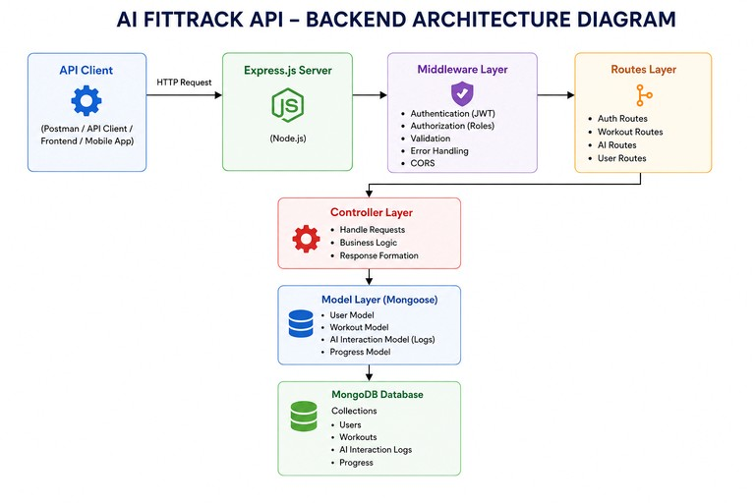
The FitTrack AI follows a layered architecture based on the MVC (Model–View–Controller) design pattern. The application separates routing, business logic, database interaction, middleware, and AI services into independent modules, making the project easier to maintain and scale.
When a client sends an HTTP request, the Express server receives it and forwards it to the corresponding route. Protected routes first pass through the authentication middleware, which validates the JWT token before granting access. Controllers process validated requests and invoke business logic or AI services as required. Database interactions are handled through Mongoose models, while Google Gemini AI is accessed through a dedicated service layer. Finally, the controller returns a structured JSON response to the client.
This layered approach improves modularity, security, and maintainability while ensuring that each component has a single responsibility.

Overall Architecture Components
Client Application (React / Mobile App / Postman)
Express Server
API Routes
Authentication Middleware
Controllers
Services
Google Gemini AI Service
MongoDB Database
Mongoose Models
Each component communicates through well-defined interfaces, ensuring loose coupling and easier future enhancements.

Components Definition
The FitTrack AI follows a modular backend architecture in which every component performs a dedicated responsibility. The separation of concerns ensures maintainability, scalability, and efficient execution of requests. Each request passes through multiple layers before reaching the database or AI service, ensuring secure and reliable processing.

1. Client Layer (Frontend/API Consumer)
The Client Layer is the entry point of the application. It can be a React application, mobile application, or API testing tool such as Postman. The client sends HTTP requests to the backend server and receives JSON responses.

Responsibilities
Sends API requests. Displays workout information.
Stores JWT token after login.
Invokes AI recommendation APIs.
Displays success and error responses.

APIs Accessed
Authentication APIs
Workout APIs
AI Recommendation APIs
AI Fitness Insight APIs

2. Express Server Gateway
The Express server acts as the central gateway of the application. It listens for incoming requests, configures middleware, parses request bodies, enables CORS, and routes requests to the appropriate controllers.

Responsibilities
Starts HTTP server
Parses JSON requests
Enables Cross-Origin Resource Sharing (CORS)
Registers application routes
Connects middleware
Handles centralized errors

Example Responsibilities
Receive HTTP Request
Validate Request Format
Forward Request to Routes
Return JSON Response

3. Authentication Middleware
Authentication middleware protects all secured APIs by validating the JSON Web Token (JWT). Every protected request must include a valid Authorization header.

Responsibilities
Read Authorization Header
Extract JWT Token
Verify JWT Signature
Decode User Information
Attach User Information to Request
Reject Unauthorized Requests

Benefits
Prevents unauthorized access
Secures workout information
Allows only authenticated users to access protected APIs
Eliminates repeated authentication logic inside controllers

4. Route Layer
Routes define the application's API endpoints and map incoming HTTP requests to controller methods. Each route represents a specific functionality of the system.

Authentication Routes
Register User
Login User
User Profile

Workout Routes
Add Workout
Get All Workouts
Search Workouts
Get Workout by ID
Update Workout
Delete Workout

AI Routes
Workout Recommendation
Fitness Insights

5. Controller Layer
Controllers contain the application's business logic. They receive requests from routes, validate input data, invoke services or database operations, and generate standardized JSON responses.

Authentication Controller
Responsible for:
User Registration
User Login
User Profile Retrieval

Workout Controller
Responsible for:
Creating Workout Records
Retrieving Workout Records
Updating Workouts
Deleting Workouts
Searching Workouts

AI Controller
Responsible for:
Sending prompts to Google Gemini
Receiving AI-generated recommendations
Returning AI responses to clients

6. Service Layer
The Service Layer contains reusable business logic that can be shared among multiple controllers.

Gemini AI Service
Responsible for:
Preparing prompts
Sending prompts to Google Gemini
Receiving AI-generated responses
Returning formatted recommendations

JWT Service
Responsible for:
Creating JWT Tokens
Configuring Token Expiry
Verifying User Identity

Password Service
Responsible for:
Hashing Passwords
Comparing Passwords During Login

7. Database Layer
MongoDB stores all persistent application data. Mongoose acts as an Object Data Modeling (ODM) library that simplifies communication between Node.js and MongoDB.

Collections
Users Collection
Workouts Collection

Advantages
Flexible Schema
High Performance
Easy Data Retrieval
Scalable Architecture

Entity Relationship (ER) Diagram Description
The AI FitTrack backend consists of two primary collections that are logically connected through a one-to-many relationship.
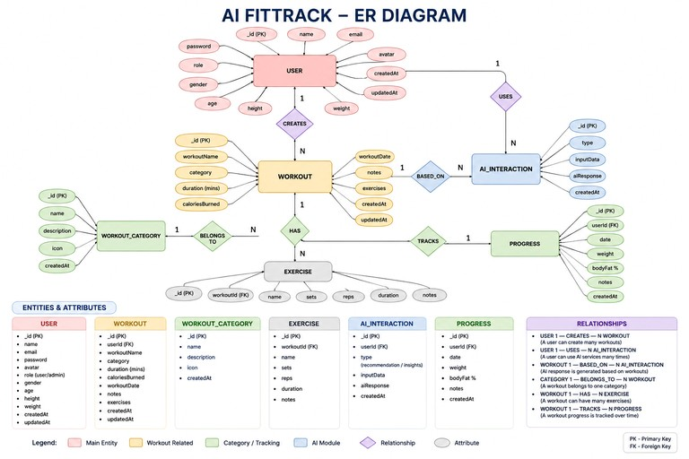
1. User Entity
The User entity stores authentication and profile information.

Attributes
Field | Type | Description
_id | ObjectId | Primary Key
name | String | User Name
email | String | Unique Email Address
password | String | Encrypted Password
createdAt | Date | Record Creation Time
updatedAt | Date | Last Updated Time

Constraints
Email must be unique.
Password is encrypted using bcrypt.
Name is mandatory.
JWT token is generated after successful login.
2. Workout Entity
The Workout entity stores workout-related information for each authenticated user.

Attributes
Field | Type | Description
_id | ObjectId | Primary Key
user | ObjectId | References User Collection
workoutName | String | Workout Name
category | String | Workout Category
duration | Number | Duration (Minutes)
caloriesBurned | Number | Calories Burned
workoutDate | Date | Workout Date
createdAt | Date | Created Timestamp
updatedAt | Date | Updated Timestamp

Relationship
User → Workout
Relationship Type: One-to-Many
A single user can create multiple workout records. Each workout belongs to only one authenticated user.
Example:
John Doe
Morning Running
Evening Jogging
Upper Body Strength
Cycling Session
This relationship is maintained using the user field inside the Workout schema, which stores the ObjectId of the corresponding user.

Key Features
The FitTrack AI provides a complete backend solution for workout tracking and AI-assisted fitness guidance.

1. Secure Authentication
The application implements JWT-based authentication.
Features include:
User Registration
Secure Login
Password Encryption
JWT Generation
Protected APIs

2. Workout Management
Users can perform complete CRUD operations.
Supported Operations
Add Workout
View Workout
Update Workout Delete Workout
Each workout is linked to its authenticated user.

3. Workout Search
Users can search workouts using:
Workout Name
Workout Category Workout Date
This improves accessibility of workout history.

4. Google Gemini Integration
The backend communicates with Google Gemini AI to generate intelligent workout recommendations.
Input
Age
Fitness Goal
Experience Level
Output
Weekly Workout Plan
Suggested Exercises
Training Tips Safety Recommendations

5. AI Fitness Insights
The AI module analyzes workout statistics.
Input
Total Workouts
Average Duration
Calories Burned
Output
Performance Analysis
Improvement Suggestions
Motivational Advice
Fitness Progress Summary

6. Centralized Error Handling
The application returns meaningful JSON error responses for:
Invalid Credentials
Missing Authentication Token
Validation Errors
Database Errors Internal Server Errors

7. RESTful API Design
The backend follows REST principles.
Supported HTTP Methods
GET
POST
PUT
DELETE
Responses are returned in JSON format.

8. Modular Architecture
The project separates responsibilities into
Models
Controllers
Routes
Middleware
Services
Configuration
This improves maintainability and scalability.

Roles and Responsibilities
The AI FitTrack backend supports one primary role.
Authenticated User

Responsibilities
Register an account.
Login securely.
View profile information.
Add workout records. View workout history.
Search workouts. Update workouts.
Delete workouts.
Request AI workout recommendations. Request AI fitness insights.

Permissions
Operation |  | Permission
Register | Yes
Login | Yes
View Profile | Yes
Add Workout | Yes
Get Workouts | Yes
Search Workouts | Yes
Update Workout | Yes
Delete Workout | Yes
AI Recommendation | Yes
Fitness Insights | Yes

User Flow
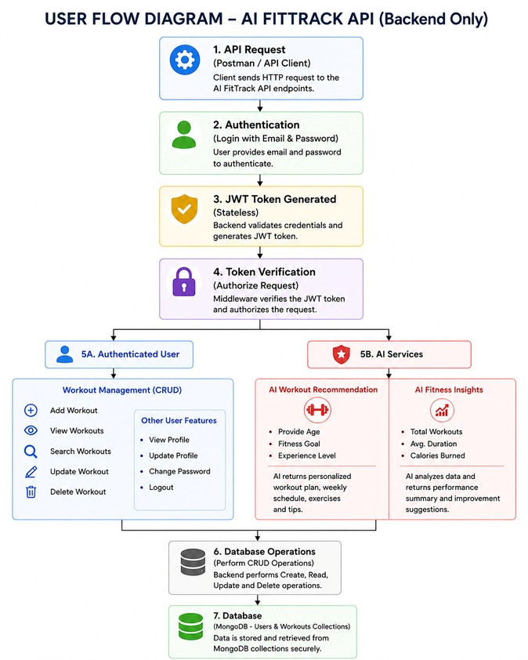

MVC Architecture Pattern
The FitTrack AI is designed using the Model–View–Controller (MVC) architecture pattern.
This architecture separates application logic into independent components, improving code organization, maintainability, and scalability.
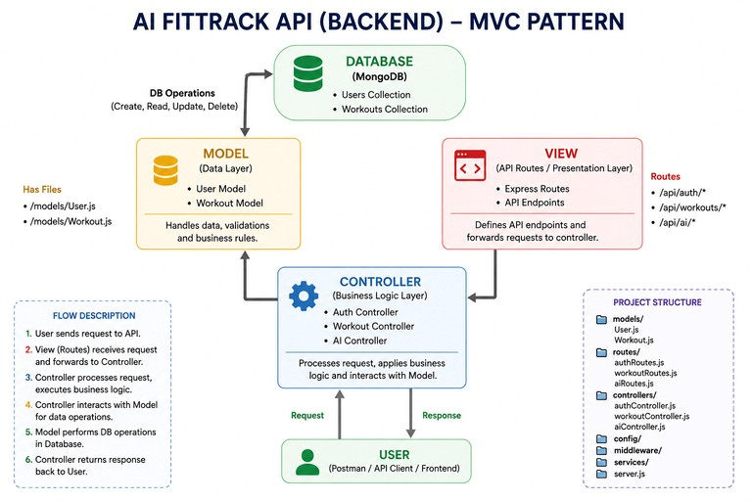

Model Layer (Data Layer)
The Model Layer defines the structure of the application's data using Mongoose schemas. It communicates directly with MongoDB and performs database operations.
Models in the project include:
User Model
Workout Model
Responsibilities:
Schema Definition
Data Validation
CRUD Operations
Collection Mapping

View Layer (API Interface)
Since AI FitTrack is a backend REST API, there are no traditional UI templates. The View Layer is represented by API consumers such as React applications, mobile applications, or Postman, which interact with the backend through HTTP requests and receive JSON responses.
Responsibilities:
Send Requests
Receive JSON Responses
Display Data
Handle Client-side Interaction

Controller Layer (Business Logic)
The Controller Layer acts as the intermediary between the View and Model. It processes incoming requests, validates input, invokes services and models, and sends structured JSON responses back to the client.
Responsibilities:
Request Validation
Business Logic Execution
Database Interaction
AI Service Invocation
Response Generation
The separation of these three layers ensures loose coupling, simplifies testing, enhances code readability, and makes the application easier to extend with future features.

Epic 2: Project Setup and Configuration
The FitTrack AI project follows a well-structured backend architecture that separates business logic, routing, database operations, middleware, and AI services into individual modules. This modular design improves code readability, maintainability, and scalability while making the project easier to debug and extend.
The backend is developed using Node.js and Express.js, with MongoDB as the primary database and Google Gemini AI for intelligent fitness recommendations.

Creating Project Folder

Step 1: Create the Project Folder
Create a new folder with the project name.
AI-FitTrack-API
Step 2: Open the Project
Open the project folder in Visual Studio Code.

Step 3: Create the Server Folder
Inside the project directory, create a folder named:
server
All backend source code will be maintained inside this folder.
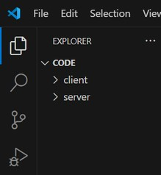

Step 4: Initialize Node Project
Open the terminal inside the server folder and execute:
npm init -y
This command generates the package.json file containing project metadata and dependency information.

Step 5: Install Required Packages
Install the required dependencies.
npm install express mongoose dotenv bcryptjs jsonwebtoken cors
Install Nodemon as a development dependency.
npm install --save-dev nodemon

Environment Variables
Sensitive information is stored in the .env file.
Example
PORT=5000
MONGO_URI=mongodb://localhost:27017/aifittrack
JWT_SECRET=your_secret_key
GEMINI_API_KEY=your_google_gemini_api_key
Using environment variables improves security by preventing sensitive information from being exposed in source code.

Epic 3: Backend Development
Backend development focuses on implementing REST APIs that allow authenticated users to manage workouts and interact with Google Gemini AI.
The project is divided into multiple modules that collectively perform authentication, workout management, AI integration, and database operations.
Major modules include:
Server Configuration
Database Configuration
Authentication
Workout Management
AI Recommendation
Middleware
Error Handling
Video Link:
https://drive.google.com/file/d/1KswrctSaPI0eOYyJ3GkbbVHvHsU3Ef ZJ/view?usp=sharing

Epic 4: Database Configuration
The FitTrack AI uses MongoDB as its primary NoSQL database for storing user credentials and workout information. Mongoose serves as the Object Data Modeling (ODM) library, enabling seamless interaction between the application and the MongoDB database. Mongoose provides schema validation, middleware support, data relationships, and
simplified CRUD operations.
The database layer is responsible for maintaining data integrity, validating incoming requests, and ensuring secure storage of user information.

MongoDB Configuration
MongoDB stores application data in collections rather than traditional relational database tables. The FitTrack AI maintains separate collections for users and workouts.

Database Collections
Users Collection
Workouts Collection
Each collection stores JSON-like documents (BSON format), allowing flexible schema design while maintaining efficient data retrieval.

Installing Mongoose
Install Mongoose using npm.
npm install mongoose
Mongoose acts as the bridge between the Node.js application and MongoDB by providing schema definitions, validation, and database methods.

MongoDB Connection
The database connection is configured inside the config/db.js file. This module establishes a connection to the MongoDB server when the application starts.
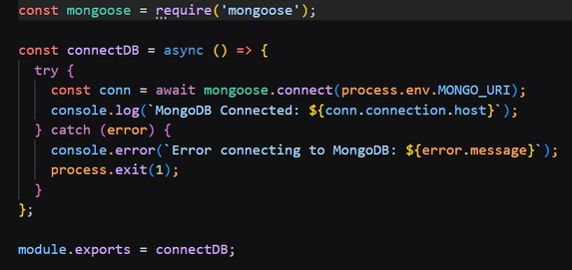

Responsibilities
Connect to MongoDB
Handle Connection Errors
Display Connection Status
Export Database Connection

Advantages
Centralized database configuration Reusable connection module
Automatic connection management
Simplified error handling

Mongoose Schemas
The AI FitTrack backend contains two primary Mongoose schemas:
- User Schema
- Workout Schema
Schemas define the structure, validation rules, and relationships for MongoDB documents.

1. User Schema (models/User.js)
The User schema stores authentication information for registered users.
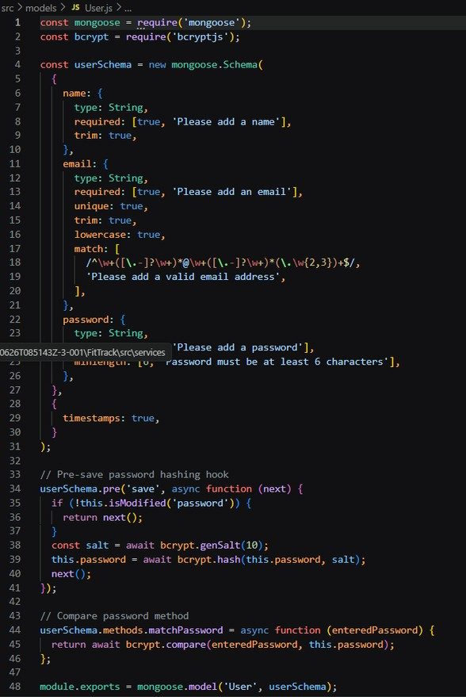

Validation Rules
Name cannot be empty. Email must be unique.
Password is mandatory.
Password is encrypted using bcrypt.js before saving. Automatic timestamps are enabled.

User Schema Features
Email uniqueness validation
Password hashing
Automatic timestamps
Secure authentication support
JWT integration

2. Workout Schema (models/Workout.js)
The Workout schema stores workout information created by authenticated users.
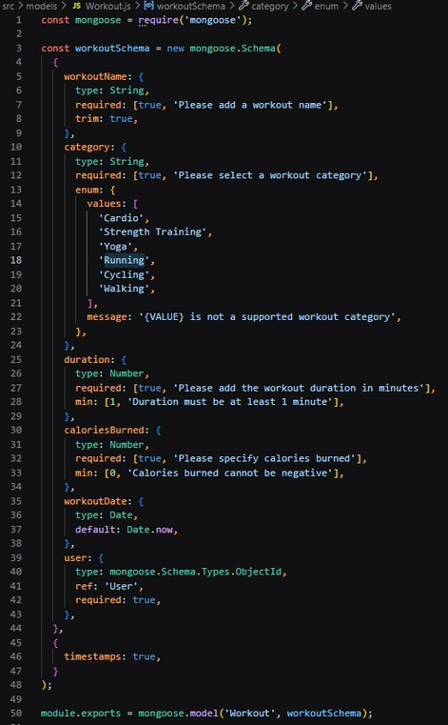

Validation Rules
Workout Name is mandatory.
Category is mandatory.
Duration must be greater than zero.
Calories Burned must be greater than or equal to zero.
Workout Date is required.
Every workout belongs to one authenticated user.

Workout Schema Features
Schema validation
Automatic timestamps User relationship
Easy search support
Efficient CRUD operation

Epic 5: Project Execution
· Install Postman or ThunderClient (VS Code extension).
· Start the backend server:
“npm start”

API Testing
API testing ensures that every endpoint functions correctly and returns the expected response. The FitTrack AI is tested using Postman, allowing developers to verify request handling, authentication, database operations, and AI integration.
Testing is performed in the following order:
- Authentication APIs
- Workout APIs
- AI APIs

Authentication API Testing

Register User
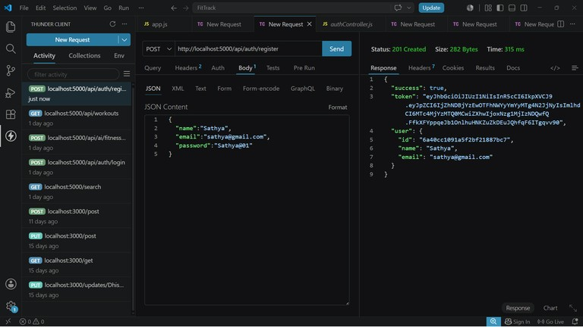

Login User
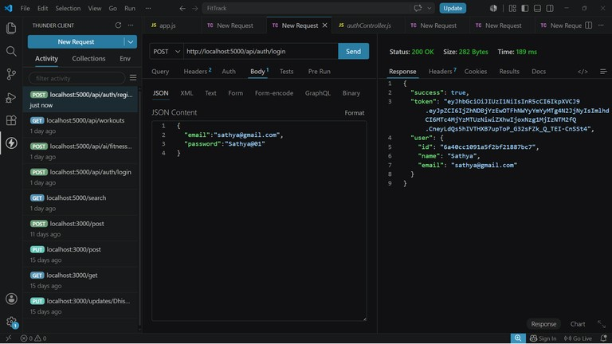

Get Profile
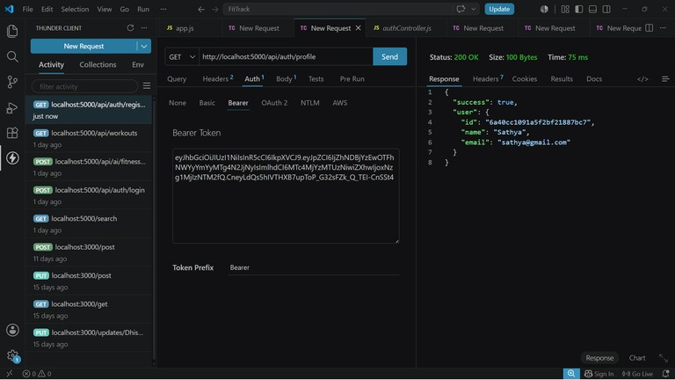

Workout API Testing

Add Workout
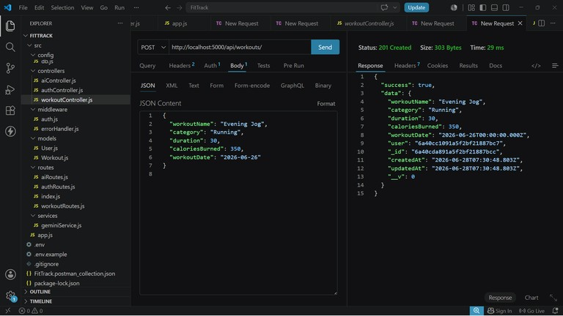

Get All Workouts
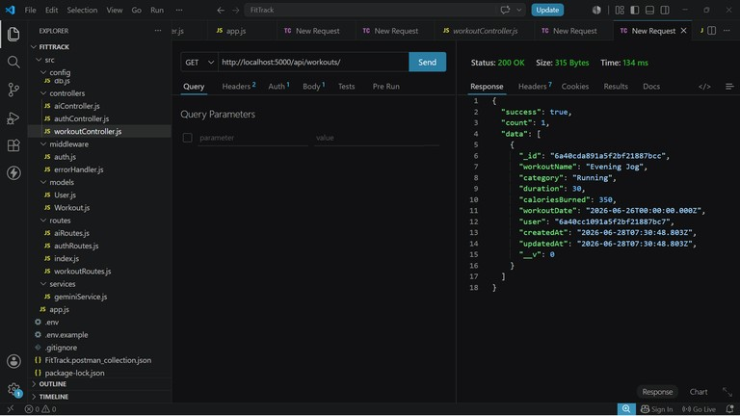

Get Workout By ID
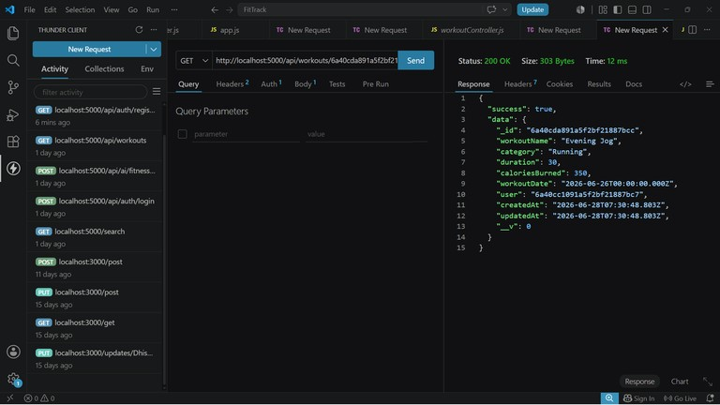

Update Workout
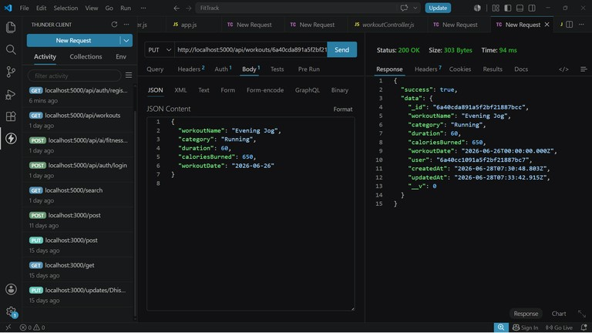

Delete Workout
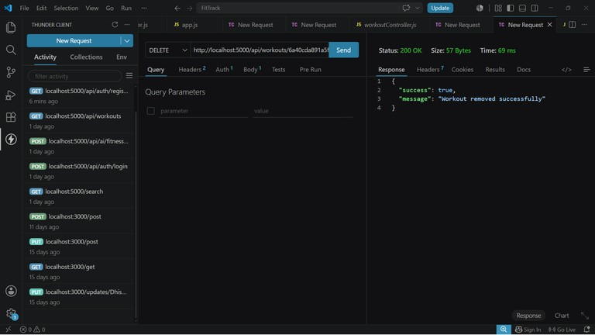

AI API Testing

Workout Recommendation
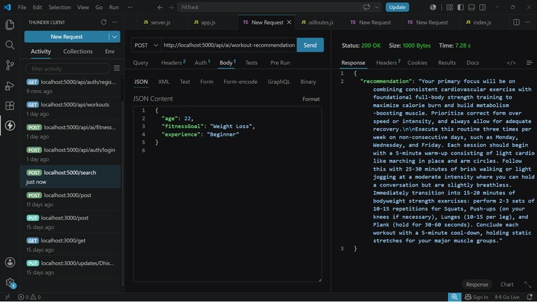

Fitness Insights
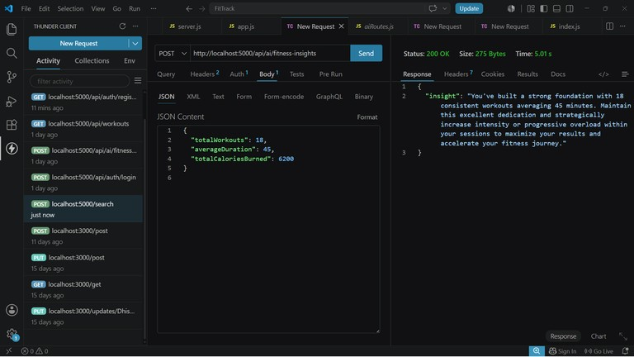
Demo Video Link:
https://drive.google.com/file/d/1KswrctSaPI0eOYyJ3GkbbVHvHsU 3EfZJ/view?usp=drive_link
API TESTING VIDEO : https://drive.google.com/file/d/1TCXG48a-
78ryxF3gipdRMwRBwuhAgPaa/view?usp=drive_link
CodeDrive:https://drive.google.com/drive/folders/1hwmKxkHQkU I62JR1svI3xCQ2ShZ6Lj9y.

