Low Level Design (add product module)

Project Code | Team-7
Project Name | Online Banking System

Prepared/Modified by | Role | Date of Preparation
Reviewed by | Role | Date of Review
Approved by | Role | Date of Approval
Circulation List | amit.agarwal@igate.com, mrunalee.kothari@igate.com, keerthi.parthasarathy@igate.com, nidhi.shetty@igate.com, nikeeta.menon@igate.com, shrikant.sutar@igate.com, bhagyashree.vedpathak@igate.com | Version Number of the template:1.0
Version Number | 1.3

Table of Contents

1. Description Of The Unit 3
2. References 4
3. Dependencies / Assumptions 5
4. Class Diagrams 6
5. Sequence Diagrams 7
6. Design Components 8
6.1 List Of UI Components 8
6.2 List Of Design Classes 8
7. Re-Usable Routines/Components 9
8. Messages 10
9. Configuration Files 11
10. Crud Matrix Table 12
11. Data Mapping Matrix 13
12. Action Flow Matrix 14
13. Stored Procedures 15
14. Program Specification / Pseudo Code 16
REVISION HISTORY OF THE WORK PRODUCT 17

Description Of The Unit

The Login module allows user to login and user can perform operations. This module can be used by the user.
On clicking on the New User button in home page, user is redirected to the New user page in which user should fill the details like username, login password, transaction password, secret question. If the entered details are invalid, appropriate error messages are displayed.
After entering the details, these are inserted into the database on clicking submit button.

References

Reference | Description
Repository reference | https://github.com/VISH9415/PLP-OBS
Class Diagram | /Project Documents/Design Documents/HLD/Class Diagrams
URS | /Project Documents/Requirements/Case Study/
UTP | /Project Documents/Test Plan/UTP/Test Cases/signup /UTP_SignUpModule.xlsm
DB Design | /Project Documents/Design Documents/HLD/DB Design/

Dependencies / Assumptions

Dependencies:
This module is dependent on the signup module wherein the user details are taken and stored in the database.

Assumptions:
UserId and password of the user are in the database. The user details are stored in the database through signup module whereas admin/sales manager valid credentials are already exists in the database. Lock status is not considered.

Class Diagrams

Class Diagram

Sequence Diagrams

Sequence Diagram
NA

Design Components

List Of UI Components

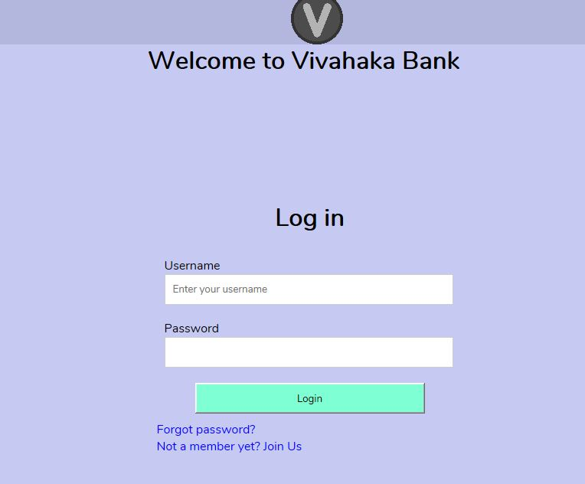

List Of Design Classes

Sr. No. | LLD Name | Class Name | Method Name | Method Description
1 | Login  Module | UserBean | Appropriate getters and setters methods | Getters retrieve the property values and setters set the property values
2 | Login  Module | BankController | existingUser(@RequestParam(“username”) String username,@RequestParam(“password”) String password,HttpServletRequest request,Model model) :String | Calls of fetchUserById() of BankingServiceImpl class. If it returns an object, it redirects to success page. Otherwise it redirects to the Error page showing error message.
3 | Login  Module | BankingServiceImpl | fetchUserById():UserBean | Calls fetchUserById() of BankingDAOImpl class and returns the result to the controller.
4 | Login  Module | BankingDAOImpl | fetchUserById():UserBean | Retrieves details of the login credentials from the database.

Re-Usable Routines/Components

Re-Usable Routines/Components

- CSS files
- Javascript files
- DataAccessException class
- Database properties files
- Logger properties files

Messages

#. | Type | Message Text
M1 | Error | Enter a valid product name
M2 | Error | Enter a valid product description
M3 | Error | Select a product sub-category
M4 | Error | Enter a valid product price
M5 | Error | Enter a valid product quantity
M6 | Error | This field cannot be empty

Configuration Files

File Name | Path | Description
oracle.properties | /Development/Source | To configure database connection.
web.xml | /Development/Source | To configure the bean properties.
Servlet-config.xml | /Development/Source | To configure the request mapping and view resolver.
logger.properties | /Development/Source | To configure the logger.
error.properties | /Development/Source | To configure error messages.

Crud Matrix Table

# | Table Name | Create | Read | Update | Delete
1. | AccountBean | N | N | N | N
2. | CustomerBean | N | N | N | N
3. | FundTransferBean | N | N | N | N
4. | PayeeBean | N | N | N | N
5. | ServiceTrackerBean | N | N | N | N
6. | TransactionsBean | N | N | N | N
7. | UserBean | N | Y | N | N

Data Mapping Matrix

Sr. No. | Screen Label | Field Source | Field Type | Data Type | Max Length | Data Flow | Mandatory
1 | Username | NA | Label | NA | NA | UI | NA
2 | username | UserBean.userName | TextBox | Varchar2 | 50 | UI→D | Yes
3 | Password | NA | Label | NA | NA | UI | NA
4 | loginPassword | UserBean.loginPassword | TextBox | Varchar2 | 30 | UI→D | Yes
5 | Login | NA | Button | NA | NA | UI | NA
6 | Forgot Password? | NA | Link | NA | NA | UI | NA
7 | Not a member yet? Join Us | NA | Link | NA | NA | UI | NA

Legend
D → UI (Database to User Interface)
UI → D (User Interface to Database)
UI (User Interface Only)

Action Flow Matrix

Sr. No. | Action | Description | Process
1 | On click of User Button in Index Page | Redirected to the login page | The user clicks on the User button in the indexpage and gets redirected to the login page.
2 | On click of login button in login page | The user details are validated and Home page is displayed. | Login credentials entered by the user is matched with the details corresponding to the database when login button is pressed.

REVISION HISTORY OF THE WORK PRODUCT

# | Date | Version # | Section Changed | Details of changes made | Approved By
1 |  | 1.0 | LLD prepared | N/A
2 |  | 1.1 | Reusable components | Reusable components added.
3 |  | 1.2 | Reusable components,  References,  Data Mapping Matrix. | Reusable Components added.  File name with relative path is added in the references section.  The name of text boxes (screen label is changed).
4 |  | 1.3 | Configuration files,UI Components | Paths of the configuration files is updated and UI components (Screen Shots) added.

