CollabBoard — Technical Project Report
Full-Stack Collaborative Agile Kanban Task Management Application
Project Name | CollabBoard (Collaborative Task Management Board)
Repository | https://github.com/kavikaran-marazin/kanban_board-project.git
Architecture | React + Node.js/Express 5 REST API + MongoDB Mongoose
Scope & Status | Full-Stack Implementation (Frontend UI, REST API, Auth, MongoDB Persistence, Theme Engine)

1. Introduction & Project Overview
CollabBoard is a collaborative Kanban-style task management web application created to streamline agile teamwork, sprint planning, and project tracking. The system enables users to create customizable project boards, organize workflows into structured columns (TO DO, DOING, and COMPLETED), create detailed tasks with priorities and due dates, move tasks across stages, and maintain persistent state across browser sessions.
The application is built on a decoupled full-stack architecture combining a component-driven React 18 single-page frontend, an asynchronous Node.js and Express 5 REST API, and a persistent MongoDB document store managed via Mongoose.
2. Team Members & Responsibilities Matrix
The development of CollabBoard was carried out collaboratively across specialized frontend, backend, UI/UX, and integration responsibilities:
Member Name | Assigned Role | Specific Responsibilities & Contribution
Himas | Backend Leader & Full-Stack Developer) | Led the backend architecture and developed REST APIs, authentication, MongoDB/Mongoose integration, CRUD operations, middleware, and frontend-backend API connectivity. Also developed the frontend Dashboard and Authentication features, including Login, Registration, user session handling, and JWT token management.
Thirunavukkarasu Kavikaran | Full-Stack Developer & Project Coordinator | Contributed to frontend and backend integration, API connectivity, and module integration. Coordinated project development, managed GitHub branches and pull requests, and ensured frontend components, backend services, and database functionality worked together as a complete application.
NM Rifadh | UI/UX & Figma Designer | Created and maintained the Figma design system, layout specifications, spacing tokens, color palettes, and visual interface consistency.
Prageeth | Frontend Developer – Kanban Board | Developed Kanban column components, task card layout, board header controls, and interactive board state management.
Florington Dianstith | Full-Stack Developer – Task Management Module | Developed task-related frontend components, including task creation and editing interfaces, priority controls, due date handling, and task status management. Also contributed to the backend by creating Mongoose database models, supporting REST API and controller development, implementing task CRUD operations, and integrating the Task Management module with MongoDB and the frontend.
Nilas | Frontend Developer – Team & Collaboration | Developed team/member management interfaces, collaborator avatar displays, and board membership controls.
Rizni | Frontend Developer – Settings | Developed application settings panel, user preferences, theme customization engine, and logout session handling.
Anik Ahamed | Responsive Design & QA Tester | Conducted responsive layout testing across desktop, tablet, and mobile devices, performing cross-browser UI/UX quality assurance.

3. System Architecture & Tech Stack
The project follows a clean Model-View-Controller (MVC) and modular component architecture, ensuring strict separation between presentation, business logic, and database persistence.
Layer | Technology | Implemented Responsibilities in Codebase
Frontend Framework | React 18 (Vite Build Tool) | Modular UI components, Hooks (useState, useEffect, useCallback, useMemo), dynamic view switching, modals, toast feedback.
User Interface & Styling | Pure Vanilla CSS Design System | CSS custom properties (variables), responsive flex/grid layouts, light/dark theme tokens, interactive transitions, and glassmorphism.
Client Storage & State | localStorage API | Persistent caching for JWT bearer tokens (collabboard-token), authenticated user profile (collabboard-user), and active theme preference.
Backend Framework | Node.js (ES Modules) + Express 5 | REST API architecture with dedicated routes/, controllers/, models/, and middleware/ folders, JSON body parsing, CORS configuration.
Database & ODM | MongoDB + Mongoose 9.x | Relational document modeling, schema validation, population of foreign references (User, Board, Column, Task), and automated timestamps.
Security & Auth | JWT (jsonwebtoken) + bcryptjs | Salted password encryption (10 rounds), token generation, route authorization middleware for protected API endpoints.

4. Database Schema & Data Models
The MongoDB database uses four primary Mongoose models with normalized ObjectId referencing to support scalable workspaces without document size limits:
• User Model (`models/User.js`): Manages user credentials and identities. Fields include `name` (String, required), `email` (String, required, unique, lowercase), `password` (Hashed String, required), and `avatar` (String default).
• Board Model (`models/Board.js`): Represents project workspaces. Fields include `title` (String, required), `subtitle` (String), `owner` (ObjectId ref User), `members` (Array of ObjectId ref User), and `timestamps` (createdAt, updatedAt).
• Column Model (`models/Column.js`): Defines the workflow stages within each board. Fields include `title` (String, required), `board` (ObjectId ref Board, required), `position` (Number, default 0), and `timestamps`.
• Task Model (`models/Task.js`): Encapsulates work items. Fields include `title` (String, required), `description` (String), `priority` (Enum: 'low', 'medium', 'high'), `dueDate` (Date), `board` (ObjectId ref Board, required), `column` (ObjectId ref Column, required), `assignees` (Array of ObjectId ref User), `completed` (Boolean, default false), and `timestamps`.
5. Backend REST API Endpoints Specification
The Express server implements full CRUD operations across all entities with modular controller logic:
Method | Route Endpoint | Controller Handler | Description & Payload
POST | /api/auth/register | registerUser | Registers user, hashes password, auto-creates default board & welcome tasks, returns JWT.
POST | /api/auth/login | loginUser | Validates email and bcrypt password hash, returns user object and JWT token.
GET | /api/auth/me | getMe | Fetches authenticated user profile from token.
GET | /api/boards | getBoards | Lists all boards with populated owners and members.
POST | /api/boards | createBoard | Creates board and initializes standard default columns (TO DO, DOING, COMPLETED).
GET | /api/boards/:id | getBoardById | Retrieves single board metadata.
PUT | /api/boards/:id | updateBoard | Updates board title, subtitle, or member list.
DELETE | /api/boards/:id | deleteBoard | Cascades deletion of board, associated columns, and tasks.
GET | /api/columns/board/:boardId | getColumnsByBoard | Fetches all workflow columns belonging to a board ID.
POST | /api/columns | createColumn | Adds a new column with specified position to a board.
PUT | /api/columns/:id | updateColumn | Updates column title or order position.
DELETE | /api/columns/:id | deleteColumn | Deletes column and all contained tasks.
GET | /api/tasks/board/:boardId | getTasksByBoard | Retrieves all tasks for a board with populated column and assignee data.
GET | /api/tasks/column/:columnId | getTasksByColumn | Retrieves tasks filtered by a specific column.
POST | /api/tasks | createTask | Creates a new task in a specified column with priority and due date.
PUT | /api/tasks/:id | updateTask | Updates title, description, priority, column assignment, or completion status.
DELETE | /api/tasks/:id | deleteTask | Permanently deletes a task by ID.

6. Frontend Component Architecture & Key Features
The React 18 user interface is structured into focused, reusable components adhering to high standards of modularity:
• LandingPage (`LandingPage.jsx`): Presents an interactive hero section, workflow benefits, feature highlights, and direct entry points to registration and sign-in.
• Authentication Views (`LoginPage.jsx`, `Register.jsx`): Handles user onboarding and login with client-side form validation, error messaging, password confirmation, and JWT session initiation.
• Dashboard (`Dashboard.jsx`): The central workspace displaying active boards, board creation buttons, statistics widgets, and the primary Kanban columns layout.
• BoardHeader (`BoardHeader.jsx`): Displays the current board title and subtitle, team member avatar stacks, search/filter controls, and the 'New Task' creation trigger.
• KanbanColumn (`KanbanColumn.jsx`): Renders a workflow stage column with task counters, column status badges, individual TaskCards, and quick-add task triggers.
• TaskCard (`TaskCard.jsx`): Displays task information including priority badges (High, Medium, Low), due date reminders, completion checkbox toggle, and click-to-edit triggers.
• TaskModal (`TaskModal.jsx`): A comprehensive dialog for creating and editing tasks with input fields for Title, Description, Priority selector, Column selector, and Due Date.
• CreateBoardModal (`CreateBoardModal.jsx`): Modal allowing users to create new boards with custom titles and project subtitles, instantly initializing default columns.
• Settings & Theme Engine (`Settings.jsx`): Allows users to customize application preferences and switch seamlessly between Light Mode, Dark Mode, and System Default theme.
• Toast Notifications (`Toast.jsx`): Non-intrusive floating feedback notifications for user actions, API updates, and status messages.
• Navigation Bars (`TopAppBar.jsx`, `BottomNavBar.jsx`): Provides responsive header navigation for desktop and bottom navigation for mobile screen viewports.
📌 Client-Side Resilience: CollabBoard integrates client-side persistence via localStorage for authentication tokens (collabboard-token), user profile data, and theme preference, ensuring uninterrupted workflows across browser reloads.
7. Visual UI Walkthrough with Application Screenshots
The following screenshots illustrate the actual application interface captured from the running instance on localhost:
Figure 1: CollabBoard Landing Page & Hero Section
The landing page presents the platform's value proposition, workflow features, and navigation routes for
new and returning users.
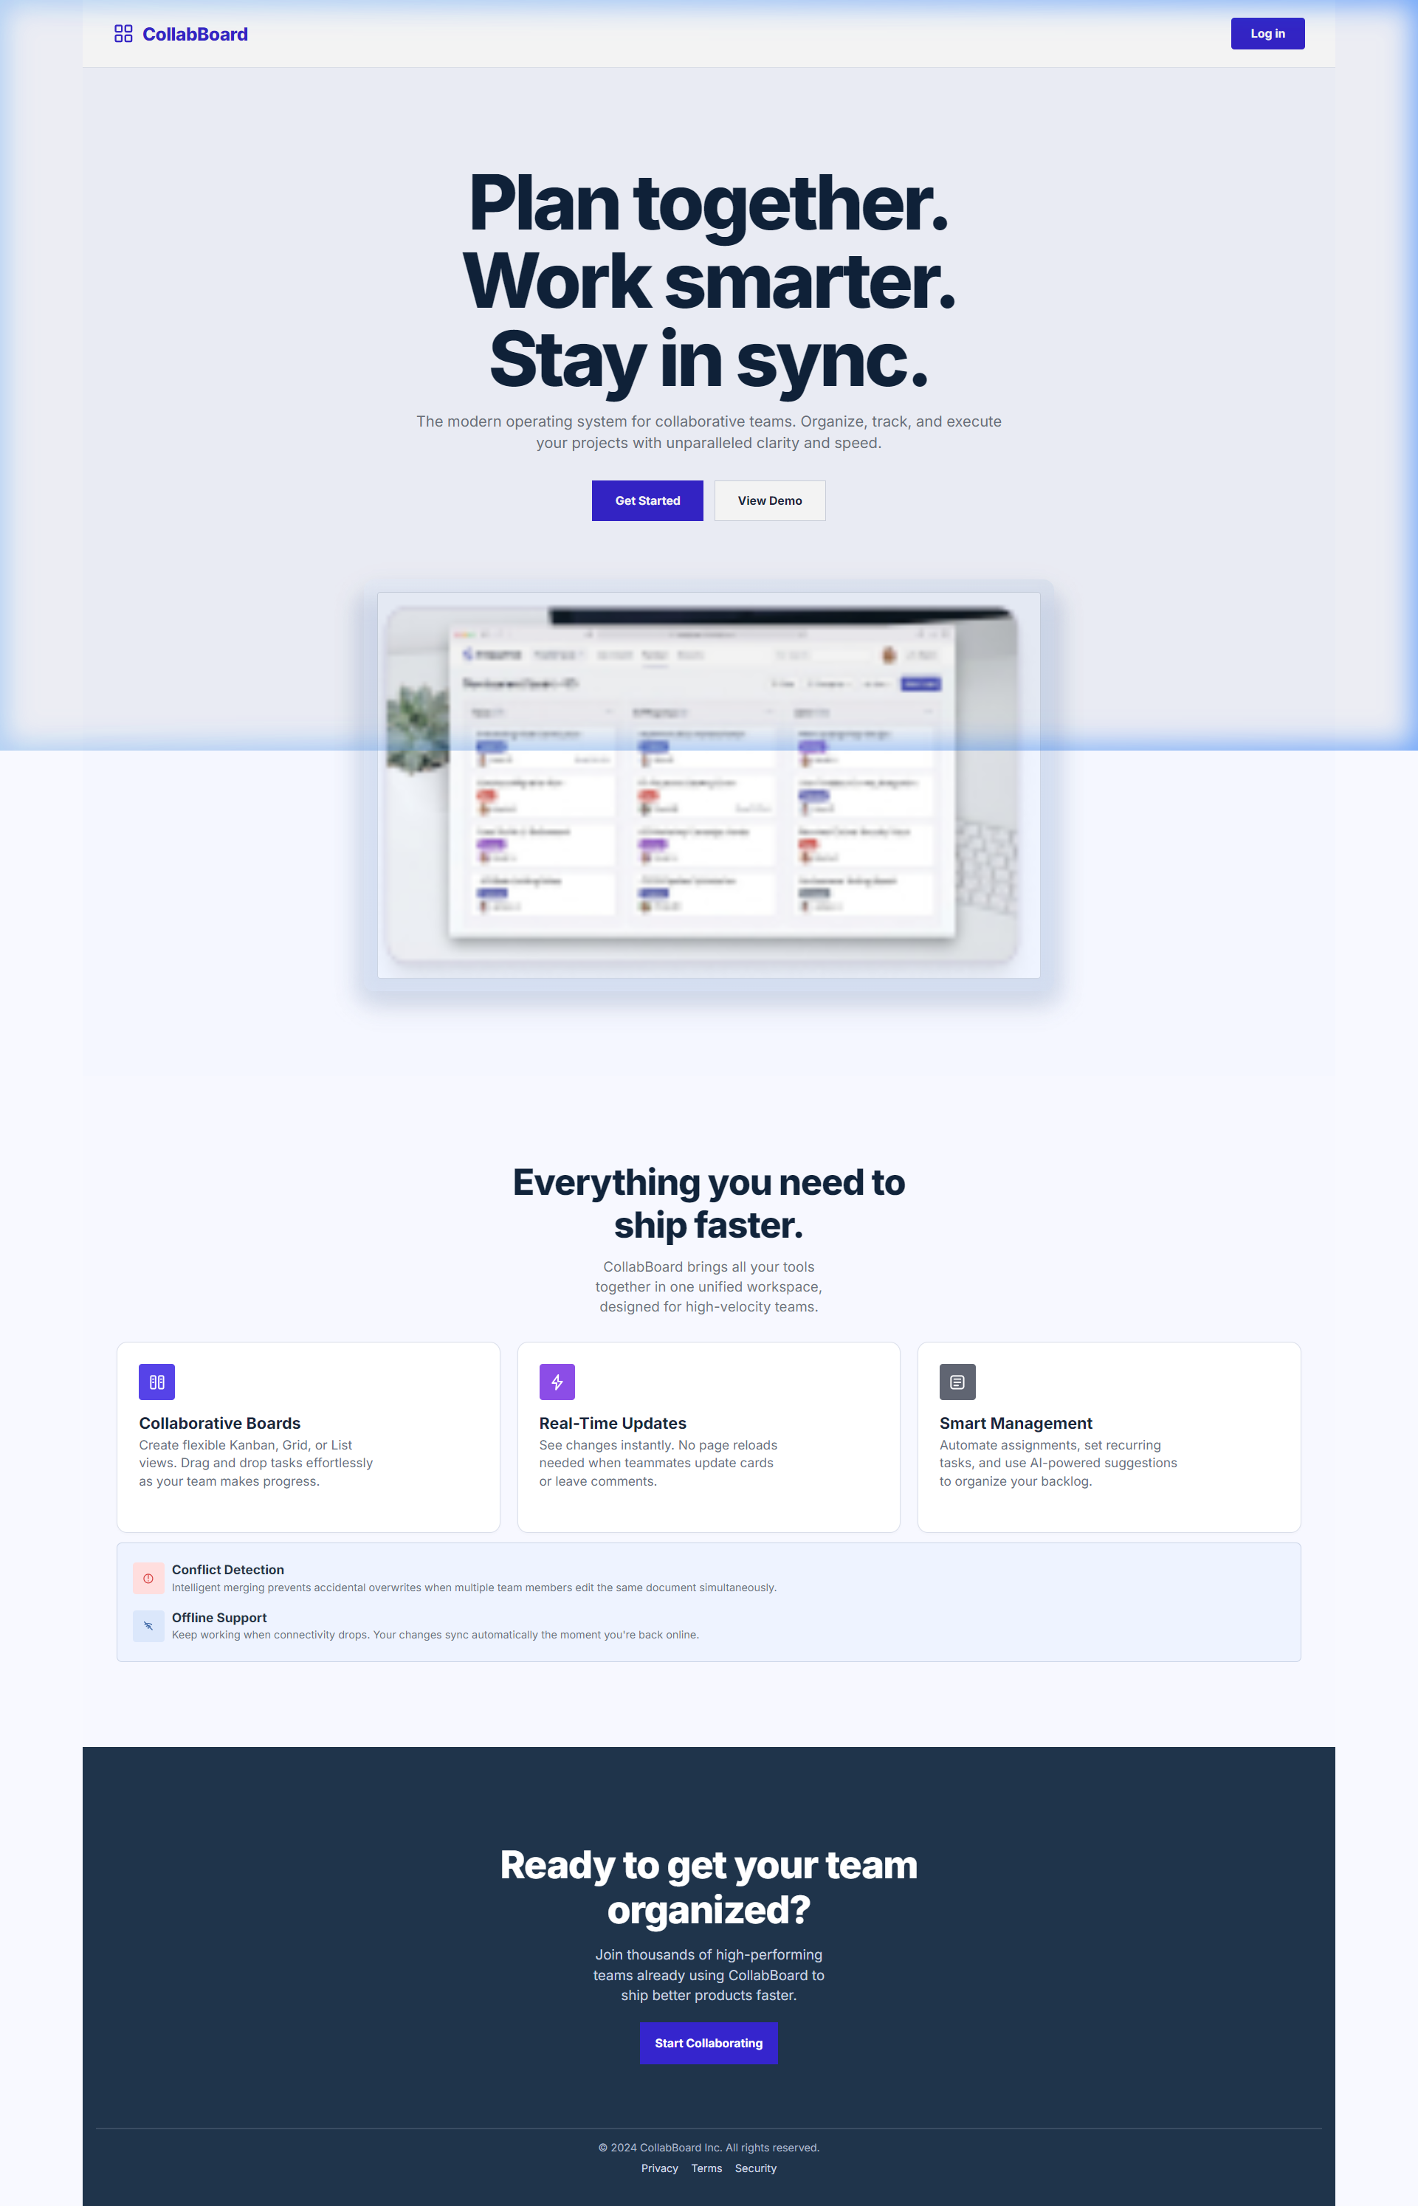

Figure 2: Secure User Registration Form
User registration form with state management, input validation, terms confirmation, and backend bcrypt password hashing.
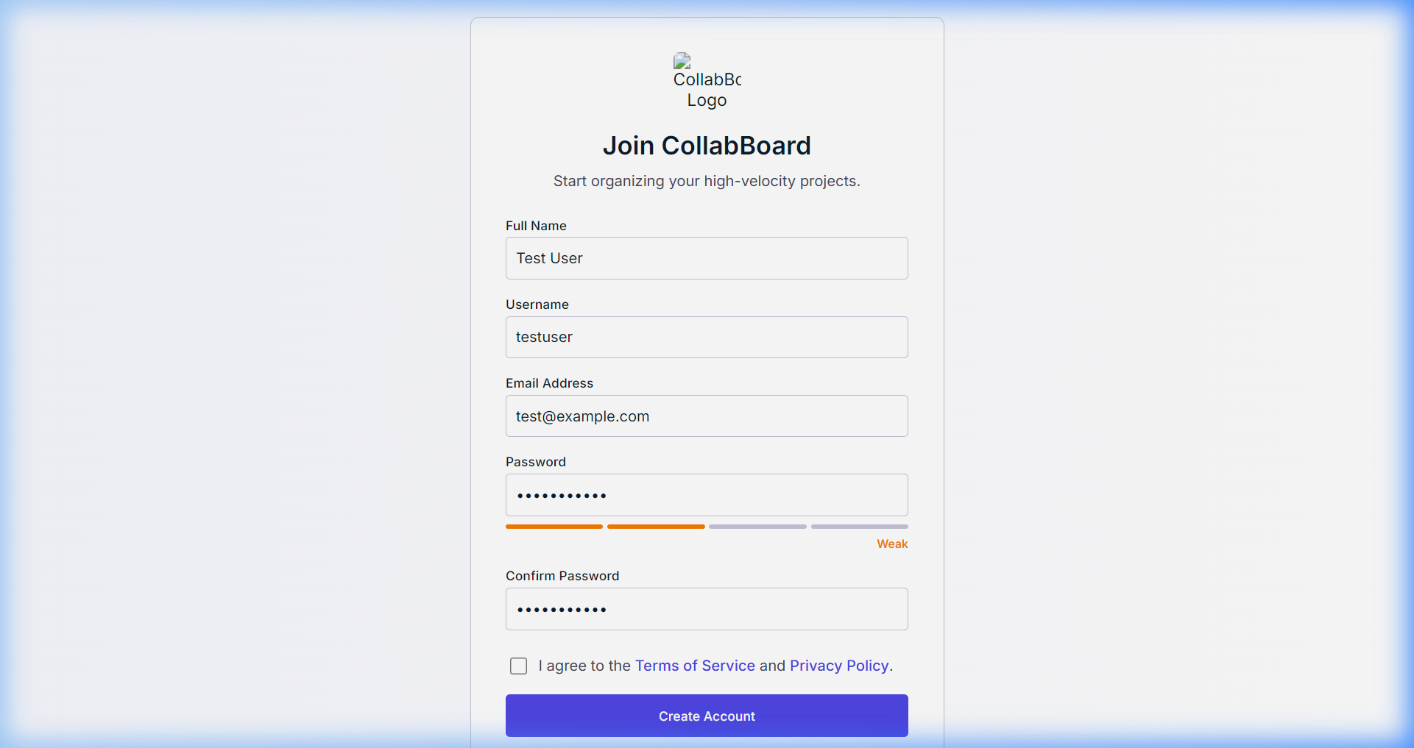

Figure 3: Interactive Kanban Board View
The main board view displaying workflow columns, task counters, priority tags, quick task action buttons, and board switching.
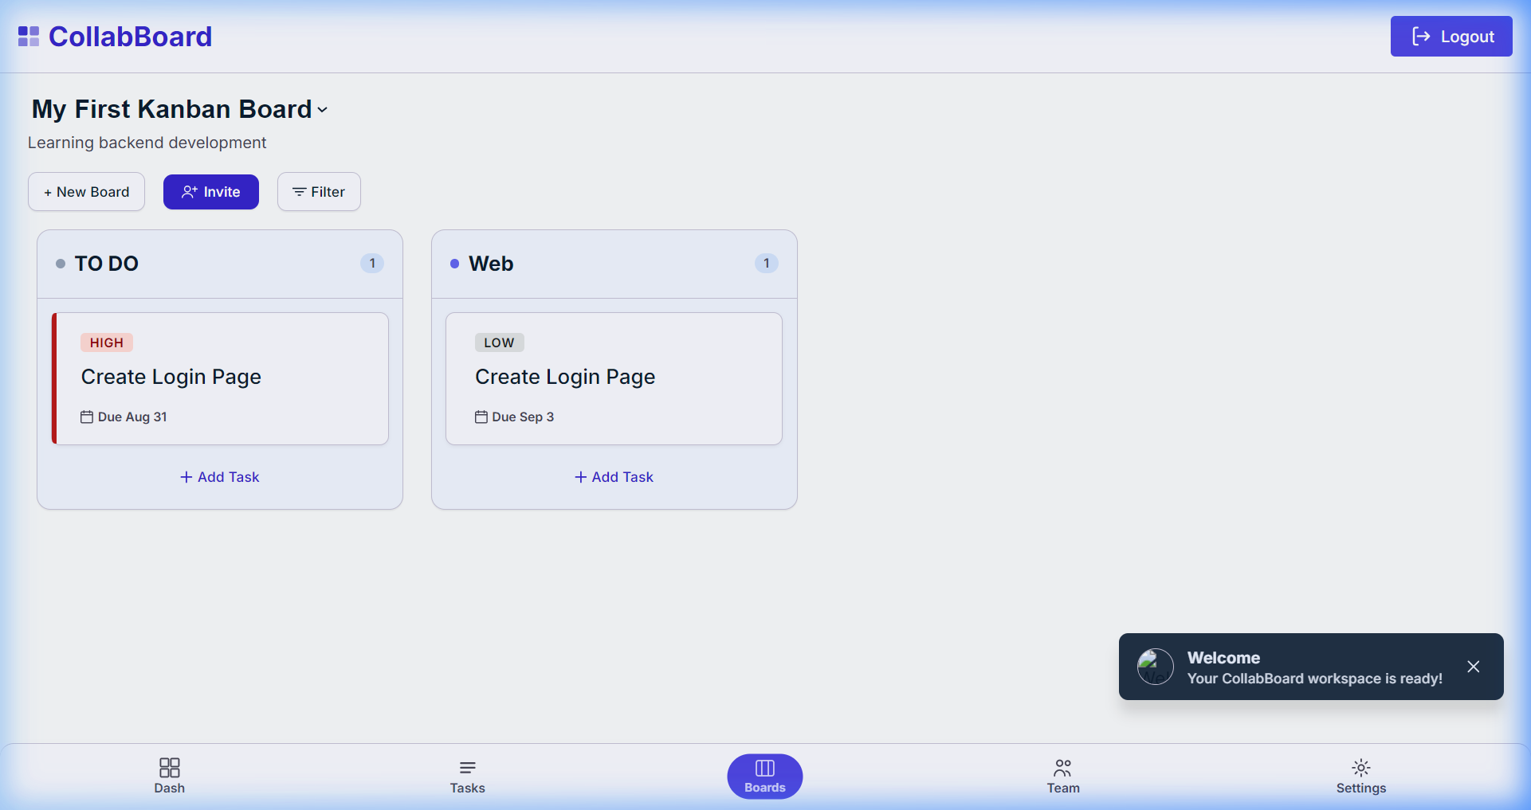

Figure 4: Task Creation & Metadata Modal
Modal dialog allowing users to specify task title, description, priority (Low/Medium/High), due date, and target column.
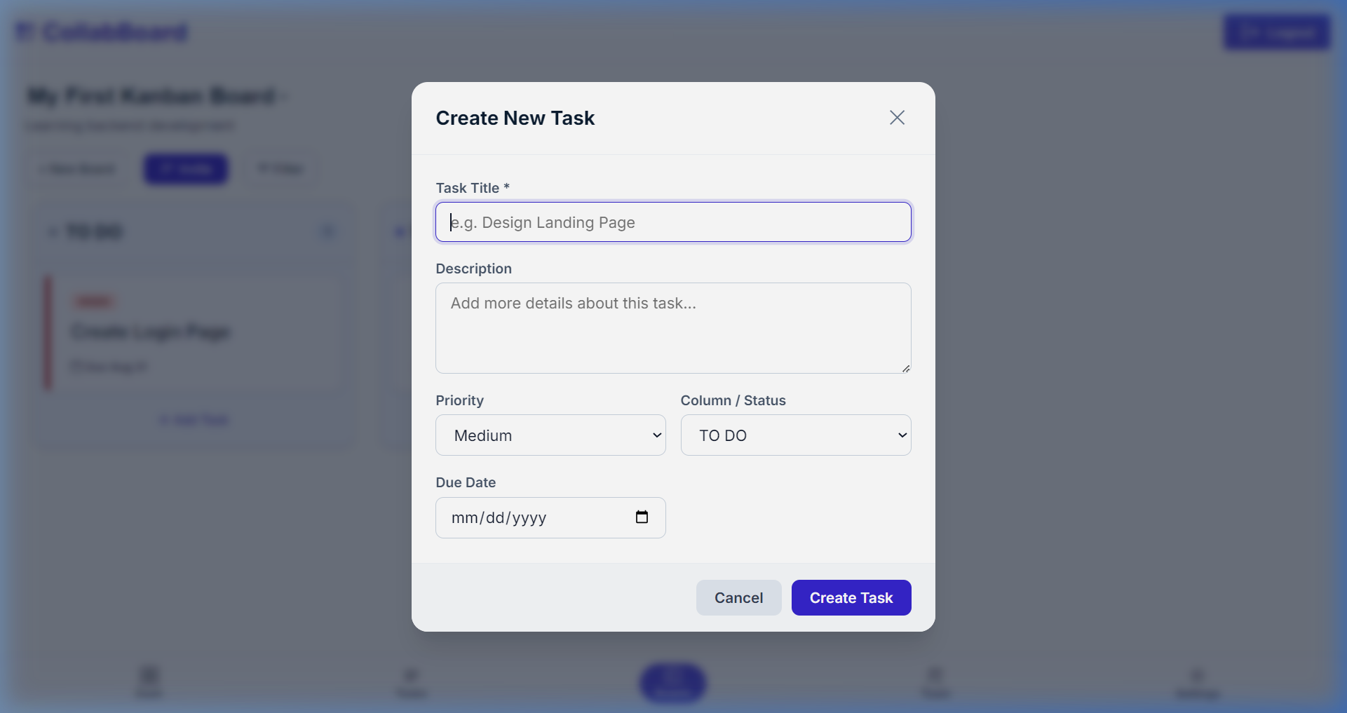

Figure 5: Task Status Editing & Column Movement
Task modification and status transition interface, allowing tasks to move seamlessly between workflow columns with live MongoDB persistence.
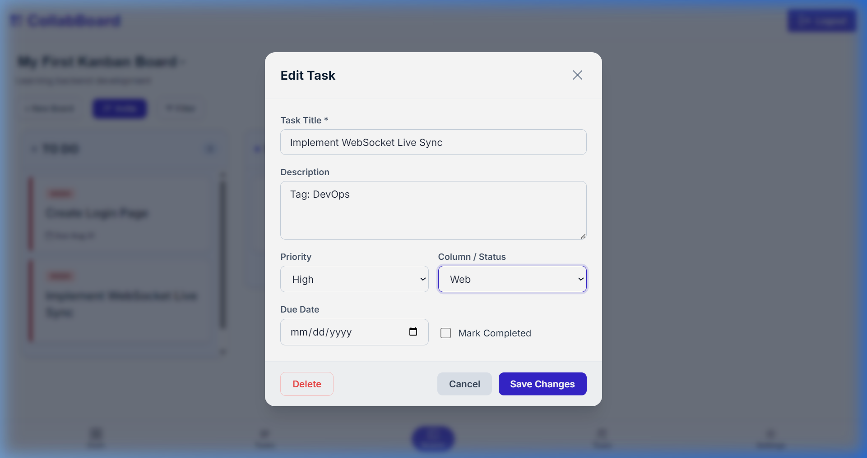

Figure 6: Workspace Settings & Dark Mode Theme Switcher
Theme settings interface supporting Light, Dark, and System preference options stored in localStorage for persistent user experience.
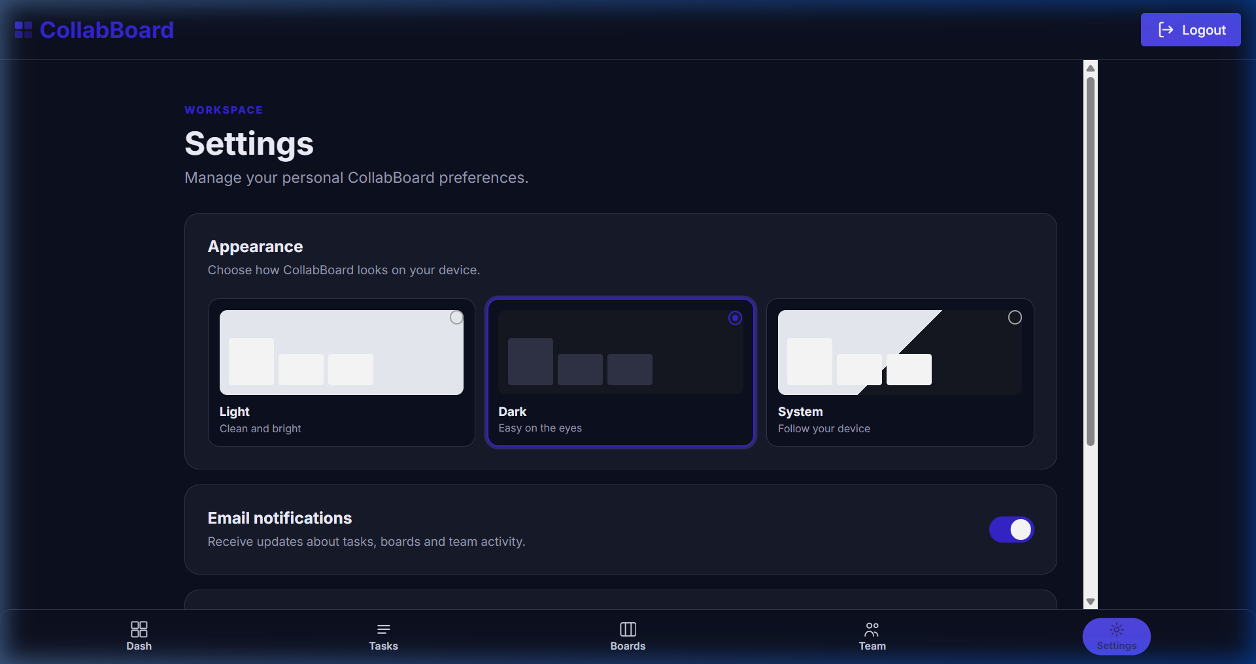

8. Conclusion
CollabBoard successfully demonstrates the progressive construction of a production-ready, full-stack collaborative application. By cleanly separating concerns between a responsive React 18 frontend, an Express 5 REST API, and a MongoDB persistent document store, the application delivers a fluid and reliable task management experience.
Key achievements realized in the current codebase include:
• End-to-End Task Lifecycle: Complete CRUD support enabling users to create, read, update, move across columns, complete, and delete tasks in real time.
• Multi-Board Workspace Architecture: Support for creating multiple independent project boards with automated initialization of workflow columns and sample tasks.
• Secure Authentication & State Resilience: JWT-based stateless authentication paired with client-side localStorage caching to maintain login sessions and user preferences through network reloads.
• Modular Full-Stack Division: Clear separation of responsibilities between lead backend API engineering and specialized frontend component development.
• Modern & Accessible UI/UX: A custom vanilla CSS design system incorporating responsive layouts, fluid glassmorphism, micro-animations, and full Dark/Light theme customizability.
The codebase provides a solid, extensible foundation for ongoing agile collaboration, delivering both technical rigor and an intuitive user experience.

— End of Technical Report —

