Building and Securing a DevSecOps Pipeline
Group Technical Report: OWASP NodeGoat — IE3142 DevOps Security
Submission date: 1 October 2026 (Courseweb)
Group Members
Group Member name | Student ID | Role
Bandara R.G.K.M | IT24102496 | Member 1 — Exploit demos and screenshots, SAST
Polkotuwa P G R L | IT24102874 | Member 2 — Report, ethical form, viva preparation
Nawarathna D.M.L.K | IT24103282 | Member 3 — CI/CD workflows, secrets
Batuwanthudawa O.J.R.D.K.H.I | IT24104380 | Member 4 — Application selection, Docker, fixes
Repository: https://github.com/kavimadusanka/NodeGoat-DevSecOps
Contents
1. Executive Summary and System Overview 1
1.1 Technology stack and containerisation 1
1.2 Architecture and data flows 1
2. Threat Model and Risk Assessment (LO2) 1
3. Secure Coding: Exploit-and-Fix (LO2) 1
3.1 VUL-01: Server-side JavaScript injection (eval RCE, CWE-95) 1
3.2 VUL-02: NoSQL injection via $where (CWE-943) 1
3.3 VUL-03: Insecure direct object reference (CWE-639) 1
3.4 VUL-04: Server-side request forgery (CWE-918) 1
3.5 Before and after SAST results 1
4. CI/CD Pipeline Design and Security Automation (LO3) 1
5. Secrets Management 1
6. Industry Trends and Case Study 1
7. Reflection and Future Improvements 1
8. Individual Contribution Statement and AI Usage Disclosure 1
References 1
Appendix A. Exploit-and-Fix Evidence (not counted in word limit) 1
Appendix B. Pipeline Evidence 1

1. Executive Summary and System Overview
This report documents how our group built a working DevSecOps pipeline around OWASP NodeGoat, an intentionally vulnerable Node.js / Express / MongoDB web application chosen from Appendix A.1 of the assignment brief. NodeGoat satisfies the two-component rule (web application plus database), runs fully offline and ships with a Dockerfile. We kept depth over scale: rather than scanning everything, we selected four exploitable vulnerabilities, proved each one working against an unmodified baseline copy of the application, fixed the code, replayed the identical request against the fixed build and confirmed the attack failed. A Semgrep SAST scan was run on both versions.
The fixed application is delivered through a GitHub Actions pipeline with four blocking security gates (SAST, dependency scanning, secrets scanning and container image scanning). Secrets are never committed: the application reads them from a local .env file and the pipeline reads them from GitHub Actions encrypted secrets.

1.1 Technology stack and containerisation
The stack is Node.js with Express for the web tier and MongoDB for the data tier. Each component is containerised: the web tier uses the application Dockerfile and the database uses the official MongoDB image, brought up together with a single docker compose up --build -d. To demonstrate exploit-and-fix side by side, we ran two Compose projects: the baseline (unmodified, port 4001, docker-compose.baseline.yml) and the fixed build (port 4000). Both are bound to 127.0.0.1 and used only in our isolated lab, as declared in our Ethical Clearance Form.

1.2 Architecture and data flows
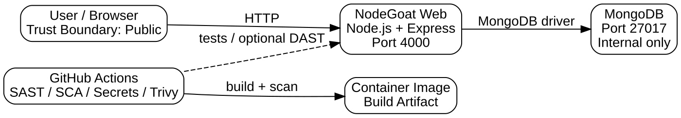
Figure 1: Architecture, data flows (F1–F4) and trust boundaries (TB1–TB4).
F1 is the browser or attacker sending HTTP requests to the Express container, crossing the boundary from the untrusted zone into our application network. F2 is the Express container querying MongoDB, which sits in a data tier not published to the host. F3 is the server-side fetch performed by the stock research feature, crossing outward to an external network and is the origin of the SSRF risk. F4 represents developer pushes to GitHub, which trigger the pipeline. Runtime secrets enter the web container from the .env file.

2. Threat Model and Risk Assessment (LO2)
We applied STRIDE to the flows in Figure 1. Each threat is specific to a NodeGoat feature rather than a generic template entry. Likelihood (L) and impact (I) use a 5×5 scale (1 = low, 5 = high); the score is L × I, where 15 or more is treated as high.
ID | STRIDE | Threat (application-specific) | L | I | Score | Rating justification | Mitigating control and location
T1 | Elevation of Privilege | Attacker sends JavaScript in the contributions form; the server evaluates it (RCE, VUL-01). | 4 | 5 | 20 | Form is reachable by any logged-in user and payload is trivial; full server compromise. | Strict numeric parsing and range validation, eval removed.  app/app/routes/contributions.js  Semgrep rule in security/semgrep.yml.
T2 | Tampering / Info Disclosure | NoSQL injection through the allocations threshold parameter and a $where clause (VUL-02). | 4 | 4 | 16 | Query string is attacker controlled; leaks all users’ financial data. | Numeric validation and a structured query instead of $where.  app/app/data/allocations-dao.js
T3 | Information Disclosure | IDOR: a user changes the ID in /allocations/:id and reads another user’s data (VUL-03). | 5 | 4 | 20 | Only needs URL editing; confidential data of other users exposed. | Server-side ownership check against the session user.  app/app/routes/allocations.js
T4 | Spoofing / Info Disclosure | SSRF: the url parameter of /research makes the server call internal or attacker hosts (VUL-04). | 3 | 5 | 15 | Needs login, but can reach internal services and cloud metadata. | Client URL ignored; fixed allowlisted upstream only.  app/app/routes/research.js
T5 | Spoofing | Stolen or guessed credentials and session hijack (plain passwords, weak cookies). | 3 | 4 | 12 | Offline-crackable if database leaks; session theft enables impersonation. | Password hashing, secure session cookie flags and Helmet headers; secrets in .env.
T6 | Tampering | CSRF: a malicious page submits state-changing forms for a logged-in victim. | 3 | 3 | 9 | Needs social engineering but actions limited to profile data. | CSRF tokens on forms (application middleware).
T7 | Information Disclosure | Secrets or vulnerable dependencies committed or shipped in the image. | 3 | 4 | 12 | Common developer mistake; exposure persists in git history. | Gitleaks, npm audit and Trivy gates in .github/workflows/security.yml.  .env.example holds placeholders only.
T8 | Repudiation / DoS | No audit trail of failed logins; unbounded requests can exhaust the single container. | 2 | 3 | 6 | Low-value lab target, but weak monitoring hides attacks. | Residual risk, accepted for this scope (Section 7).

The four highest-scoring threats (T1–T4) map directly to the exploit-and-fix work in Section 3, so every headline risk is backed by a demonstrated attack and a verified control.

3. Secure Coding: Exploit-and-Fix (LO2)
All requests below were run from Kali Linux with curl against our own containers. The baseline is on port 4001 and the fixed build on port 4000. The same request is replayed against both. Full screenshots are in Appendix A.

3.1 VUL-01: Server-side JavaScript injection (eval RCE, CWE-95)
Exploit. The contributions handler passed form fields to eval(). We posted preTax=1+1 (URL-encoded as 1%2B1) and the baseline page then displayed “Employee Pre-Tax: 2 %”, proving the server executed our expression as code. A real attacker would replace the arithmetic with process or require calls.
Fix. eval was removed; inputs are parsed as numbers, checked for finite values and range, and rejected otherwise.
Re-test. The identical request to the fixed app returned “Invalid contribution percentages” and stored nothing (Figures A1 and A2).

3.2 VUL-02: NoSQL injection via $where (CWE-943)
Exploit. The allocations DAO built a MongoDB $where JavaScript string from the threshold query parameter. Sending x' || 'a'=='a made the condition always true, and the baseline returned the allocations of every user (John Doe, Node Goat Admin and Will Smith) instead of those matching the filter (Figure A3).
Fix. The threshold must be a validated integer and the query uses a normal comparison operator rather than a server-evaluated string.
Re-test. The same payload on the fixed app returned an error page and no data (Figure A4); the application treats the malformed value as invalid input.

3.3 VUL-03: Insecure direct object reference (CWE-639)
Exploit. After logging in as user1, requesting /allocations/1 on the baseline returned “Asset Allocations for Node Goat Admin” — another user’s data (Figure A5).
Fix. The route no longer trusts the ID in the URL; it authorises against the session user and returns only that user’s record.
Re-test. With the same session and URL, the fixed app returned “Asset Allocations for John Doe”, the logged-in user’s own record; the admin data was not disclosed (Figure A6).

3.4 VUL-04: Server-side request forgery (CWE-918)
Exploit. We started a Python web server on port 8000 and called the baseline /research endpoint with url=http://host.docker.internal:8000/. The Python log shows a request arriving from the baseline container, and the application embedded the response in its page, proving the server fetched an attacker-chosen address (Figure A7).
Fix. The url parameter is ignored and the server only calls a fixed, trusted upstream with the stock symbol.
Re-test. The same call to the fixed app returned the upstream stock page for the requested symbol and produced no new request in the Python log (Figure A8).

3.5 Before and after SAST results
We ran Semgrep 1.178.0 with its community ruleset (--config auto) on the baseline source and on the fixed source. The baseline scan covered 73 files with 256 rules and reported 28 findings, all blocking (Figure A9). On the fixed source, the same finding markers reduced to 17, down from 22 on the equivalent markers in the baseline scan (Figure A10). We also created custom rules in security/semgrep.yml that target the four vulnerability patterns directly; these will be added to the evidence once a YAML escaping error on line 15 (an unescaped $ inside a double-quoted string) is corrected. Some findings remain after the fix — for example the use of plain http.createServer without TLS — because these are deployment-level issues in a local lab rather than the four exploited flaws. We report them honestly and treat TLS termination as future work. SAST alone did not prove the fixes; the before/after exploit replays above are the primary evidence.

4. CI/CD Pipeline Design and Security Automation (LO3)
The workflow .github/workflows/security.yml runs on every push and pull request. It installs dependencies, runs the regression test script (npm run security:test) and then executes four gates:
Gate | Tool | What it checks | Fail condition
1. SAST | Semgrep | Source code against security rules | Any blocking finding fails the job
2. Dependency (SCA) | npm audit | Known vulnerable npm packages | Critical severity fails the job (--audit-level=critical)
3. Secrets | Gitleaks | Hardcoded keys and credentials in files and history | Any detected secret fails the job
4. Container image | Trivy | OS and library CVEs in the built Docker image | CRITICAL/HIGH with fix available fail the job (--ignore-unfixed)

A second workflow, security-gate-demonstration, deliberately reintroduces a vulnerable pattern so that the gate fails on purpose. This gives the required evidence that the pipeline genuinely blocks a bad build and does not merely warn. An optional OWASP ZAP DAST workflow (dast-zap.yml) is also provided for extra credit. One improvement identified in review is to pin the Trivy action to a released version rather than @master, so the scanner itself cannot change unexpectedly (supply-chain hygiene).
The green “DevSecOps Security Pipeline” run and the red “Security Gate Demonstration” run from the GitHub Actions tab are shown in Appendix B (Figures B1 and B2).
Local regression scans confirmed the pipeline results: npm audit reported [N] critical vulnerabilities, Gitleaks detected [N] secrets, and Trivy reported [N] CRITICAL/HIGH CVEs with fixes available. Outputs are stored under security-results/ in the repository.

5. Secrets Management
No credential is hardcoded or committed. The repository contains only .env.example with placeholders. For the running application, each team member creates a local .env (ignored by git) in which SESSION_SECRET is generated with openssl rand -hex 32 and the seeded admin, user1 and user2 passwords are random values; Docker Compose passes them to the web container as environment variables. For the pipeline, the same four values (SESSION_SECRET, SEED_ADMIN_PASSWORD, SEED_USER1_PASSWORD, SEED_USER2_PASSWORD) are stored as GitHub Actions encrypted secrets and referenced with the secrets context, so they never appear in source or logs. Gitleaks enforces this continuously. Passwords stored in the database are hashed. HashiCorp Vault was not implemented; it is listed as a future improvement.

6. Industry Trends and Case Study
Capital One (2019). An attacker exploited a server-side request forgery weakness in a web application firewall running on AWS to reach the instance metadata service, obtained temporary credentials and read data for roughly 100 million people. This is the same vulnerability class as our VUL-04. The lesson for DevSecOps is that SSRF is dangerous because the server sits inside a trusted network: our fix (ignore client-supplied URLs, allow only a fixed upstream) is the application-level control, while network egress restrictions and least-privilege credentials limit the blast radius. Automated SAST in the pipeline can flag unsafe outbound requests before release.
Equifax (2017). An unpatched Apache Struts vulnerability (CVE-2017-5638) led to the exposure of personal data of about 147 million people. This illustrates why software composition analysis must run on every build. Our npm audit and Trivy gates automate the inventory and patch check that was missing, and they fail the build rather than relying on a manual process.
Trends. Industry guidance increasingly places injection, broken access control and SSRF in the OWASP Top 10, and emphasises “shift-left” scanning and secrets-free repositories. Our four exploited flaws correspond to Injection (A03), Broken Access Control (A01) and SSRF (A10) in that list, which shows the project reflects current risk priorities rather than historic ones.

7. Reflection and Future Improvements
With more time we would: (1) add HashiCorp Vault to inject secrets at runtime and rotate them; (2) terminate TLS with a reverse proxy, which would clear the remaining http-server SAST findings; (3) run the OWASP ZAP DAST scan on every pull request and gate on medium-severity alerts; (4) publish and pin all third-party actions by commit SHA; (5) add audit logging and rate limiting to address T8; and (6) add automated exploit tests (the four curl replays) as regression tests in the pipeline so a reintroduced flaw is caught by behaviour, not only by rules. The main lesson was that SAST output is noisy and incomplete by itself; demonstrating each exploit before and after gave far stronger assurance than a finding count.

8. Individual Contribution Statement and AI Usage Disclosure
Member | Student ID | Contribution | Signature
Bandara R.G.K.M (Member 1) | IT24102496 | Exploit demos and screenshots, SAST | Bandara
Polkotuwa P G R L (Member 2) | IT24102874 | Report, ethical form, viva preparation | Polkotuwa
Nawarathna D.M.L.K (Member 3) | IT24103282 | CI/CD workflows, secrets | Nawarathna
Batuwanthudawa O.J.R.D.K.H.I (Member 4) | IT24104380 | Application selection, Docker, fixes | Batuwanthudawa

AI tool disclosure. We used Claude (Anthropic) to review the project status and produce setup and troubleshooting commands for Kali Linux (installing Semgrep, running scans, running the baseline and fixed containers), to help interpret tool errors, and to help draft this report from our own screenshots and scan outputs. All exploit runs, scans and screenshots were performed by the group, and the code fixes were written and reviewed by the group.

References
[1] OWASP Foundation, “OWASP NodeGoat,” GitHub. [Online]. Available: https://github.com/OWASP/NodeGoat
[2] A. Shostack, Threat Modeling: Designing for Security. Indianapolis, IN, USA: Wiley, 2014.
[3] Semgrep, Inc., “Semgrep documentation.” [Online]. Available: https://semgrep.dev/docs/
[4] U.S. Department of Justice, “Seattle tech worker arrested for data theft involving large financial services company,” Jul. 2019. [Online]. Available: https://www.justice.gov/
[5] U.S. Government Accountability Office, “Data protection: Actions taken by Equifax and federal agencies in response to the 2017 breach,” GAO-18-559, Aug. 2018.
[6] OWASP Foundation, “OWASP Top 10:2021.” [Online]. Available: https://owasp.org/Top10/
[7] Aqua Security, “Trivy documentation.” [Online]. Available: https://trivy.dev/
[8] Gitleaks, “Gitleaks: detect secrets in git repos.” [Online]. Available: https://github.com/gitleaks/gitleaks
[9] GitHub, “Using secrets in GitHub Actions.” [Online]. Available: https://docs.github.com/actions/security-guides/using-secrets-in-github-actions

Appendix A. Exploit-and-Fix Evidence
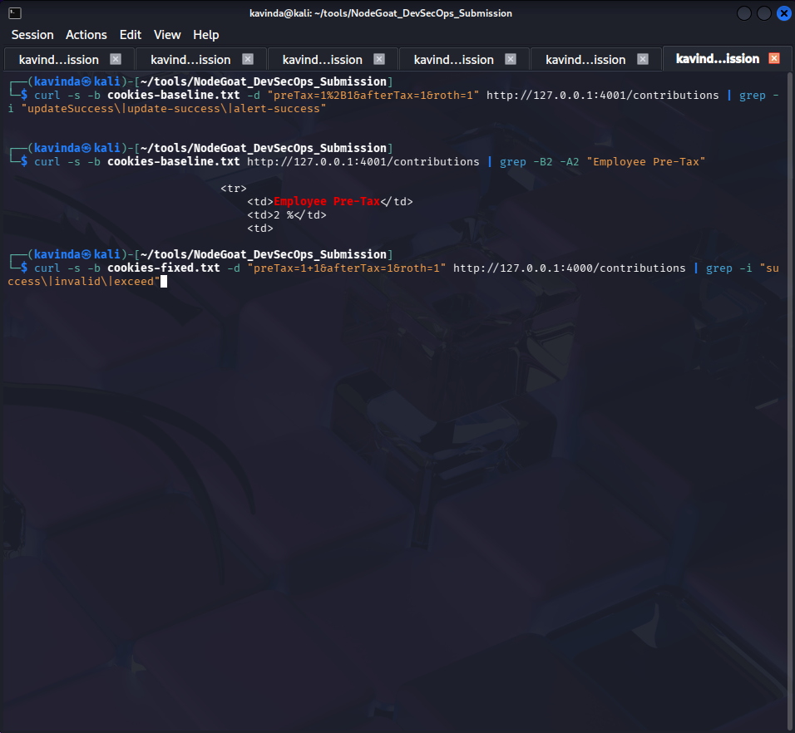
Figure A1. VUL-01 baseline (port 4001): preTax=1+1 is evaluated.
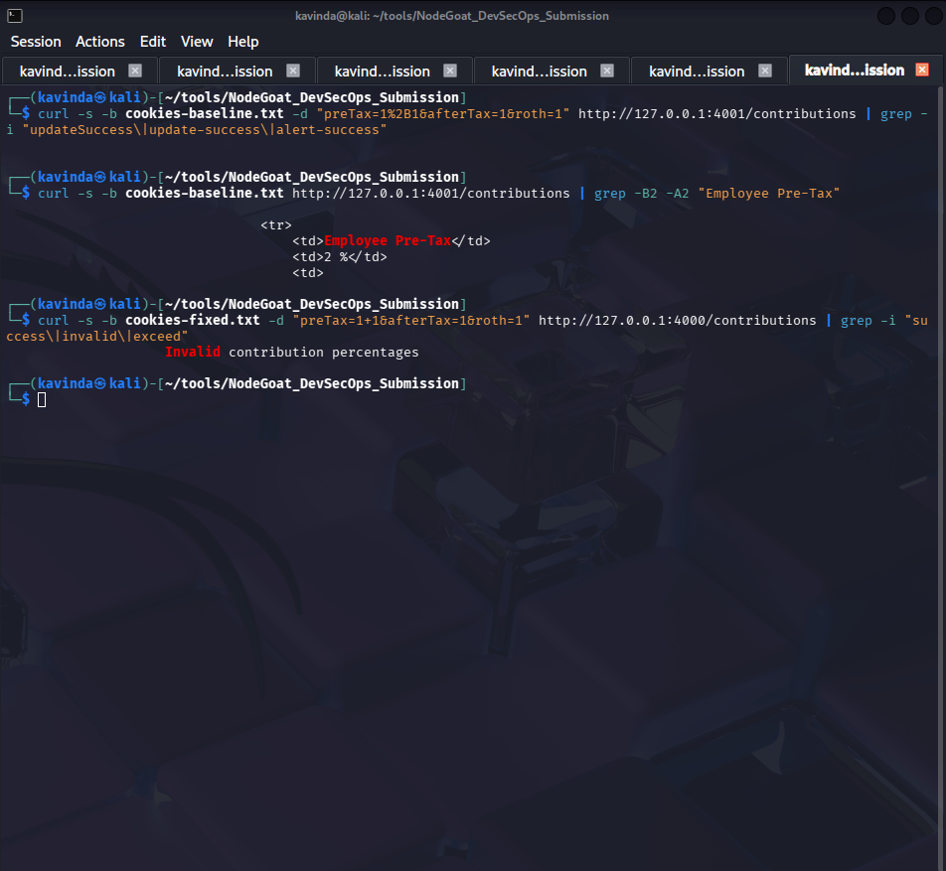
Figure A2. VUL-01 fixed (port 4000): same input returns “Invalid contribution percentages”.
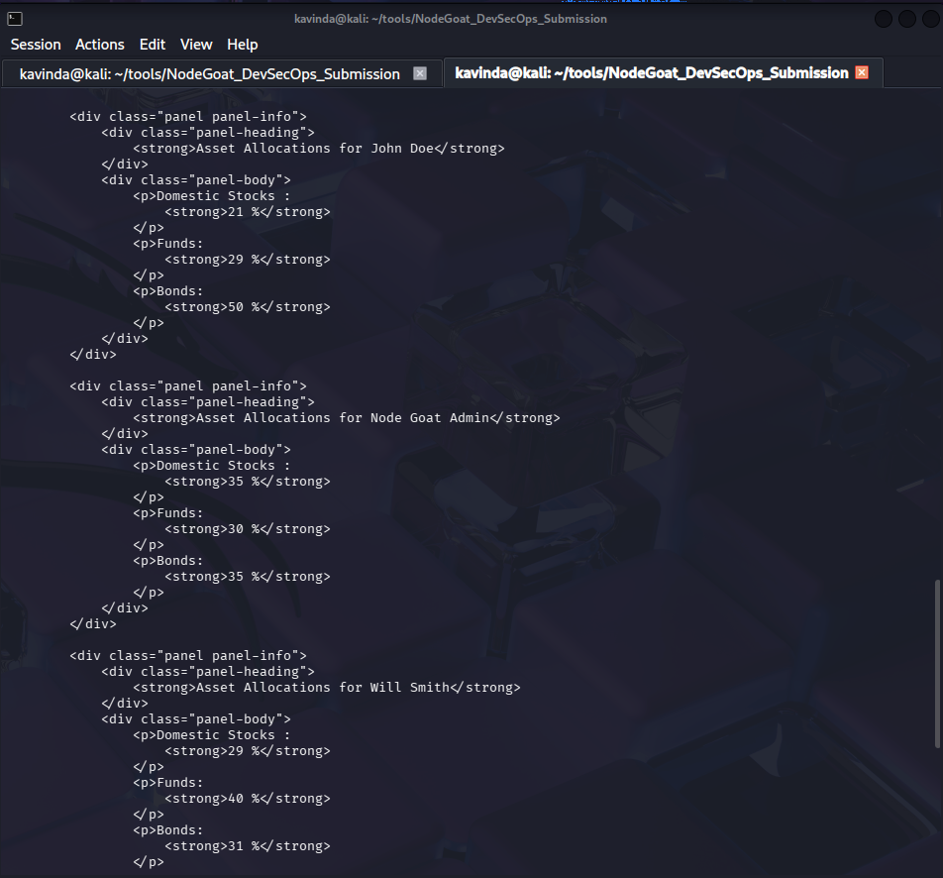
Figure A3. VUL-02 baseline: injected threshold returns allocations for all users.
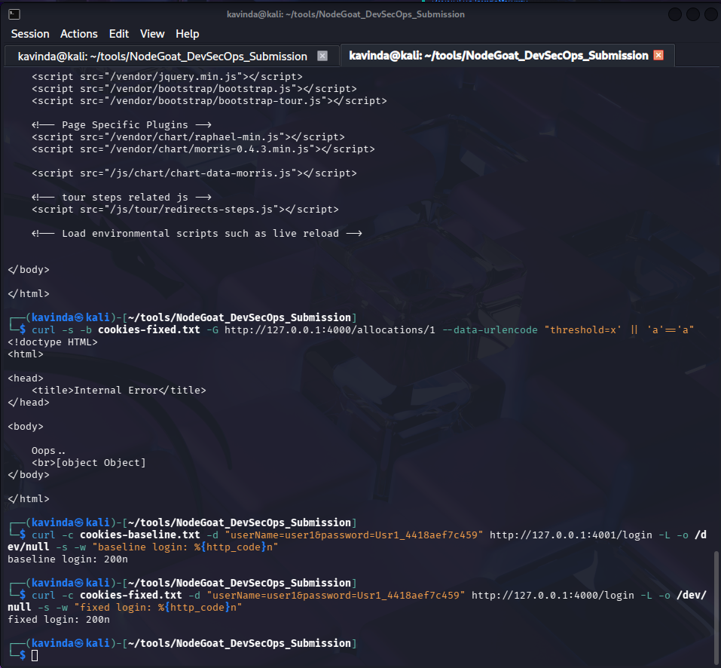
Figure A4. VUL-02 fixed: injected threshold returns an error and no data.
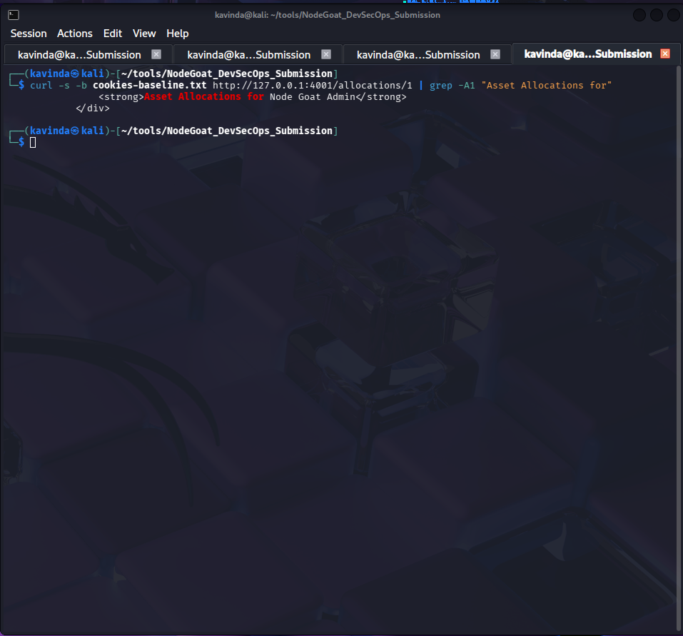
Figure A5. VUL-03 baseline: user1 session reads another user’s allocation.
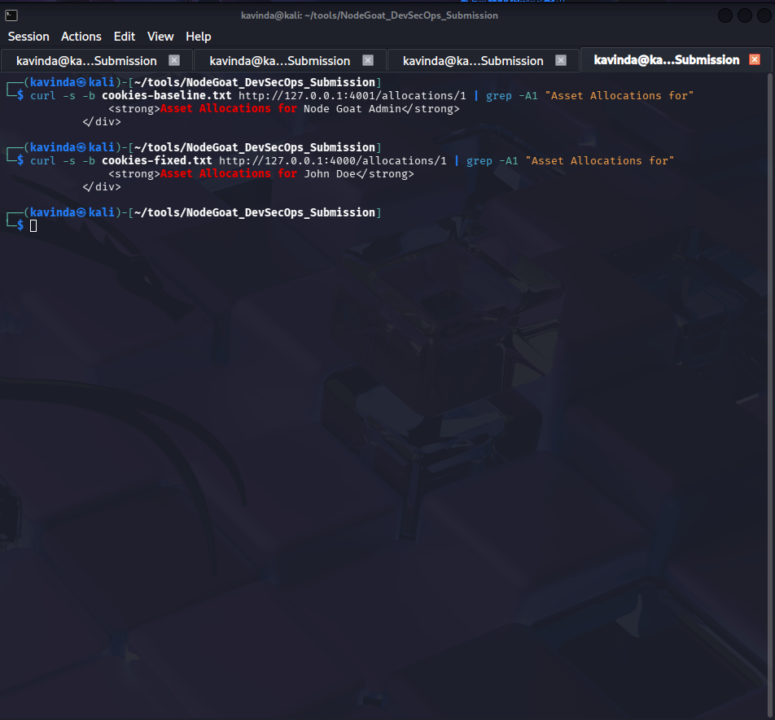
Figure A6. VUL-03 fixed: same request returns only the logged-in user’s own record.
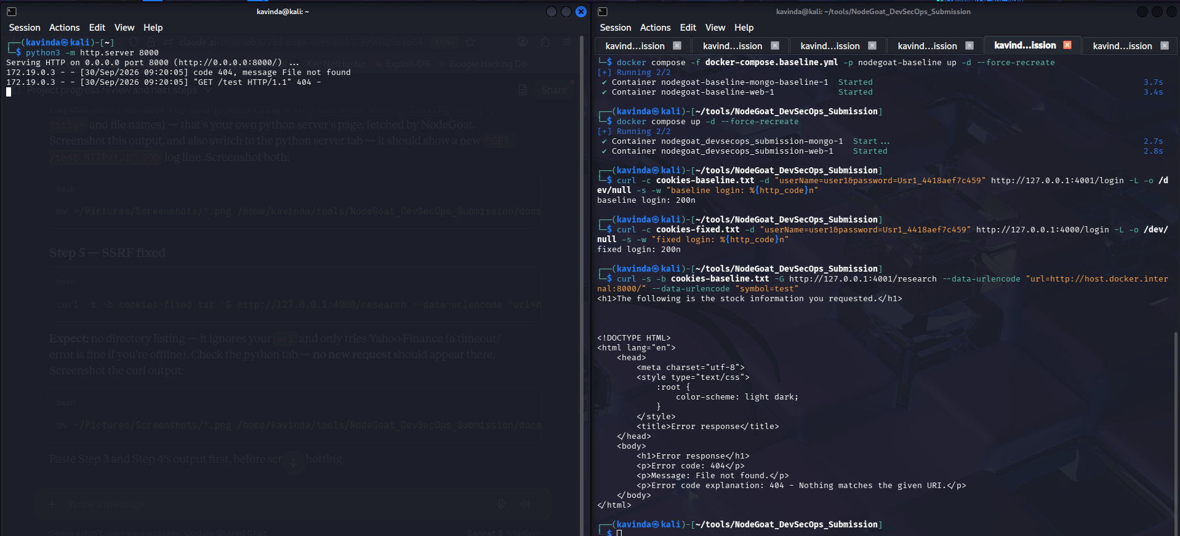
Figure A7. VUL-04 baseline: server fetches attacker-controlled URL.
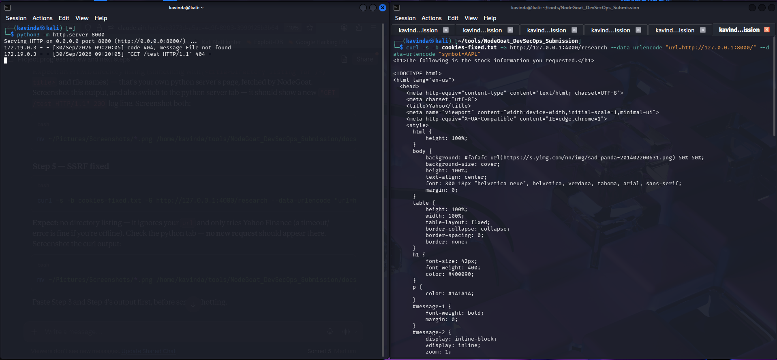
Figure A8. VUL-04 fixed: URL ignored, no request reaches the attacker server.
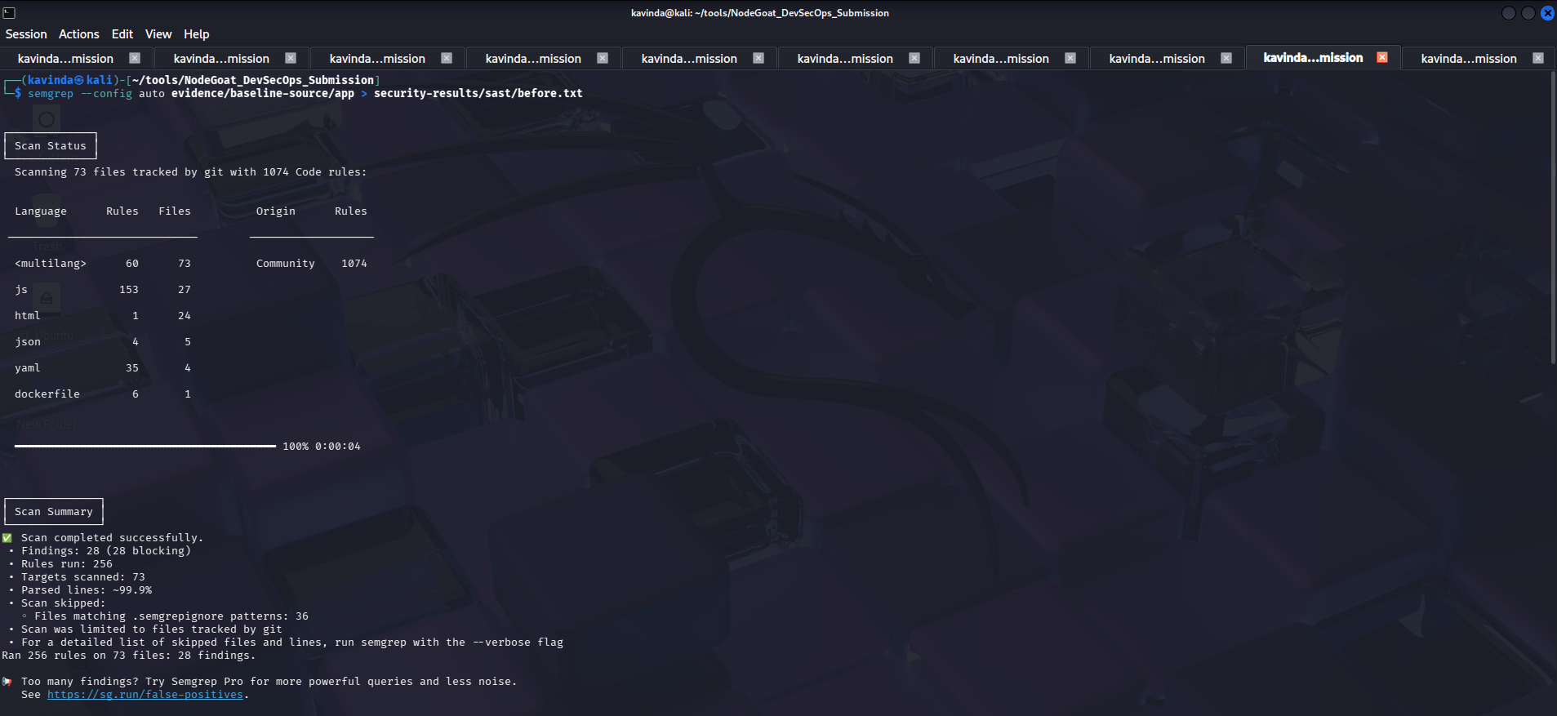
Figure A9. Semgrep on baseline source: 28 findings (all blocking), 256 rules, 73 files.
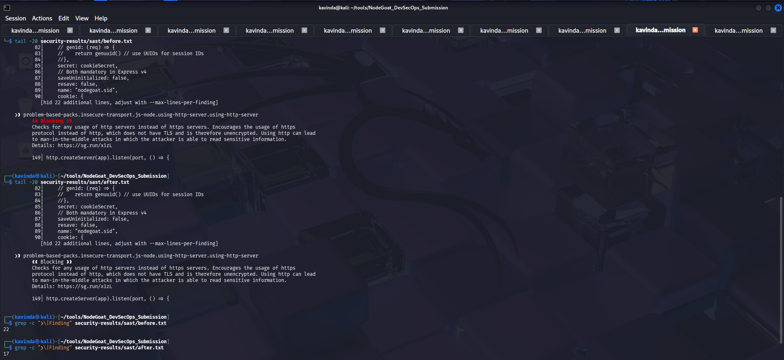
Figure A10. Semgrep on fixed source: finding count reduced (22 to 17 on equivalent markers).

Appendix B. Pipeline Evidence
Insert screenshot here
Green “DevSecOps Security Pipeline” run from the GitHub Actions tab
Figure B1. Green “DevSecOps Security Pipeline” run (all four security gates passing).
Insert screenshot here
Red “Security Gate Demonstration” run from the GitHub Actions tab
Figure B2. Red “Security Gate Demonstration” run (gate blocks the deliberately vulnerable build).
Gitleaks, npm audit and Trivy outputs are stored under security-results/ in the repository.

