CO543 – Image Processing
Lab 05
E/16/057
Chamith U.K.D.K

RGB colour space

Color components separately
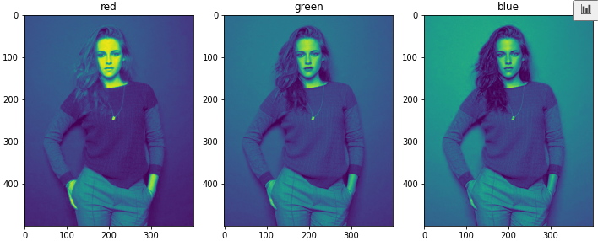

Merging black the color channels

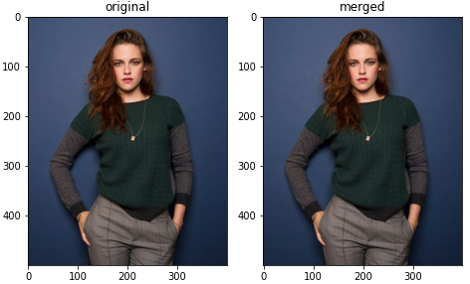

There is no difference between the original image and the merged image.

Color spaces and transformations

gray image
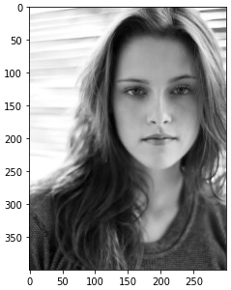

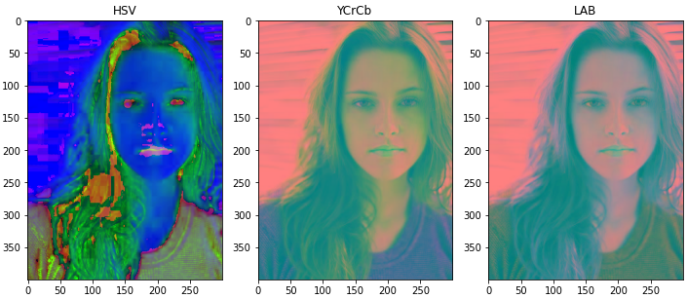

The YCrCb Colour-Space

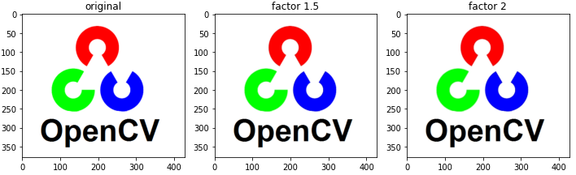

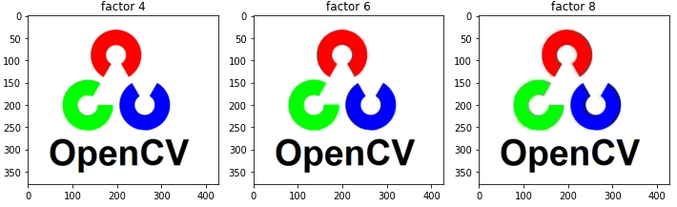

We can observe that when using a scale factor of 1.5 and 2, there is almost no change in the resultant images. But when scaling factor becomes larger or equal than 4, it is starting to get distorted. We can clearly see that in the edges of the circle like shapes in the logo.

Custom transformation function

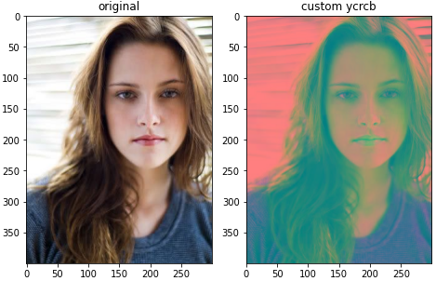

Color spaces for segmentation

Here I have used RGB color space rather than BGR color space because, I am using matplotlib library to display images in Jupyter notebook and matplotlib uses RGB color space to display images.

Approximate color ranges for green color in different color spaces:

 | Min value | Max value
RGB | [0 104 0] | [72 186 65]
HSV | [57 88 90] | [68 242 231]
YCrCb | [62 46 71] | [159 88 129]
LAB | [111 49 137] | [174 114 207]

Detecting green color in RGB color space:

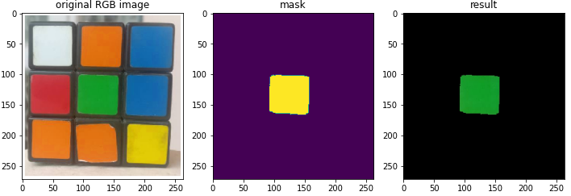

Detecting green color in HSV color space:

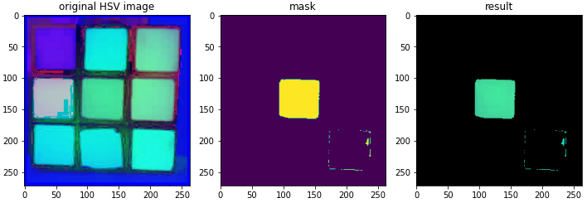

Detecting green color in YCrCb color space:

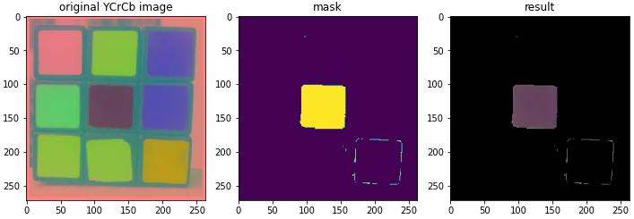

Detecting green color in LAB color space:

