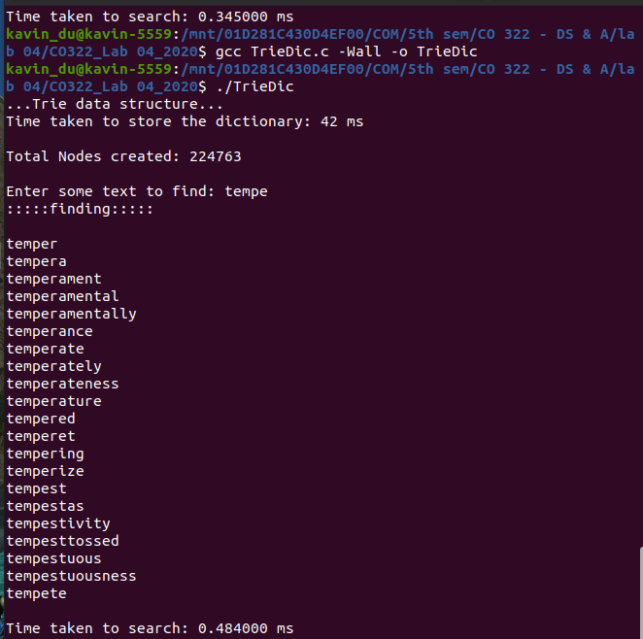
CO 322 Data Structures and Algorithms
Lab 04 - Tree ADT
E/16/057 – Chamith UKDK

The program was tested on the provided three dictionaries.
All non-alphabetic characters were removed when reading the word list and converted whole word to lowercase.

Compile and run:
TrieDic.c - code implementation for part 1

gcc TrieDic.c -Wall -o TrieDic
./TrieDic

RadixTreeDic.c – code implementation for part 2

gcc RadixTreeDic.c -Wall -o RadixTreeDic
./RadixTreeDic

Both files can be compiled using default arguments for GCC. Both files were created and tested on a Linux machine. The user will be asked to type a word in the console for searching.

Trie Data structure:
Time taken to store dictionary
Time taken to search

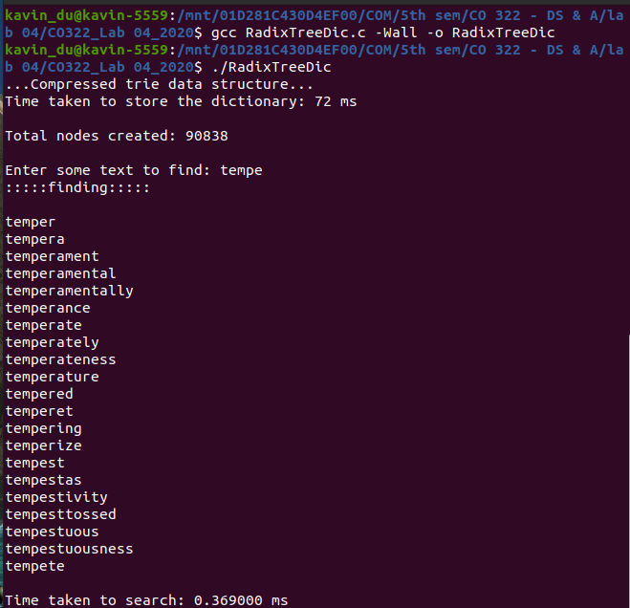
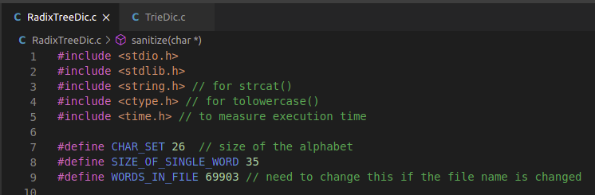

Radix tree(Compressed trie) data structure:

Time taken to store the dictionary

Time taken to search

The program was tested for all three text files that provided. The program is currently running for 70000 words file. Since program is reading a given file line by line, if you change the filename you have to specify how many lines in that file as below. (for both C files)

Number of lines for each text file:

wordlist70000.txt → 69903
wordlist10000.txt → 10000
wordlist1000.txt → 1000

Observations and conclusion:
(70000 word list was used for analysis)

Times taken to load the dictionary:-
Trie structure → 42 ms
Radix Tree structure → 72 ms

Times taken to show suggestions:-

 | “tempe” | “has” | “a”
Trie structure | 0.484 ms | 0.230 ms | 39.756 ms
Radix tree structure | 0.369 ms | 0.392 ms | 29.220 ms

Since trie data structure keep nodes for each letter, it has to create new node for each letter. But the redundant nodes have been removed in the radix tree and it only keeps nodes for new strings. Since the nodes are less in radix tree it takes less time to search a word. But the branching factor is high for a given word, we can’t gain much time advantage when searching for that word in Radix tree.

Even the nodes are less, the implementation is complex in the radix structure. So it takes more time to load the dictionary in to a radix tree.

Space analysis:

Total nodes created in :-
Trie structure → 224763
Radix Tree structure → 90838

When the createNode() function is called, each time the number of node count was increased. As we can see, total number of nodes are much larger in the Trie structure than Radix tree structure. Therefore we gain the advantage of memory space when using radix tree.

