**Code:**

#include "BluetoothSerial.h"

// Initialize Bluetooth

BluetoothSerial SerialBT;

#define RELAY1 18 // GPIO pin for Relay 1

#define RELAY2 19 // GPIO pin for Relay 2

void setup() {

Serial.begin(115200);

SerialBT.begin("ESP32_HomeAutomation"); // Bluetooth name

pinMode(RELAY1, OUTPUT);

pinMode(RELAY2, OUTPUT);

// Turn off devices initially

digitalWrite(RELAY1, LOW);

digitalWrite(RELAY2, LOW);

Serial.println("Bluetooth Home Automation System Ready!");

}

void loop() {

if (SerialBT.available()) {

char command = SerialBT.read();

// Control devices

if (command == '1') {

digitalWrite(RELAY1, HIGH);

Serial.println("Device 1 ON");

}

if (command == '2') {

digitalWrite(RELAY1, LOW);

Serial.println("Device 1 OFF");

}

if (command == '3') {

digitalWrite(RELAY2, HIGH);

Serial.println("Device 2 ON");

}

if (command == '4') {

digitalWrite(RELAY2, LOW);

Serial.println("Device 2 OFF");

}

}

}

**Circuit Diagram:**

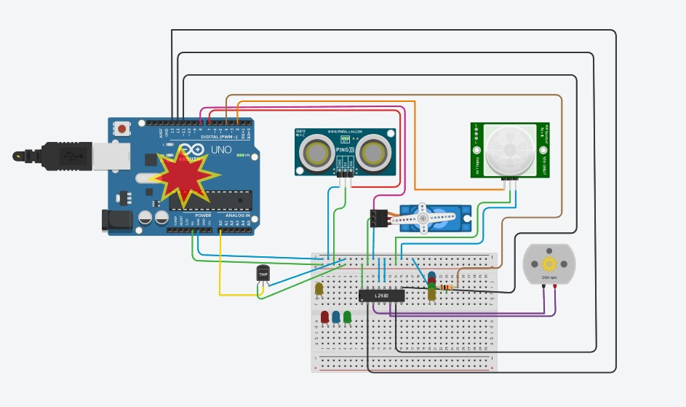

**Working Demo:**

