**Circuit Design:**

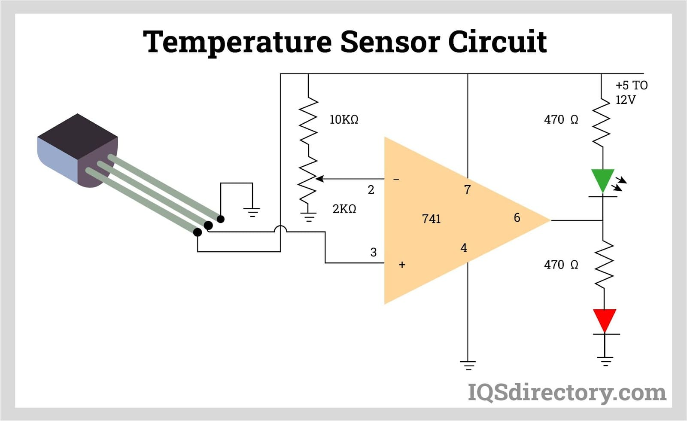

**Code:**

#include <Wire.h>

#include <LiquidCrystal_I2C.h>

#include <DHT.h>

#define DHTPIN 4 // Data pin for DHT22

#define DHTTYPE DHT22 // DHT22 sensor type

DHT dht(DHTPIN, DHTTYPE);

LiquidCrystal_I2C lcd(0x27, 16, 2); // I2C address: 0x27, 16x2 display

void setup() {

Serial.begin(115200);

dht.begin();

lcd.init();

lcd.backlight();

lcd.setCursor(0, 0);

lcd.print("Temp Monitor");

delay(2000);

}

void loop() {

float temp = dht.readTemperature();

float hum = dht.readHumidity();

if (isnan(temp) || isnan(hum)) {

Serial.println("Failed to read from DHT sensor!");

return;

}

// Display on LCD

lcd.clear();

lcd.setCursor(0, 0);

lcd.print("Temp: ");

lcd.print(temp);

lcd.print(" C");

lcd.setCursor(0, 1);

lcd.print("Humidity: ");

lcd.print(hum);

lcd.print(" %");

// Display on Serial Monitor

Serial.print("Temperature: ");

Serial.print(temp);

Serial.println(" °C");

Serial.print("Humidity: ");

Serial.print(hum);

Serial.println(" %");

delay(2000); // Update every 2 seconds

}

**Output Demonstration:**

