**System Design:**

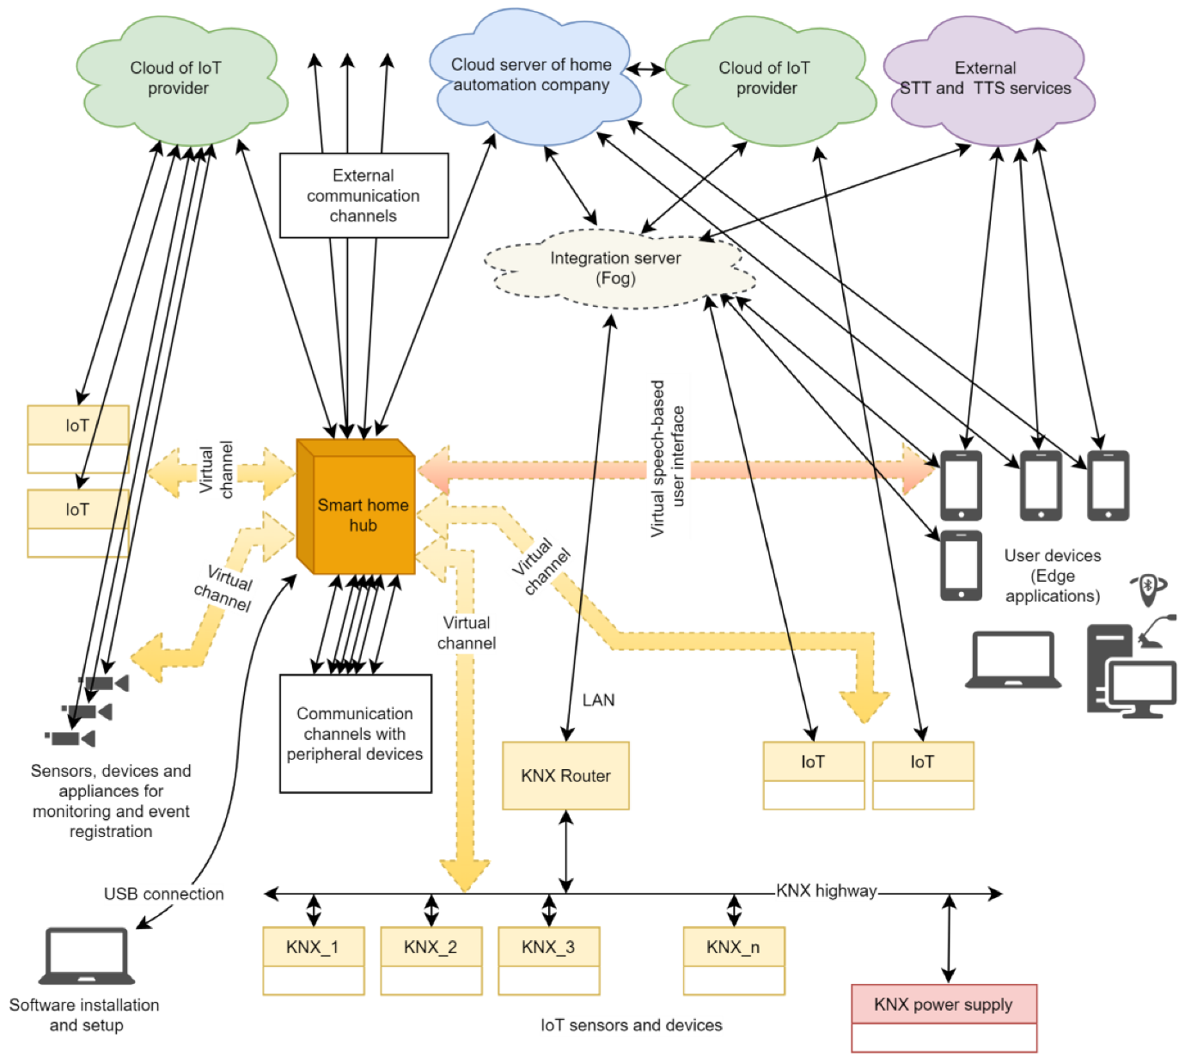

**Code:**

#include "BluetoothSerial.h"

BluetoothSerial SerialBT; // Initialize Bluetooth

#define RELAY1 18

#define RELAY2 19

void setup() {

Serial.begin(115200);

SerialBT.begin("ESP32_VoiceControl"); // Bluetooth name

pinMode(RELAY1, OUTPUT);

pinMode(RELAY2, OUTPUT);

digitalWrite(RELAY1, LOW);

digitalWrite(RELAY2, LOW);

Serial.println("ESP32 Voice Control Ready!");

}

void loop() {

if (SerialBT.available()) {

String command = SerialBT.readString();

command.trim();

if (command == "turn on light") {

digitalWrite(RELAY1, HIGH);

Serial.println("Light ON");

} else if (command == "turn off light") {

digitalWrite(RELAY1, LOW);

Serial.println("Light OFF");

}

if (command == "turn on fan") {

digitalWrite(RELAY2, HIGH);

Serial.println("Fan ON");

} else if (command == "turn off fan") {

digitalWrite(RELAY2, LOW);

Serial.println("Fan OFF");

}

}

}

**Output Demonstration:**

