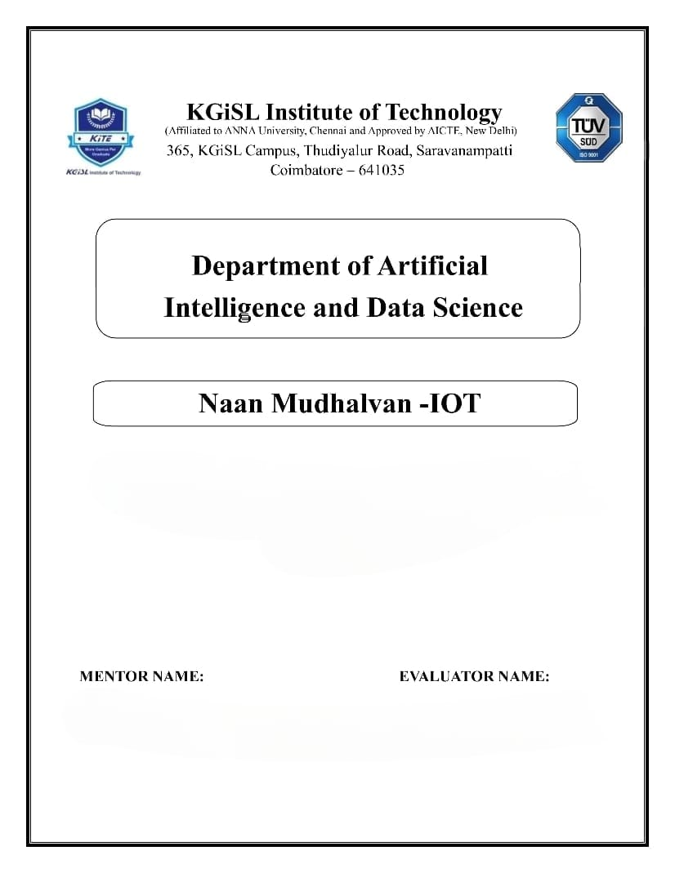

**The flowchart covers the entire process, from data collection using sensors to displaying real-time air quality information on a web platform.**

**PROBLEM STATEMENT : PUBLIC TRANSPORT OPTIMIZATION**

Mr.MOHANKUMAR.M

Ms.AKILANDESWARI.M

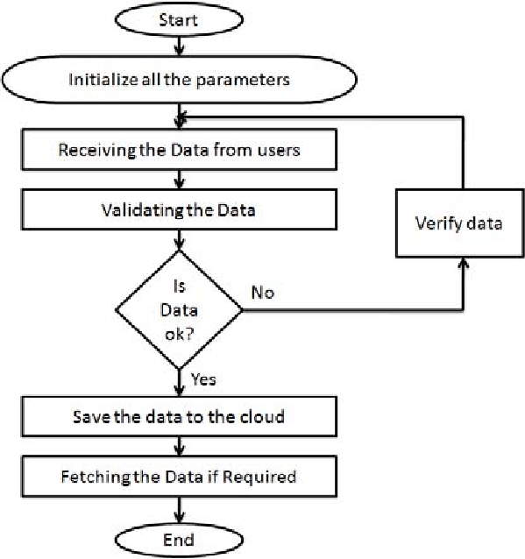

**1. Data Collection (IoT Devices):**

- Traffic FlowSensors (PM2.5 and PM10)

- Gas Sensors (NO2, CO, O3, SO2, VOCs)

**2. Data Transmission and Processing:**

- IoT devices continuously collect data.

- Use an appropriate Data Transmission Protocol (e.g., MQTT, HTTP).

- Secure communication with encryption and authentication.

- Process the data for accuracy and reliability.

**3. Health Recommendations:**

**Children:**

- Stay Indoors on Poor Air Quality Days: Encourage parents to keep children indoors during days with high levels of air pollutants, especially during peak pollution hours.

**General Population:**

- Use Masks on High Pollution Days: Suggest the use of masks, particularly N95 masks, on days when air quality is severely impacted.

Pregnant Women:

- Minimize Outdoor Exposure: Advise pregnant women to minimize outdoor activities on days when air quality is poor to reduce exposure to harmful pollutants.

**Community-wide Recommendations:**

- Promote Green Spaces: Advocate for the creation and maintenance of green spaces to improve overall air quality.

**4. Web Platform:**

- It involves figuring out the best routes for buses or trains to take and scheduling them at times that work well for passengers.

- The goal is to minimize delays, so passengers don't have to wait too long for their ride and can reach their destination on time.

- Managing the right number of vehicles and assigning them to routes based on passenger demand, so there are enough seats but not too many empty ones.

- Providing passengers with real-time information about when their bus or train will arrive, so they can plan their journeys effectively.

- Reducing the environmental impact by using cleaner and more efficient vehicles, which can be better for the environment and reduce operating costs.

- Ensuring that the public transportation system is cost-effective, both for the operators and for passengers.

**1. GPS Sensors:**

- A GPS sensor is a device that uses signals from satellites to determine the precise location, speed, and direction of an object or person on Earth.

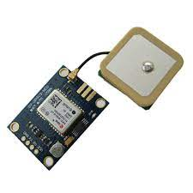

**2. Traffic Flow Sensors:**

- detect the presence of a vehicle using the reflection of ultrasonic waves transmitted from ultrasonic transmitters installed directly above the road.

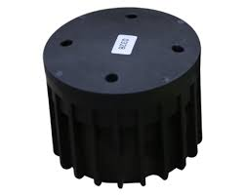

**Full Procedure:**

- Start by identifying what you want to achieve. Do you want to reduce delays, lower costs, or make the system more environmentally friendly.

-Use sensors to gather information about passenger numbers, traffic conditions, and environmental factors.

- Look at the data to understand patterns and problems, like overcrowded buses or traffic bottlenecks.

- Plan the best paths for vehicles to follow, taking into account traffic and passenger demand.

- Decide which vehicles go on which routes, so you use them efficiently.

- Implement systems like GPS and apps to provide real-time information to passengers and monitor vehicles.

-Choose cleaner and more efficient vehicles to reduce pollution.

- Give passengers updates on when their ride will arrive, and provide information on mobile apps and websites.

- Continuously gather data, analyze how well the system is working, and make changes to improve it.

- Display real-time transport information on a web platform for passengers to access.

**This flowchart provides an overview of the entire system, from data collection to user interaction, to address the lack of accessible real-time air quality data in your region.**

