**Day 2- Assignment 1:**

**------------------------------------------------------------------------------------------------------------------------------------------**

**Problem:** SDLC Overview - Create a one-page infographic that outlines the SDLC phases (Requirements, Design, Implementation, Testing, Deployment), highlighting the importance of each phase and how they interconnect.

**Solution:**

* SDLC is a software development life cycle
* It is a process of developing the reliable and stable project

**Phases of SDLC:**

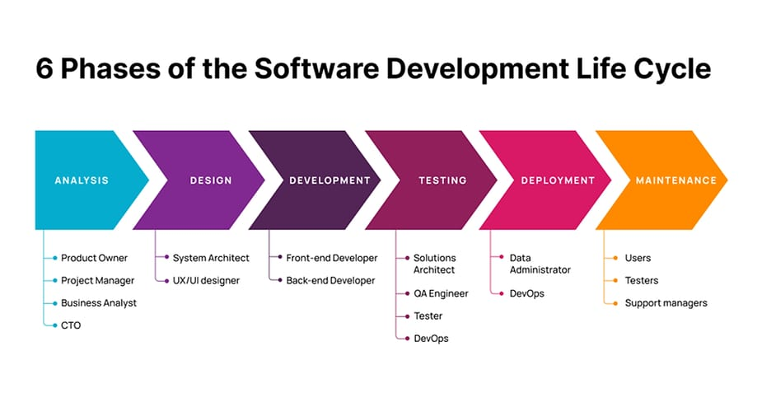

**1. Requirements**

* Gather and analyze business needs.
* Define project goals, deliverables, and constraints

**2. Design**

* Create system architecture and design specifications.
* Develop data models and user interfaces.

**3. Implementation**

* Write and compile code based on design specifications.
* Develop features and functionalities.

**4. Testing**

* Verify the system against requirements.
* Identify and fix defects.

**5. Deployment**

* Release the system to production.
* Ensure users are trained and supported.

**6. Maintenance:**

* Upgrades and Updates has to be done in this phase.