**Day 3- Assignment 3**

**------------------------------------------------------------------------------------------------------------------------------------------**

**Problem** What are Agile principles?

**Solution**:

Agile principles are part of the Agile Manifesto, which provides guidance for developing software efficiently and effectively. Here are the 12 key principles:

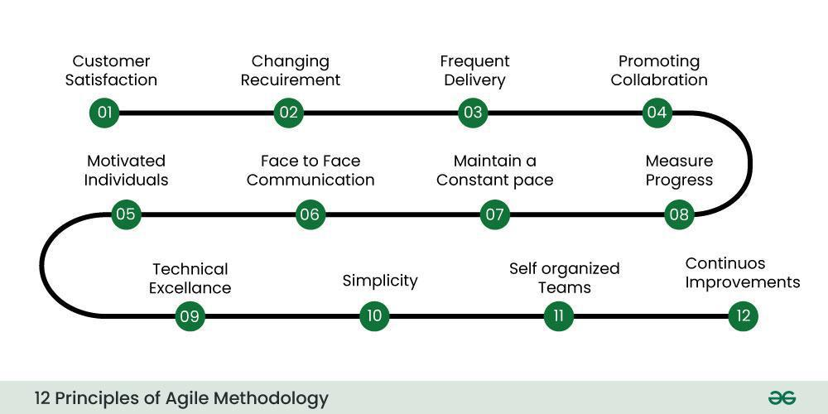

1. *Customer Satisfaction*: Prioritize customer satisfaction through early and continuous delivery of valuable software.

2. *Changing Requirements*: Embrace changing requirements, even late in development, to maintain a competitive edge.

3. *Frequent Delivery*: Deliver working software frequently, with a preference for shorter timescales.

4. *Promoting Collaboration*: Business people and developers must work together daily throughout the project.

5. *Motivated Individuals*: Build projects around motivated individuals. Give them the environment and support they need and trust them to get the job done.

6. *Face-to-Face Conversation*: The most efficient and effective method of conveying information is face-to-face conversation.

7. *Measure Progress*: Working software is the primary measure of progress.

8. *Maintain a constant pace *: Agile processes promote sustainable development. Teams should maintain a constant pace indefinitely.

9. *Technical Excellence*: Continuous attention to technical excellence and good design enhances agility.

10. *Simplicity*: Simplicity—the art of maximizing the amount of work not done—is essential.

11. *Self-Organizing Teams*: The best architectures, requirements, and designs emerge from self-organizing teams.

12. *Continuous Improvement*: At regular intervals, the team reflects on how to become more effective, then tunes and adjusts its behavior accordingly.

These principles help ensure that Agile teams are adaptable, responsive, and capable of delivering high-quality software in a collaborative and sustainable manner.