UML DIAGRAMS
Smart Student Grievance and Complaint Management System
Contents
1. Use Case Diagram
2. Class Diagram
3. Sequence Diagram
4. Activity Diagram
5. State Machine Diagram
Standard UML notation is used throughout. Each diagram is presented with a title and a brief explanation.

1. Use Case Diagram
This diagram identifies the actors of the system (Student, Grievance Officer, Admin and the SMS/Email Gateway), the use cases each actor can perform, the system boundary, and the include and extend relationships between use cases.
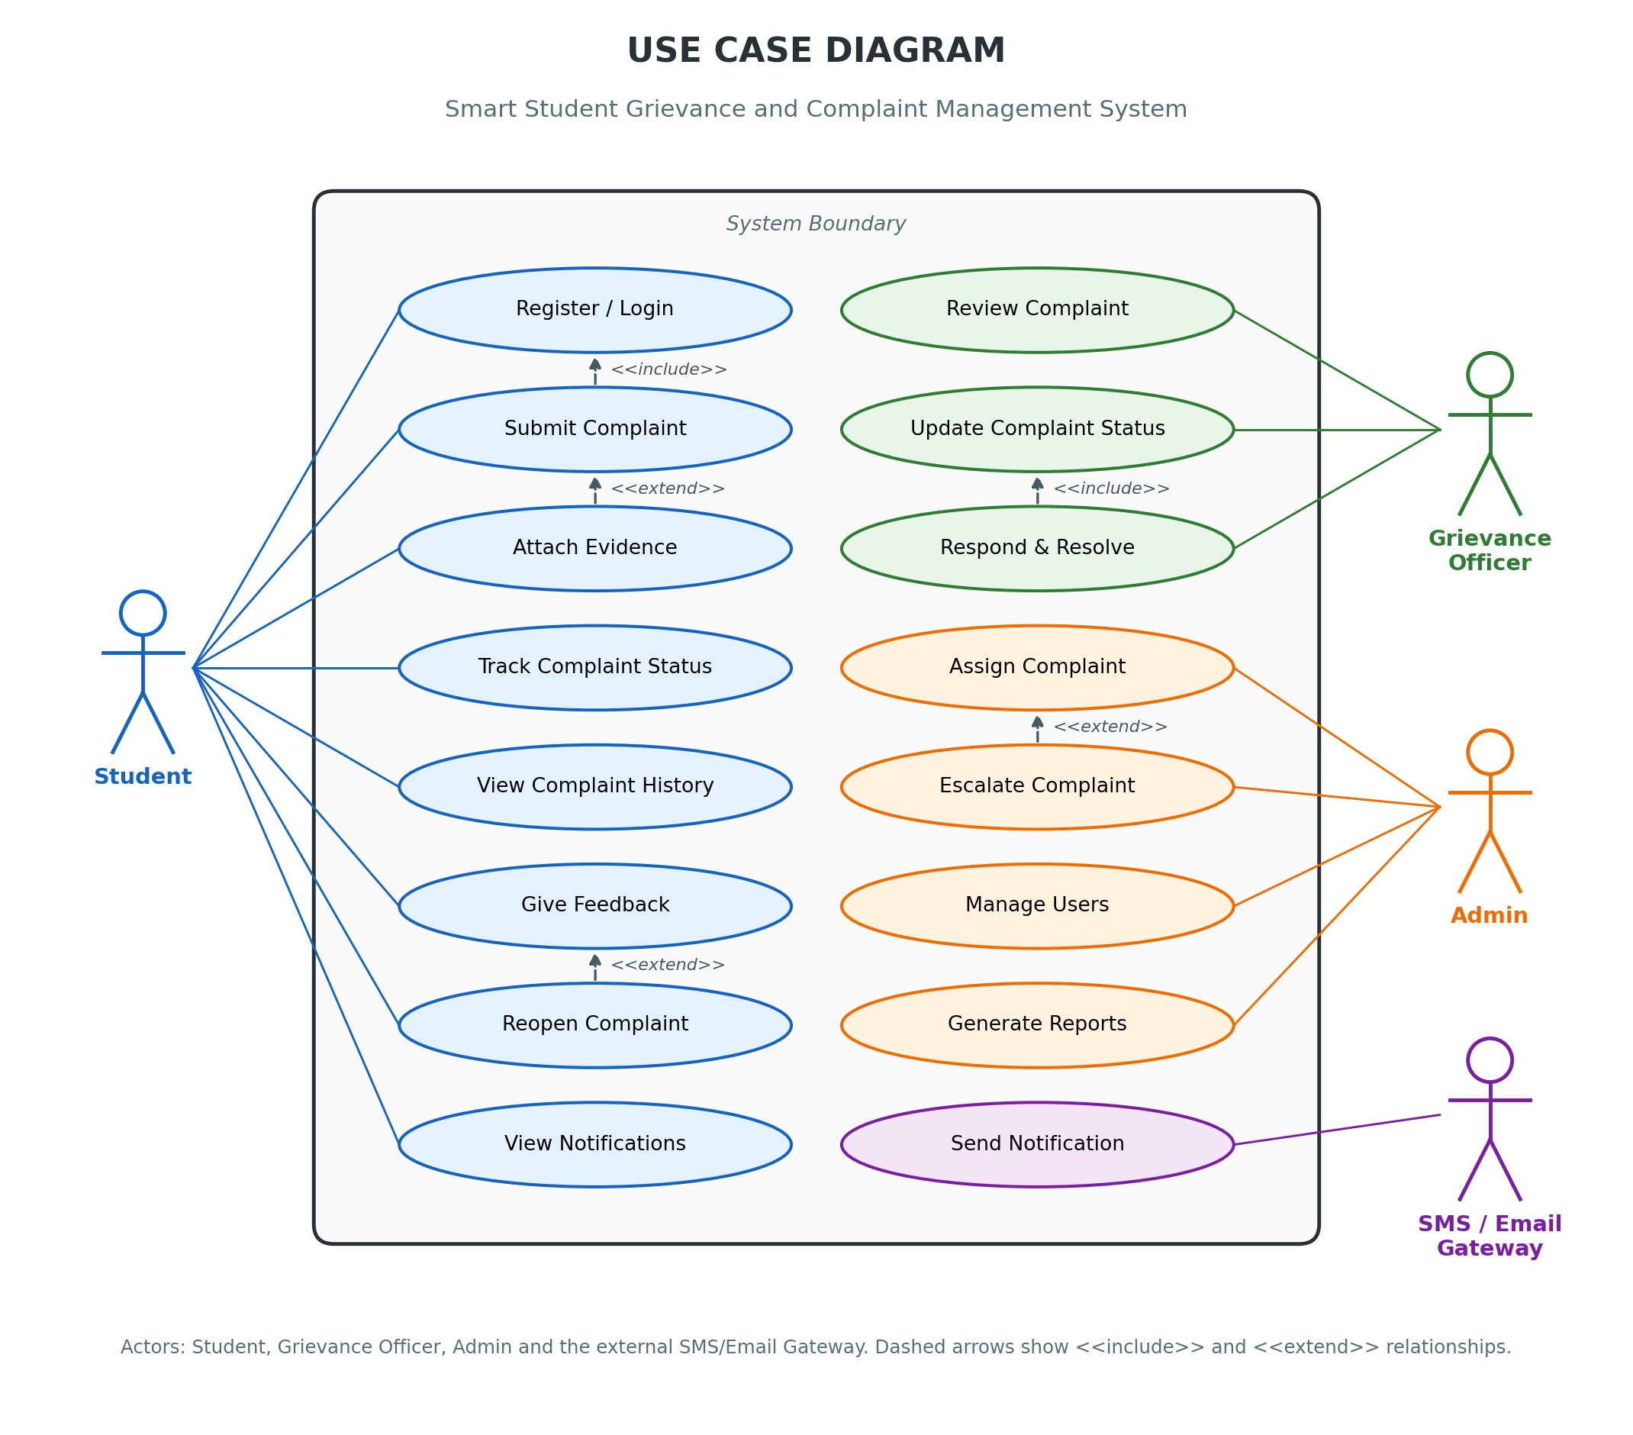
Figure 1: Use Case Diagram

2. Class Diagram
This diagram represents the classes of the system with their attributes and operations. User is the parent class of Student, GrievanceOfficer and Admin. Complaint is associated with Category, Evidence, Response, Feedback and Notification, and Admin generates Reports.
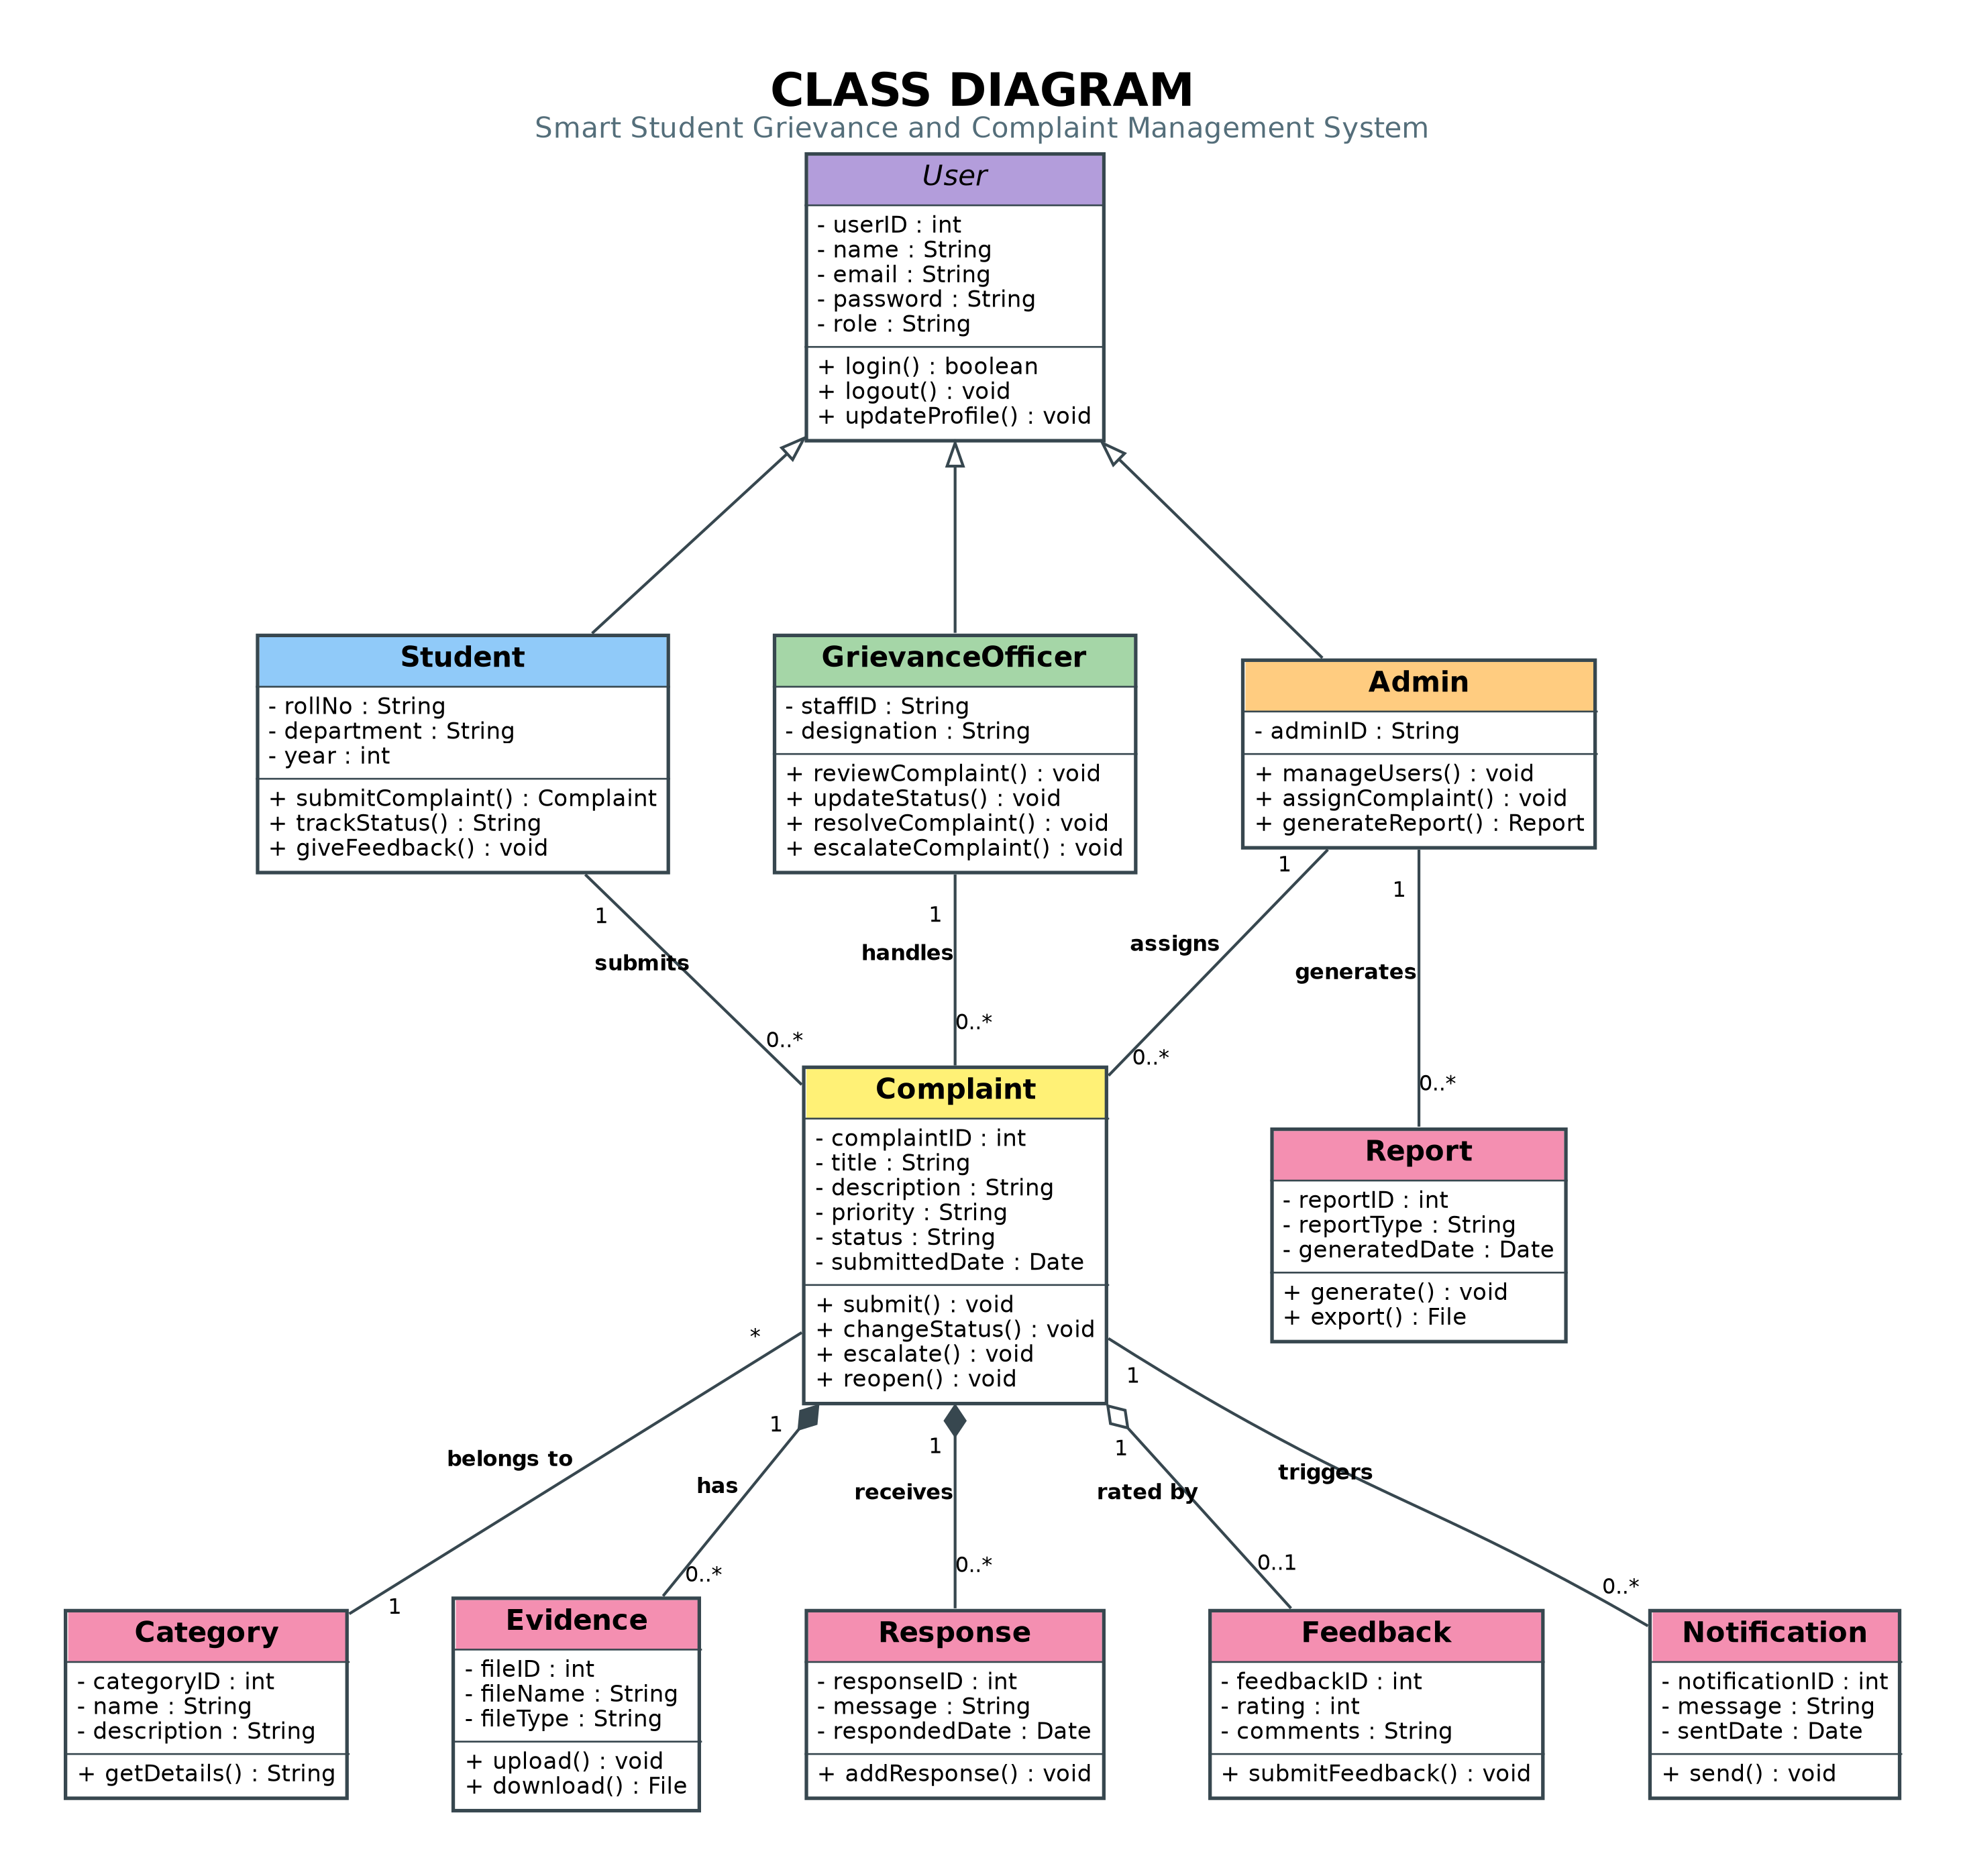
Figure 2: Class Diagram

3. Sequence Diagram
This diagram illustrates the order of messages exchanged between the Student, Web Portal, Complaint Manager, Database, Notification Service and Grievance Officer while a complaint is submitted, assigned, resolved and notified.
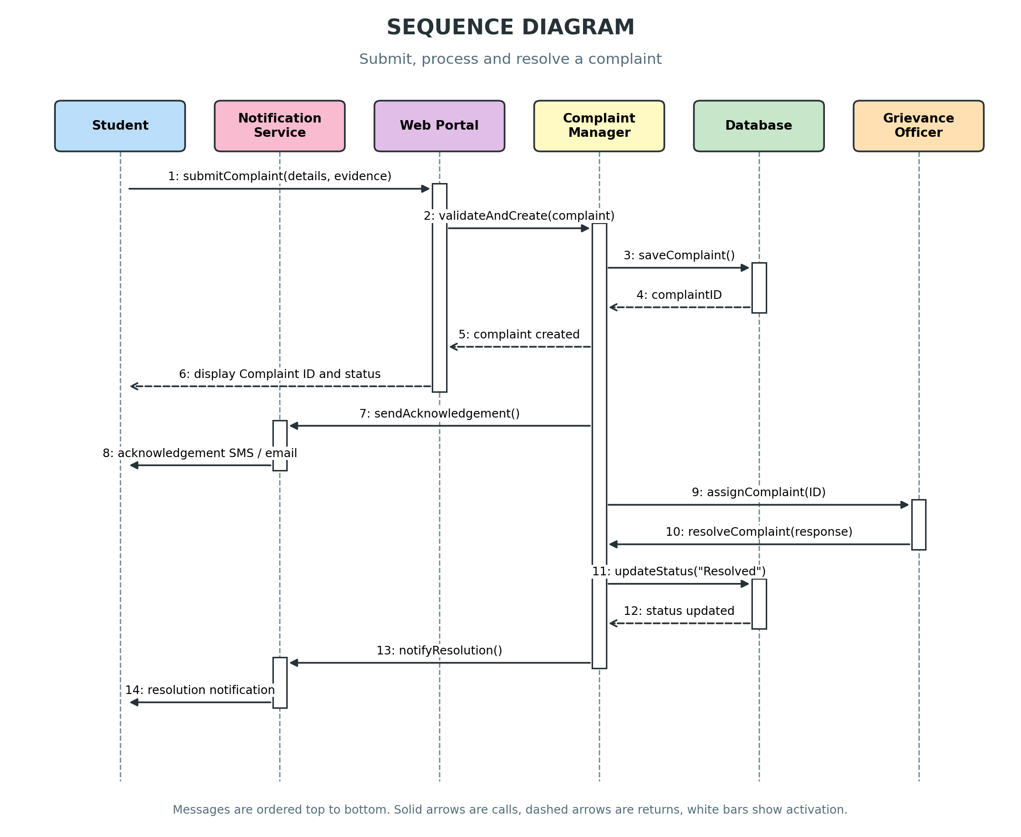
Figure 3: Sequence Diagram

4. Activity Diagram
This swimlane diagram shows the workflow of complaint submission and resolution across the Student, System, Admin and Grievance Officer, including decision points for data validation, escalation, resolution and student satisfaction, with start and end nodes.
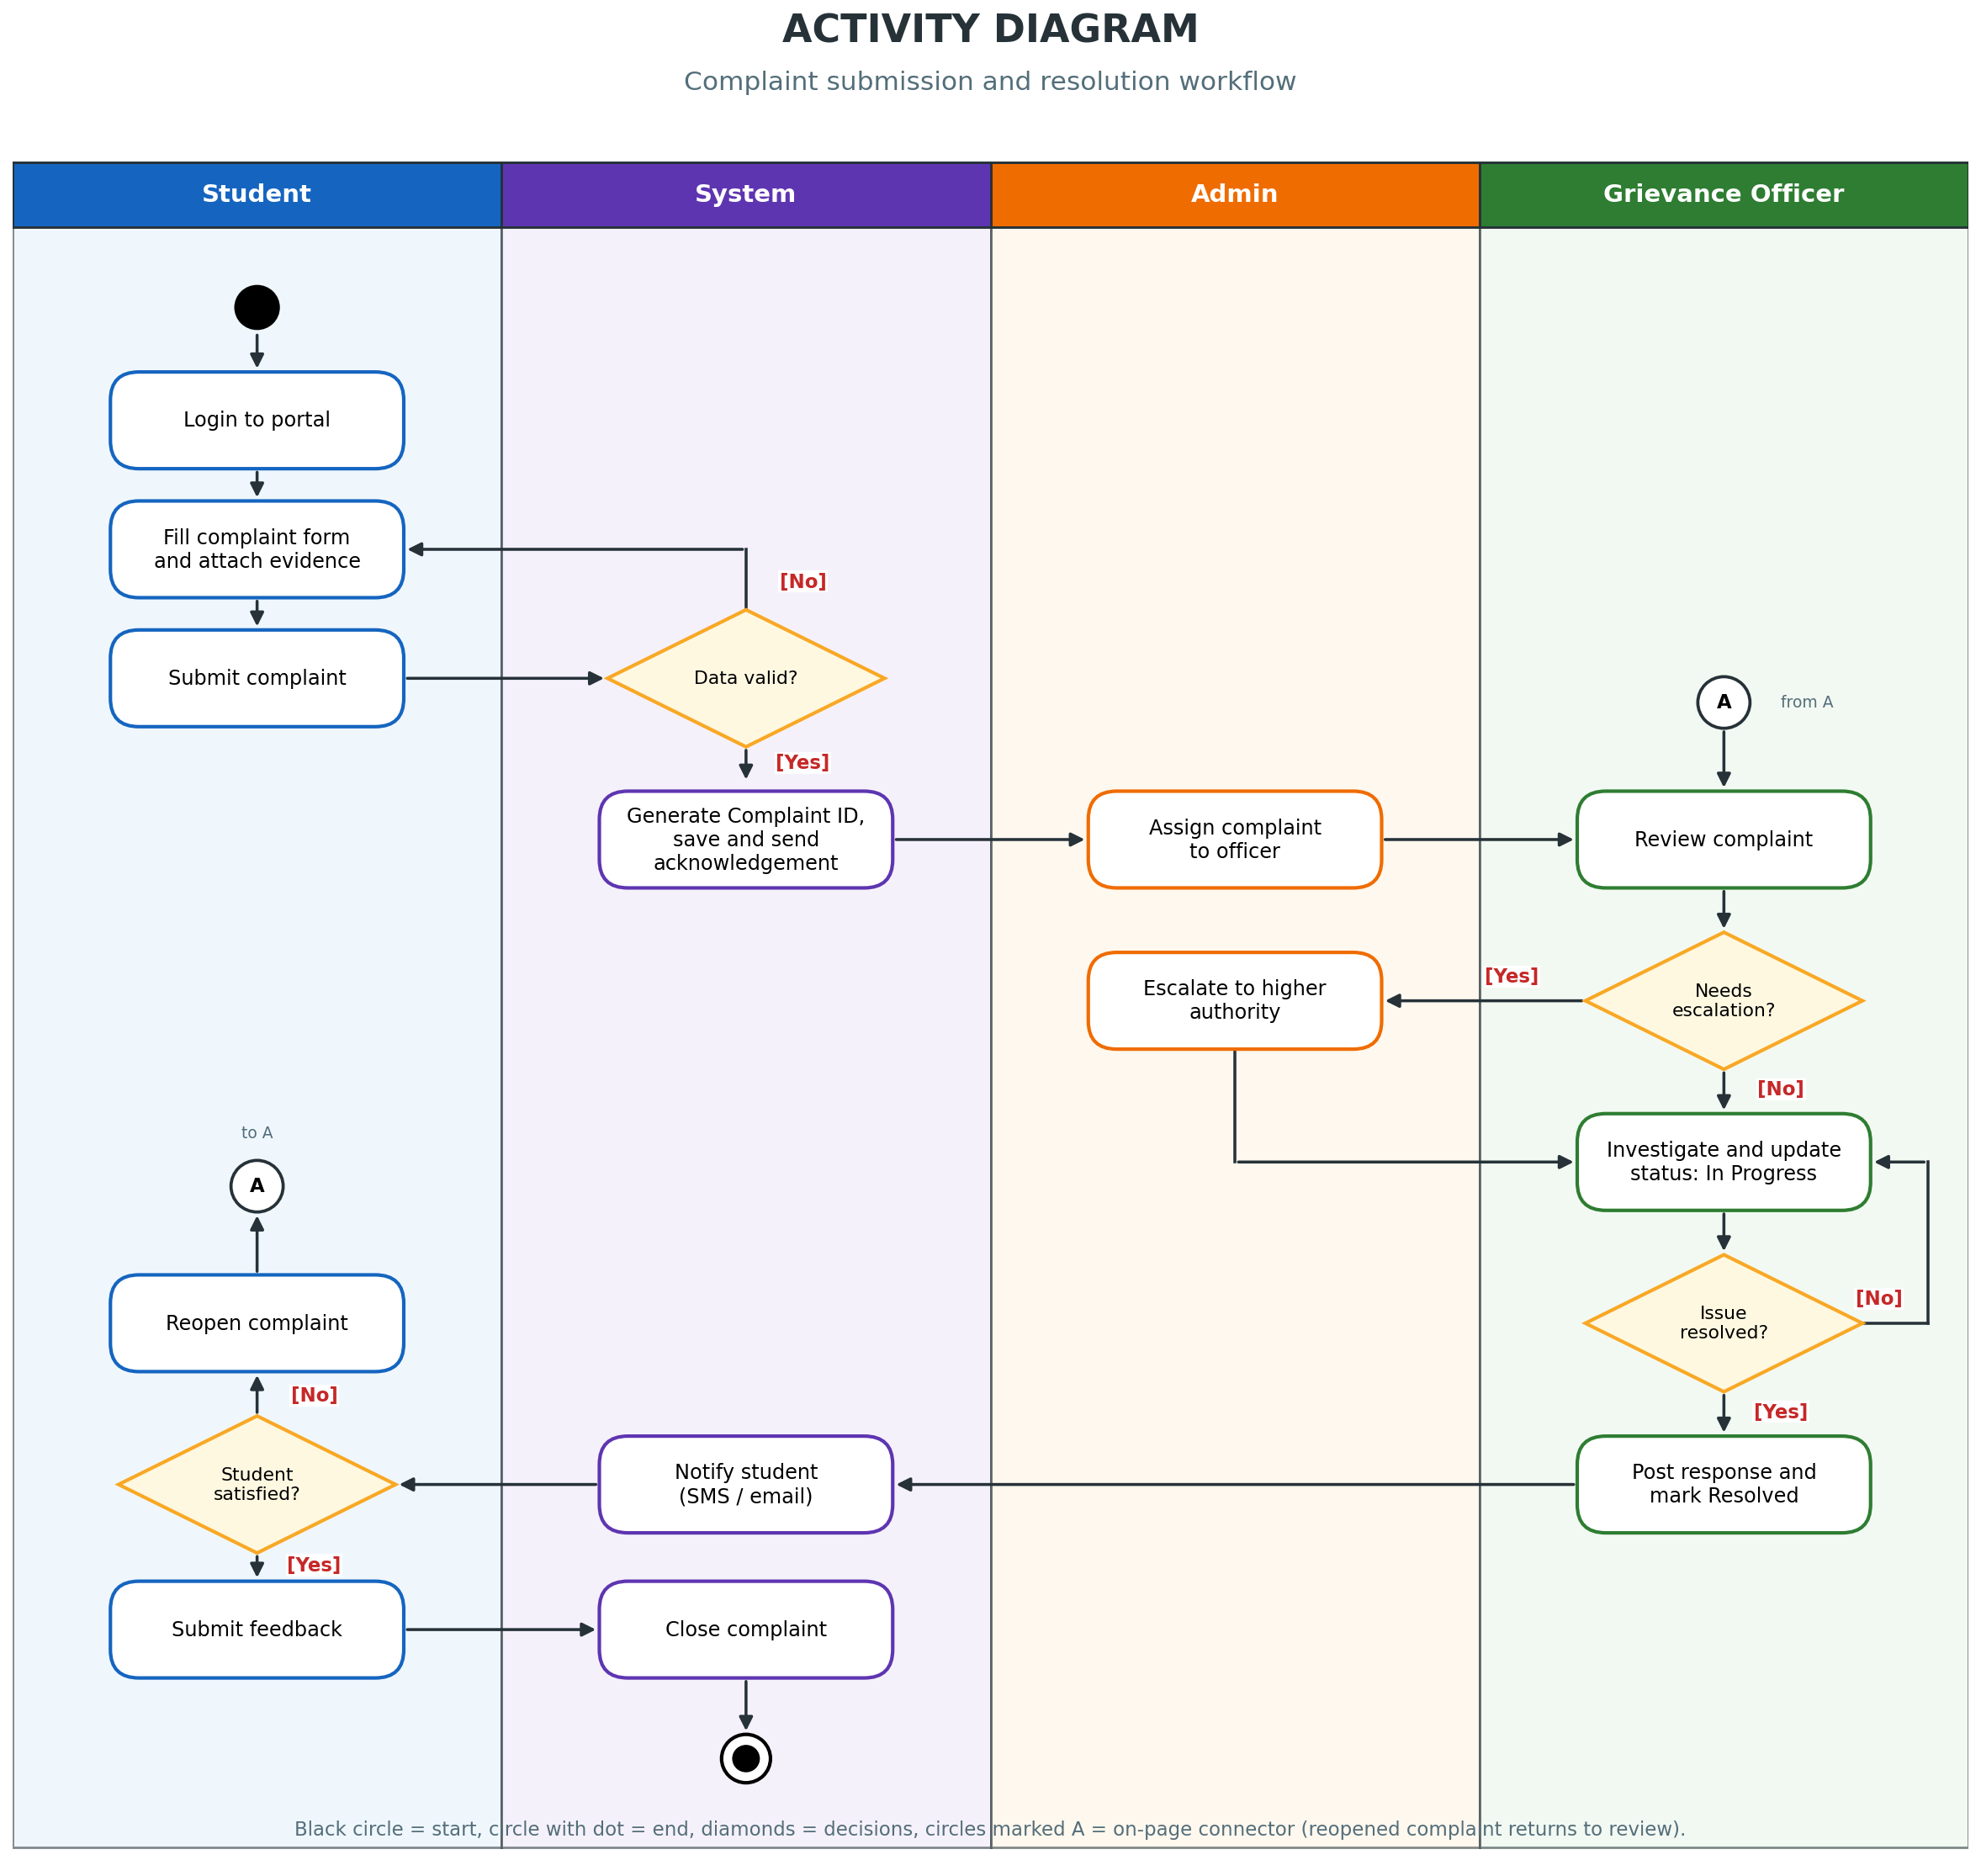
Figure 4: Activity Diagram

5. State Machine Diagram
This diagram shows the significant states of a Complaint object (Submitted, Under Review, Assigned, In Progress, Escalated, Resolved, Reopened, Closed and Rejected) and the events or conditions that trigger transitions between them.
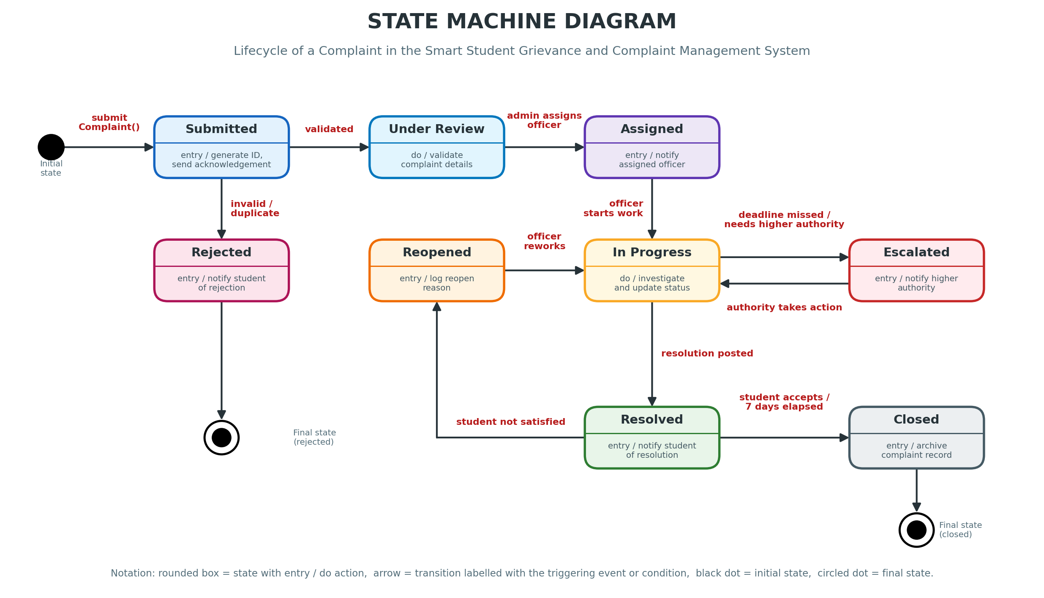
Figure 5: State Machine Diagram

