**DAY-4**

*TASK - 2*

*CODE –*

package D4;

import org.openqa.selenium.By;

import org.openqa.selenium.JavascriptExecutor;

import org.openqa.selenium.WebDriver;

import org.openqa.selenium.WebElement;

import org.openqa.selenium.chrome.ChromeDriver;

import org.openqa.selenium.chrome.ChromeOptions;

import io.github.bonigarcia.wdm.WebDriverManager;

public class D4T2 {

public static void main(String[] args) throws InterruptedException {

WebDriverManager.chromedriver().setup();

ChromeOptions co=new ChromeOptions();

co.addArguments("--remote-allow-origins=*");

WebDriver driver = new ChromeDriver(co);

driver.get("https://demo.opencart.com/index.php?route=account/register&language=en-gb");

WebElement fname=driver.findElement(By.id("input-firstname"));

fname.sendKeys("Johnathon");

WebElement lname=driver.findElement(By.id("input-lastname"));

lname.sendKeys("Wick");

WebElement email=driver.findElement(By.id("input-email"));

email.sendKeys("jw@gmail.com");

WebElement password=driver.findElement(By.id("input-password"));

password.sendKeys("123456");

JavascriptExecutor js=(JavascriptExecutor)driver;

js.executeScript("window.scrollBy(0,1000)","");

Thread.sleep(3000);

WebElement subscribe = driver.findElement(By.id("input-newsletter-yes"));

subscribe.click();

}

}

*OUTPUT -*

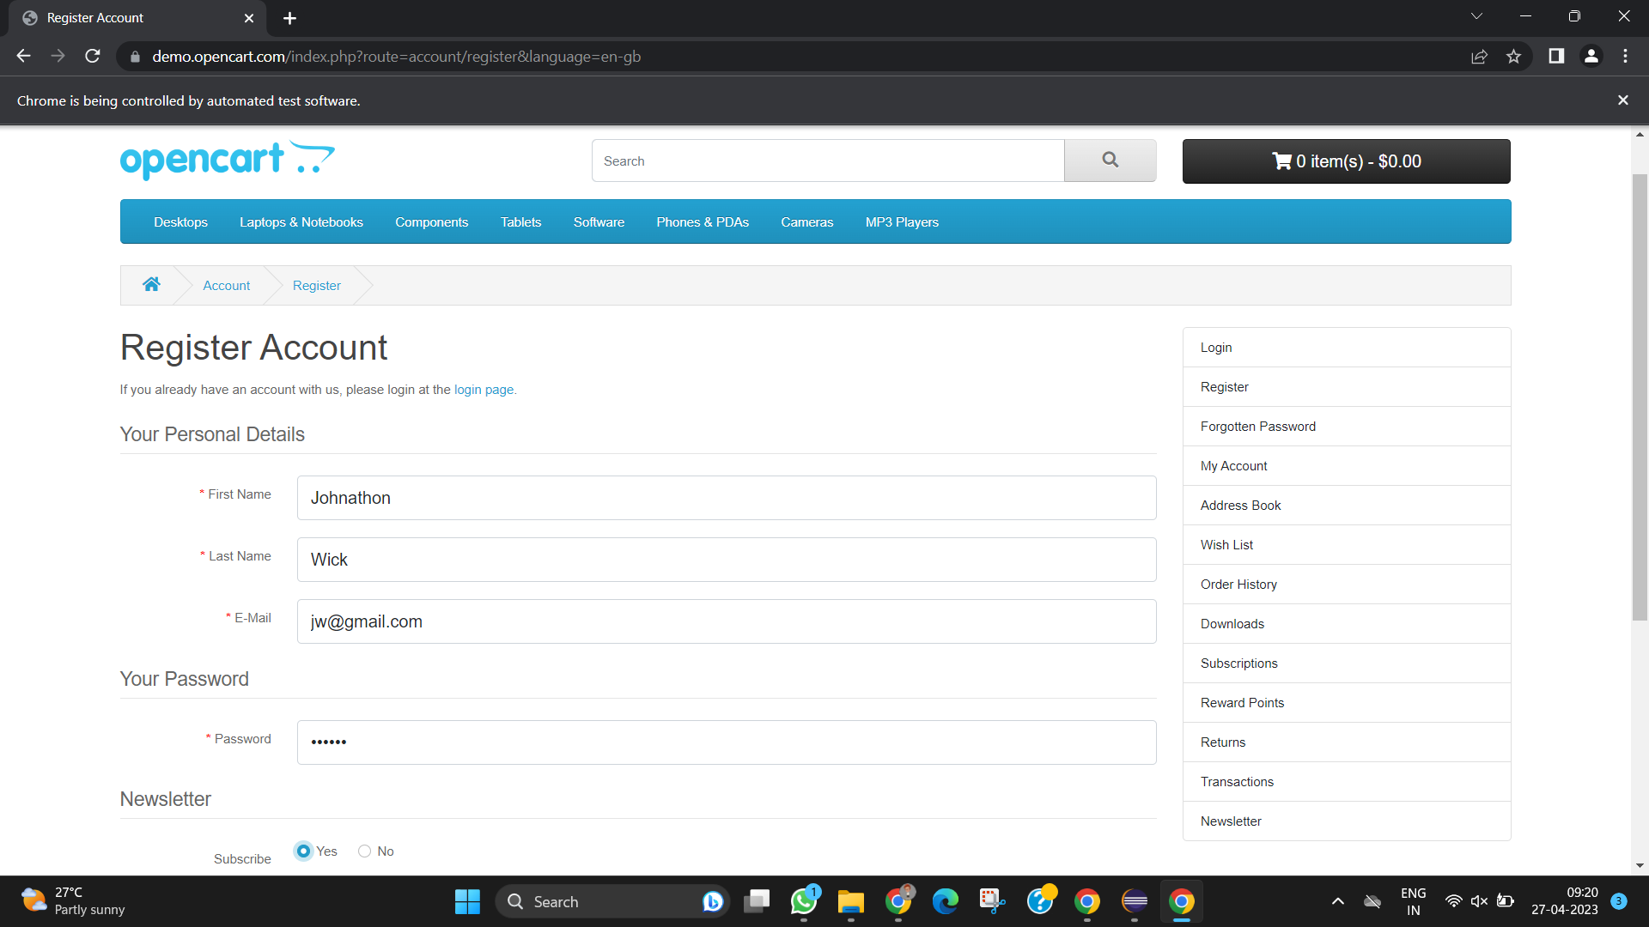

*TASK-3*

*CODE –*

*package D4;*

*import org.openqa.selenium.By;*

*import org.openqa.selenium.JavascriptExecutor;*

*import org.openqa.selenium.WebDriver;*

*import org.openqa.selenium.WebElement;*

*import org.openqa.selenium.chrome.ChromeDriver;*

*import org.openqa.selenium.chrome.ChromeOptions;*

*import io.github.bonigarcia.wdm.WebDriverManager;*

*public class D4T3 {*

*public static void main(String[] args) throws InterruptedException {*

*WebDriverManager.chromedriver().setup();*

*ChromeOptions co = new ChromeOptions();*

*co.addArguments("--remote-allow-origins=*");*

*WebDriver driver = new ChromeDriver(co);*

*driver.get("https://demo.opencart.com/index.php?route=checkout/voucher&language=en-gb");*

*WebElement rname = driver.findElement(By.xpath("//*[@id=\"input-to-name\"]"));*

*rname.sendKeys("Kavin Aditya");*

*WebElement remail = driver.findElement(By.xpath("//*[@id=\"input-to-email\"]"));*

*remail.sendKeys("ka@gmail.com");*

*WebElement name = driver.findElement(By.xpath("//*[@id=\"input-from-name\"]"));*

*name.sendKeys("Kavin Aditya");*

*WebElement email = driver.findElement(By.xpath("//*[@id=\"input-from-email\"]"));*

*email.sendKeys("ka@gmail.com");*

*WebElement gift = driver.findElement(By.xpath("//*[@id=\"input-theme-7\"]"));*

*gift.click();*

*WebElement msg = driver.findElement(By.xpath("//*[@id=\"input-message\"]"));*

*msg.sendKeys("Hello!!!");*

*JavascriptExecutor js=(JavascriptExecutor)driver;*

*js.executeScript("window.scrollBy(0,250)","");*

*Thread.sleep(3000);*

*WebElement amount = driver.findElement(By.xpath("//*[@id=\"input-amount\"]"));*

*amount.clear();*

*amount.sendKeys("5");*

*WebElement check = driver.findElement(By.xpath("//*[@id=\"form-voucher\"]/div[8]/div/div/input"));*

*check.click();*

*WebElement btn = driver.findElement(By.xpath("//*[@id=\"form-voucher\"]/div[8]/div/button"));*

*btn.click();*

*}*

*}*

*OUTPUT -*

*TASK – 4*

*CODE –*

*package D4;*

*import org.openqa.selenium.By;*

*import org.openqa.selenium.JavascriptExecutor;*

*import org.openqa.selenium.WebDriver;*

*import org.openqa.selenium.WebElement;*

*import org.openqa.selenium.chrome.ChromeDriver;*

*import org.openqa.selenium.chrome.ChromeOptions;*

*import io.github.bonigarcia.wdm.WebDriverManager;*

*public class D4T4 {*

*public static void main(String[] args) throws InterruptedException {*

*WebDriverManager.chromedriver().setup();*

*ChromeOptions co = new ChromeOptions();*

*co.addArguments("--remote-allow-origins=*");*

*WebDriver driver = new ChromeDriver(co);*

*driver.get("https://demo.opencart.com/index.php?route=checkout/voucher&language=en-gb");*

*WebElement rname = driver.findElement(By.xpath("//*[@id=\"input-to-name\"]"));*

*rname.sendKeys("Kavin Aditya");*

*WebElement remail = driver.findElement(By.xpath("//*[@id=\"input-to-email\"]"));*

*remail.sendKeys("kavinadityatr@gmail.com");*

*WebElement name = driver.findElement(By.xpath("//*[@id=\"input-from-name\"]"));*

*name.sendKeys("Kavin");*

*WebElement email = driver.findElement(By.xpath("//*[@id=\"input-from-email\"]"));*

*email.sendKeys("kavin@gmail.com");*

*WebElement gift = driver.findElement(By.xpath("//*[@id=\"input-theme-7\"]"));*

*gift.click();*

*WebElement msg = driver.findElement(By.xpath("//*[@id=\"input-message\"]"));*

*msg.sendKeys("Hello!!!");*

*JavascriptExecutor js=(JavascriptExecutor)driver;*

*js.executeScript("window.scrollBy(0,250)","");*

*Thread.sleep(3000);*

*WebElement amount = driver.findElement(By.xpath("//*[@id=\"input-amount\"]"));*

*amount.clear();*

*amount.sendKeys("5");*

*WebElement check = driver.findElement(By.xpath("//*[@id=\"form-voucher\"]/div[8]/div/div/input"));*

*check.click();*

*WebElement btn = driver.findElement(By.xpath("//*[@id=\"form-voucher\"]/div[8]/div/button"));*

*btn.click();*

*}*

*}*

*OUTPUT -*

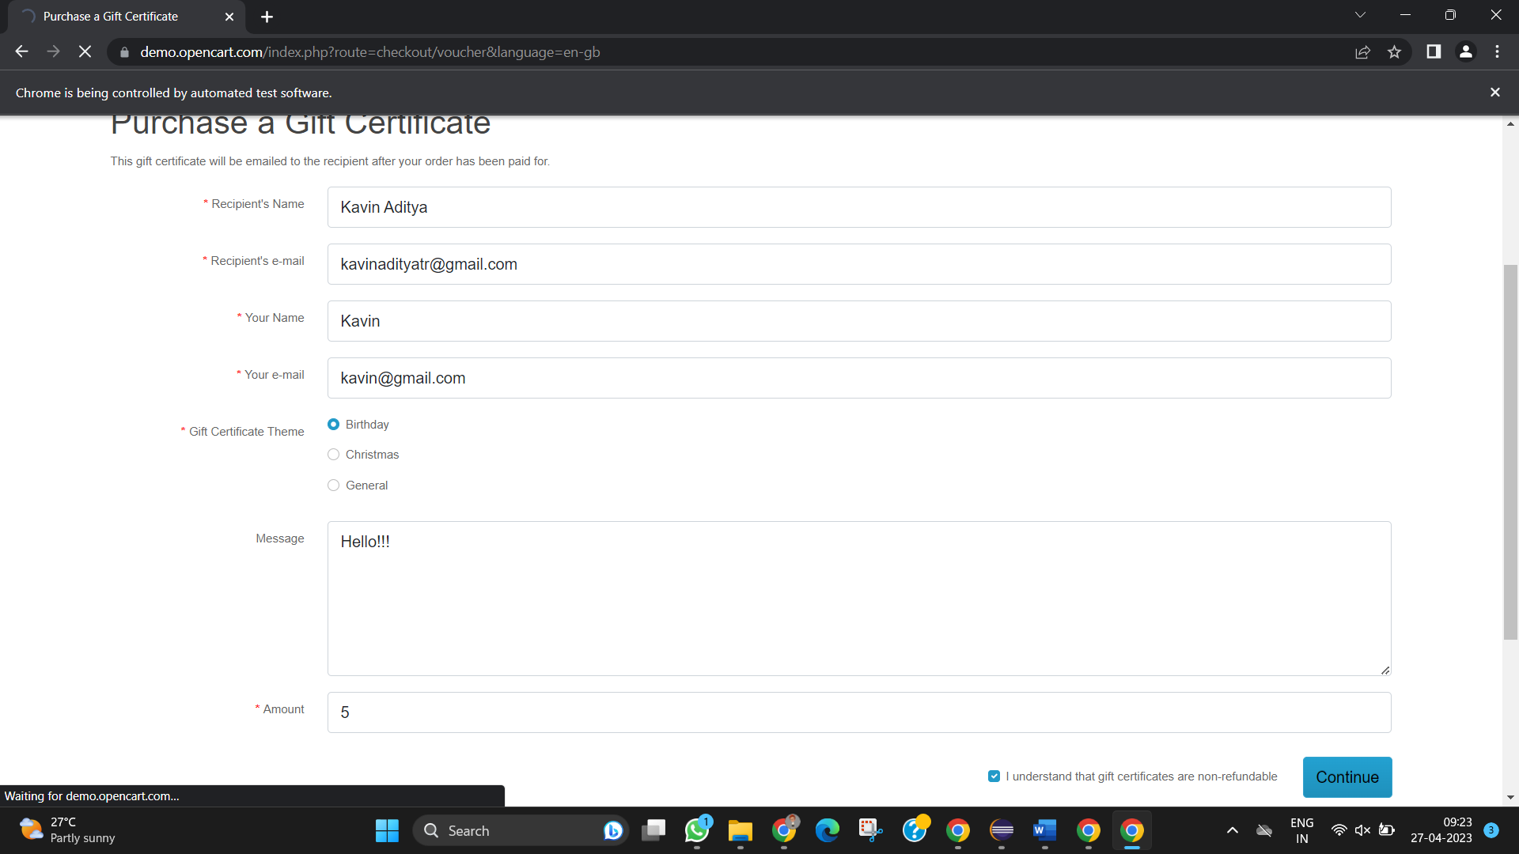

*TASK – 5.1*

*CODE –*

*package D4;*

*import org.openqa.selenium.By;*

*import org.openqa.selenium.JavascriptExecutor;*

*import org.openqa.selenium.WebDriver;*

*import org.openqa.selenium.WebElement;*

*import org.openqa.selenium.chrome.ChromeDriver;*

*import org.openqa.selenium.chrome.ChromeOptions;*

*import io.github.bonigarcia.wdm.WebDriverManager;*

*public class D4T5 {*

*public static void main(String[] args)*

*{*

*WebDriverManager.chromedriver().setup();*

*ChromeOptions co = new ChromeOptions();*

*co.addArguments("--remote-allow-origins=*");*

*WebDriver driver = new ChromeDriver(co);*

*driver.get("https://j2store.net/free/");*

*driver.manage().window().maximize();*

*String url1 = driver.getCurrentUrl();*

*if(url1.equals("https://j2store.net/free/"))*

*{*

*System.out.println("url validated");*

*}*

*JavascriptExecutor js=(JavascriptExecutor)driver;*

*js.executeScript("window.scrollBy(0,1000)","");*

*WebElement clothing = driver.findElement(By.xpath("//*[@id=\"Mod112\"]/div/div/ul/li[1]/h4/a"));*

*clothing.click();*

*url1 = driver.getCurrentUrl();*

*if(url1.equals("https://j2store.net/free/index.php/shop?filter_catid=11"))*

*{*

*System.out.println("url validated");*

*}*

*}*

*}*

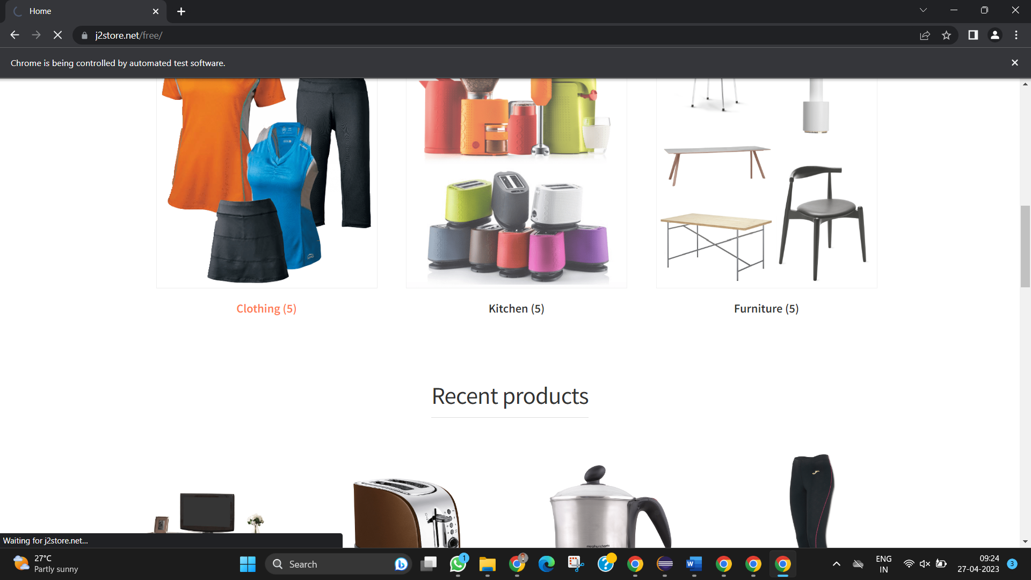

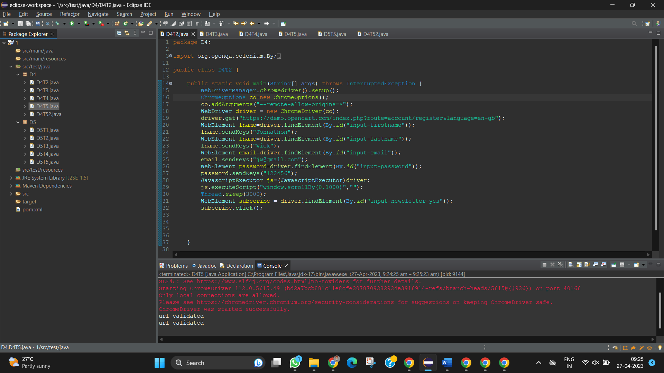

*TASK – 5.2*

*CODE -*

package D4;

import java.util.List;

import org.openqa.selenium.By;

import org.openqa.selenium.JavascriptExecutor;

import org.openqa.selenium.WebDriver;

import org.openqa.selenium.WebElement;

import org.openqa.selenium.chrome.ChromeDriver;

import org.openqa.selenium.chrome.ChromeOptions;

import io.github.bonigarcia.wdm.WebDriverManager;

public class D4T52 {

public static void main(String[] args) throws InterruptedException {

WebDriverManager.chromedriver().setup();

ChromeOptions co = new ChromeOptions();

co.addArguments("--remote-allow-origins=*");

WebDriver driver = new ChromeDriver(co);

driver.get("https://j2store.net/free/");

driver.manage().window().maximize();

JavascriptExecutor js=(JavascriptExecutor)driver;

js.executeScript("window.scrollBy(0,1000)","");

driver.findElement(By.linkText("Clothing (5)")).click();

Thread.sleep(5000);

List<WebElement> l1 = driver.findElements(By.xpath("//h2[@class='product-title']"));

for(WebElement link : l1)

{

System.out.println(link.getText());

}

}

}

