**DAY-7**

***TASK -1***

package D7;

import org.openqa.selenium.WebDriver;

import org.openqa.selenium.chrome.ChromeDriver;

import org.openqa.selenium.chrome.ChromeOptions;

import org.testng.Assert;

import org.testng.annotations.Test;

import io.github.bonigarcia.wdm.WebDriverManager;

public class D7T1 {

@Test

public void f() {

WebDriverManager.chromedriver().setup();

ChromeOptions co =new ChromeOptions();

co.addArguments("--remote-allow-origin=*");

WebDriver driver=new ChromeDriver(co);

driver.get("https://demo.wpeverest.com/user-registration/guest-registration-form/");

String title=driver.getTitle();

String expectedtitle="Guest Registration Form – User Registration";

Assert.assertEquals(title, expectedtitle);

}

}

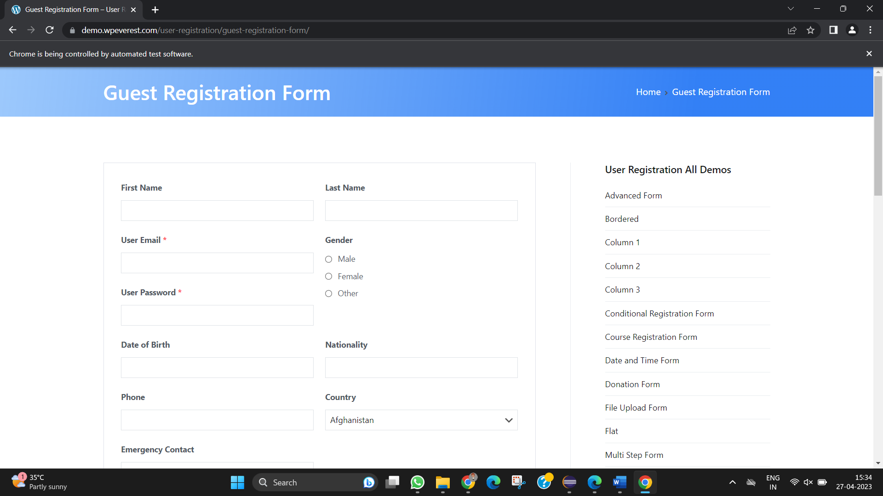

***TASK-2***

*package D7;*

*//import java.util.Scanner;*

*import org.testng.Assert;*

*import org.testng.annotations.BeforeSuite;*

*import org.testng.annotations.Test;*

*public class D7T2*

*{*

*int a,b,c;*

*@BeforeSuite*

*void getdata()*

*{*

*a=7;*

*b=4;*

*}*

*@Test*

*public void add() {*

*c=a+b;*

*Assert.assertEquals(c,11);*

*}*

*public void sub() {*

*c=a-b;*

*Assert.assertEquals(c, 3);*

*}*

*public void mul() {*

*c=a*b;*

*Assert.assertEquals(c, 28);*

*}*

*public void div() {*

*Assert.assertEquals(c, 1);*

*}*

*}*

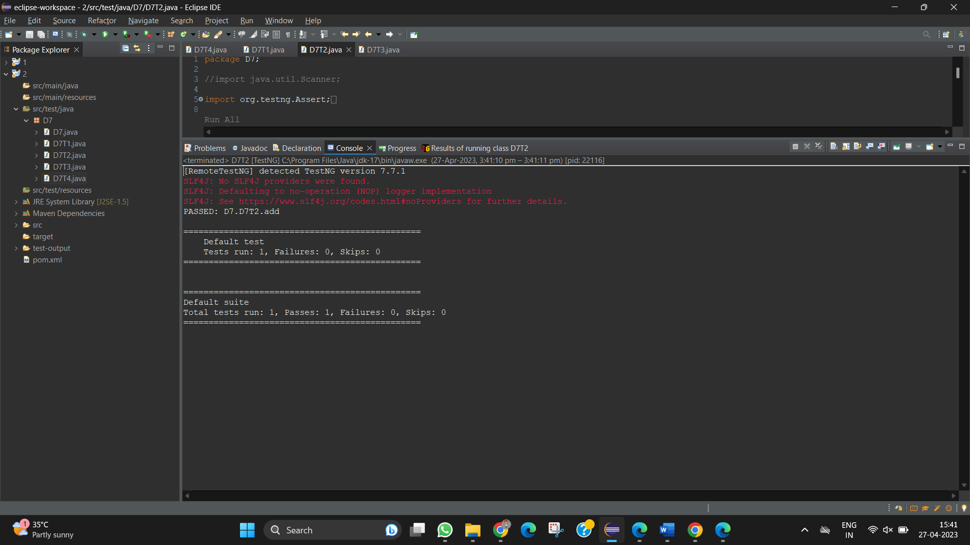

***TASK-3***

*package D7;*

*import org.testng.annotations.Test;*

*import io.github.bonigarcia.wdm.WebDriverManager;*

*import org.testng.annotations.BeforeMethod;*

*import org.testng.annotations.AfterMethod;*

*import org.openqa.selenium.By;*

*import org.openqa.selenium.WebDriver;*

*import org.openqa.selenium.WebElement;*

*import org.openqa.selenium.chrome.ChromeDriver;*

*import org.openqa.selenium.chrome.ChromeOptions;*

*import org.testng.Assert;*

*public class D7T3 {*

*WebDriver driver;*

*@Test*

*public void openURL() throws InterruptedException {*

*Thread.sleep(3000);*

*WebElement userName = driver.findElement(By.name("username"));*

*WebElement password = driver.findElement(By.name("password"));*

*WebElement submit = driver.findElement(By.xpath("//*[@class='oxd-button oxd-button--medium oxd-button--main orangehrm-login-button']"));*

*userName.sendKeys("Admin");*

*password.sendKeys("admin123");*

*submit.click();*

*Thread.sleep(3000);*

*String expectedURL = "https://opensource-demo.orangehrmlive.com/web/index.php/dashboard/index";*

*//String expectedURL = "https://opensource-demo.orangehrmlive.com/web/index.php/auth/login";*

*String actualURL = driver.getCurrentUrl();*

*Assert.assertEquals(expectedURL, actualURL);*

*}*

*@BeforeMethod*

*public void setup() {*

*//System.setProperty("webdriver.chrome.driver","C:\\Users\\tharu\\Downloads\\chromedriver_win32\\chromedriver.exe");*

*WebDriverManager.chromedriver().setup();*

*ChromeOptions co = new ChromeOptions();*

*co.addArguments("--remote-allow-origins=*");*

*driver = new ChromeDriver(co);*

*driver.manage().window().maximize();*

*String url = "https://opensource-demo.orangehrmlive.com/web/index.php/auth/login";*

*driver.get(url);*

*driver.manage().window().maximize();*

*}*

*@AfterMethod*

*public void teardown() {*

*driver.close();*

*}*

*}*

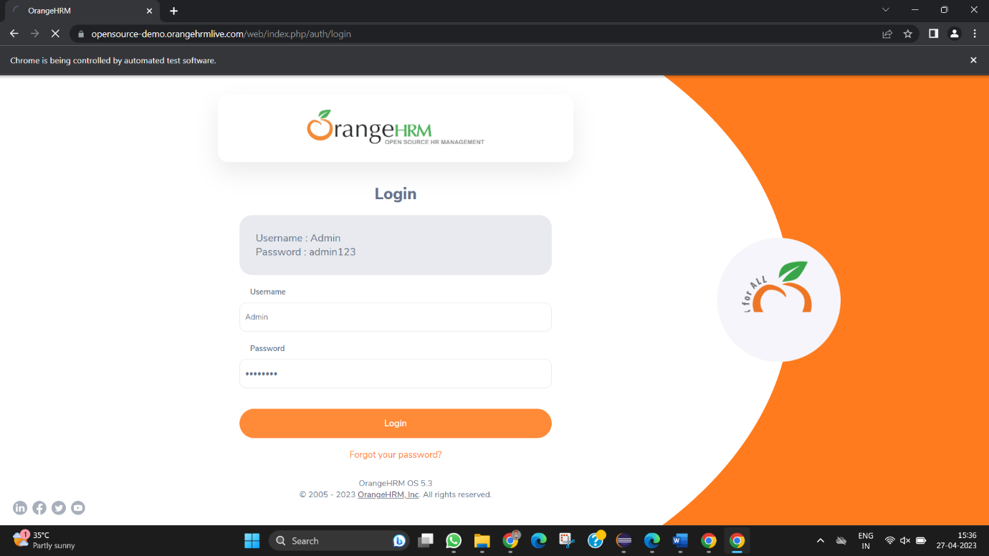

***TASK-4***

package D7;

import org.openqa.selenium.By;

import org.openqa.selenium.chrome.ChromeOptions;

import org.openqa.selenium.edge.EdgeDriver;

import org.testng.Assert;

import org.testng.annotations.Test;

import io.github.bonigarcia.wdm.WebDriverManager;

public class D7T4 {

EdgeDriver driver = new EdgeDriver();

@Test

public void LoginPage() throws InterruptedException {

WebDriverManager.chromedriver().setup();

ChromeOptions co = new ChromeOptions();

co.addArguments("--remote-allow-origins=*");

driver.get("https://opensource-demo.orangehrmlive.com/web/index.php/dashboard/index");

driver.manage().window().maximize();

Thread.sleep(6000);

driver.findElement(By.xpath("//*[@id=\"app\"]/div[1]/div/div[1]/div/div[2]/div[2]/form/div[1]/div/div[2]/input")).sendKeys("Admin");

driver.findElement(By.xpath("//*[@id=\"app\"]/div[1]/div/div[1]/div/div[2]/div[2]/form/div[2]/div/div[2]/input")).sendKeys("admin123");

String str = driver.getCurrentUrl();

driver.findElement(By.xpath("//*[@id=\"app\"]/div[1]/div/div[1]/div/div[2]/div[2]/form/div[3]/button")).click();

String after = driver.getCurrentUrl();

Assert.assertNotEquals(str, after);

}

@Test(dependsOnMethods="LoginPage")

public void Signout() throws InterruptedException {

Thread.sleep(6000);

driver.findElement(By.xpath("//*[@id=\"app\"]/div[1]/div[1]/header/div[1]/div[2]/ul/li/span")).click();

String before = driver.getCurrentUrl();

driver.findElement(By.xpath("//*[@id=\"app\"]/div[1]/div[1]/header/div[1]/div[2]/ul/li/ul/li[4]/a")).click();

String after = driver.getCurrentUrl();

Assert.assertNotEquals(before, after);

}

}

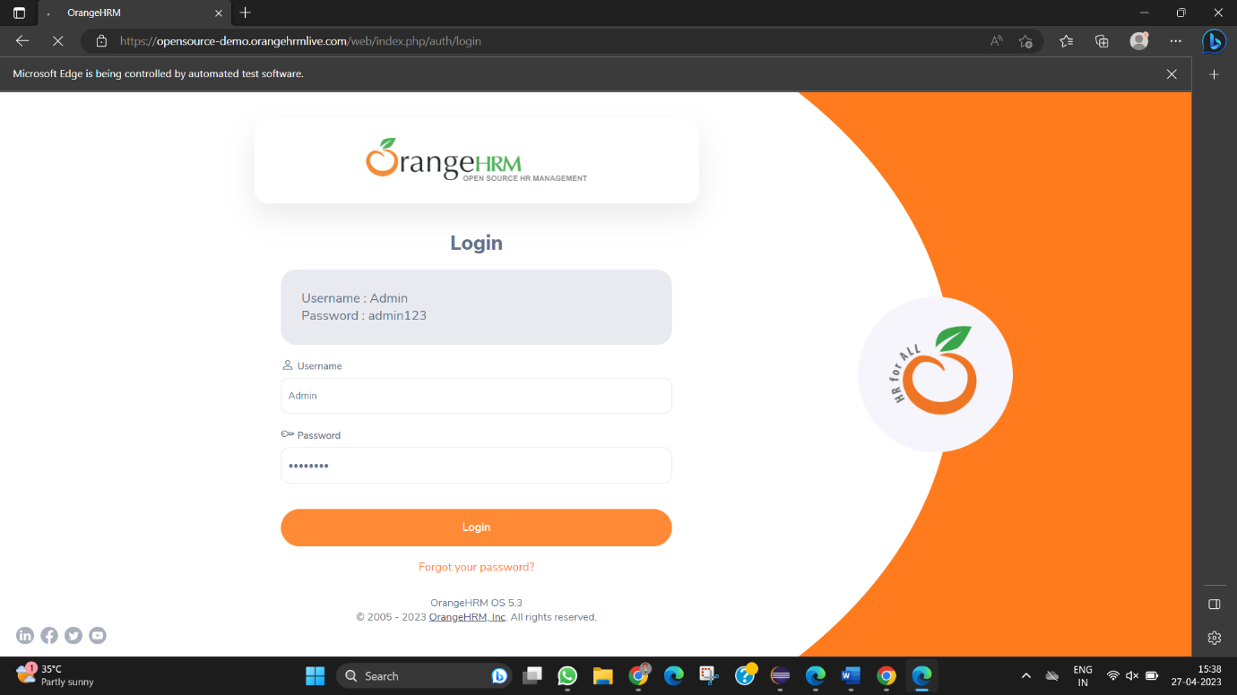

*TASK-5*

package D7;

import org.openqa.selenium.By;

import org.openqa.selenium.edge.EdgeDriver;

import org.openqa.selenium.edge.EdgeOptions;

import org.testng.Assert;

import org.testng.annotations.Test;

import io.github.bonigarcia.wdm.WebDriverManager;

public class D7T5 {

@Test

public void Task1() {

WebDriverManager.chromedriver().setup();

EdgeOptions co = new EdgeOptions();

co.addArguments("--remote-allow-origins=*");

EdgeDriver driver = new EdgeDriver(co);

driver.get("https://www.godaddy.com/en-in");

driver.manage().window().maximize();

String title = driver.getTitle();

String url = driver.getCurrentUrl();

Assert.assertEquals(url, "https://www.godaddy.com/en-in");

Assert.assertEquals(title,"Domain Names, Websites, Hosting & Online Marketing Tools - GoDaddy IN");

// driver.close();

}

public void Task2() {

WebDriverManager.chromedriver().setup();

}

}

