POLYNOMIAL EQUATONS AND THEIR ROOTS. WORKSHEET. HL.

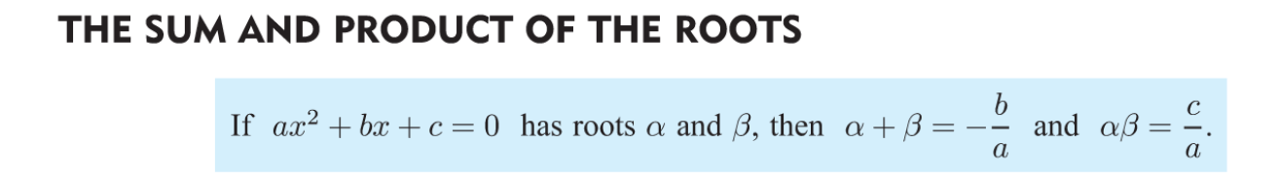
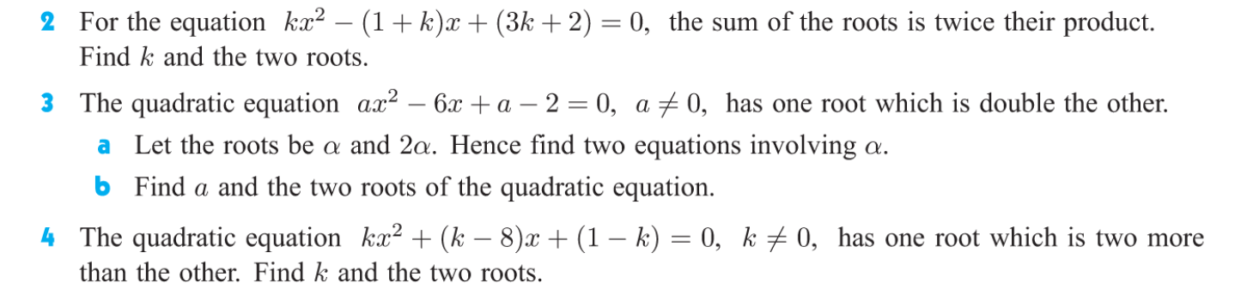
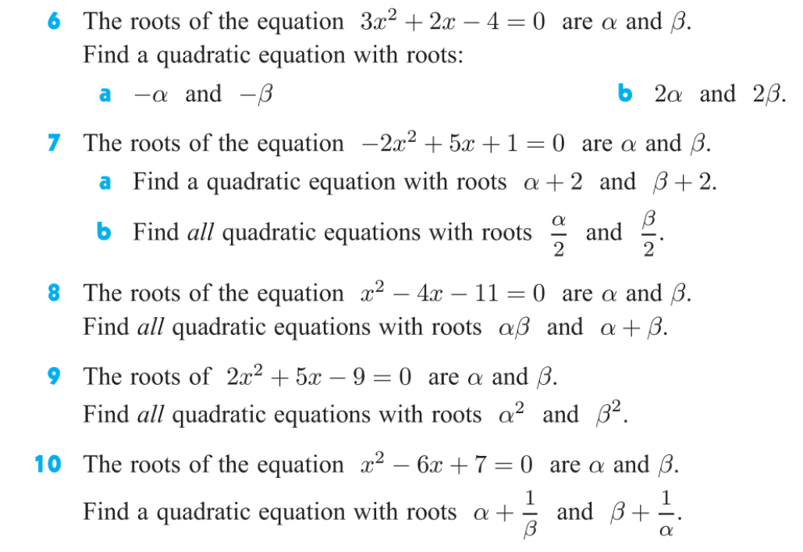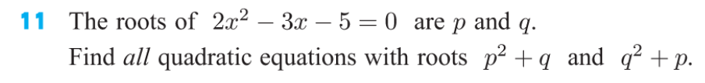
ANSWERS:
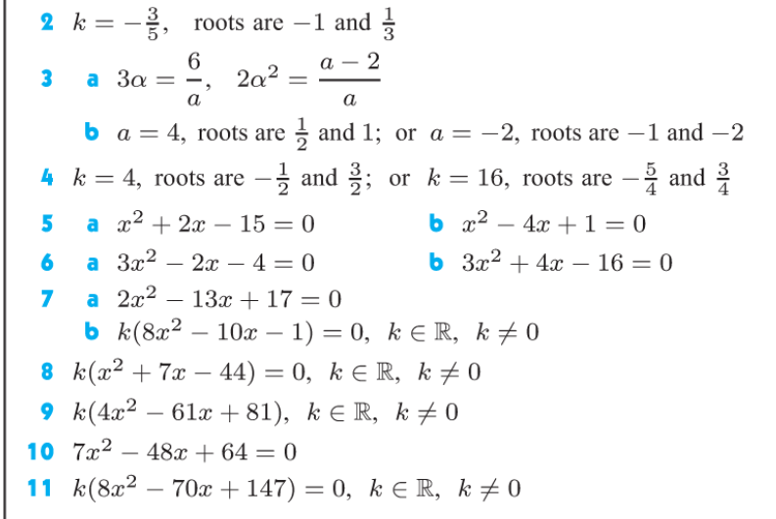
Polynomial equations of higher degree than 2 and its roots.
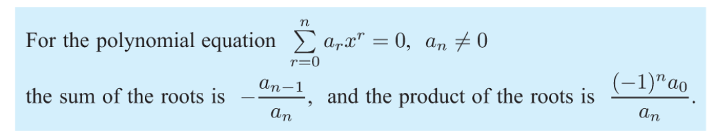
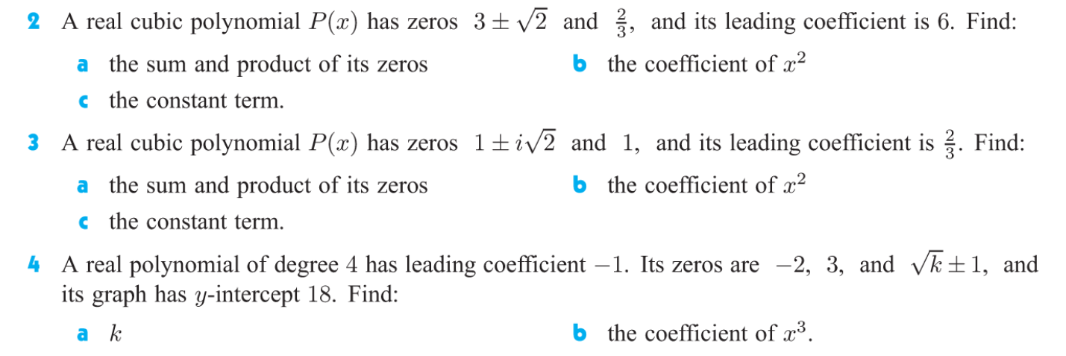
ANSWERS”
