MAA HL
Test on Exponents and Logarithms (1)
(without GDC)

Marks: /40
by Christos Nikolaidis
Date: 28 November 2019

Name of student: __________________________________________________

1. [Maximum mark: 6]
Let 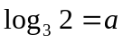 and 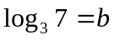. Express the following in terms of and .
(a) 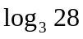 [2]
(b) 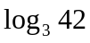 [2]
(c) 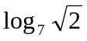 [2]

..................................................................................................................................
..................................................................................................................................
..................................................................................................................................
..................................................................................................................................
..................................................................................................................................
..................................................................................................................................
..................................................................................................................................
..................................................................................................................................
..................................................................................................................................
..................................................................................................................................
..................................................................................................................................
..................................................................................................................................
..................................................................................................................................
..................................................................................................................................
..................................................................................................................................
..................................................................................................................................
Turn over
2. [Maximum mark: 6]
Solve the logarithmic equation
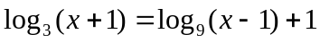
..................................................................................................................................
..................................................................................................................................
..................................................................................................................................
..................................................................................................................................
..................................................................................................................................
..................................................................................................................................
..................................................................................................................................
..................................................................................................................................
..................................................................................................................................
..................................................................................................................................
..................................................................................................................................
..................................................................................................................................
..................................................................................................................................
..................................................................................................................................
..................................................................................................................................
..................................................................................................................................
..................................................................................................................................
..................................................................................................................................
..................................................................................................................................
..................................................................................................................................
..................................................................................................................................
..................................................................................................................................
..................................................................................................................................
..................................................................................................................................
..................................................................................................................................
..................................................................................................................................
3. [Maximum mark: 5]
Solve the system of equations
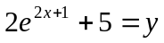
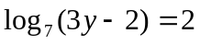

..................................................................................................................................
..................................................................................................................................
..................................................................................................................................
..................................................................................................................................
..................................................................................................................................
..................................................................................................................................
..................................................................................................................................
..................................................................................................................................
..................................................................................................................................
..................................................................................................................................
..................................................................................................................................
..................................................................................................................................
..................................................................................................................................
..................................................................................................................................
..................................................................................................................................
..................................................................................................................................
..................................................................................................................................
..................................................................................................................................
..................................................................................................................................
..................................................................................................................................
..................................................................................................................................
..................................................................................................................................
..................................................................................................................................
..................................................................................................................................
Turn over
4. [Maximum mark: 4]
Show that
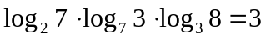

..................................................................................................................................
..................................................................................................................................
..................................................................................................................................
..................................................................................................................................
..................................................................................................................................
..................................................................................................................................
..................................................................................................................................
..................................................................................................................................
..................................................................................................................................
..................................................................................................................................
..................................................................................................................................
..................................................................................................................................
..................................................................................................................................
..................................................................................................................................
..................................................................................................................................
..................................................................................................................................
..................................................................................................................................
..................................................................................................................................
..................................................................................................................................
..................................................................................................................................
..................................................................................................................................
..................................................................................................................................
..................................................................................................................................
..................................................................................................................................
..................................................................................................................................
..................................................................................................................................
5. [Maximum mark: 6]
Solve the equation
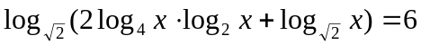
..................................................................................................................................
..................................................................................................................................
..................................................................................................................................
..................................................................................................................................
..................................................................................................................................
..................................................................................................................................
..................................................................................................................................
..................................................................................................................................
..................................................................................................................................
..................................................................................................................................
..................................................................................................................................
..................................................................................................................................
..................................................................................................................................
..................................................................................................................................
..................................................................................................................................
..................................................................................................................................
..................................................................................................................................
..................................................................................................................................
..................................................................................................................................
..................................................................................................................................
..................................................................................................................................
..................................................................................................................................
..................................................................................................................................
..................................................................................................................................
..................................................................................................................................
Turn over
6. [Maximum mark: 6]
(a) Show that [1]
(b) Hence solve the equation 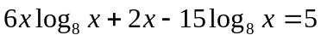 [5]
..................................................................................................................................
..................................................................................................................................
..................................................................................................................................
..................................................................................................................................
..................................................................................................................................
..................................................................................................................................
..................................................................................................................................
..................................................................................................................................
..................................................................................................................................
..................................................................................................................................
..................................................................................................................................
..................................................................................................................................
..................................................................................................................................
..................................................................................................................................
..................................................................................................................................
..................................................................................................................................
..................................................................................................................................
..................................................................................................................................
..................................................................................................................................
..................................................................................................................................
..................................................................................................................................
..................................................................................................................................
..................................................................................................................................
..................................................................................................................................
..................................................................................................................................
..................................................................................................................................
7. [Maximum mark: 7]
The cubic function 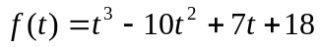 is divisible by 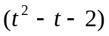.
(a) Find the three real roots of 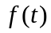. [4]
(b) Solve the exponential equation
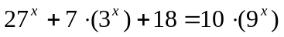 [3]

..................................................................................................................................
..................................................................................................................................
..................................................................................................................................
..................................................................................................................................
..................................................................................................................................
..................................................................................................................................
..................................................................................................................................
..................................................................................................................................
..................................................................................................................................
..................................................................................................................................
..................................................................................................................................
..................................................................................................................................
..................................................................................................................................
..................................................................................................................................
..................................................................................................................................
..................................................................................................................................
..................................................................................................................................
..................................................................................................................................
..................................................................................................................................
..................................................................................................................................
..................................................................................................................................
..................................................................................................................................
..................................................................................................................................
..................................................................................................................................

