WORKSHEET ON TRANFORMATIONS OF FUNCTIONS AA
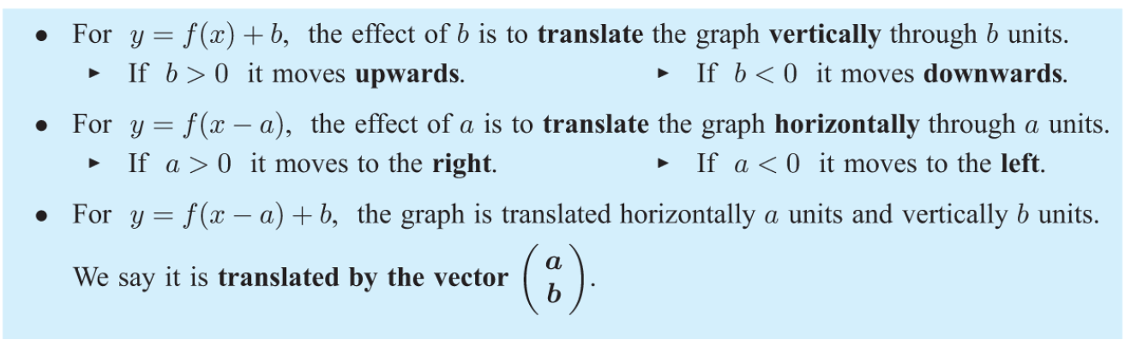
Questions ;
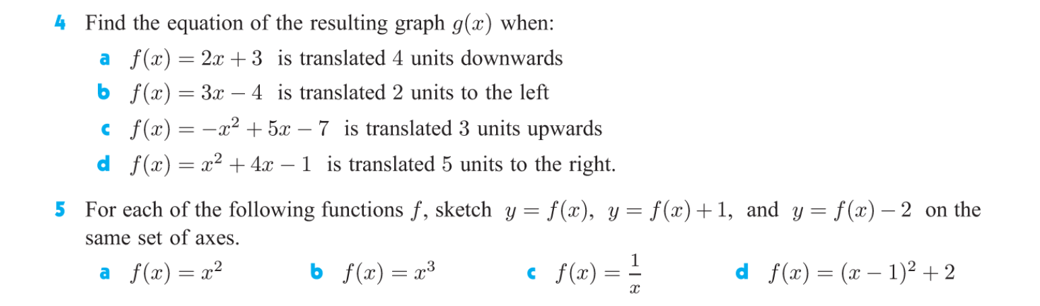
ANSWERS:
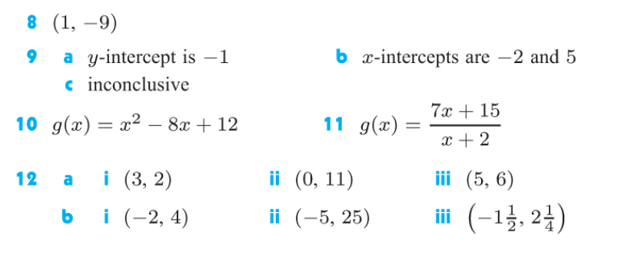
/DILATIONS
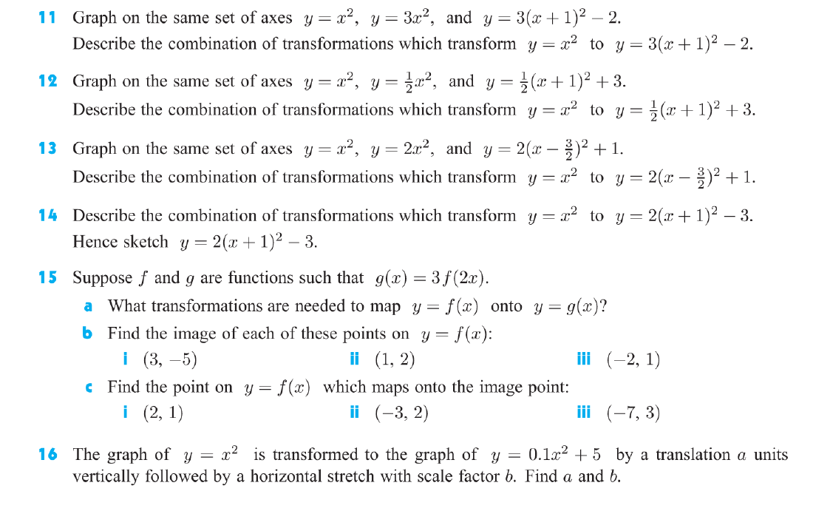
ANSWERS:
REFLECTIONS
ANSWERS
COMPOSITE TRANFORMATIONS:
ANSWERS:

