WORKSHEET SPECIAL RATIONAL FUNCTIONS AND ABSOLUTE VALUED FUNCTIONS
1.
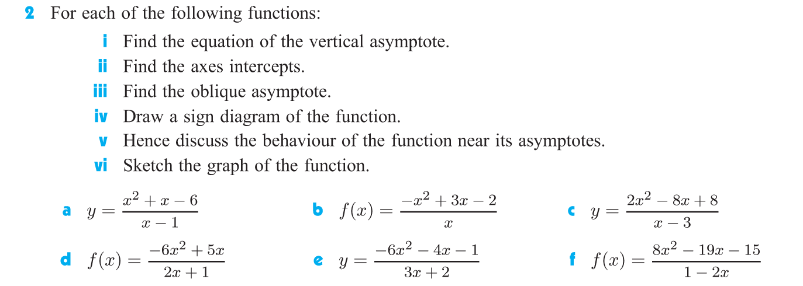
ANSWERS;

ANSWERS:

ANSWERS INEQUALITIES;

