WORKSHEET TRIGONOMETRY ANY TRIANGLE AASL
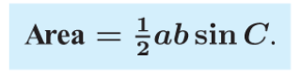
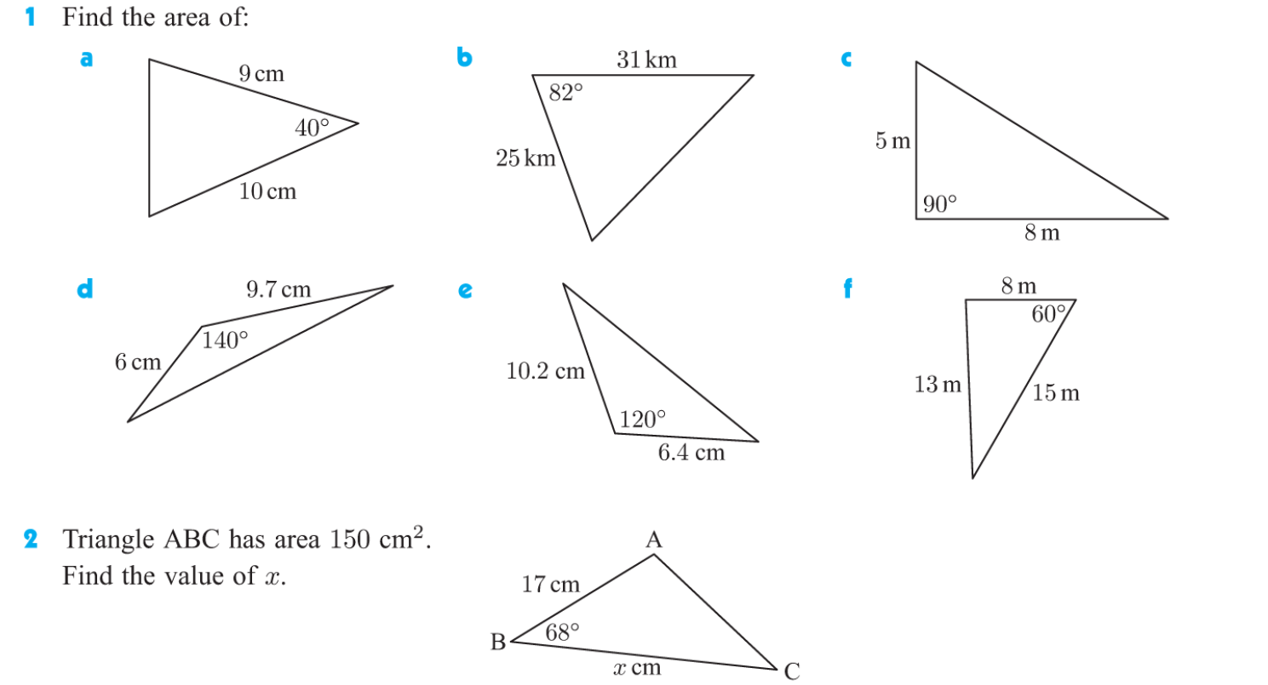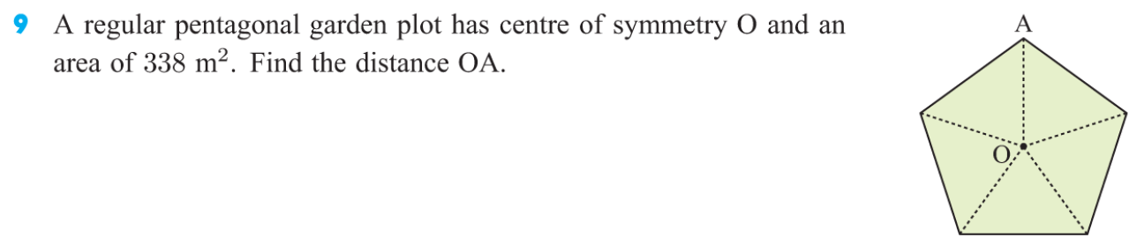

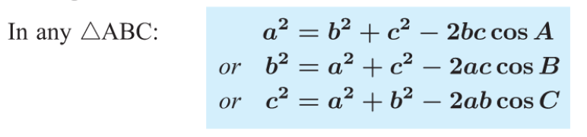
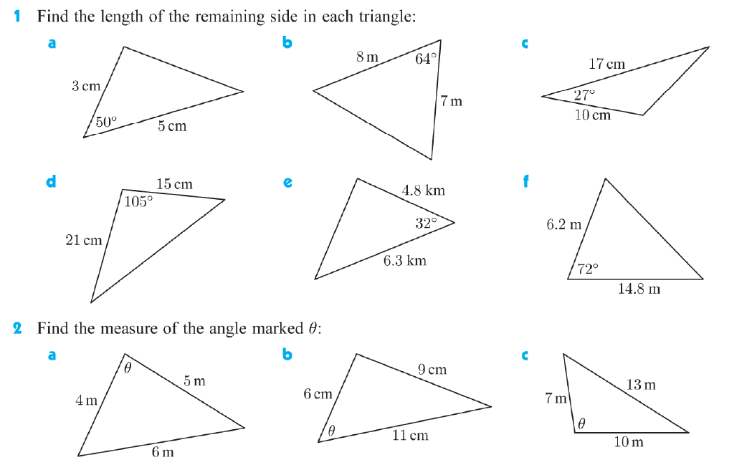
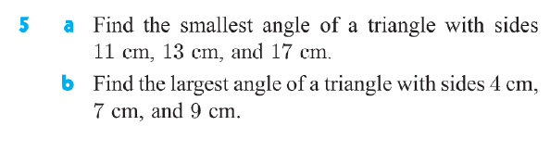
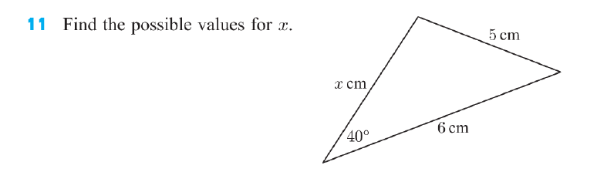

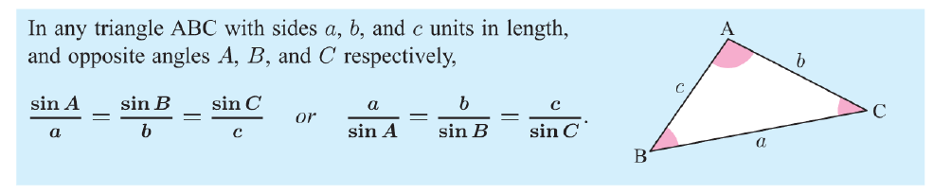
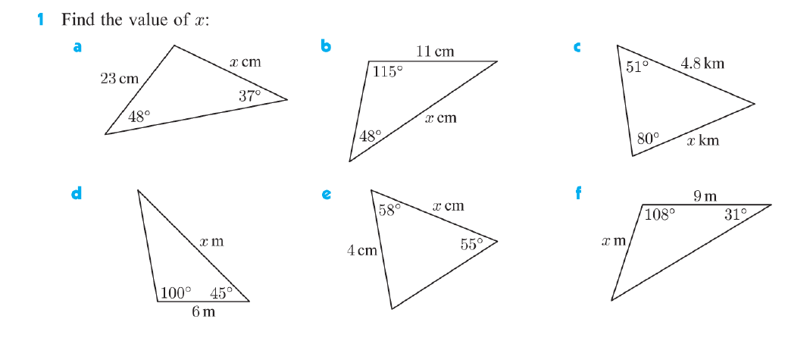

Informatio 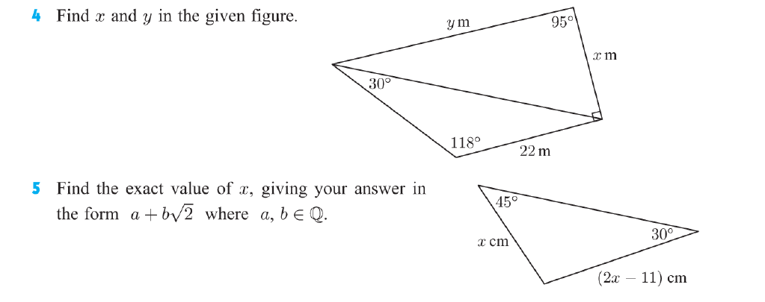
INFORMATION:
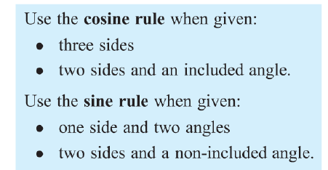
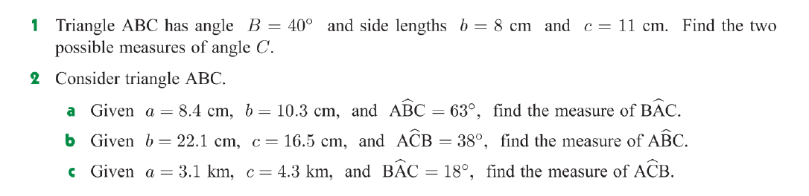
ANSWERS:
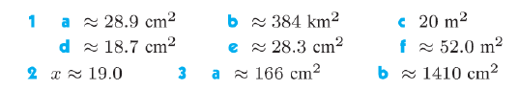
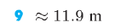
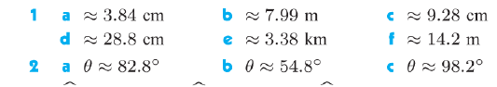
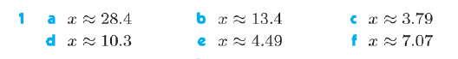
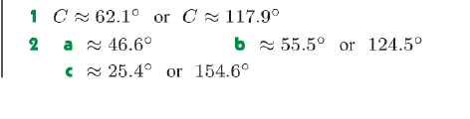
BEARINGS:
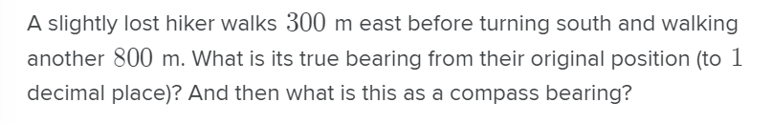

ANSWER:
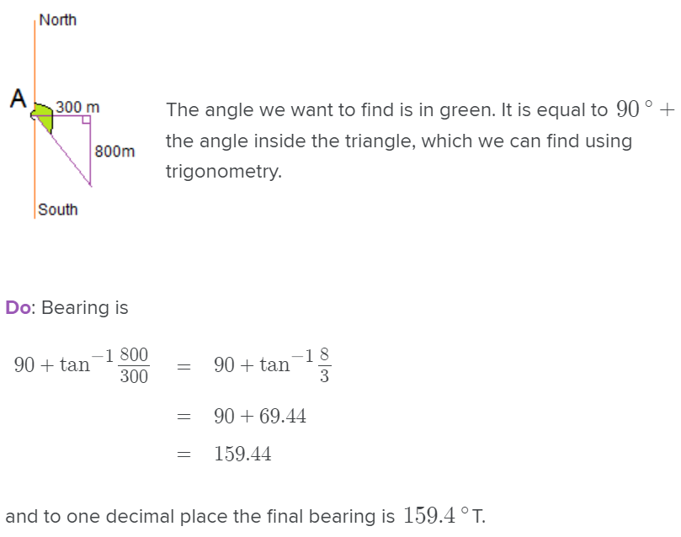
A ship leaves port A on a bearing of 030°. It sails a distance of 25 km to point B.
At B, the ship changes direction to a bearing of 100°. It sails a distance of 40 km to reach point C. This information is shown in the diagram below.
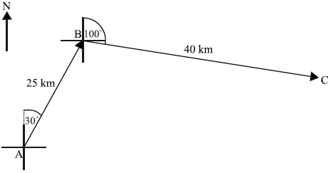
diagram not to scale
A second ship leaves port A and sails directly to C.
(a) Find the distance the second ship will travel.
(4)
(b) Find the bearing of the course taken by the second ship.
(3)
(Total 7 marks)

ANSWER:
(a) finding = 110° (= 1.92 radians) (A1)
evidence of choosing cosine rule (M1)
e.g. AC2 = AB2 + BC2 – 2(AB)(BC) cos
correct substitution A1
e.g. AC2 = 252 + 402 – 2(25)(40) cos 110°
AC = 53.9 (km) A1 N3
(b) METHOD 1
correct substitution into the sine rule A1
e.g.
= 44.2° A1
bearing = 074° A1 N1
METHOD 2
correct substitution into the cosine rule A1
e.g.
= 44.3° A1
bearing = 074° A1 N1
[7]

3,
The diagram shows a triangular region formed by a hedge [AB], a part of a river bank [AC] and a fence [BC]. The hedge is 17 m long and is 29°. The end of the fence, point C, can be positioned anywhere along the river bank.
(a) Given that point C is 15 m from A, find the length of the fence [BC].
(3)
(b) The farmer has another, longer fence. It is possible for him to enclose two different triangular regions with this fence. He places the fence so that is 85°.
(i) Find the distance from A to C.
(ii) Find the area of the region ABC with the fence in this position.
(5)
(c) To form the second region, he moves the fencing so that point C is closer to point A.
Find the new distance from A to C.
(4)
(d) Find the minimum length of fence [BC] needed to enclose a triangular region ABC.
(2)
(Total 14 marks)

Answer:
(a) for using cosine rule (M1)
(A1)
(A1) (N0) 3
Notes: Either the first or the second line may be implied, but not both. Award no marks if 8.24 is obtained by assuming a right (angled) triangle (BC = 17 sin 29).
(i)
for using sine rule (may be implied) (M1)
(A1)
(A1) (N2)
(ii) (A1)
(Accept) (A1) (N1) 5
(c) from previous triangle
Therefore alternative (A1)
(M1)(A1)
(A1) (N1) 4
(d)
Minimum length for BC when = 90°or diagram
showing right triangle (M1)
(A1) (N1) 2
[14]

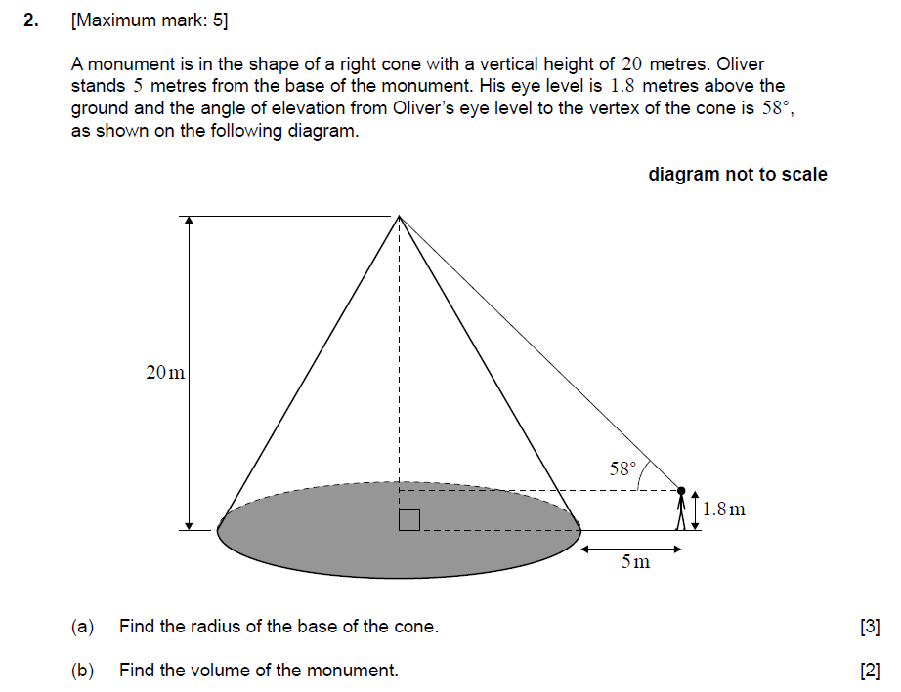
MS
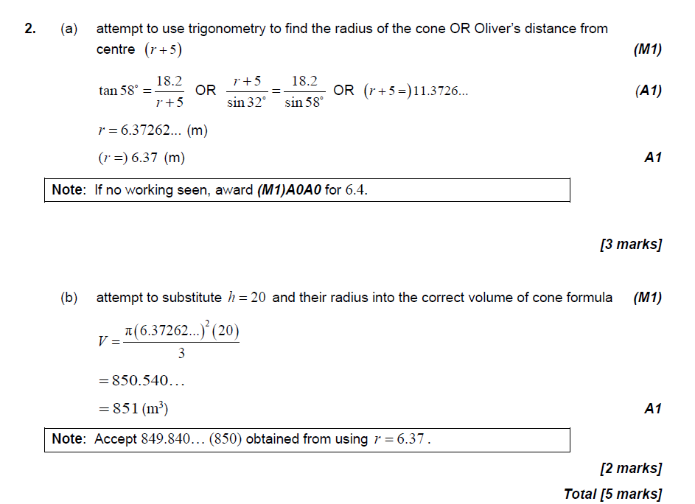
The points P, Q, R are three markers on level ground, joined by straight paths PQ, QR, PR as shown in the diagram. QR = 9 km, = 35°, = 25°.
Diagram not to scale
(a) Find the length PR.
(3)
(b) Tom sets out to walk from Q to P at a steady speed of 8 km h–1. At the same time, Alan sets out to jog from R to P at a steady speed of a km h–1. They reach P at the same time. Calculate the value of a.
(7)
(c) The point S is on [PQ], such that RS = 2QS, as shown in the diagram.
Find the length QS.
(6)
(Total 16 marks)

(a) Sine rule (M1)(A1)
PR =
= 5.96 km (A1) 3
(b) EITHER
Sine rule to find PQ
PQ = (M1)(A1)
= 4.39 km (A1)
OR
Cosine rule: PQ2 = 5.962 + 92 – (2)(5.96)(9) cos 25 (M1)(A1)
= 19.29
PQ = 4.39 km (A1)
Time for Tom = (A1)
Time for Alan = (A1)
Then = (M1)
a = 10.9 (A1) 7
(c) RS2 = 4QS2 (A1)
4QS2 = QS2 + 81 – 18 × QS × cos 35 (M1)(A1)
3QS2 + 14.74QS – 81 = 0 (or 3x2 + 14.74x – 81 = 0) (A1)
⇒ QS = –8.20 or QS = 3.29 (G1)
therefore QS = 3.29 (A1)
OR
(M1)
⇒ sin sin 35 (A1)
= 16.7° (A1)
Therefore, = 180 – (35 + 16.7)
= 128.3° (A1)
(M1)
QS =
= 3.29 (A1) 6
There is a vertical tower TA of height 36 m at the base A of a hill. A straight path goes up the hill from A to a point U. This information is represented by the following diagram.
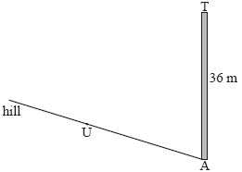
The path makes a 4° angle with the horizontal.
The point U on the path is 25 m away from the base of the tower.
The top of the tower is fixed to U by a wire of length x m.
(a) Complete the diagram, showing clearly all the information above.
(3)
(b) Find x.
(4)
(Total 7 marks)

(a)
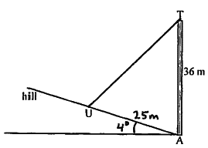 A1A1A1 N3 3
Note: Award A1 for labelling 4° with horizontal, A1 for labelling [AU] 25 metres, A1 for drawing [TU].
(b) TÂU = 86º (A1)
evidence of choosing cosine rule (M1)
correct substitution A1
e.g. x2 = 252 + 362 – 2(25)(36) cos 86º
x = 42.4 A1 N3 4
[7]

The graph of the function f (x) = 3x – 4 intersects the x-axis at A and the y-axis at B.
(a) Find the coordinates of
(i) A;
(ii) B.
(b) Let O denote the origin. Find the area of triangle OAB.

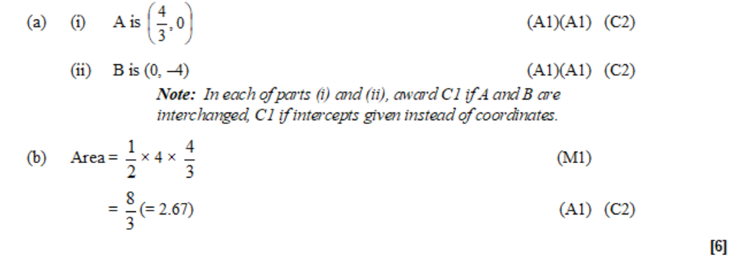
Two boats A and B start moving from the same point P. Boat A moves in a straight line at 20 km h–1 and boat B moves in a straight line at 32 km h–1. The angle between their paths is 70°.
Find the distance between the boats after 2.5 hours.

(M1)(A2)
OR
2.5 × 20 = 50 (M1)(A1)
2.5 × 32 = 80 (A1)
d2 = 502 + 802 – 2 × 50 × 80 × cos 70° (M1)(A1)
d = 78.5 km (A1) (C6)
[6]

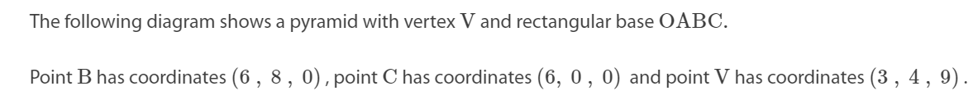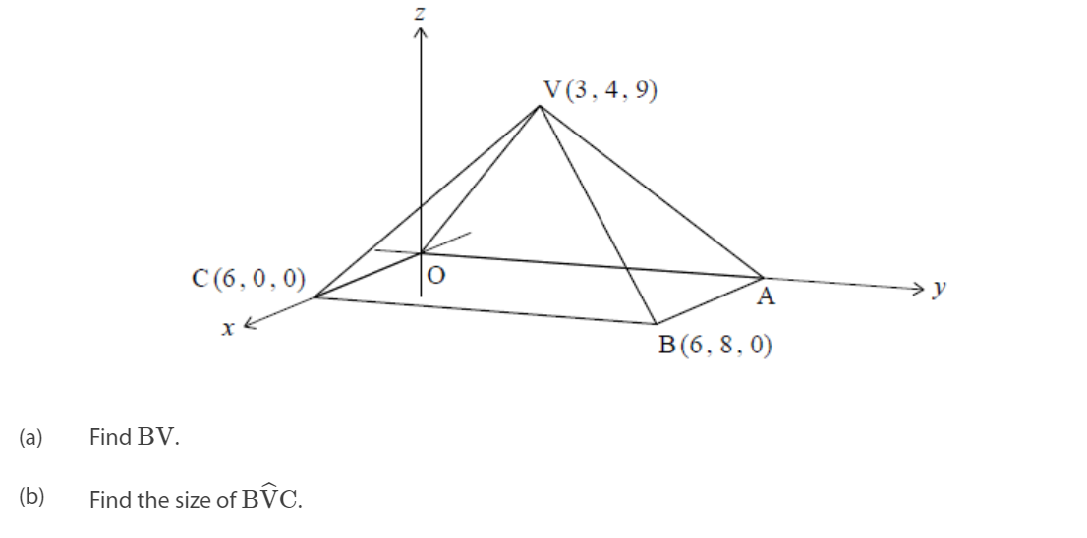

MS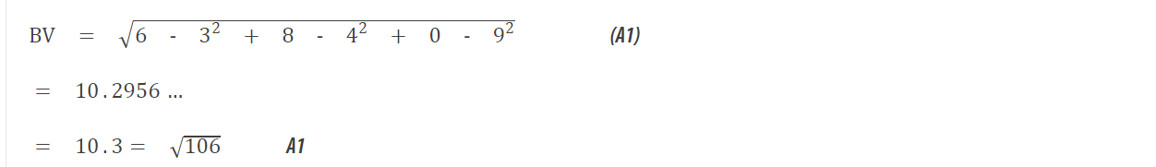 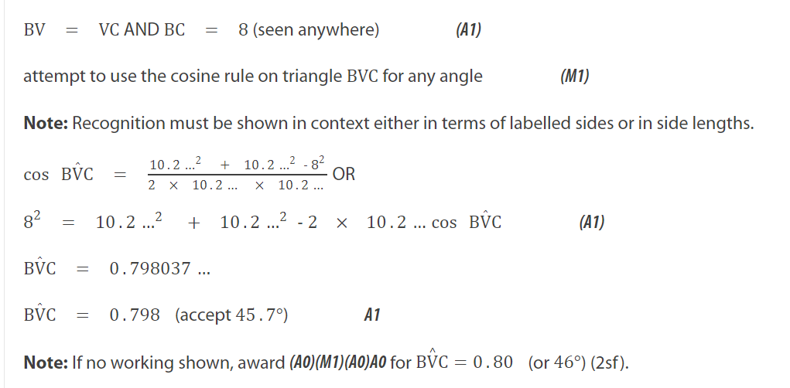
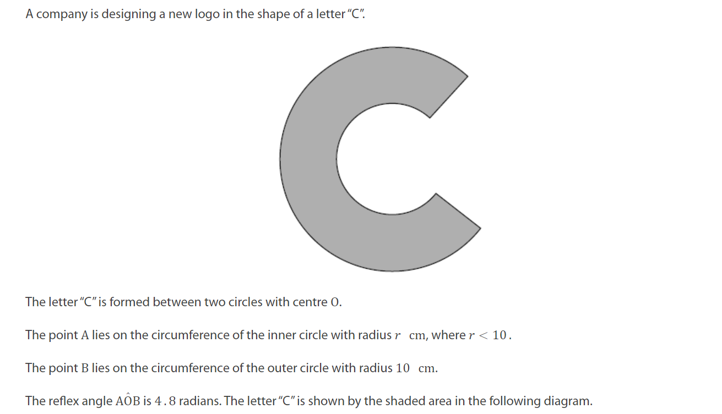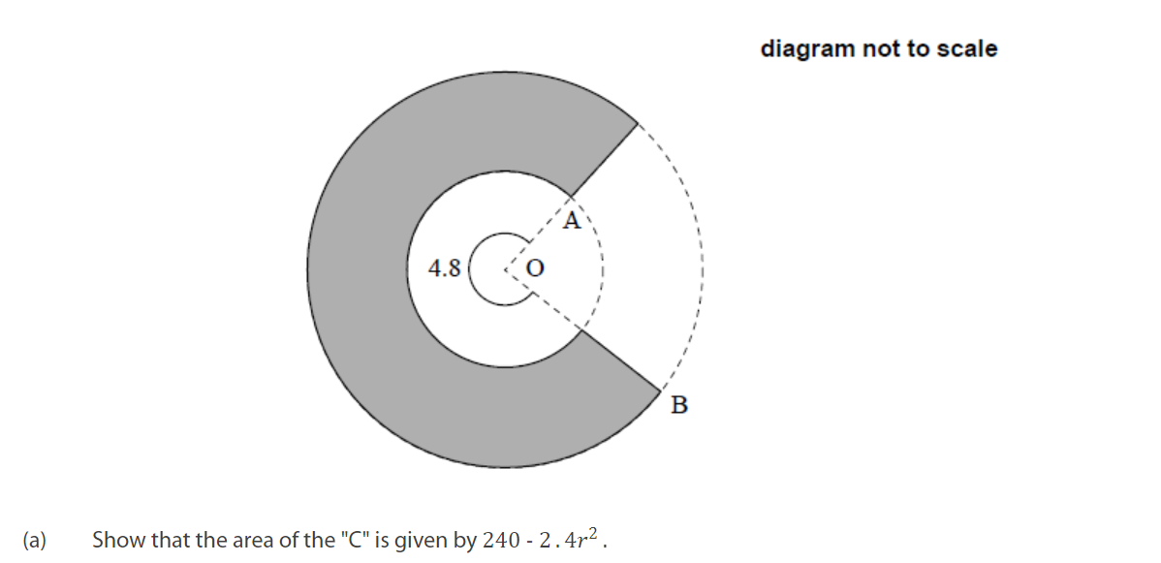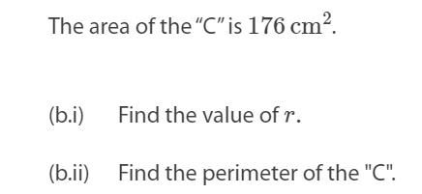
MS
