REMAINDER , FACTOR AND FUNDEMENTAL THM OF ALGEBRA
WORKSHEET HL AA
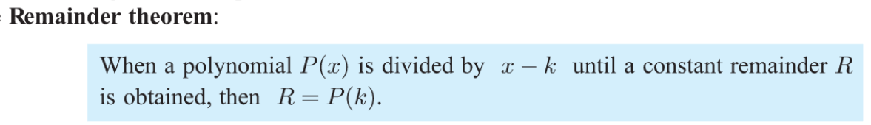
FACTOR THM.
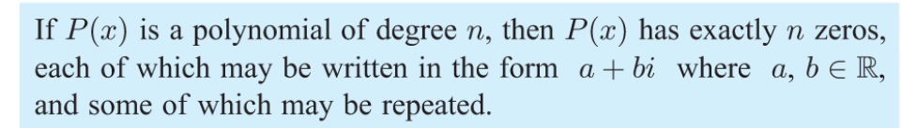
1.
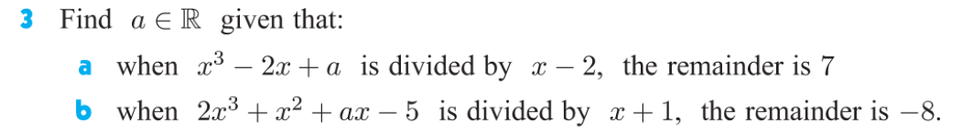
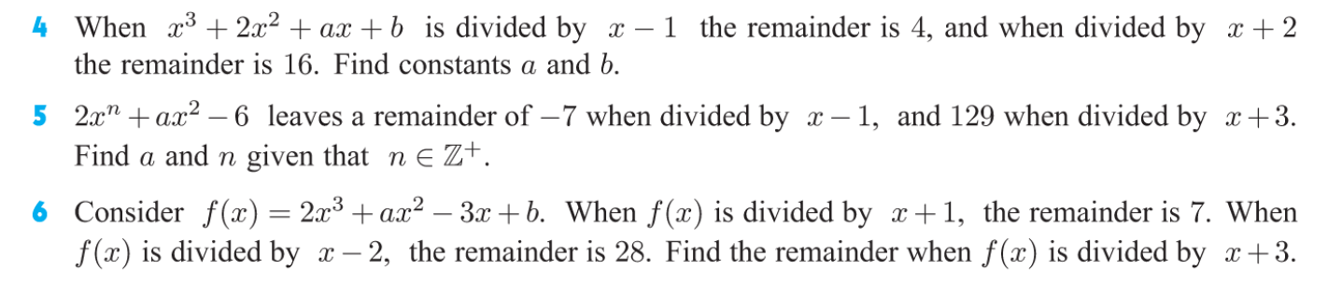
Answers:
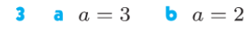
2.
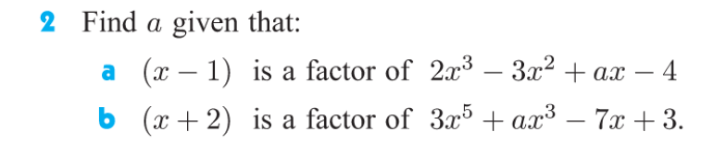
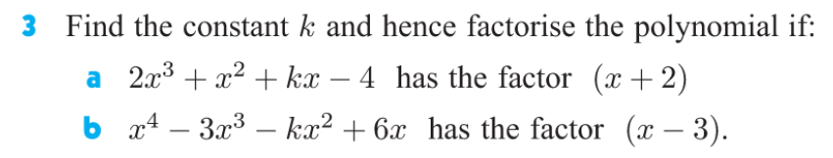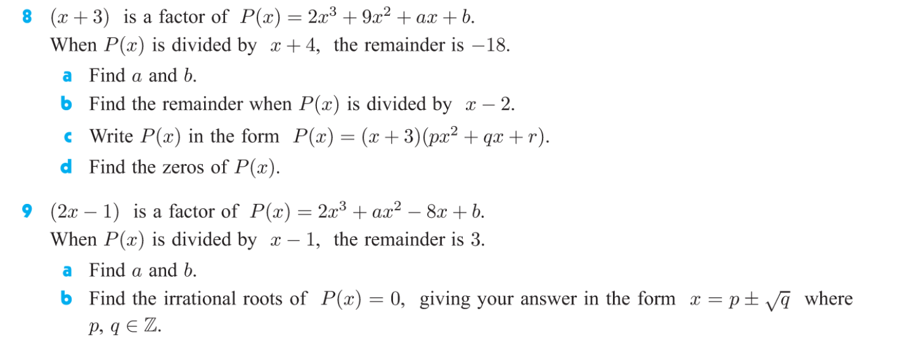
ANSWERS,
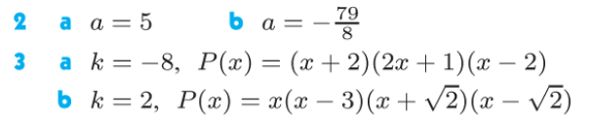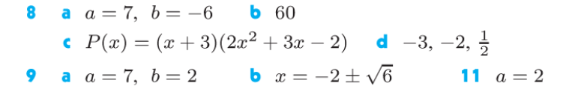
FTA:
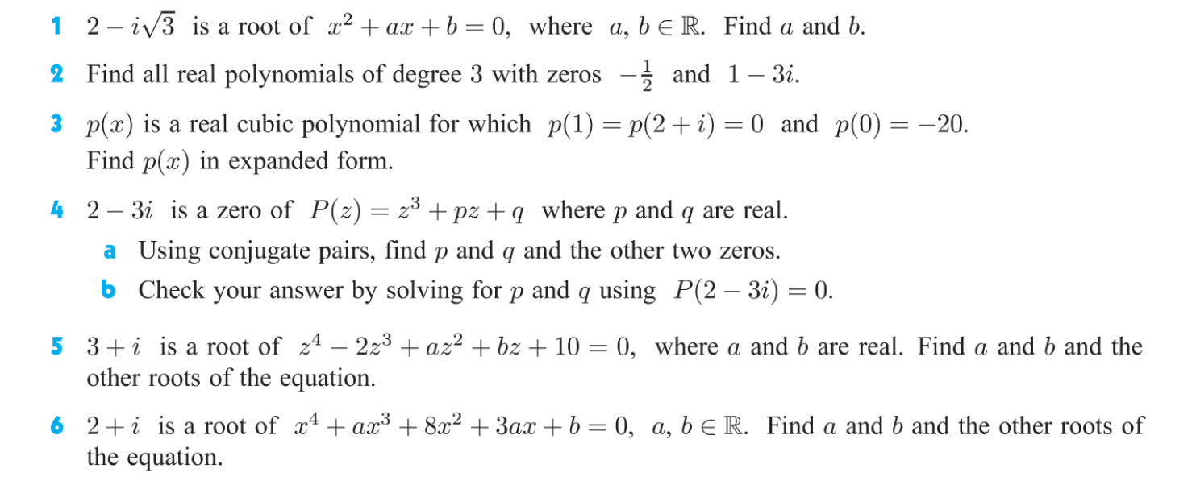
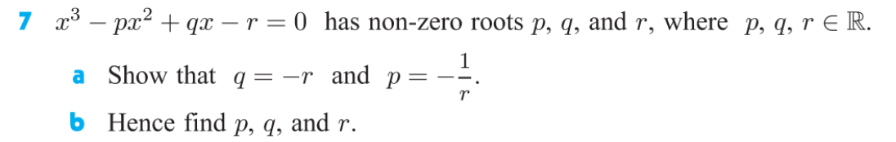
ANSWERS:
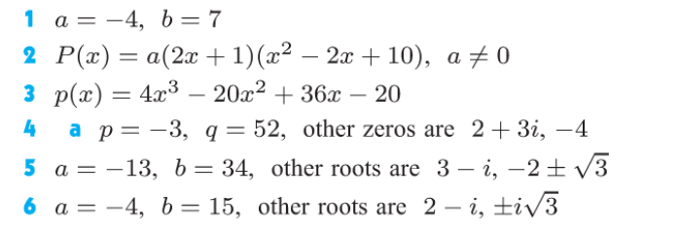
7; p=q=1 &r = -1

