**UNIVERSITY COLLEGE OF ENGINEERING TINDIVANAM**

(A Constituent College of Anna University)



**Electronics and Communication Engineering**

**NAAN MUDHALVAN**

**DIGITAL MARKETING**

**ASSIGNMENT**

**NAME:** MOHAMED AMEENUL ASLAM.H

**NM ID:** **E85DF6C27746FA4BAA94436782635262**

**USER NAME:** au422420106019

**1.Create a blog or website using Blogspot and Customize the theme design and post new article with 500 words.**

**LINK:** https://azlmzcrftz2k23.blogspot.com/2023/10/a-journey-with-azlams-craftz.html

**SCREENSHOTS:**

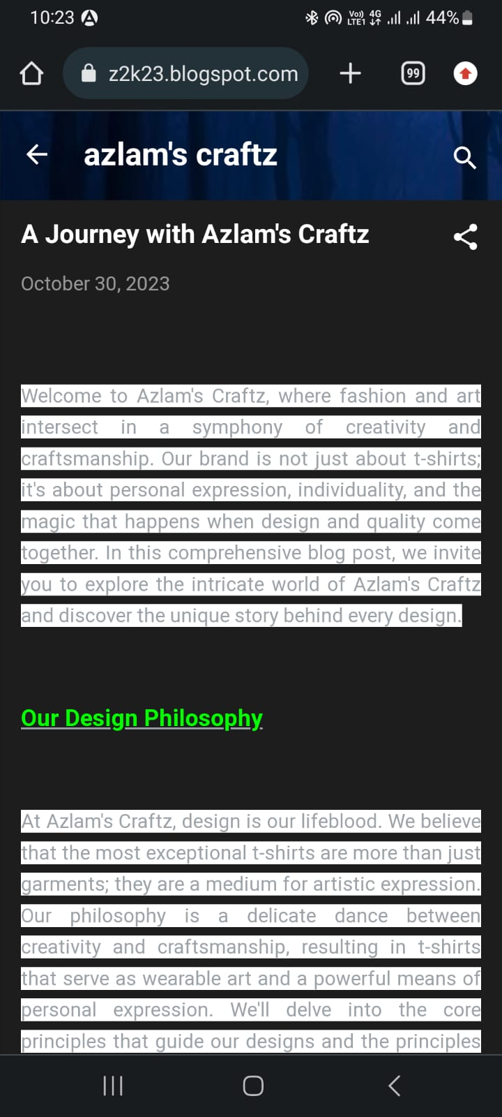

1. **Create a New Facebook Business Page and post one social media poster for your brand.**

**LINK:** https://www.facebook.com/profile.php?id=61553056525756&sk=map

**SCREENSHOT:**

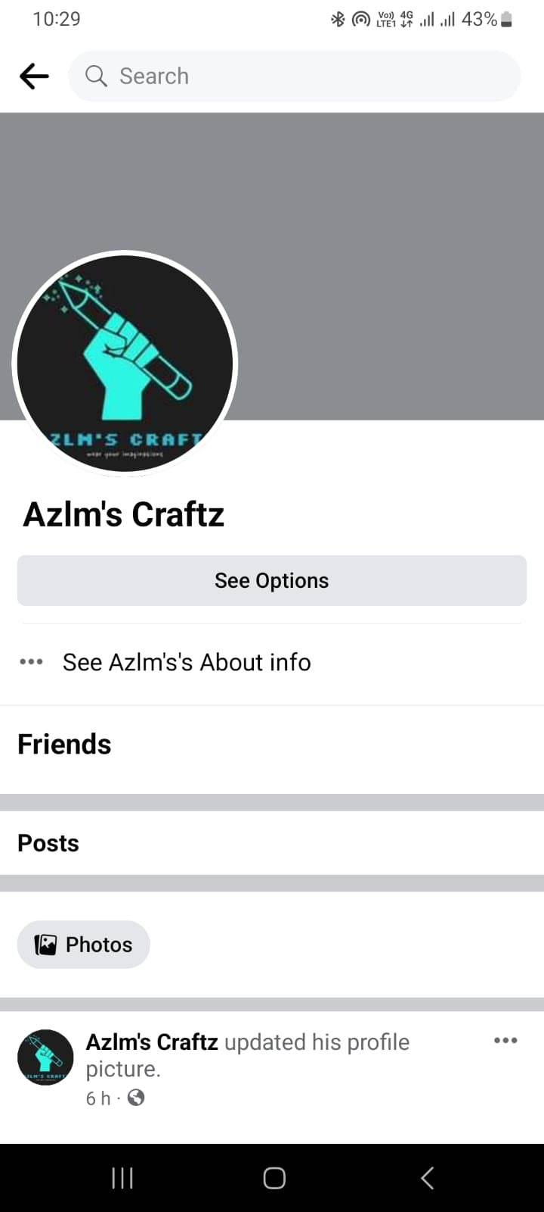

1. **Create and design a social media advertisement poster using Canva.**



**Create Email Newsletter design using Canva tool.**

