UNIVERSITY COLLEGE OF ENGINEERING TINDIVANAM

(A Constituent College of Anna University)

Electronics and Communication Engineering NAAN MUDHALVAN

DIGITAL MARKETING ASSIGNMENT

**NAME:** K.ANNAMALAI

**NM ID: 43FDD9AF6717048B47C494A21D587987**

**BRAND NAME:** ANNA MOBILES AND SERVICES

**USER NAME:** au422420106001

**1.Create a blog or website using Blogspot and Customize the theme design and post new article with 500 words.**

**LINK:** [**https://annamobiles.blogspot.com/?m**](https://annamobiles.blogspot.com/?m)

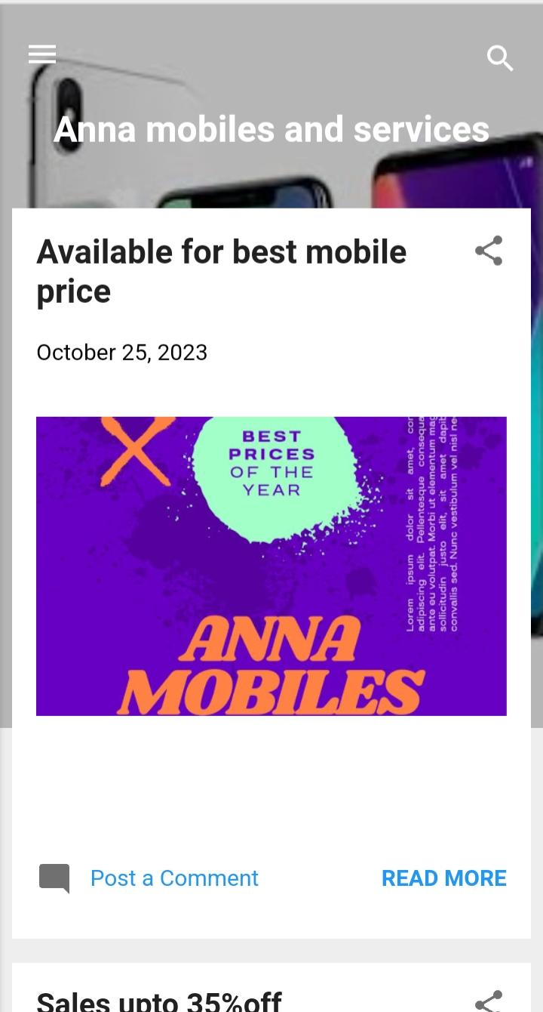**SCREENSHOT**

2.Create a New Facebook Business Page and post one social media poster for your brand.

**LINK:**  <https://www.facebook.com/profile.php?id=61552769579943&mibextid=ZbWKwL>

**SCREENSHOT:**

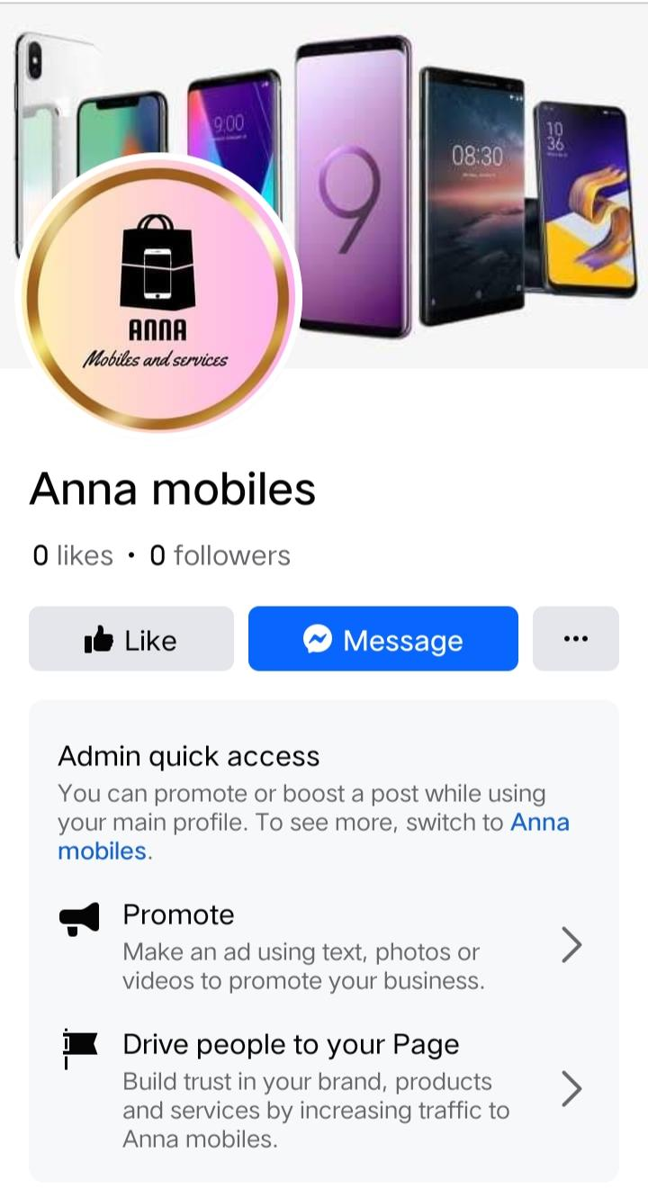

**3.Create and design a social media advertisement poster using Canva.**

**SCREENSHOTS:**

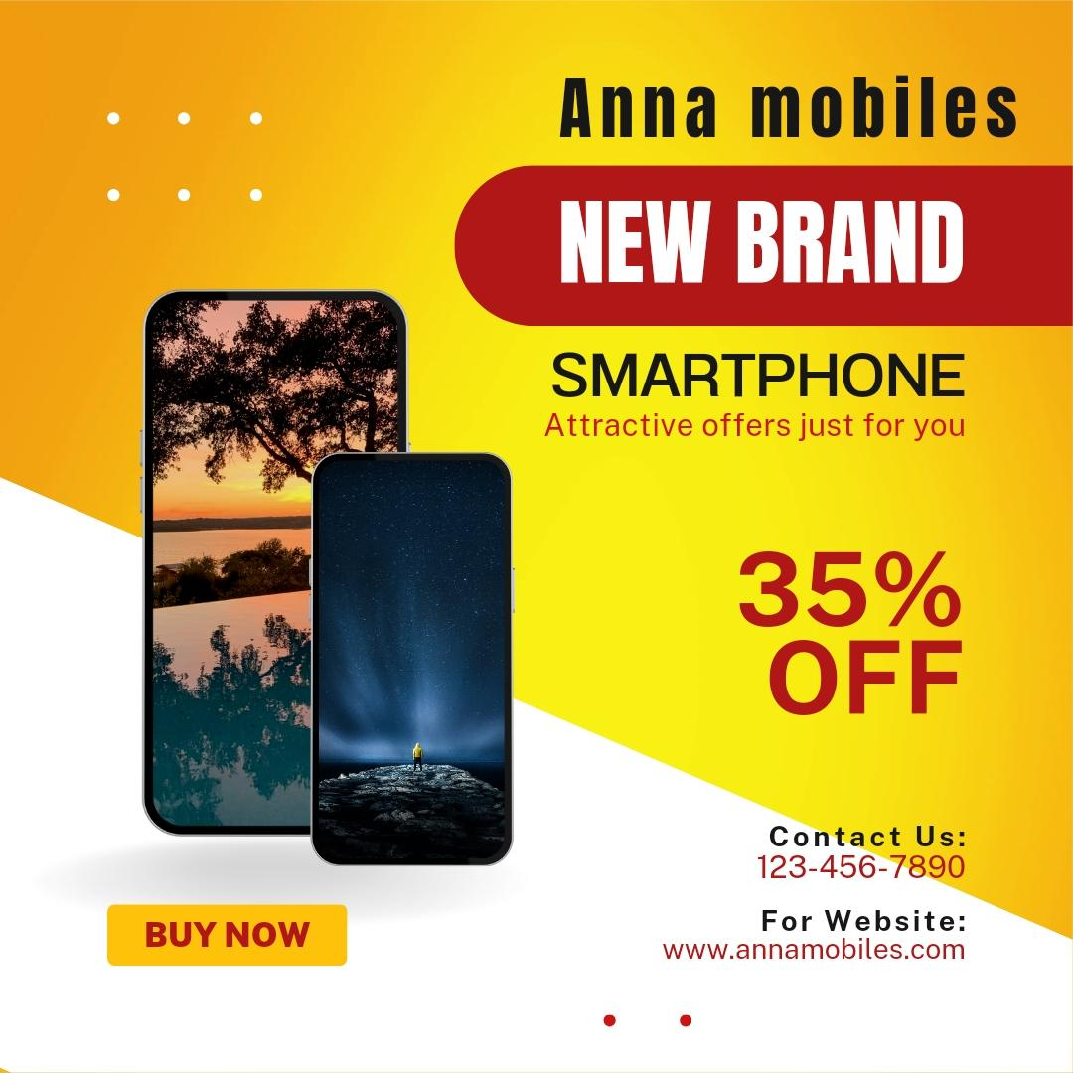

4.Create Email Newsletter design using Canva tool.

**SCREENSHOTS:**

