**UNIVERSITY COLLEGE OF ENGINEERING TINDIVANAM**

(A Constituent College of Anna University)



**Electronics and Communication Engineering**

**NAAN MUDHALVAN**

**DIGITAL MARKETING**

**ASSIGNMENT**

**NAME:** MAHAVEER.S

**NM ID: E16EC6B42F12730A66E48B511CCF9C95**

**USER NAME:** au422420106301

**1.Create a blog or website using Blogspot and Customize the theme design and post new article with 500 words.**

**LINK:** https://mahaveerphotostudio.blogspot.com/?m=1

**SCREENSHOTS:**

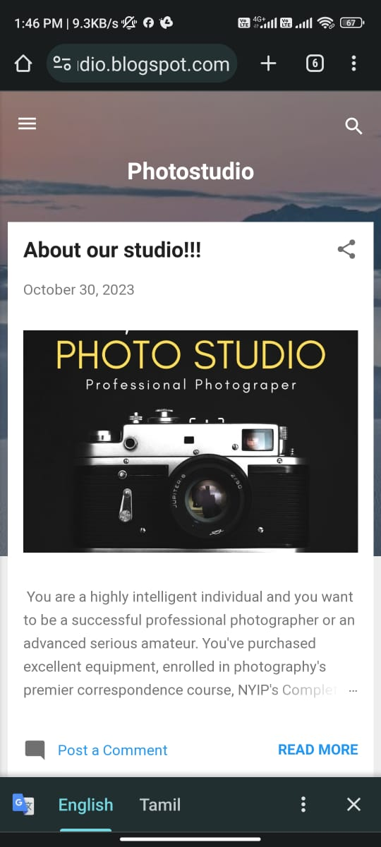

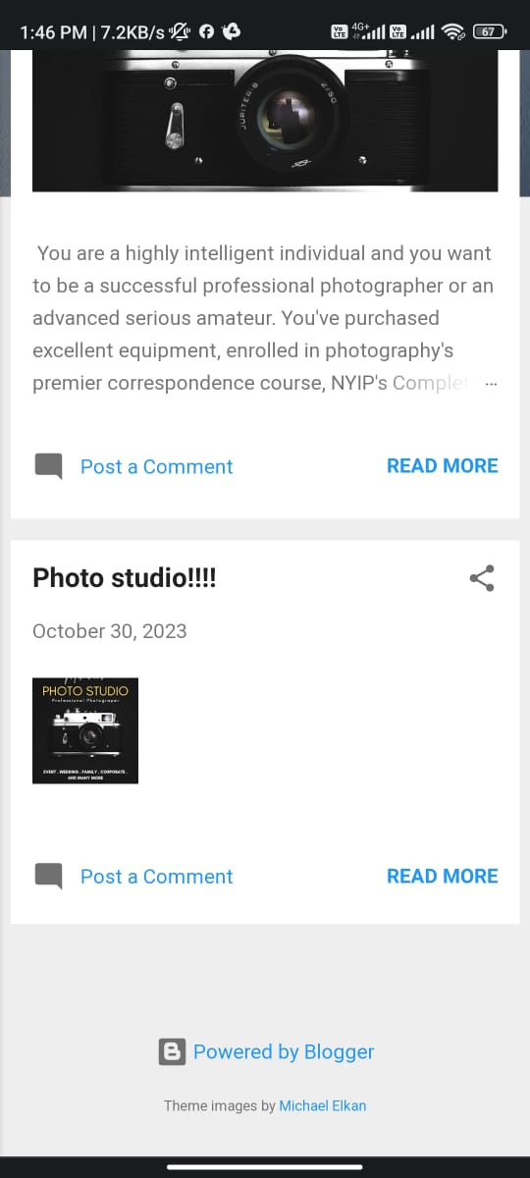

1. **Create a New Facebook Business Page and post one social media poster for your brand.**

**LINK:** https://www.facebook.com/profile.php?id=61553062705157&mibextid=ZbWKwL

**SCREENSHOT:**

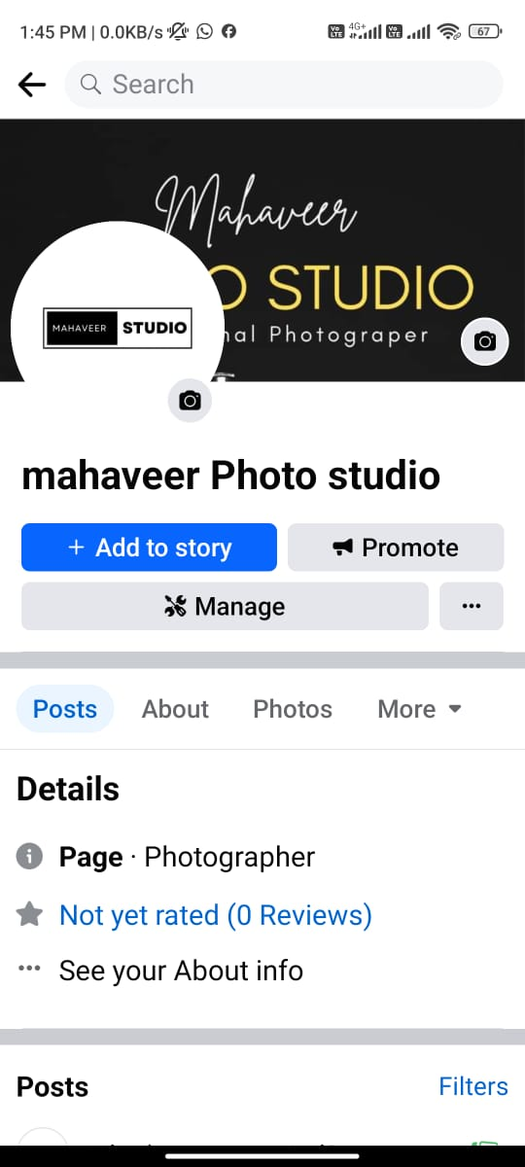

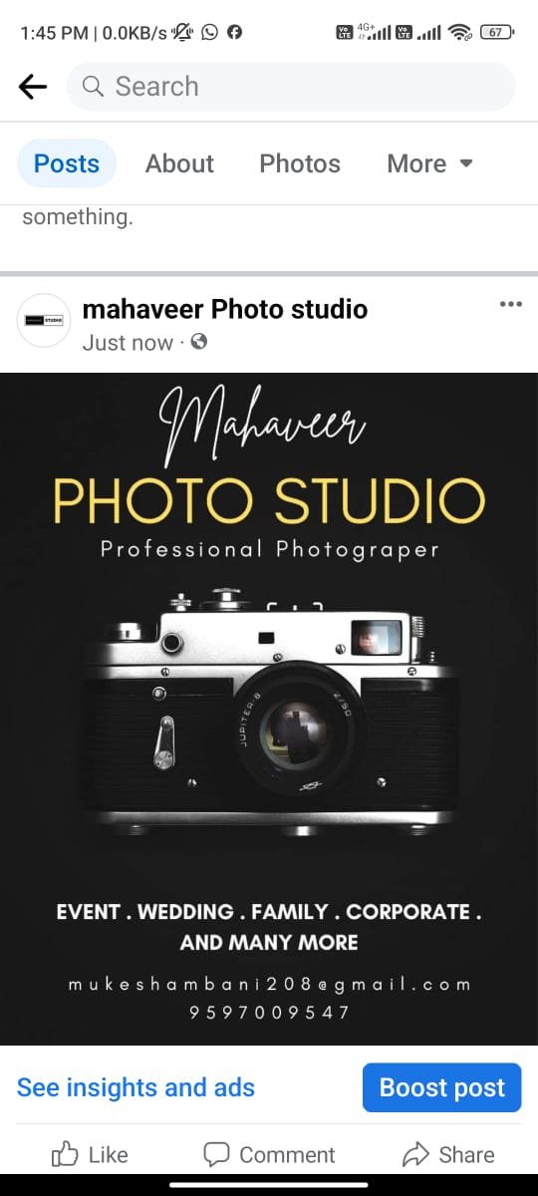

1. **Create and design a social media advertisement poster using Canva.**



**Create Email Newsletter design using Canva tool.**

