AVOID FIRE ACCIDENTS IN EV VEHICLE WITH MULTI FAULT DETECTION USING AI AND IOT

A PROJECT REPORT

Submitted by
BOOMIKA P 613521105007
KAVINAYA P 613521105020
SUVITHA M 613521105045
In partial fulfillment for the award of the degree
of
BACHELOR OF ENGINEERING
In
ELECTRICAL AND ELECTRONICS ENGINEERING
GOVERNMENT COLLEGE OF ENGINEERING
DHARMAPURI-636704



ANNA UNIVERSITY :: CHENNAI 600 025
MAY 2025

AVOID FIRE ACCIDENTS IN EV VEHICLE WITH MULTI FAULT DETECTION USING AI AND IOT

A PROJECT REPORT

Submitted by
BOOMIKA P 613521105007
KAVINAYA P 613521105004
SUVITHA M 613521105017
In partial fulfillment for the award of the degree
of
BACHELOR OF ENGINEERING
In
ELECTRICAL AND ELECTRONICS ENGINEERING
GOVERNMENT COLLEGE OF ENGINEERING
DHARMAPURI-636704

ANNA UNIVERSITY :: CHENNAI 600 025
MAY 2025

BONAFIDE CERTIFICATE
Certified that this project report “AVOID FIRE ACCIDENTS IN EV VEHICLE WITH MULTI FAULT DETECTION USING AI AND IOT” is the bonafide work of “BOOMIKA P (613521105007), KAVINAYA P (613521105020), SUVITHA M (613521105045) ” who carried out the project work under my supervision.

SIGNATURE SIGNATURE
Dr.S SENTHILKUMAR Mr.S NIRMALKUMAR

HEAD OF THE DEPARTMENT SUPERVISOR
Professor (CAS) , Assisstant professor,
Electrical and Electronics Engineering, Electrical and Electronics Engineering,
Government college of Engineering, Government college of Engineering ,
Dharmapuri-636704. Dharmapuri-636704.

Submitted for the University Examination held at Government College of Engineering, Dharmapuri on ……………………

INTERNAL EXAMINER EXTERNAL EXAMINER

DECLARATION

We affirm that the project work titled "AVOID FIRE ACCIDENTS IN EV VEHICLE WITH MULTI FAULT DETECTION USING AI AND IOT" being submitted in partial fulfillment for the award of BACHELOR OF ENGINEERING is the original work carried out by us. It has not been part of any other project work submitted for an award of degree either in this or any other university
Signature of the candidates

BOOMIKA P KAVINAYA P
613521105007 613521105020

SUVITHA M
613521105045

I Certify that the declaration made above by the candidates is true .

Mr. S NIRMALKUMAR,
Assistant professor,
Electrical and Electronics Engineering
Government college of Engineering ,
Dharmapuri-636704
i

ACKNOWLEDGEMENT

We wish to convey our sincere thanks and gratitude to our beloved Principal Dr.V.SUMATHY, M.E,Ph.D., for providing us the great opportunity with all facilities required for success of our project work.

We wish our sincere thanks to the Head of the Department of Electrical and Electronics Engineering, Dr.S.SENTHILKUMAR, M.E,Ph.D., who with his careful supervision has ensured us in attaining perfect work.

We extended sincere thanks to our project guide Assistant professor Mr.S.NIRMALKUMAR , M.E., for his valuable suggestion,motivation and constant encouragement.

At the outset we express our profound thanks to our esteemed Faculty Members and technical staff for their support by providing us with essential facilities.

We are really indebted to our parents, faculty members and friends for their timely help, morally with the blessings of the almighty, we will continue to feel the success.

ii
ABSTRACT

Battery storage forms the most important part of any electric vehicle (EV) as it stores the necessary energy for the operation of EV. So, in order to extract the maximum o/p of a battery & to ensure its Power transfer it is necessary that a efficient battery management system exist is the same. It monitors the Parameters, determine Hardware and software and provide necessary services to ensure safe operation of battery. The proposed system only monitor the battery and Power transfer but also protect it to avoid accidents from occurring. In the focus is on leveraging On-board Diagnostics (OBD) technology, which is a self-diagnostic system in vehicles, to enhance the monitoring and reporting of Electric Vehicle (EV) battery conditions. The primary goal is to detect and analyze the state of EV batteries and provide real-time alerts to vehicle users via their mobile phones. To achieve this, the project proposes the implementation of Deep learning-based data analysis techniques for predicting battery conditions. This involves collecting data from the vehicle's OBD system, such as voltage levels, temperature, charging cycles, etc., and using Deep learning algorithms to analyze this data and predict the current and future health status of the EV battery. The aims to introduce a new design for battery monitoring during charging. This could involve the development of specialized hardware or software solutions that enhance the monitoring capabilities of the EV battery during the charging process, ensuring optimal charging conditions and prolonging battery life.

iii

TABLE OF CONTENTS
CHAPTER NO. TITLE PAGE N0
 |  | DECLARATION | i
 |  | ACKNOWLEDGEMENT | ii
 |  | ABSTRACT | iii
 |  | LIST OF FIGURES | vii
 |  | LIST OF ABBREVIATIONS | ix
1 |  | INTRODUCTION | 1
 |  | 1.1 OVERVIEW | 1
 |  | 1.2 PROBLEM DEFINITON | 2
2 |  | LITERATURE SURVEY | 3
 |  | 2.1 LITERATURE REVIEW | 4
 |  | 2.2 EXISTING SYSTEM  2.3 PROPOSED SYSTEM2.  iv  2.4 OBJECTIVE | 8  8  9
3 |  | HARDWARE DETAILS | 10
 |  | 3.1 .SOLAR CELL | 10
 |  | 3.2.LDR | 16
 |  | 3.3 IC 7805 | 19
 |  | 3.4 BATTERY | 20
 |  | 3.5 PASSIVE DEVICES | 22
 |  | 3.5.1 RESISTOR | 22
 |  | 3.5.2 CAPACITOR | 23
 |  | 3.6 ACTIVE DEVICES | 24
 |  | 3.7.1 DIODE | 24
 |  | 3.7.2 TRANSISTOR | 26
 |  | 3.8 LED | 27
 |  | 3.9 RELAY | 28
 |  | 3.10 DC GEAR MOTOR | 30
 |  | 3.11 IR SENSOR MODULE | 31
 |  | v
 |  | 3.12 MICROCONTROLLER | 32
4 |  | BLOCK DIAGRAM AND CIRCUIT DIAGRAM | 43
 |  | 4.1 BLOCK DIAGRAM | 43
 |  | 4.2 SYSTEM OPERATION | 44
 |  | 4.3 CIRCUIT DIAGRAM | 45
5 |  | SOFTWARE DETAILS | 47
 |  | 5..1.EMBEDDED ‘C’ | 47
 |  | 5.2 KEIL | 51
5 |  | CONCLUSION | 52
 |  | REFERENCES | 53
 |  | APPENDIX | 54
 |  | A.SOURCE CODING | 54

vi
LIST OF FIGURES

FIGURE NO. TITLES PAGE NO

3.1 BLOCK DIAGRAM OF THE SYSTEM 8
3.2 CIRCUIT DIAGRAM OF EV SYSTEM 9
3.3 HEAD LAMP MOTION SYSTEM 10
4.1 ARCHITECTURE OF MICROCONTROLLER 14
4.2 NUVOTON/52 PIN CONFIGURATIONS 15
4.3 BASIC CIRCUIT CONNECTIONS 16
4.4 SCHEMATIC OF LDR AND SYMBOL 20
4.5 LDR OPERATION 21
4.6 CONSTRUCTION OF LDR 22
4.7 SCHEMATIC OF SOLAR CELL (PANEL) 24
4.8 CONSTRUCTION OF SOLAR CELL (PANEL) 26
4.9 INTERNAL SECTION OF SOLAR CELL (PANEL 28
4.10 GENERATION OF PHOTON (PANEL) 29
4.11 PIN DETAILS OF IC 7805 30
4.12 SCHEMATIC DIAGRAM OF LEAD ACID
BATTERY 31

vii

4.13 SCHEMATIC DIAGRAM OF RESISTOR 32
4.14 SCHEMATIC DIAGRAM OF CAPACITOR 33
4.15 SCHEMATIC DIAGRAM OF DIODE 34
4.16 SCHEMATIC DIAGRAM OF TRANSISTOR 36
4.17 LED SYMBOL AND CONSTRUCTION 37
4.18 SCHEMATIC OF RELAY 38
4.19 SYMBOL OF RELAY 39
4.20 SCHEMATIC DIAGRAM OF DC MOTOR 41
4.21 IR SENSOR MODULE 42

viii

LIST OF ABBREVIATIONS

AI ARTIFICIAL INTELLIGENCE
ANN A NEURON NETWORK
BESS BATTERY ENERGY STORAGE SYSTEM
CPU CENTRAL PROCESSING UNIT
DC DIRECT CURRENT
DIP DUAL IN-LINE PACKAGE
LDR LIGHT DEPENDENT RESISTOR
LED LIGHT EMITTING DIODE
IP INTERNET PROTOCOL
IR INFRA RED
ISMC INTEGRAL SLIDING MODE CONTROL
MPPT MAXIMUM POWER POINT TRACKING
PV PHOTOVOLTAIC
PSO PARTICLE SWARM OPTIMIZATION
RAM RANDOM ACCESS MEMORY
RSM RESPONSE SURFACE METHODOLOGY
UART UNIVERSAL ASYNCHRONOUS RECEIVER &
TRANSMITTER

Ix

TITLE

ABSTRACT

CHAPTER 1 INTRODUCTION
  - INTRODUCTION
The growing adoption of electric vehicles (EVs) has accelerated the need for efficient and reliable battery management systems to ensure optimal performance, longevity, and safety. Lithium-ion (Li-ion) batteries, the most widely used energy storage solution in EVs, require continuous monitoring to prevent overheating, overcharging, and capacity degradation. An IoT-based battery monitoring system offers real-time data collection and analysis, enabling proactive maintenance and enhancing the overall efficiency of EVs. This paper presents the design and implementation of a smart battery monitoring system that leverages IoT technology to track key battery parameters, including voltage, current, temperature, and state of charge (SoC). By integrating sensors, cloud computing, and wireless communication, the system provides remote access to battery health metrics, predictive maintenance alerts, and fault detection mechanisms. Such an intelligent monitoring approach not only ensures the safety and reliability of EVs but also contributes to optimizing battery lifespan and energy efficiency.
Electric vehicle (EV) charging infrastructure planning is crucial for ensuring the widespread adoption and efficient operation of EVs. Various factors, including charging demand, grid constraints, and traffic flow, influence the optimal placement and configuration of charging stations. Several studies have explored different strategies and methodologies to address these challenges effectively. Optimal planning of charging stations involves designing charging spots with multiple cables to maximize utilization and minimize waiting time for users. By implementing a single output with multiple cables, stations can dynamically allocate power to different vehicles based on demand, improving charging efficiency and station throughput [1]. This approach ensures that more vehicles can be serviced simultaneously without requiring additional physical infrastructure. The placement of EV charging stations is a complex problem that involves multiple considerations, such as geographical distribution, power availability, and user convenience. A structured formulation of the problem helps identify the best locations while considering practical constraints like land use policies, grid capacity, and projected demand. The complexity of this problem necessitates the use of optimization algorithms to derive feasible and cost-effective solutions [2].
Integrating charging stations into distribution networks requires careful assessment of power delivery constraints to avoid excessive stress on the grid. A well-designed planning framework incorporates power flow analysis and grid capacity evaluation to determine optimal station placement. This approach ensures that new charging stations do not compromise the stability and reliability of the electricity distribution system [3]. Traffic flow constraints play a significant role in planning EV charging stations, as high-traffic areas require strategically placed stations to minimize detours and queuing times. Multi-objective optimization techniques can balance factors such as travel convenience, infrastructure costs, and grid impact, leading to a well-rounded planning strategy that meets both user and system requirements [4]. A collaborative planning strategy integrates power distribution and EV charging systems to optimize resource allocation. By coordinating the development of both infrastructures, planners can enhance system efficiency, reduce costs, and improve service availability. Multi-objective approaches consider trade-offs between investment costs, energy efficiency, and service reliability to arrive at an optimal configuration [5].
The design criteria for EV fast-charging infrastructure must consider local mobility patterns to ensure accessibility and convenience. In regions with high EV adoption, fast-charging networks should be distributed based on travel behavior, ensuring that drivers have sufficient charging opportunities during their commutes. Analyzing regional driving patterns allows for a more user-centric and effective deployment of charging stations [6]. Large-scale EV charging requires robust scheduling algorithms to manage demand efficiently. Evolutionary algorithm-based approaches can optimize charging schedules, balancing load distribution across stations and reducing peak demand on the grid. These algorithms enhance overall system efficiency by dynamically adjusting charging patterns based on real-time data and demand forecasts [7].

  - Objectives of the Project
The main objective of this project is to develop an efficient battery management system (BMS) that enhances the performance, safety, and longevity of battery storage in electric vehicles (EVs). The proposed system aims to go beyond basic monitoring by incorporating advanced protection mechanisms to prevent potential hazards and optimize power transfer. The specific objectives of the project are as follows:
- To design a real-time battery monitoring system that tracks essential parameters such as voltage, current, and temperature to ensure efficient operation and prevent malfunctions.
- To implement a fault detection mechanism that identifies battery abnormalities, including overcharging, deep discharge, and thermal runaway, minimizing the risk of accidents.
- To integrate protective measures that safeguard the battery pack from critical failures, ensuring safe and reliable operation.
- To develop an intuitive display system using an LCD to provide real-time battery status updates, including charge levels, power transfer efficiency, and operational alerts.
- To enhance energy optimization and power transfer efficiency by implementing smart control algorithms that regulate battery output based on demand and load conditions.
- To ensure seamless hardware and software integration for effective data processing, communication, and system management, enabling users to maximize battery performance and lifespan.

  - Scope of the Project
The scope of this project is limited to the development and implementation of a battery management system (BMS) for electric vehicles (EVs). The system is designed to ensure efficient power transfer, real-time monitoring, and protection of the EV battery. The key functionalities of the proposed model include:
- Real-time monitoring of battery parameters such as current, voltage, and temperature.
- Fault detection and protection to prevent overheating, overcharging, and short circuits.
- Power transfer optimization to maximize battery efficiency and lifespan.
- User interface integration with an LCD display for real-time status updates.
- Safe operation assurance to prevent accidents and improve overall system reliability.

  - Components Used
    - Arduino Nano
Arduino Nano has similar functionalities as Arduino Duemilanove but with a different package. The Nano is inbuilt with the ATmega328P microcontroller, same as the Arduino UNO. The main difference between them is that the UNO board is presented in PDIP (Plastic Dual-In-line Package) form with 30 pins and Nano is available in TQFP (plastic quad flat pack) with 32 pins. The extra 2 pins of Arduino Nano serve for the ADC functionalities, while UNO has 6 ADC ports but Nano has 8 ADC ports. The Nano board doesn’t have a DC power jack as other Arduino boards, but instead has a mini-USB port. This port is used for both programming and serial monitoring. The fascinating feature in Nano is that it will choose the strongest power source with its potential difference, and the power source selecting jumper is invalid.
Arduino Nano Pinout Description
Taking this pin-out diagram below as reference, we shall discuss all the functionalities of each and every pin.
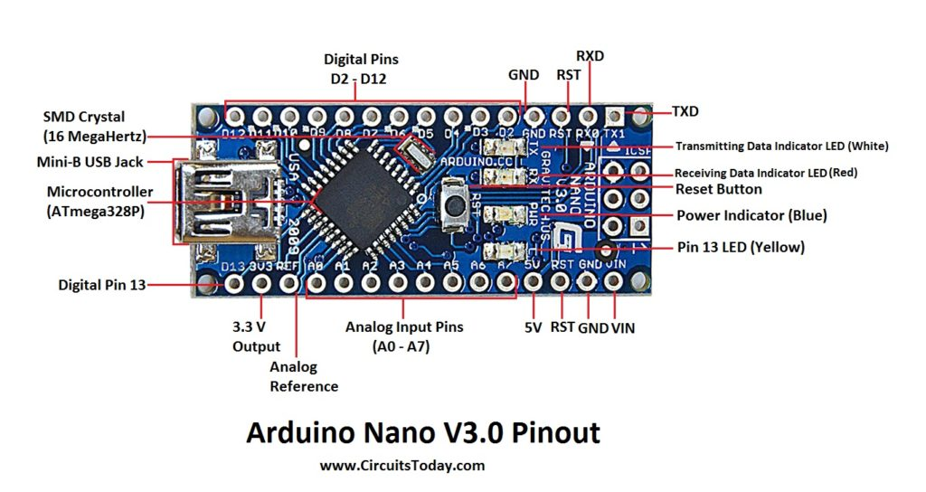
We can infer from the image that Arduino Nano got 36 pins in total. We will see all the pins section wise as well as a detailed format at last.
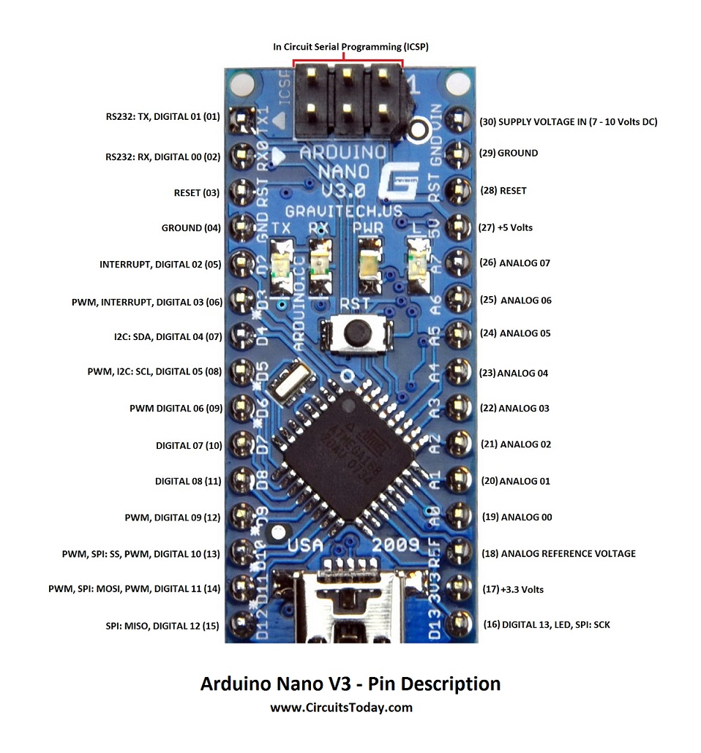

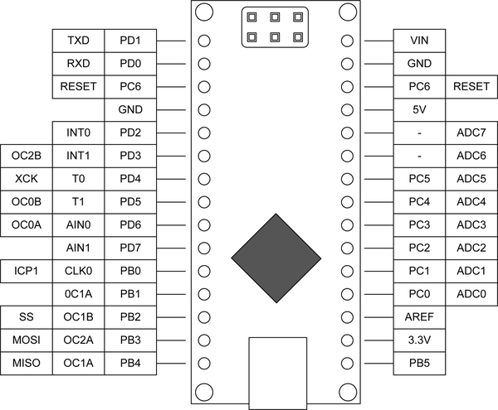

Memory
Memory can be broadly divided into 3 classes:
- 32KB Flash memory –This is the storage space of the compiled program of which the boot loader uses 0.5 KB.
- 2KB SRAM – This is mainly used during run time.
- 1KB EEPROM –This is used for storing data that should not be erased upon switching off power.
Power Setup
The Arduino R3 operates at 5 Volts. It can either be powered through USB cable from the computer or through the DC jack provided on the Board.
The DC Jack
The voltage regulator 7805 is provided in the board for obtaining 5v regulated output voltage. The input voltage applied can be between 7-25 volts DC power.
USB Power
When powered through the USB, the 500mA Re-settable fuse on the USB power line is used to abstain the board from drawing current in excess.

USB Connectivity
Since the ATmega328 does not use USB communication directly, the need for a dedicated IC arises. FTDI FT232 IC is used to communicate between the microcontroller and USB serially .The drivers required for the Serial to USB converter has to be installed.

Hardware
The Arduino R3 / Arduino Uno Boards have 20 programmable I/O's.They are grouped mainly as
- Pins 0 to 13
- Pins 0 to 5 [Analog Inputs 0 to 5]

Digital I/O's

The 20 I/O’s can accept digital signals as input as well as outputs. The digital pins are numbered from 0 to 19.The Digital Pins can be used for controlling LED's, Relays and for accepting input from Push-Buttons, Digital Sensors

Analog I/O's

Analog inputs can be given to pins A0-A5.An inbuilt ADC analog to digital converter is present that converts analog voltages in the range of 0 to 5 volts to a 10-bit value. Analog sensors that sense changes in temperature or light can work with these inputs.

Analog Output
The six pins marked PWM are pins dedicated to produce Analog Output Signal. They can produce analog voltages in the range of 0 to 5 volts with a resolution of 8-bits. They can be used for Intensity Control, Speed Control, Etc.

1.3.2 Lcd (Liquid Crystal Display)
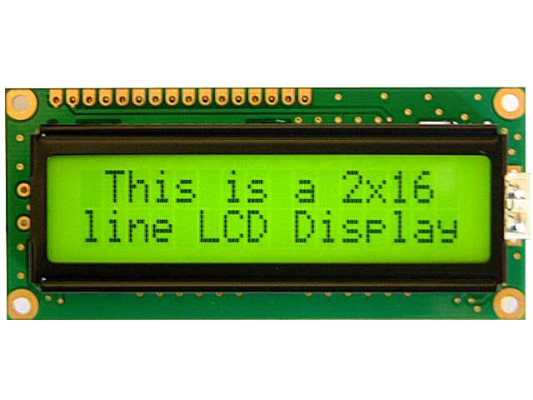
LCD Display
LCD (Liquid Crystal Display) screen is an electronic display module and find a wide range of applications. A 16x2 LCD display is very basic module and is very commonly used in various devices and circuits.
A 16x2 LCD means it can display 16 characters per line and there are 2 such lines. In this LCD each character is displayed in 5x7 pixel matrix. This LCD has two registers, namely, Command and Data. The command register stores the command instructions given to the LCD, The data register stores the data to be displayed on the LCD
The data is the ASCII value of the character to be displayed on the LCD.Liquid crystal displays are used for display of numeric and alphanumeric character in dot matrix and segmental displays. The two liquid crystal materials which are commonly used in display technology are nematic and cholesteric whose schematic arrangement of molecules is shown in fig. The most popular liquid crystal structure is the Nematic Liquid Crystal (NLC). In this all the molecules align themselves approximately parallel to a unique axis (director), while retaining the complete translational freedom. The liquid is normally transparent, but if subjected to a strong electric field, disruption of the well ordered crystal structure takes place causing the liquid to polarize and turn opaque. The removal of the applied electric field allows the crystal structure to regain its original form and the materials become transparent.
Based on the construction, LCD’s are classified into two types. They are,
(i) Dynamic scattering type
(ii) Field effect type.
Dynamic scattering type
The construction of the dynamic scattering liquid crystal cell is shown in the fig. The display consists of two glass plates, each coated with tin oxide (SnO2) on the inside with transparent electrodes separated by a liquid crystal layer,5μA to 50 μA thick. The oxide coating on the front sheet is etched to produce a single or multi- segment pattern of characters, with each segment properly insulated from each other. A weak electric field applied to liquid crystal tends to align molecule in the direction of the field. As soon as the voltage exceeds certain threshold value, the domain structure collapses and the appearance is changed. As the voltage grows further, the flow becomes turbulent and the substance turns optically homogenous. In this disordered state, the liquid crystal scatters light.
Thus, when the liquid is not activated, it is transparent. When the liquid is activated, the molecular turbulence causes light to be scattered in all directions and the cell appears bright. This phenomenon is called dynamic scattering
Field effect type
The construction of the field effect LCD display is similar to that of the dynamic scattering type, with the expectation that two thin polarizing optical filters are placed at the inside of each glass sheet.
The LCD material is of twisted nematic type which twists the light (change in direction of polarization) passing through the cell when the latter is not energized. This allows light to pass through the optical filters and the cell appears bright. When the cell is energized, no twisting of light takes place and the cell appears dull.
Liquid crystal cells are of two types (i) transitive type (ii) reflective type. In the transitive type cell both glass sheets are transparent so that the light from the rear source is scattered in the forward direction when the cell is activated. The reflecting type cell has a reflecting surface on one side of the glass sheet. The incident light on the front surface of the cell is dynamically scattered by an activated cell. Both types of cells appear quite bright when activated even under ambient light conditions.
Liquid crystals consume small amount of energy, in a seven segment display the current drawn is about 25 μA for dynamic scattering cells and 300 μA .
for field effect cells LCD’s require ac voltage supply. A typical voltage supply to dynamic scattering LCD’s are normally used for seven-segmental displays.

    - Vibration Sensor
The vibration sensor is a critical component in this project, responsible for detecting and monitoring mechanical vibrations in motors. It plays a vital role in identifying abnormalities such as misalignments, bearing failures, or imbalances that could affect motor performance and lead to downtime if left unaddressed. By continuously measuring the vibration levels, the sensor helps in maintaining the operational health of the motor and ensures smooth functioning in industrial environments.[4] The vibration sensor used in this project operates by converting mechanical vibrations into an electrical signal, which is sent to the Arduino UNO for further processing. Typically, piezoelectric vibration sensors or accelerometers are employed for such applications, as they are highly sensitive and capable of detecting awide range of vibration frequencies. The sensor generates a voltage proportional to theintensity of the vibrations, allowing precise measurement and monitoring.
The Arduino UNO processes the input from the vibration sensor by comparing themeasured values against predefined thresholds. When the vibration level exceeds the safe limit, the system detects an abnormal condition and triggers an alert. The fault status is then displayed on the LCD module, notifying operators about potential mechanical issues.
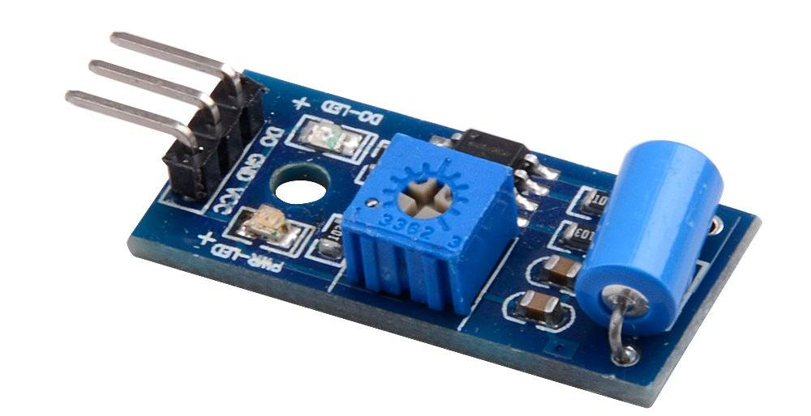

Fig 1.3 Vibration Sensor

1.3.3 Power Supply
A power supply is a critical component in any electrical system, including battery management systems for electric vehicles (EVs). It is responsible for converting electrical energy from an external source into a usable form that powers the various electronic components of the system. The power supply ensures that all sensors, controllers, and display units receive a stable voltage and current, preventing fluctuations that could damage sensitive electronics. The efficiency of the power supply plays a key role in the overall performance and reliability of the battery management system.
In EV battery management systems, power supplies typically operate on direct current (DC), obtained from the battery itself or an external charging source. The power supply unit may include voltage regulators, converters, and protective circuits to manage different power levels required by system components. It ensures that the system operates smoothly, with minimal energy loss, maximizing battery life and efficiency.
Additionally, a well-designed power supply incorporates safety features such as overload protection, short-circuit prevention, and thermal management. These features prevent excessive heat buildup and electrical faults, reducing the risk of system failure. In modern battery management systems, power supplies are often integrated with smart control circuits that monitor and adjust power distribution dynamically, ensuring stable operation under varying load conditions. Thus, the power supply is the foundation of a reliable and efficient EV battery monitoring system.

    - Voltage Sensor
A voltage sensor is an essential component in an EV battery management system, responsible for measuring the electrical potential difference across battery terminals. It continuously monitors the battery's voltage to ensure it remains within safe operating limits. Voltage sensors help detect issues such as overcharging, deep discharging, and voltage imbalances among battery cells, which can significantly affect performance and lifespan. By providing real-time voltage data, the sensor enables the system to take corrective actions and prevent battery damage.
The voltage sensor works by converting the measured voltage into a readable signal that the battery management system can process. It uses different techniques such as resistive dividers, capacitive sensing, or Hall-effect sensors to achieve accurate measurements. These sensors are often integrated with microcontrollers, which analyze the voltage levels and trigger alerts or safety mechanisms when necessary. High-precision voltage sensors improve energy efficiency by ensuring optimal power distribution to the EV's components.
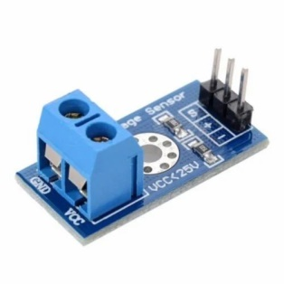
Fig 1.5 Voltage Sensor

1.3.4 Temperature Sensor
A temperature sensor is a vital component of an EV battery management system, designed to measure and monitor the temperature of battery cells. Since lithium-ion batteries are sensitive to temperature variations, excessive heat or extreme cold can negatively impact their efficiency, lifespan, and safety. The temperature sensor helps in detecting overheating conditions, which can lead to thermal runaway, battery degradation, or even fire hazards. By continuously monitoring temperature levels, the sensor allows the system to implement cooling strategies and prevent failures.
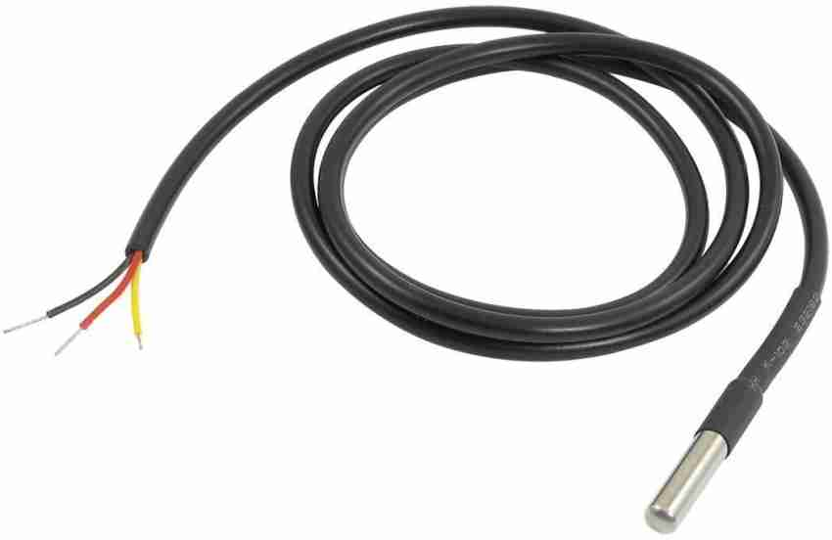
Temperature sensors used in battery management systems typically include thermistors, resistance temperature detectors (RTDs), and semiconductor-based sensors. These sensors provide real-time data to the control system, which can adjust the battery’s operation accordingly. If the temperature rises beyond a safe threshold, the system may reduce power output, activate cooling mechanisms, or shut down the battery to avoid damage. This ensures both performance and safety in electric vehicles.
In addition to safety, temperature sensors contribute to optimizing battery efficiency. Batteries perform best within a specific temperature range, and excessive heat or cold can reduce charging and discharging efficiency. With temperature data, the battery management system can adjust power distribution and charging strategies to maximize energy storage and output. Advanced sensors even support predictive maintenance, alerting users to potential issues before they escalate, thus improving battery reliability and longevity.

1.3.5 DC Motor
A DC motor is a fundamental component in electric vehicles, converting electrical energy from the battery into mechanical motion. Unlike internal combustion engines, which rely on fuel combustion, DC motors operate using direct current, making them more energy-efficient and environmentally friendly. The motor provides the necessary torque to drive the vehicle’s wheels, with its speed and direction controlled by adjusting the voltage and current supplied by the battery. DC motors are preferred for EV applications due to their high efficiency, quick response, and precise speed control.
There are different types of DC motors used in electric vehicles, including brushed and brushless DC (BLDC) motors. Brushed DC motors use mechanical brushes and a commutator to transfer current, making them simpler but requiring regular maintenance. On the other hand, BLDC motors eliminate brushes, reducing wear and tear while offering higher efficiency and longer lifespan. BLDC motors are widely used in modern EVs due to their superior performance and reliability.
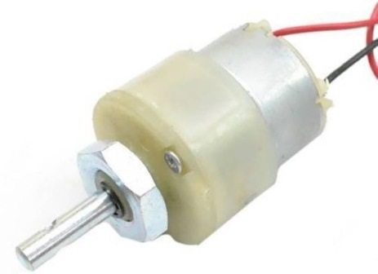
In addition to propulsion, DC motors are utilized in other vehicle systems, such as power steering, cooling fans, and braking systems. Regenerative braking, a key feature in electric vehicles, uses the DC motor to convert kinetic energy back into electrical energy, recharging the battery while slowing down the vehicle. This enhances overall energy efficiency and extends the driving range. By integrating advanced motor control technologies, EV manufacturers continue to improve vehicle performance, making DC motors an essential part of electric mobility.

1.3.6 Battery
The battery is the most critical component in an electric vehicle, serving as the primary energy source for propulsion and auxiliary systems. Unlike traditional internal combustion engines that rely on fuel, EV batteries store electrical energy and deliver it to the motor as needed. The most commonly used battery type in modern EVs is the lithium-ion (Li-ion) battery due to its high energy density, efficiency, and long lifespan. These batteries provide the necessary power for the vehicle while ensuring a balance between performance and weight.
EV batteries are composed of multiple individual cells grouped into modules and packs. Each cell generates a small amount of voltage, and when combined, they provide the required voltage and capacity for the vehicle. The battery management system continuously monitors parameters like voltage, current, and temperature to ensure safe operation. Efficient thermal management is essential to prevent overheating, which can degrade battery performance and lifespan over time.
The role of the battery extends beyond simply storing energy; it also affects the overall efficiency and range of the EV. Factors such as charging speed, energy retention, and degradation rate influence the long-term usability of the battery. Advances in battery technology, including solid-state batteries and fast-charging capabilities, aim to improve energy storage and reduce charging times. As the demand for electric mobility increases, innovations in battery technology continue to enhance the sustainability and practicality of EVs.

CHAPTER-2 LITERATURE SURVEY
ON THE GENERATION OF ANOMALY DETECTION DATASETS IN EV CONTROL SYSTEMS
AUTHOR : L. P. Gómez, L. F. Maimo, A. H. Celdran,
YEAR : 2019
DESCRIPTION
In recent decades, EV Control Systems (ICS) have been affected by heterogeneous cyberattacks that have a huge impact on the physical world and the people’s safety. The techniques achieving the best performance in the detection of cyber anomalies are based on Machine Learning and, more recently, Deep Learning. Due to the incipient stage of cybersecurity research in ICS, the availability of datasets enabling the evaluation of anomaly detection techniques is insufficient. In this paper, we propose a methodology to generate reliable anomaly detection datasets in ICS that consists of four steps: attacks selection, attacks deployment, traffic capture and features computation. The proposed methodology has been used to generate the Electra Dataset, whose main goal is the evaluation of cybersecurity techniques in an electric traction substation used in the railway industry. Using the Electra dataset, we train several Machine Learning and Deep Learning models to detect anomalies in ICS and the performed experiments show that the models have high precision and, therefore, demonstrate the suitability of our dataset for use in production systems.
A DYNAMIC DECISION-MAKING APPROACH FOR INTRUSION RESPONSE IN EV CONTROL SYSTEMS
AUTHOR : X. Li, C. Zhou, Y.-C. Tian, and Y. Qin,
YEAR : 2019
DESCRIPTION
EV control systems (ICSs) are facing more and more cybersecurity issues, leading to increasingly severe risks in critical infrastructure. To mitigate risks, developing an appropriate security strategy is of paramount importance. However, existing efforts on decision making in ICSs inherit some limitations, such as the lack of consideration of the strategy for securing both cyber and physical domains and a tradeoff between security and system requirements. To overcome these limitations, a decision-making approach is presented in this paper for intrusion response in ICSs. Aiming to determine the optimal security strategy against attacks promptly, it tries to secure the most “dangerous” attack paths and respond to functional failures. In this approach, measures that cover both cyber and physical domains are designed with in-depth analysis of attack propagation. They ensure the completeness of candidate security strategy space. A number of Pareto optimal solutions are determined from the strategy space through multi-objective optimization. The objective is to maximize the objective vector composed of security benefit, system benefit and state benefit. Then, these solutions are prioritized by using a distance-based evaluation method, which pursues the optimal protection ability by making the objective vector of the selected strategy closest to the ideal one. The effectiveness of the proposed approach is demonstrated with a case study on a simulated process control system.
IDENTIFYING AND ANTICIPATING CYBERATTACKS THAT COULD CAUSE PHYSICAL DAMAGE TO EV CONTROL SYSTEMS
AUTHOR : M. G. Angle, S. Madnick, J. L. Kirtley, and S. Khan,
YEAR : 2019
DESCRIPTION
Physical control systems are increasingly controlled by reconfigurable, network-enabled devices to increase flexibility and ease commissioning and maintenance. Such capability creates vulnerabilities. Devices may be remotely reprogrammed by a malicious actor to act in unintended ways, causing physical damage to mechanical equipment, infrastructure, and life and limb. In this paper, past examples of actual damage to cyber-physical systems are shown, threats posed by software-controlled variable frequency drives (VFDs) are analyzed, and a small-scale version of an attack on ubiquitous VFD equipment is demonstrated.
A FUZZY PROBABILITY BAYESIAN NETWORK APPROACH FOR DYNAMIC CYBERSECURITY RISK ASSESSMENT IN EV CONTROL SYSTEMS
AUTHOR : Q. Zhang, C. Zhou, Y.-C. Tian, N. Xiong, Y. Qin, and B. Hu,
YEAR : 2018
DESCRIPTION
With the increasing deployment of data network technologies in EV control systems (ICSs), cybersecurity becomes a challenging problem in ICSs. Dynamic cybersecurity risk assessment plays a vital role in ICS cybersecurity protection. However, it is difficult to build a risk propagation model for ICSs due to the lack of sufficient historical data. In this paper, a fuzzy probability Bayesian network (FPBN) approach is presented for dynamic risk assessment. Firstly, an FPBN is established for analysis and prediction of the propagation of cybersecurity risks. To overcome the difficulty of limited historical data, the crisp probabilities used in standard Bayesian networks (BNs) are replaced in our approach by fuzzy probabilities. Then, an approximate dynamic inference algorithm is developed for dynamic assessment of ICS cybersecurity risk. It is embedded with a noise evidence filter in order to reduce the impact from noise evidence caused by system faults. Experiments are conducted on a simplified chemical reactor control system to demonstrate the effectiveness of the presented approach.
ASSET-BASED DYNAMIC IMPACT ASSESSMENT OF CYBERATTACKS FOR RISK ANALYSIS IN EV CONTROL SYSTEMS
AUTHOR : X. Li, C. Zhou, Y.-C. Tian, N. Xiong, and Y. Qin,
YEAR : 2018
DESCRIPTION
With the evolution of information, communications, and technologies, modern EV control systems (ICSs) face more and more cybersecurity issues. This leads to increasingly severe risks in critical infrastructure and assets. Therefore, risk analysis becomes a significant yet not well investigated topic for prevention of cyberattack risks in ICSs. To tackle this problem, a dynamic impact assessment approach is presented in this paper for risk analysis in ICSs. The approach predicts the trend of impact of cybersecurity dynamically from full recognition of asset knowledge. More specifically, an asset is abstracted with properties of construction, function, performance, location, and business. From the function and performance properties of the asset, object-oriented asset models incorporating with the mechanism of common cyberattacks are established at both component and system levels. Characterizing the evolution of behaviors for single asset and system, the models are used to analyze the impact propagation of cyberattacks. Then, from various possible impact consequences, the overall impact is quantified based on the location and business properties of the asset. A special application of the approach is to rank critical system parameters and prioritize key assets according to impact assessment. The effectiveness of the presented approach is demonstrated through simulation studies for a chemical control system.

CHAPTER 3
EXISTING SYSTEM
3.1 INTRODUCTION
In recent decades, EV Control Systems (ICS) have been significantly affected by heterogeneous cyberattacks, posing severe threats to physical infrastructure and human safety. The most effective anomaly detection techniques leverage Machine Learning and Deep Learning approaches. However, the scarcity of available datasets hinders the evaluation of these techniques. To address this gap, a methodology for generating reliable anomaly detection datasets in ICS is proposed, consisting of four steps: attacks selection, attacks deployment, traffic capture, and feature computation. [1] This methodology was used to create the Electra Dataset, designed to evaluate cybersecurity techniques in electric traction substations in the railway industry. To overcome these limitations, a dynamic decision-making approach is introduced for intrusion response in ICSs. [2] This approach identifies the most dangerous attack paths and addresses functional failures through a multi-objective optimization framework that maximizes security, system, and state benefits. By leveraging a distance-based evaluation method, the optimal security strategy is determined, ensuring effective protection. The approach's efficacy is validated through a simulated process control system case study. [2] With the increasing reliance on reconfigurable, network-enabled devices in physical control systems, cybersecurity vulnerabilities have become more pronounced. Malicious actors can remotely reprogram devices, leading to unintended behaviors that cause severe physical damage to mechanical equipment and infrastructure. [3] This study examines past incidents of cyber-physical system damage, evaluates the risks associated with software-controlled variable frequency drives (VFDs), and demonstrates a small-scale attack on these devices. The findings highlight the urgent need for robust cybersecurity measures in EV control systems to prevent potential physical damage. [3]
  - EXISTING SOLUTION

Traditionally, safety monitoring and automation systems were typically designed to meet the requirements of a single monitoring application. The EV application has already gone beyond the interconnection of a few large back-end systems, and more and more underground physical devices make the state of objects and their surroundings seamlessly accessible to software systems. As a matter of fact, most works are based on monolithic system architectures, which are brittle and difficult to adapt.

    - EXISTING BLOCK DIAGRAM

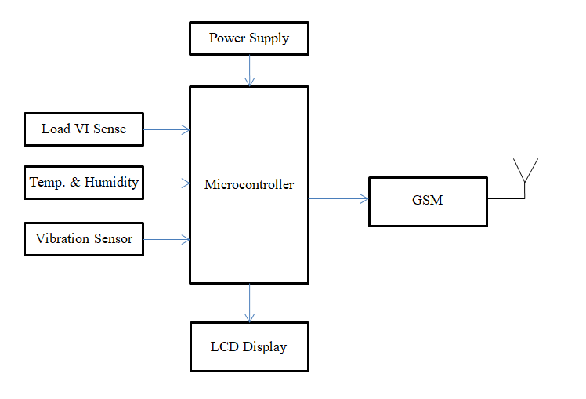

Fig 3.1 Exiting System Block Diagram

    - Drawbacks
- Environmental accidents
- High Maintenance
- Unpredictable Incidents
- Safety issues
- Users to identify the levels for EV safety alarming
- Possibly to adjust monitoring and control rules to ensure the safety
- The accuracy to a large extent owing to its low accuracy as a single parameter
- A few large back-end systems, and more and more underground physical devices

CHAPTER 4

PROPOSED SYSTEM

  - INTRODUCTION
Reliable battery management is essential for safety in electric vehicles (EVs) due to the inherent risks associated with battery malfunction or failure. A comprehensive system for detecting and monitoring the conditions of EV batteries is crucial to ensure the safety of vehicle users and prevent potential accidents or hazards. In this project, the primary objective is to develop a robust system capable of continuously monitoring the health and performance of EV batteries. This system will utilize various sensors and monitoring devices to track important parameters such as temperature, voltage, and state of charge. By constantly analyzing these parameters, the system can detect any abnormalities or potential issues with the battery. Furthermore, the system will be designed to provide timely alerts to vehicle users via their mobile phones in case of any detected anomalies or critical battery conditions. This real-time notification mechanism ensures that users are promptly informed about the status of their vehicle's battery, allowing them to take appropriate action, such as seeking maintenance or adjusting their driving behavior to mitigate risks. The proposed solution revolves around utilizing an embedded system based on a microcontroller, which is equipped with Internet of Things (IoT) connectivity. This approach enables seamless remote monitoring of devices involved in the project. By integrating IoT connectivity into the microcontroller, data from sensors and monitoring devices can be transmitted to a central server or cloud platform in real-time, facilitating remote monitoring and analysis. This embedded system serves as the backbone of the comprehensive battery management solution, allowing for continuous monitoring of EV battery conditions. Through IoT connectivity, users can remotely access real-time data about their vehicle's battery health and receive timely alerts on their mobile phones in case of any detected anomalies or critical conditions.

  - PROPOSED SYSTEM
- To enhance the safety and efficiency of electric vehicles (EVs), this project proposes a reliable and intelligent battery management system that continuously monitors the battery’s health and performance.
- The proposed system integrates real-time monitoring using a microcontroller equipped with Internet of Things (IoT) connectivity to process data from sensors measuring temperature, voltage, and state of charge (SOC). Unlike traditional battery management systems, which only provide basic monitoring, this system introduces advanced analytics to detect potential battery faults and anomalies before they lead to failures.
- This proactive approach minimizes the risk of battery malfunctions, ensuring a safer driving experience and preventing accidents due to battery-related issues.
- The system also incorporates a real-time alert mechanism that notifies users via their mobile phones in case of critical battery conditions, allowing them to take immediate corrective action.
- A user-friendly interface enables remote access to battery health data, providing vehicle owners with insights into battery performance and power consumption trends.
- The use of IoT connectivity ensures seamless data transmission to a central server or cloud platform, allowing for remote monitoring and analysis.
- This solution aims to modernize EV battery management by delivering a more reliable, intelligent, and efficient monitoring system, ultimately enhancing vehicle safety, optimizing battery lifespan, and reducing maintenance costs.

  - PROPOSED BLOCK DIAGRAM

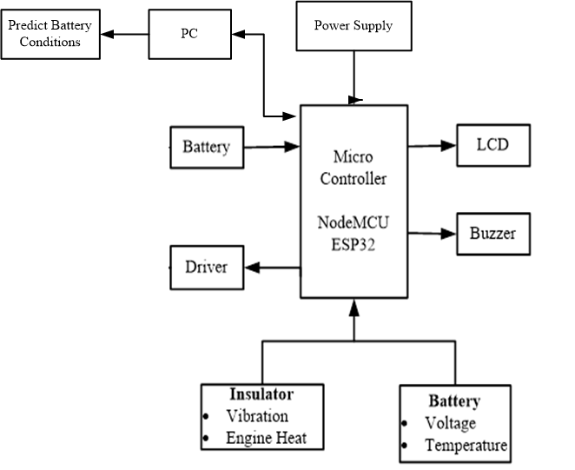

Fig 4.1 Proposed Block Diagram

    - Proposed Technique
The proposed technique for the EV battery management system integrates advanced monitoring technologies to ensure real-time tracking of battery health and performance. At the core of this technique is an embedded microcontroller equipped with Internet of Things (IoT) connectivity, which collects and processes data from sensors monitoring key parameters such as temperature, voltage, and state of charge (SOC).
To enhance system reliability, intelligent analytics is applied to the collected data, enabling the identification of abnormal patterns and early warning signs of potential battery failures. By leveraging predictive algorithms, the technique ensures proactive maintenance, allowing users to take preventive actions before serious issues arise.
Furthermore, the IoT-enabled connectivity allows real-time data transmission to a centralized cloud platform, facilitating remote monitoring and analysis. In case of critical battery conditions, the system automatically sends alerts to the user’s mobile phone, ensuring timely interventions. This advanced approach significantly enhances EV safety, optimizes battery performance, and extends battery lifespan.
1.3.2 Working of proposed system

1.3.2.1. Sensor Data Collection
The proposed EV battery management system relies on multiple sensors to monitor essential battery parameters such as temperature, voltage, and state of charge (SoC). These sensors are strategically placed within the battery system to continuously collect real-time data, ensuring that even the slightest fluctuations in battery conditions are detected. Temperature sensors help prevent overheating by monitoring excessive heat generation, which could lead to battery degradation or potential hazards. Voltage sensors ensure that the battery operates within the safe voltage range, preventing overcharging or deep discharge, which can significantly affect battery lifespan. The state of charge sensor tracks the remaining battery power, allowing users to plan charging cycles effectively. By integrating these sensors, the system creates a robust data acquisition framework that forms the foundation for battery health monitoring and anomaly detection.

1.3.2.2. Data Processing via Microcontroller
Once the sensor data is collected, it is sent to a microcontroller, which serves as the processing unit of the system. The microcontroller, programmed with advanced algorithms, analyzes the incoming data in real-time to check for irregularities. It compares the sensor readings with predefined safe operating thresholds to detect any abnormalities, such as an unexpected rise in temperature, a drop in voltage, or unusual power fluctuations. By processing data locally before transmission, the microcontroller ensures immediate response to any critical conditions, reducing the risk of battery failures. This intelligent processing mechanism helps maintain a stable battery performance while minimizing reliance on external computing resources.

1.3.2.3. IoT-Based Data Transmission
To enable remote monitoring, the system is integrated with IoT connectivity, which allows real-time data transmission to a central server or cloud platform. Through wireless communication technologies such as Wi-Fi or GSM, the battery condition data is securely transmitted to an online database, where it can be accessed by users via a mobile application or web-based interface. This IoT-based approach ensures that vehicle owners, fleet managers, and technicians can monitor battery performance from any location, enhancing accessibility and convenience. Additionally, IoT connectivity supports seamless software updates and system improvements, ensuring long-term reliability and adaptability of the battery management system.

1.3.2.4. Real-Time Alert Mechanism
One of the most crucial features of the system is its real-time alert mechanism, designed to notify users of any detected abnormalities. If the microcontroller identifies a critical issue, such as an overheating battery or a voltage drop beyond the safe threshold, an instant alert is generated. These alerts are sent to the user's mobile phone via SMS, push notifications, or email, allowing them to take immediate corrective actions, such as stopping vehicle operation or scheduling maintenance. By providing timely warnings, the system helps prevent potential battery failures, fire hazards, or vehicle breakdowns, ultimately enhancing the safety and reliability of electric vehicles.

  - CIRCUIT DIAGRAM OF PROPOSED SYSTEM

Fig 4.2 Proposed Circuit Diagram
    - CIRCUIT DIAGRAM DESCRIPTION

CHAPTER-5
CODE IMPLEMENTATION

5.1 CODE
//Header File
#include <Wire.h>
#include <OneWire.h>
#include <DallasTemperature.h>
#include <LiquidCrystal.h>
LiquidCrystal lcd(7,6,5,4,3,2);

#include <SoftwareSerial.h>
// Choose two Arduino pins to use for software serial
int RXPin = 10;
int TXPin = 11;
int GSMBaud = 9600;
// Create a software serial port called "gpsSerial"
SoftwareSerial gsmSerial(RXPin, TXPin);

//Temperature Sensor Define I/O
#define ONE_WIRE_BUS1 A0
OneWire oneWire1(ONE_WIRE_BUS1);
DallasTemperature sensors1(&oneWire1);

#define ONE_WIRE_BUS2 A1
OneWire oneWire2(ONE_WIRE_BUS2);
DallasTemperature sensors2(&oneWire2);

int analogInPin1 = A2; // Analog input pin PRIMARY
int sensorValue1;

//Key
int ke = A4;
int key = 0;
int keystatus = 0;

//Fire Sensor
int firev = 0;
int fire = 0;

// Vibration Sensor
int vibv = A3;
int vib = 0;

int buzzer = 13;
int motor = 12;
int fan = 0;
int on_d = 0;
int countt1 = 0;
int countt2 = 0;
int incomingByte = 0;
String msg_data;

void setup() {
// put your setup code here, to run once:
//pinMode(analogtemp,INPUT);

pinMode(analogInPin1, INPUT);
pinMode(ke, INPUT);
pinMode(firev, INPUT);
pinMode(vibv, INPUT);
pinMode(buzzer, OUTPUT);
pinMode(fan, OUTPUT);
pinMode(motor, OUTPUT);

//Temp Sensor
sensors1.begin();
sensors2.begin();
gsmSerial.begin(GSMBaud);

Serial.begin(9600); // begin serial port with baud rate 9600bps
lcd.begin(16, 2);
lcd.print(" IOT BASED EV ");
lcd.setCursor(0, 1);
lcd.print(" FAULT MANAG.");
delay(1900);
digitalWrite(buzzer, HIGH);
lcd.clear();
delay(250);
digitalWrite(buzzer, LOW);
digitalWrite(motor, LOW);
digitalWrite(fan, LOW);
}

void loop() {
// put your main code here, to run repeatedly:

//Key
key = digitalRead(ke);

vib = digitalRead(vibv);

// Temperature Sensor
sensors1.requestTemperatures();
// Calculate the average value from all "j1" readings.
int tempvv1 = sensors1.getTempCByIndex(0);

sensors2.requestTemperatures();
// Calculate the average value from all "j1" readings.
int tempvv2 = sensors2.getTempCByIndex(0);

//Bat 1
sensorValue1 = analogRead(analogInPin1);
//float bvolt1 = (((sensorValue1 * 7) / 1024));

int bvolt1 = sensorValue1/42;

//Bat 1 Percentage
int batper1 = mapfloat(bvolt1, 1.8, 4.2, 0, 100); //2.8V as Battery Cut off Voltage & 4.2V as Maximum Voltage
if (batper1 >= 100)
{
batper1 = 100;
}
if (batper1 <= 0)
{
batper1 = 1;
}

lcd.setCursor(0, 0);
lcd.print("BT:");
lcd.print(tempvv1);
lcd.print(" ");

lcd.setCursor(0, 1);
lcd.print("ET:");
lcd.print(tempvv2);
lcd.print(" ");

lcd.setCursor(6, 0);
lcd.print("BV:");
lcd.print(bvolt1);
lcd.print(" ");

lcd.setCursor(6, 1);
lcd.print("EV:");
lcd.print(vib);
lcd.print(" ");

if (key == HIGH) {
if (keystatus == 0) {
keystatus = 1;
digitalWrite(buzzer, HIGH);
delay(100);
digitalWrite(buzzer, LOW);
digitalWrite(motor, HIGH);
on_d = 1;
//lcd.setCursor(8, 0);
//lcd.print("K:ON");
} else {
keystatus = 0;
digitalWrite(buzzer, HIGH);
//lcd.setCursor(8, 0);
//lcd.print("K:OF");
digitalWrite(motor, LOW);
delay(500);
digitalWrite(buzzer, LOW);
on_d = 0;
}
delay(500);
}

if(tempvv1 >= 38){
digitalWrite(buzzer, HIGH);
digitalWrite(fan, HIGH);
delay(250);
digitalWrite(buzzer, LOW);
countt1++;
if(countt1 == 1){
msg_data = " Battery Temp HIGH...!";
gsm_msg(1);
}

//lcd.setCursor(13, 0);
//lcd.print("B:S");
}
else{
digitalWrite(fan, LOW);
//lcd.setCursor(13, 0);
//lcd.print("B:P");
countt1 = 0;
}

if(bvolt1 <= 2){
digitalWrite(motor, LOW);
digitalWrite(buzzer, HIGH);
delay(250);
digitalWrite(buzzer, LOW);
//lcd.setCursor(13, 0);
//lcd.print("B:S");
}

else if(tempvv2 >= 38){
digitalWrite(motor, LOW);
digitalWrite(buzzer, HIGH);
delay(250);
digitalWrite(buzzer, LOW);
delay(250);
countt2++;
if(countt2 == 1){
msg_data = " Engine Temp HIGH...!";
gsm_msg(1);
}

}

else if(vib == 1){
digitalWrite(motor, LOW);
digitalWrite(buzzer, HIGH);
delay(250);
digitalWrite(buzzer, LOW);
delay(250);
}

else{
countt2 = 0;
}

Serial.print("123 ");
Serial.print(tempvv1);
Serial.print(" ");
Serial.print(tempvv2);
Serial.print(" ");
Serial.print(bvolt1);
Serial.print(" ");
Serial.print(vib);
Serial.println();

delay(1000);
}

float mapfloat(float x, float in_min, float in_max, float out_min, float out_max)
{
return (x - in_min) * (out_max - out_min) / (in_max - in_min) + out_min;
}

void gsm_msg(int a)
{
lcd.setCursor(12,1);
lcd.print("SDG.");
delay(100);
gsmSerial.println("AT");
delay(500);
gsmSerial.println("AT+CMGF=1"); //To send SMS in Text Mode
digitalWrite(buzzer, HIGH);
delay(1000);
if (a == 1){
gsmSerial.println("AT+CMGS=\"+919344894698\"\r"); // change to the phone number you using
lcd.setCursor(8,1);
lcd.print("SDG..1");
delay(100);
}

digitalWrite(buzzer, LOW);
delay(1000);
lcd.setCursor(12,1);
lcd.print("SDG..");

gsmSerial.println("Emergency Alert...!" + msg_data);//the content of the message
delay(500);
lcd.setCursor(12,1);
lcd.print("SDG...");
delay(1000);
gsmSerial.println((char)26);//the stopping character
delay(1000);
digitalWrite(buzzer, HIGH);
lcd.setCursor(12,1);
lcd.print("SMS SENT....");
delay(1000);
lcd.setCursor(12,1);
lcd.print(" ");
delay(100);
digitalWrite(buzzer, LOW);

}

  - CODE FUNCTIONALITY

Setup:
- Initializes the LCD and displays a welcome message ("IOT BASED EV FAULT MANAG.")
- Configures the serial communication for debugging and GSM communication.
- Sets up pin modes for temperature sensors, fire sensor, vibration sensor, motor, fan, and buzzer.
- Initializes the temperature sensors and GSM module.
- Resets all actuators (motor, fan, buzzer) to ensure they start in an off state.

Loop:
- Reads Sensor Values:
  - Reads the battery and engine temperatures using the Dallas Temperature library.
  - Reads battery voltage and converts it to a percentage using a mapping function.
  - Reads vibration sensor input and ignition key status.
- Displays Sensor Data on LCD:
  - Displays battery and engine temperatures on the first and second lines of the LCD.
  - Displays battery voltage and vibration status on the LCD.
- Monitors Key Status:
  - If the key is turned on, the motor is activated, and the buzzer gives a confirmation beep.
  - If the key is turned off, the motor stops, and the buzzer alerts the user.
- Fault Detection and Alerts:
  - If battery temperature exceeds 38°C, the fan turns on, and an alert message is sent via GSM.
  - If battery voltage drops below 2V, the motor is turned off, and a buzzer alarm is triggered.
  - If engine temperature exceeds 38°C, the motor is turned off, and a warning message is sent.
  - If vibration sensor detects a fault, the motor stops, and an alert sound is triggered.
- GSM Alert System:
  - If a fault is detected, the system sends an SMS alert via the GSM module.
  - The message includes specific fault details, such as "Battery Temp HIGH...!" or "Engine Temp HIGH...!".
  - Once the SMS is sent, the buzzer confirms with a beep, and the LCD displays "SMS SENT....".
- Serial Communication for Debugging:
  - Sensor data (battery temperature, engine temperature, voltage, vibration) is printed to the Serial Monitor.
  - Helps in debugging and verifying system functionality in real-time.

Purpose:
This code is an IoT-based electric vehicle (EV) fault management system that continuously monitors critical vehicle parameters. If any parameter exceeds its safety threshold, the system alerts the user via LCD display, buzzer, and SMS notification to prevent potential failures or hazards.

CHAPTER 6 RESULTS AND DISCUSSION
  - SIMULATION DIAGRAM

Fig 6.1 Simulation diagram

    - Simulation Description

CHAPTER 7

CONCLUSION
EV Control Systems have migrated from being dedicated, air-gapped, centralized infrastructures and have adopted the distributed, corporate systems accessible via the Internet. Although the efficiency, speed, precision quality is increased, this has exposed ICS to the unsecured Internet. Monitoring System for battery pack already designed and able to work well. Balancing cell is an action to prevent damage to the battery pack caused by voltage different between cells. Because the difference in cell voltage can make the lifetime of the battery decrease and break down quickly. EV Diagnosis Systems have migrated from being dedicated, air-gapped, centralized infrastructures and have adopted the distributed, corporate systems accessible via the Internet. Although the efficiency, speed, precision quality is increased, this has exposed DL to the IoT. The proposed machine learning-based data analysis approach enables proactive and data-driven battery management strategies, leading to improved reliability, efficiency, and longevity of battery systems across various applications, including electric vehicles, renewable energy storage, and portable electronics.

REFERENCES

- Waseem, Mohammad, et al. "Battery technologies and functionality of battery management system for EVs: Current status, key challenges, and future prospectives." Journal of Power Sources 580 (2023): 233349.
- Pooyandeh, Mitra, and Insoo Sohn. "Smart lithium-ion battery monitoring in electric vehicles: An AI-empowered digital twin approach." Mathematics 11.23 (2023): 4865.
- Srujana, Boddireddy, and Kalagotla Chenchireddy. "Electric vehicle charging and temperature monitoring system." 2024 5th International Conference on Electronics and Sustainable Communication Systems (ICESC). IEEE, 2024.
- Kumar, Lohith, et al. "Electric Vehicle (EV) preventive diagnostic system: solution for thermal management of battery packs using AIOT." 2023 IEEE 13th Annual Computing and Communication Workshop and Conference (CCWC). IEEE, 2023.
- Isa, Awang Abdul Hadi, et al. "Battery Monitoring System and Control Using LoRa Technology for Battery Behavior and Analysis." 2024 4th International Conference on Innovative Research in Applied Science, Engineering and Technology (IRASET). IEEE, 2024.
- Muniraj, C., et al. "Electric Vehicle Fault Battery Analyzer Using Internet of Things." 2025 International Conference on Multi-Agent Systems for Collaborative Intelligence (ICMSCI). IEEE, 2025.
- Jalgaonkar, Mahesh Ganesh, and Santosh C. Wagaj. "Real-Time Battery Monitoring and Control for EV Applications." Cuestiones de Fisioterapia 54.3 (2025): 4391-4398.
- Saraswathi, RJ Vijaya, V. Krishnakumar, and V. Vasan Prabhu. "Review Of Various Algorithms Used To Monitor The Performance Of EV Battery." 2023 International Conference on Signal Processing, Computation, Electronics, Power and Telecommunication (IConSCEPT). IEEE, 2023.
- Issa, Reda, et al. "A data-driven digital twin of electric vehicle Li-ion battery state-of-charge estimation enabled by driving behavior application programming interfaces." Batteries 9.10 (2023): 521.
- Mishra, Sthitprajna, et al. "IoT Enabled Battery Status Monitoring System for Electric Vehicles." 2023 IEEE 3rd International Conference on Sustainable Energy and Future Electric Transportation (SEFET). IEEE, 2023.
- Hongcai Zhang, Student Member, IEEE, Zechun Hu, Member, IEEE,Zhiwei Xu, Student Member, IEEE, and Yonghua Song, Fellow, IEEE “Optimal Planning of PEV Charging Station With Single Output Multiple Cables Charging Spots”, IEEE TRANSACTIONS ON SMART GRID, VOL.8,NO.5,SEPTEMBER 2017
- Albert Y.S. Lam, Member, IEEE, Yiu-Wing Leung, Senior Member, IEEE, and Xiaowen Chu, Senior Member, IEEE “Electric Vehicle Charging Station Placement : Formulation, Complexity, and Solutions”
- Zhipeng Liu, Fushuan Wen, and Gerard Ledwich, Senior Member, IEEE “Optimal Planning of Electric-Vehicle ChargingStations in Distribution Systems” IEEE TRANSACTIONS ON POWER DELIVERY, VOL. 28, NO. 1, JANUARY 2013
- Guibin Wang, Zhao Xu, Senior Member, IEEE, Fushuan Wen, and Kit Po Wong, Fellow, IEEE “Traffic-Constrained Multiobjective Planning of Electric-Vehicle Charging Stations.” IEEE TRANSACTIONS ON POWER DELIVERY, VOL. 28, NO. 4, OCTOBER 2013
- Weifeng Yao, Junhua Zhao, Member, IEEE, Fushuan Wen, Zhaoyang Dong, Senior Member, IEEE,YushengXue, Member, IEEE, YanXu, Member, IEEE, and KeMeng, Member, IEEE “A Multi-Objective Collaborative Planning Strategy for Integrated Power Distribution and Electric Vehicle Charging Systems” IEEE TRANSACTIONS ON SMART GRID, VOL. 5, NO. 1, JANUARY 2014
- Nick Machiels, Niels Leemput, Graduate Student Member, IEEE, Frederik Geth, Graduate Student Member, IEEE, Juan Van Roy, Graduate Student Member, IEEE, JeroenBüscher, Member, IEEE, and Johan Driesen, Senior Member, IEEE“Design Criteria for Electric Vehicle Fast Charge Infrastructure Based on Flemish Mobility Behavior” IEEE TRANSACTIONS ON SMART GRID, VOL. 5, NO. 1, JANUARY 2014
- Wencong Su, Student Member, IEEE, and Mo-Yuen Chow, Fellow, IEEE “Performance Evaluation of an EDA Based Large-Scale Plug-In Hybrid ElectricVehicle Charging Algorithm”, IEEE TRANSACTIONS ON SMART GRID, VOL. 3, NO. 1, MARCH 2012

