**MAHENDRA INSTITUTE OF ENGINEERING AND TECHNOLOGY**

**FLOOD MONITORING AND EARLY WARNING SYSTEM**

**TEAM MEMBERS:**

**1.P.GOKULNATH**

**2.S.GOWTHAM**

**3.V.ABIN**

**4.R.K.T.KAVIN BALA**

**5.S.ARUL RAJ**

**CO-ORDINATOR:**

Mrs.ARUNA

**PLANNING:**

In most countries in the world, flood had caused damages to properties and it involved a large amount of loss to individuals and governments. Ultrasonic sensing techniques have become mature and are widely used in the various fields of engineering and basic science. One of advantage of ultrasonic sensing is its outstanding capability to probe inside objective non-destructively because ultrasound can propagate through any kinds of media including solids, liquids and gases. This study focuses only on the water level detection and early warning system (via website and/or SMS) that alerts concern agencies and individuals for a potential flood event. The study aims in helping citizens to be prepared and knowledgeable whenever there is a flood.

**INSTALLATION:**

The two monitoring devices are composed of Ultrasonic sensor to measure the distance of the water level, Arduino micro-controller that process the signal from the sensor, GSM module to send the data or information from the micro-controller to the computer server and a power source using Solar Panel, Regulator and Battery. Once a sensor is triggered, an output signal will be relayed to the micro-controller which serves as a switch that triggers the connected GSM module to send an alert message or water level status to another GSM modem connected to a computer server. Then, the developed program installed in the computer server will interpret and analyze the message received then automatically send a text message to the concern agencies’ numbers stored in a database. Also, the developed program will then automatically relay the alert message or status by uploading to the developed website. Furthermore, concern agencies, local officials and the local communities could inquire about the current status by sending a message that contains keywords.

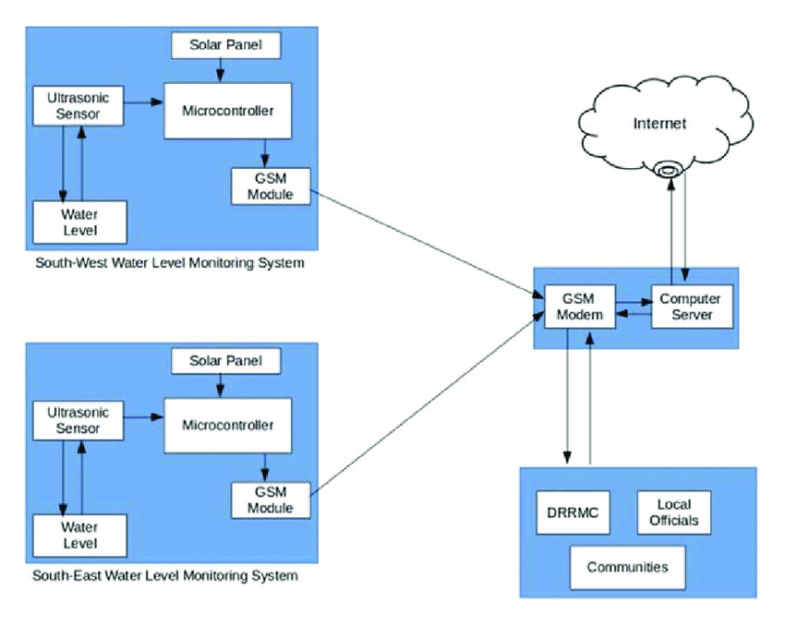

This paper presents the utilization of ultrasonic sensors because of its capability and reliability. Since the Philippines is considered among the most flood prone in the world due to variety of factors, the project NOAH relies on Ultrasonic sensors for water level monitoring. Ultrasonic sensors are deployed on hundreds of coastal tide gauge platforms that provide tsunami and tropical storm surge warning data. They are also deployed on similar platforms that monitor flooding on the different rivers. The newest flood warning system is being deployed to monitor flooding on urban street. And with continues development in ultrasonic sensing, the researchers opted to use this sensor for the project. The use of GSM also presented in this paper for transmitting data and as mode of communication to the concern stakeholders of this project. Due to its simplicity and availability to the public now-a-days, it is very obvious that information dissemination can be easily achieved. Specifically, the study utilizes the use of SMS for the reason that aside for being the cheapest way to avail and transmit information in a remote area, it doesn’t require high data bandwidth.

**CONTROLLIING:**

The ultimate aim is to build a water level detection using ultrasonic sensor to monitor the rivers in the south-east and south-west portion of the province of Isabela and develop a web and SMS application as an early warning system that provides essential information to the local communities and concern agencies.

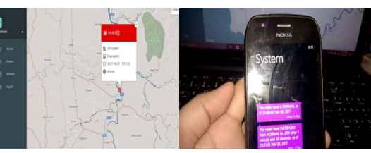

An SMS approach was used for transmitting data from the monitoring system to the computer server and for sending notification to the concern stakeholders. The SMS application was installed in the computer server to process the received data and make proper action. The application also implement

fuzzy logic algorithm for decision making. The inputs of the algorithm are the water level status coming from the two monitoring systems sent through SMS. A threshold value was set in the two monitoring system as basis for the Arduino to trigger the GSM module to send an SMS to the computer server. Then the developed program installed in the computer server send an SMS notification to the concern stakeholders and uploads an update post in the developed web-based monitoring system. After the development of the prototype, the model had undergone several tests and experimentations to check the effectiveness of the system.

**EXECUTION AND DISCUSSION:**

**4.1 Flood monitoring system that monitors the water level of the rivers using ultrasonic sensor:**

The researchers played out a model, test the ease of use and dependability of the developed prototype. It was tried first in a prototype environment that the researchers made and played out the trial. The test decided whether it meets the necessities of the client. The figure below shows the prototype assembled and the connection of the different hardware components.

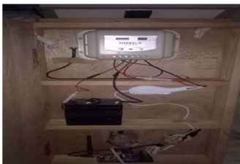

The figure shows that in the upper deck is the solar panel that is connected to a regulator. The regulator charges the battery and prevents overcharging to protect against over-voltage. And in thelowest deck lies the Arduino micro-controller topped by the GSM Module and the Ultrasonic sensor facing down detecting the distance of the water.

To be able the developed prototype function properly, a script written in Arduino programming language was uploaded first to the Arduino micro-controller board. The script was tested using the Arduino Integrated Development Environment (IDE) in a temporary environment to check if it meets the expected output.

**4.2 Design and develop an early warning system using Web and SMS:**

The researchers developed two different platforms in disseminating information to the concern stakeholders for a possible flood event. One would be the real-time monitoring through a web-based system that can be access through the Internet. Another one is the SMS notification system wherein an automatic communication between the system and the local communities and other concern agencies in the province of Isabela.

The web-based monitoring system was written in PHP programming language and used MySQL as back-end to store information uploaded by the SMS notification system. The web-based monitoring system also contains the different information for monitoring flood such as level of water, alert level, flood warning status, affected areas and update logs. Also the web application automatically updated when new information was uploaded.

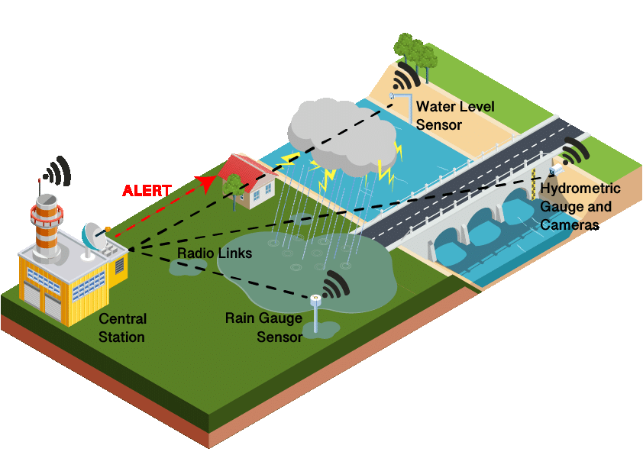

The developed SMS application acts as the brain of the entire system. It performs processing on data sent by the water level monitoring system, responsible in uploading an update for the web-based monitoring, sending notification to the concern stakeholders and reply on request for update through keywords. The SMS application implement fuzzy logic algorithm in giving notifications. Based from the alert level received that served as input, the application can provide a warning status as an output.

**CONCLUSION:**

The project contributes towards economy and the citizens. It envisions a safe, prepared and less casualty community before, during and after typhoon devastation. The model also promotes the use of real-time monitoring system through the developed web-based application and SMS notification system as an

easy medium in disseminating information particularly in the remote areas. By allowing the system in two-way communication, it gives more flexibility in providing important information to the community. Finally, the developed flood monitoring and early warning system that utilizes ultrasonic sensor to detect water level, functions perfectly according to the specification provided. It successfully passed several tests based on the different parameters.

