MelSpectrogram
- A mel-spectrogram is a visual representation of an audio signal that shows how the energy or power of the signal is distributed across different frequencies over time, but with a twist: the frequency scale is transformed to match how humans perceive sound.
- X- axis -> time
- Y_axis -> frequency, but scaled to match human hearing (mel scale = human hearing )
- Color -> represents the strength or amplitude of the signal at each time and frequency point.
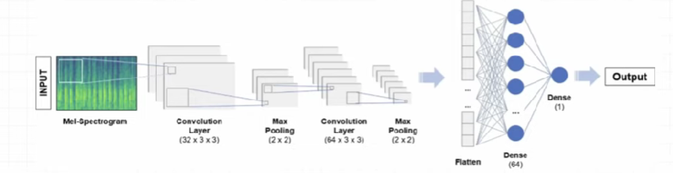
- Steps to build mel-spectrogram
  - We took samples of air pressure over time to digitally represent an audio signal ( taking the audio signal )
  - We mapped the audio signal from the time domain to the frequency domain using the fast fourier transform ( it is a method to transform the audio signal from time domain to frequency domain) and we performed this on overlapping windowsed segments of the audio signal.
  - We converted the y-axis ( frequency ) to a long scale and the color dimension (amplitude) to describes to form the spectrogram.
  - We mapped the y-axis (frequency) on to the mel scale to form the melspectrogram.
- Why fourier transform?
  - Revealing hidden patterns ( to extract the important features)
  - Human perception alignment: human hearing is more sentsitive to changes in frequency rather than changes in amplitude over time
  - Feture extraction: many important audio features are based on the frequency content of the signal
  - Noise reduction and filtering: easier to apply filters to isolate certain frequency bands, remove noise or enhance specific components of the signal
  - Compression and encoding: audio compression algorithms such as mp3 rely on frequency domain representations to efficiently encode audio data by removing perceptually less important components.
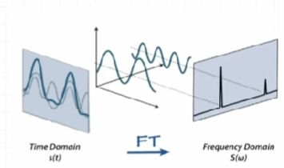

- MelScale
  - Humans hear frequencies in a non-linear way; we are more sensitive to lower frequencies and less sensitive to higher frequencies. The mel scale adjusts the frequency axis of the spectrogram so that it matches human hearing. Lower frequencies are spaced out more, and higher frequencies are spaced closer together.
