FinServe — AWS Compliance Auditing
Secure Logging • Monitoring • Encrypted Storage • Access Control
Practical Implementation Documentation

1. Objective
Design and implement a secure auditing architecture on AWS for FinServe, a financial organization that stores sensitive information. The solution records API operations and resource changes using AWS CloudTrail, stores audit records in Amazon S3, encrypts log files with AWS KMS, analyzes events with CloudWatch Logs, controls permissions through IAM, and sends security notifications using CloudWatch Alarms and Amazon SNS.

2. Proposed Architecture
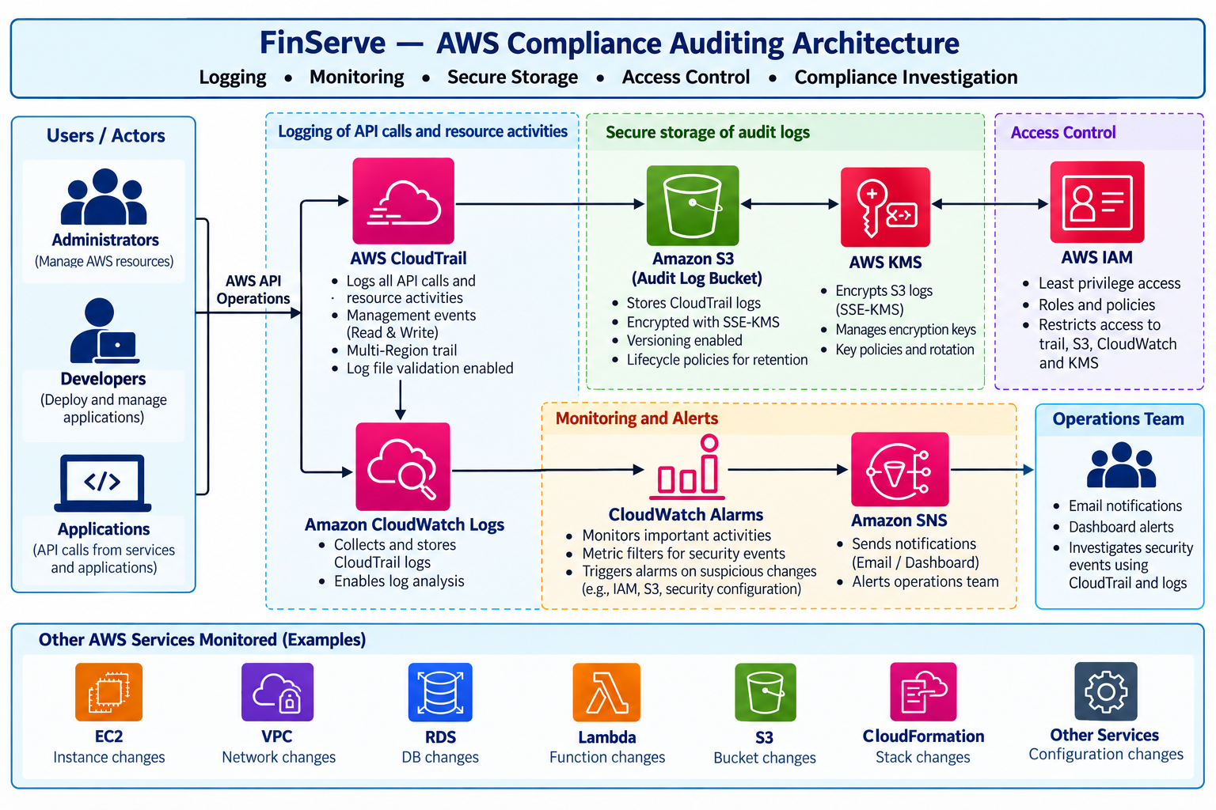
Figure 1. Proposed FinServe AWS compliance-auditing architecture.
The diagram is a proposed design, not proof that every resource has been configured. Confirm each setting in the AWS Console before marking the implementation complete. Keep the audit bucket private and restrict access to the audit records using IAM and the KMS key policy.

3. Architecture Components
Component | Purpose
AWS CloudTrail | Records management API activity and resource changes, including read and write management events.
Amazon S3 | Stores CloudTrail audit files and supports versioning and lifecycle retention settings.
AWS KMS | Provides the customer-managed encryption key used for CloudTrail log-file SSE-KMS encryption.
CloudWatch Logs | Receives CloudTrail events for searching, analysis, and metric-filter evaluation.
CloudWatch Alarms | Evaluates custom metrics and changes state when a configured security-event threshold is reached.
Amazon SNS | Sends alarm notifications to the operations/security team by email or another configured endpoint.
AWS IAM | Applies least-privilege roles and policies to control access to trails, logs, the S3 bucket, and KMS.

4. Implementation Procedure

Step 1: Create the S3 audit-log bucket
Purpose: Provide a private destination for audit records.
- Open AWS Console → S3 → Create bucket.
- Enter a globally unique name such as finserve-cloudtrail-audit-<unique-suffix> and select the intended AWS Region.
- Keep Block all public access enabled and use ACLs disabled (Bucket owner enforced).
- Enable bucket versioning. Keep default encryption enabled; CloudTrail SSE-KMS will be configured in the trail.
- Create the bucket. Do not add public bucket policies or public access permissions.
Expected verification: The bucket exists, is private, and versioning is enabled.

Step 2: Create a customer-managed KMS key
Purpose: Encrypt CloudTrail log files with a customer-managed key.
- Open AWS KMS → Customer managed keys → Create key.
- Choose Symmetric and Encrypt and decrypt.
- Create an alias such as alias/finserve-cloudtrail-key and add a description for audit-log encryption.
- Select authorized key administrators and key users. Grant only the access needed for this lab.
- Create the key in the same Region as the S3 bucket and record the key alias/ID.
Expected verification: The KMS key is enabled and available in the same Region as the destination bucket.

Step 3: Create and configure the CloudTrail trail
- Open CloudTrail → Trails → Create trail. Use the name FinServe-Audit-Trail.
- Choose the existing FinServe audit bucket and, if desired, use a prefix such as cloudtrail/.
- Enable SSE-KMS log-file encryption and select the finserve-cloudtrail-key key.
- Enable log file validation to support integrity verification of delivered log files.
- Configure a new CloudWatch Logs log group such as /aws/cloudtrail/FinServeAudit and allow the console to create/select the required delivery role.
- Enable management events for both Read and Write activity. Prefer a multi-Region trail for broader account coverage.
- Review the settings and create the trail.
Expected verification: The trail is logging, the S3 destination and KMS key are configured, and CloudWatch Logs delivery is enabled.

Step 4: Verify audit-log delivery
- Open CloudTrail → Event history and inspect recent management events.
- Open S3 → the audit bucket and check for the AWSLogs/ account folder structure after delivery has had time to occur.
- Open CloudWatch → Logs → Log groups and open /aws/cloudtrail/FinServeAudit.
- Confirm that log streams and events appear. Delivery can take several minutes.
Expected verification: A recent event is visible in Event history and delivered to the configured destinations.

Step 5: Apply least-privilege IAM access
- Open IAM and review the identities and roles used by the lab.
- Use the CloudTrail-created delivery role for CloudWatch Logs; do not remove required delivery permissions.
- Restrict access to the audit bucket and KMS key to approved administrators and required AWS services.
- Avoid granting broad S3 or KMS permissions when a narrower resource-scoped policy is sufficient.
- Do not store long-lived access keys in source code or upload them into the audit bucket.
Expected verification: Only intended identities can read audit logs or use the encryption key.

Step 6: Create an SNS topic and email subscription
- Open Amazon SNS → Topics → Create topic and choose Standard.
- Name the topic FinServe-Security-Alerts and create it.
- Open the topic → Create subscription. Select Email and enter an email address you can access.
- Open the confirmation email and confirm the subscription.
- Return to SNS and verify that the subscription status is Confirmed.
Expected verification: The SNS topic exists and the email endpoint is confirmed.

Step 7: Create a CloudWatch metric filter
Purpose: Detect important IAM changes from the CloudTrail events delivered to CloudWatch Logs.
Open CloudWatch → Logs → Log groups → /aws/cloudtrail/FinServeAudit. Create a metric filter using this pattern:
{ ($.eventName = "CreateUser") || ($.eventName = "DeleteUser") || ($.eventName = "CreateRole") || ($.eventName = "DeleteRole") || ($.eventName = "AttachRolePolicy") || ($.eventName = "DetachRolePolicy") || ($.eventName = "PutRolePolicy") || ($.eventName = "DeleteRolePolicy") || ($.eventName = "PutUserPolicy") || ($.eventName = "DeleteUserPolicy") }
- Name the filter FinServe-IAM-Changes.
- Use metric namespace FinServe/Security, metric name IAMChanges, and metric value 1.
- Create the metric filter. A test may show no matches until a matching event is generated.
Expected verification: The metric filter is saved against the correct CloudWatch log group.

Step 8: Create a CloudWatch alarm
- Open CloudWatch → Alarms → Create alarm → Select metric.
- Choose Custom namespaces → FinServe/Security → IAMChanges.
- Set statistic to Sum, period to 5 minutes, and alarm threshold to greater than or equal to 1.
- Configure the In alarm notification to publish to FinServe-Security-Alerts.
- Name the alarm FinServe-IAM-Change-Alarm and create it.
Expected verification: The alarm exists and its notification action points to the SNS topic.

Step 9: Generate a safe test event
- Use a permitted test action in your lab account, such as creating a clearly named test IAM user, only if account policy allows it.
- Do not attach permissions or create access keys for the test user unless specifically required.
- Wait for CloudTrail delivery and then search CloudTrail Event history for CreateUser or the event you generated.
- Check the CloudWatch log group and the metric/alarm state. Metric publication and alarm evaluation may take several minutes.
- If testing with an IAM user is not permitted, use another allowed management event that matches your configured filter, or adjust the filter to a safe event you can generate.
Expected verification: The activity is recorded and searchable. An alarm/email is expected only after the matching event reaches the metric filter and the alarm evaluates the metric.

Step 10: Investigate a specific activity
- Open CloudTrail → Event history and set the time range to include the test.
- Filter by the event name, for example CreateUser, and open the matching event.
- Inspect event time, event source, AWS Region, user identity/role, source IP address, request parameters, and affected resources.
- Cross-check the event in CloudWatch Logs and locate the corresponding audit files in S3.
- Record the investigation result and retain the event details as evidence for the practical.
Expected verification: You can explain who performed the action, what API operation occurred, when it occurred, and which resource was affected.

5. Data Flow and Validation
Users / Apps | AWS API  operations | CloudTrail | S3 + KMS  secure storage | CloudWatch Logs  → Alarm → SNS
Validation sequence: generate a permitted test action → find the event in CloudTrail → verify CloudWatch Logs delivery → verify encrypted S3 storage → confirm metric/alarm behavior → review SNS notification.

6. Final Verification Checklist
☐ S3 audit bucket is private; Block Public Access and versioning are enabled.
☐ KMS customer-managed key is enabled and in the same Region as the S3 destination.
☐ CloudTrail trail is logging and records Read and Write management events.
☐ Log file validation is enabled.
☐ CloudTrail delivery to S3 and CloudWatch Logs is verified.
☐ IAM access follows least privilege for logs and the KMS key.
☐ SNS email subscription is Confirmed.
☐ Metric filter and CloudWatch alarm are configured.
☐ A test activity can be located in CloudTrail Event history.
☐ The event can be investigated using identity, event time, source IP, API name, and resource details.

7. Result
The FinServe architecture is designed to record AWS management activity, store audit records in S3, protect log files with KMS encryption, analyze events through CloudWatch Logs, restrict access using IAM, and notify the operations team through CloudWatch Alarms and SNS. State that the implementation is successful only after the verification checklist has been completed in the AWS Console.

8. Conclusion
This practical demonstrates how CloudTrail, S3, CloudWatch Logs, IAM, KMS, CloudWatch Alarms, and SNS can be combined to support secure compliance auditing. It also demonstrates an investigation workflow for a specific AWS API activity. Keep the audit bucket private, preserve least-privilege access, and verify actual delivery and alert behavior before claiming end-to-end completion.

