A Multi-Signal Framework for Detecting Knowledge Decay in Enterprise Knowledge Bases Using Authoritative Source Comparison
Chapters 3 and 4 - Draft

Chapter 3
Methodology
3.1 Research Paradigm
A research paradigm defines the underlying philosophical assumptions about the nature of reality and how knowledge about that reality can be obtained, and the choice of paradigm shapes every subsequent methodological decision in this chapter. Three paradigms are commonly distinguished in information systems research: positivism, which treats reality as objective and measurable and favours quantitative, hypothesis-testing methods; interpretivism, which treats reality as socially constructed and favours qualitative methods that capture meaning and context; and pragmatism, which rejects the need to commit fully to either position and instead selects whatever combination of methods best addresses the practical research problem at hand.
This research adopts a pragmatist paradigm. A purely positivist stance would be difficult to sustain in full: while the framework's output is a measurable score validated against precision, recall and F1, the ground-truth labels that evaluation depends on are themselves the product of human judgement about what counts as "decayed", an interpretive act rather than an objectively given fact. Conversely, a purely interpretivist stance would be insufficient, since the research question specifically requires a measurable, comparative claim about detection performance rather than a rich contextual account. Pragmatism is consistent with the Design Science Research orientation established in Chapter 1: it is concerned primarily with whether an artefact works to solve a genuine practical problem, and permits the combination of a largely quantitative evaluation methodology with the qualitative judgement inherent in constructing a labelled dataset, without requiring either element to be treated as illegitimate.
3.2 Research Approach
A deductive approach begins from established theory or existing findings, derives a testable expectation from that theory, and then collects data to confirm or refute it. An inductive approach works in the opposite direction, beginning from observations and building toward a new theory or pattern. A criss-cross (abductive) approach moves iteratively between the two.
This research adopts a deductive approach. The starting point is not an open-ended observation but a specific, literature-derived expectation, established in Chapter 2: that no single existing signal, whether semantic similarity, platform metadata or structured fact-checking, is sufficient on its own to detect decay in unstructured third-party technical content, and that combining multiple complementary signals should outperform any single-signal baseline. This expectation is then tested empirically in Chapter 6 through a structured comparison between the proposed multi-signal framework and single-signal baselines. This is a deductive structure: theory and prior literature first, a specific testable expectation second, and empirical evaluation third.
3.3 Research Strategy
Of the strategies commonly available - experimental, action research, case study and phenomenology - this research adopts an experimental strategy. An experimental strategy is appropriate where a researcher constructs an artefact or intervention under controlled conditions and measures its effect against a defined baseline, which is precisely the structure of this research: a prototype framework is built, a labelled evaluation dataset with a known ground truth is constructed independently of the framework, and the framework's output is measured against that ground truth using standard classification metrics, with single-signal variants used as controlled baselines in an ablation study. Action research was not selected because it requires an iterative intervention within a real organisational setting with ongoing stakeholder participation, which is outside the scope defined in Section 1.10. Case study and phenomenology were not selected because both are oriented toward rich, context-specific qualitative understanding of a single instance or lived experience, whereas this research requires a generalisable, measurable comparison across many articles.
3.4 Fact Collection Mechanisms
Of the fact collection mechanisms commonly available - questionnaires, interviews, controlled interviews, expert opinions, participation assessment and focused discussion - this research relies primarily on expert opinion, used narrowly and only in a validation capacity. As established in the Ethics Form completed for this project, this research does not collect data from human participants: no questionnaires, interviews or focused discussions are conducted. This decision was made deliberately rather than by default, since introducing a participant-based data collection method would have required a materially different ethics approval process and would not have been necessary to answer the research question, which concerns the performance of an artefact against a labelled dataset rather than the opinions or behaviour of a population of people. Where expert judgement is used, it takes the narrow form of an optional secondary review of a sample of the ground-truth labels applied to the evaluation dataset, to sense-check the primary labelling rather than to gather new data from participants, and this review does not constitute research involving human participants in the sense the Ethics Form screens for.
3.5 Research Methodology Execution Workflow
Table 3.1 summarises how each stage of the overall research process has been, or will be, addressed, and identifies where in this dissertation each stage is documented in full.
Table 3.1: Research methodology execution workflow
Stage | How Addressed | Documented In
Problem Identification | Identification of knowledge decay as a documented, costly and currently unresolved problem for enterprise IT documentation | Chapter 1
Relevance Justification | Grounded in industry evidence of the cost of poor knowledge management and in academic evidence that stale content degrades both human and AI decision-making | Chapter 1, Section 2.3
Comparative Analysis and Gap Justification | Systematic review and comparison of existing systems, algorithms, design patterns and workflows relevant to content-decay detection | Chapter 2
Define and Finalise Objectives | Four research objectives derived directly from the identified gap, each mapped to a specific deliverable | Chapter 1, Section 1.7
Design / Development / Data Management | System design (this chapter and Chapter 4), prototype implementation, and construction of the evaluation dataset under a defined data management plan | Chapters 3-5
Evaluation and Communication | Structured experimental evaluation against baselines and an ablation study, with findings communicated through the dissertation and viva | Chapters 6-7

3.6 Design Methodology
Two broad design methodologies were considered: Object-Oriented Analysis and Design (OOAD) and Structured Systems Analysis and Design (SSAD). SSAD, built around functional decomposition and data-flow diagrams, reflects an older, process-centric view of system design that maps less naturally onto a system whose core complexity lies in the behaviour and relationships of a small number of well-defined entities (an article, an authoritative source, a decay signal, a scorer, a result) rather than in a large hierarchy of discrete data-transformation processes. OOAD, by contrast, models the system as a set of collaborating objects with clearly defined responsibilities, which maps directly onto the framework's actual structure, as shown in the Class Diagram in Section 4.6, and supports the use of UML throughout Chapter 4. This research therefore adopts OOAD exclusively as its design methodology, and does not mix it with SSAD elements, consistent with the guidance that the two should not be combined within a single design.
3.7 Project Management Methodology
Of the commonly considered project management methodologies - Scrum, Kanban and PRINCE2 - this research adopts Kanban. Scrum was considered but not selected because its ceremonies and roles (Scrum Master, Product Owner, fixed-length sprints with sprint planning and retrospectives) assume a team of contributors and do not map naturally onto a single-researcher MSc project; adopting Scrum’s full ceremony set for a project with only one contributor would add administrative overhead without a corresponding benefit. PRINCE2 was also considered and rejected as disproportionately formal and documentation-heavy for a project of this scale and duration. Kanban was selected because its core mechanism - a continuously visible backlog of tasks moved through states such as To Do, In Progress and Done - suits a single researcher managing an evolving set of build, evaluation and writing tasks without needing fixed iteration boundaries, while still providing a visual record of progress that can be reviewed at each scheduled supervision session, which serve as natural review checkpoints in place of formal sprint reviews.
3.7.1 Project Timeline
The project timeline, first presented in the proposal and reproduced here, is structured around the fixed supervision and submission schedule set by the module.
Table 3.2: Project timeline
Task | Jul | Aug | Sep | Oct | Nov
Proposal Approval | X
Literature Review | X | X
Framework Design | X | X
Dataset Collection & Labelling |  | X | X
Prototype Development |  | X | X | X
Experimental Evaluation |  |  | X | X
Results Analysis |  |  |  | X
Dissertation Writing |  |  | X | X | X
Final Review & Submission |  |  |  |  | X

3.7.2 LSEP Aspect (Legal / Social / Ethical / Professional)
Table 3.3 sets out how each LSEP dimension applies specifically to this research.
Table 3.3: LSEP analysis in relation to this research
Dimension | Application to This Research
Legal | Only publicly accessible third-party content is used, consistent with copyright and licensing terms; full article text is retained privately rather than republished, and the public GitHub repository excludes raw scraped content.
Social | The research aims to improve the reliability of technical decision-making within enterprise IT teams by reducing reliance on undetected outdated guidance.
Ethical | The framework evaluates documentation, not individuals or organisations, minimising bias and privacy risk; no personal or confidential data is collected, consistent with the completed Ethics Form.
Professional | Data integrity, accurate citation and reproducibility are maintained throughout; all technology and methodology choices are justified rather than adopted by default.

3.7.3 Risk Identification and Mitigation
Table 3.4 identifies the principal risks to this project and the corresponding mitigation adopted for each.
Table 3.4: Risk identification and mitigation strategy
Risk | Likelihood | Impact | Mitigation
Limited prior development experience delays implementation | Medium | High | Modular design with each component tested independently; supervision sessions used to validate design decisions before implementation begins
Evaluation dataset too small to yield statistically meaningful results | Medium | Medium | Dataset supplemented with systematically generated synthetic decay cases alongside genuine articles, discussed in Chapter 6
Microsoft Learn content structure changes during the project | Low | Medium | Authoritative corpus snapshot cached locally at a fixed point, rather than queried live, so results remain reproducible
Azure subscription budget exhausted before evaluation is complete | Low | Medium | Cloud resources reserved only for one-off bulk embedding tasks; day-to-day development performed on local hardware
Scope creep beyond the boundaries defined in Section 1.10 | Medium | High | Explicit in-scope/out-of-scope table agreed early and revisited at each supervision session before new work is undertaken

3.8 Chapter Summary
This chapter has set out and justified the methodological foundation of this research: a pragmatist paradigm, a deductive approach, an experimental strategy, and expert opinion used narrowly as the sole fact collection mechanism, consistent with the project's ethics scope. It has presented the research execution workflow, justified Object-Oriented Analysis and Design as the design methodology, and justified Kanban as the project management methodology, supported by a project timeline, an LSEP analysis and a risk identification and mitigation strategy. The next chapter translates this methodological foundation into a concrete system requirement specification.

Chapter 4
System Requirement Specification
4.1 Chapter Overview
This chapter translates the problem defined in Chapter 1 and the methodological decisions justified in Chapter 3 into a concrete specification for the system to be built. It identifies the stakeholders affected by the system, explains how requirements were derived given the project's ethics scope, and presents the system's behaviour and structure through a set of UML diagrams: a use case diagram, a class diagram, an activity diagram and a sequence diagram, alongside a proposed system architecture. The chapter concludes with a consolidated statement of functional and non-functional requirements.
4.2 Stakeholder Analysis
Figure 4.1 presents the system's stakeholders using an onion model, which organises stakeholders by their proximity to the system rather than by a flat, unordered list. At the core sits the system itself. The operational ring contains those who interact with the system directly: the IT professional, who submits articles and consumes results, and the researcher, who develops and evaluates the system. The contextual ring contains those who govern and assess the research but do not use the system operationally: the module leader and supervisor, and the university examiners at the viva. The wider environment contains stakeholders who are affected indirectly or who define the environment the system operates within: Microsoft, as the maintainer of the authoritative source the system depends on, and enterprise organisations more broadly, as the eventual beneficiaries of more reliable technical decision-making.
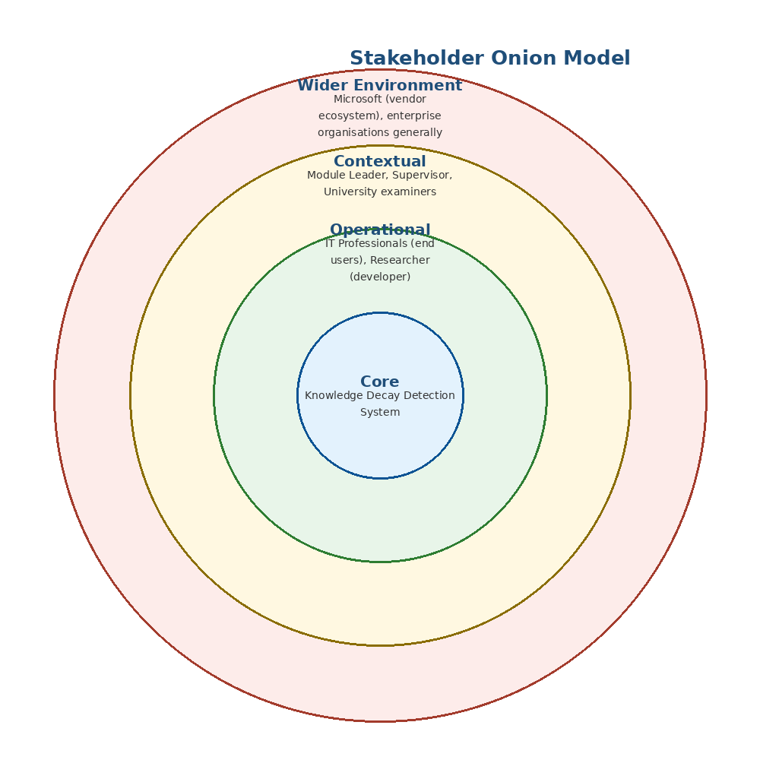
Figure 4.1: Stakeholder onion model
4.2.1 Implications of the Onion Model
The onion model has a direct design implication worth making explicit: the operational ring, not the wider environment, is this project's primary design target. The system is built to be used and evaluated by the researcher and to be usable by an IT professional; it is not built to directly serve Microsoft or the wider enterprise environment, which benefit only indirectly, through improved decisions made by IT professionals who use it. This distinction keeps the requirements in this chapter focused on the operational ring rather than expanding to satisfy stakeholders the project's scope, defined in Section 1.10, was never intended to reach.
4.3 Requirements Derivation Process
The generic process for deriving system requirements often involves a participant questionnaire, mapped against research objectives, with the reviewed results used to justify the validity of the selected requirements. This research adopts a deliberately different process, consistent with the fact collection decision justified in Section 3.4: because no questionnaires, interviews or other participant-based data collection are conducted, requirements are instead derived directly from the literature-identified gap established in Chapter 2 and the research objectives defined in Section 1.7, rather than from a participant survey. Table 4.1 makes this mapping explicit, tracing each requirement area back to the specific research objective and literature finding that motivates it.
Table 4.1: Mapping of requirement areas to research objectives and literature findings
Requirement Area | Research Objective | Literature Basis
Multi-signal decay detection (semantic, terminology, links, deprecated tech, temporal) | Objective 1: identify critical decay indicators | Section 2.5 - no single existing signal is sufficient alone
Semantic comparison against an external authoritative source | Objective 2: analyse semantic and authoritative-source comparison methods | Section 2.5.1 - SBERT measures similarity but not currency alone
Explainable output with contributing reasons, not a single score | Objective 3: implement an explainable prototype | Section 2.8 (FRESCO/An et al., 2026) - opaque scores cannot be checked by a user
Comparative evaluation against single-signal baselines and an ablation study | Objective 4: comparative evaluation against traditional methods | Section 2.6 - existing approaches evaluated using precision/recall/F1 against labelled data

4.4 Justification of Requirement Validity
In the absence of participant validation, requirement validity is instead established through direct traceability: every requirement in Section 4.11 can be traced, via Table 4.1, to a specific research objective and a specific literature finding, rather than to an unsupported design preference. Where a candidate requirement could not be traced to either the objectives or the literature review, it was treated as out of scope and recorded in Table 1.1 (Section 1.10) rather than included here. This traceability is treated as this project's substitute for participant-based requirement validation, and its limitation is acknowledged directly: it establishes that each requirement addresses an identified problem, but does not independently confirm that practitioners would prioritise these requirements in the way the literature suggests. This is recorded as a limitation of the study in Chapter 7 rather than resolved within the current scope.
4.5 Use Case Diagram and Specifications
Figure 4.2 presents the system's use cases for its two identified operational-ring actors: the IT Professional, who represents the system's end user, and the Researcher, who represents the developer acting in an evaluation capacity.
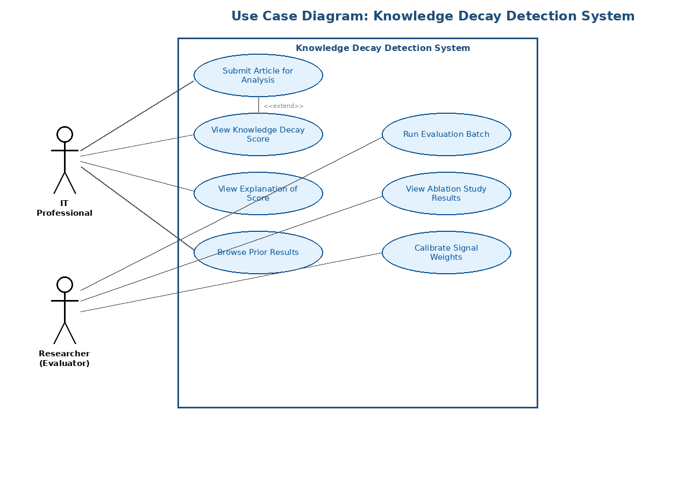
Figure 4.2: Use case diagram
4.5.1 Use Case Specification: Submit Article for Analysis
Table 4.2: Use case specification - Submit Article for Analysis
Field | Description
Actor | IT Professional
Preconditions | The system is running and the user has a URL or pasted text of a third-party technical article
Main Flow | 1. User opens the Streamlit interface. 2. User submits an article URL or pasted text. 3. System extracts and processes the content. 4. System returns a Knowledge Decay Score with explanation.
Alternative Flow | If content extraction fails (e.g. inaccessible URL), the system returns an error message rather than a score
Postconditions | A Knowledge Decay Score and explanation are displayed; the submitted article content is not persisted

4.5.2 Use Case Specification: Run Evaluation Batch
Table 4.3: Use case specification - Run Evaluation Batch
Field | Description
Actor | Researcher
Preconditions | A labelled evaluation dataset exists locally, as described in Chapter 6
Main Flow | 1. Researcher initiates a batch run against the evaluation dataset. 2. System scores every article in the dataset. 3. System compares predicted categories against ground-truth labels. 4. System reports precision, recall, F1-score and ablation results.
Alternative Flow | If a dataset entry cannot be processed, it is logged and excluded from the aggregate metrics rather than halting the batch
Postconditions | Evaluation metrics are produced and available for inclusion in Chapter 6

Detailed specifications for the remaining use cases shown in Figure 4.2 follow the same structure as Tables 4.2 and 4.3 and are provided in Appendix A, in line with the guidance to include only the most significant use case specifications in the main chapter.
4.6 Class Diagram
Figure 4.3 presents the core classes of the proposed framework and their relationships, reflecting the Object-Oriented Analysis and Design methodology adopted in Section 3.6. The DecaySignal class is shown as an abstract base class, with SemanticSimilaritySignal, TerminologyDriftSignal, BrokenLinkSignal and DeprecatedTechSignal as concrete subclasses, reflecting the multi-signal design established in Chapter 2. A TemporalSignal subclass follows the same pattern and is omitted from the diagram only for legibility.
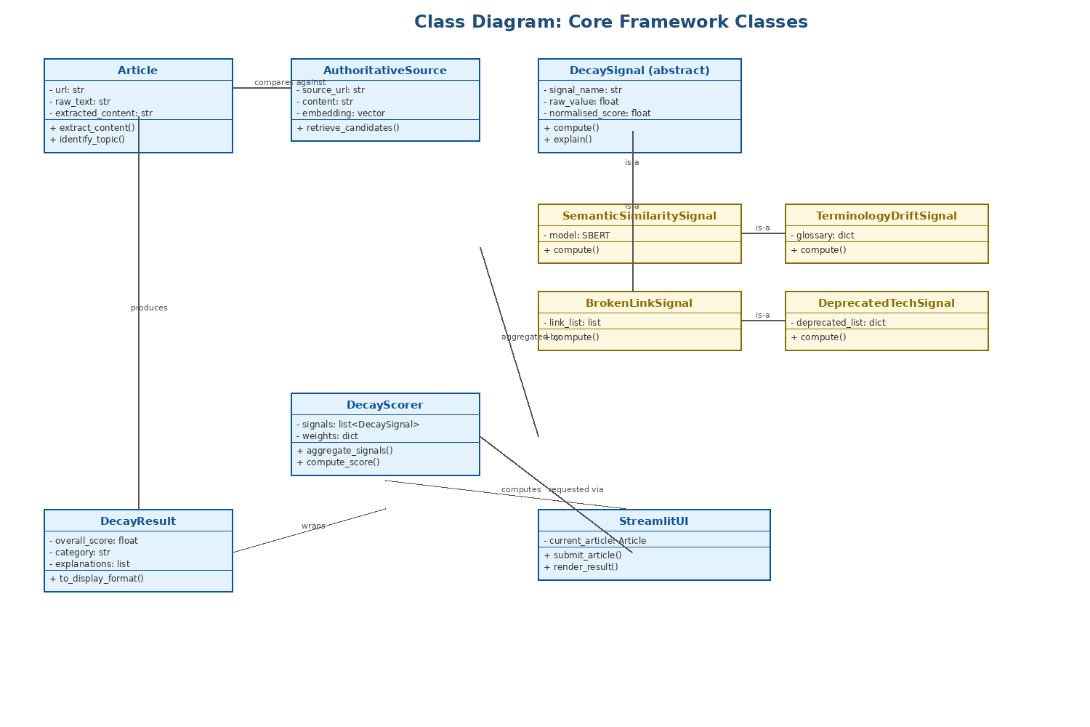
Figure 4.3: Class diagram
4.7 Activity Diagram
Figure 4.4 presents the end-to-end activity flow followed when an article is submitted for analysis, including the parallel evaluation of the five decay signals identified in Chapter 2 and the join point at which they are aggregated into a single score.
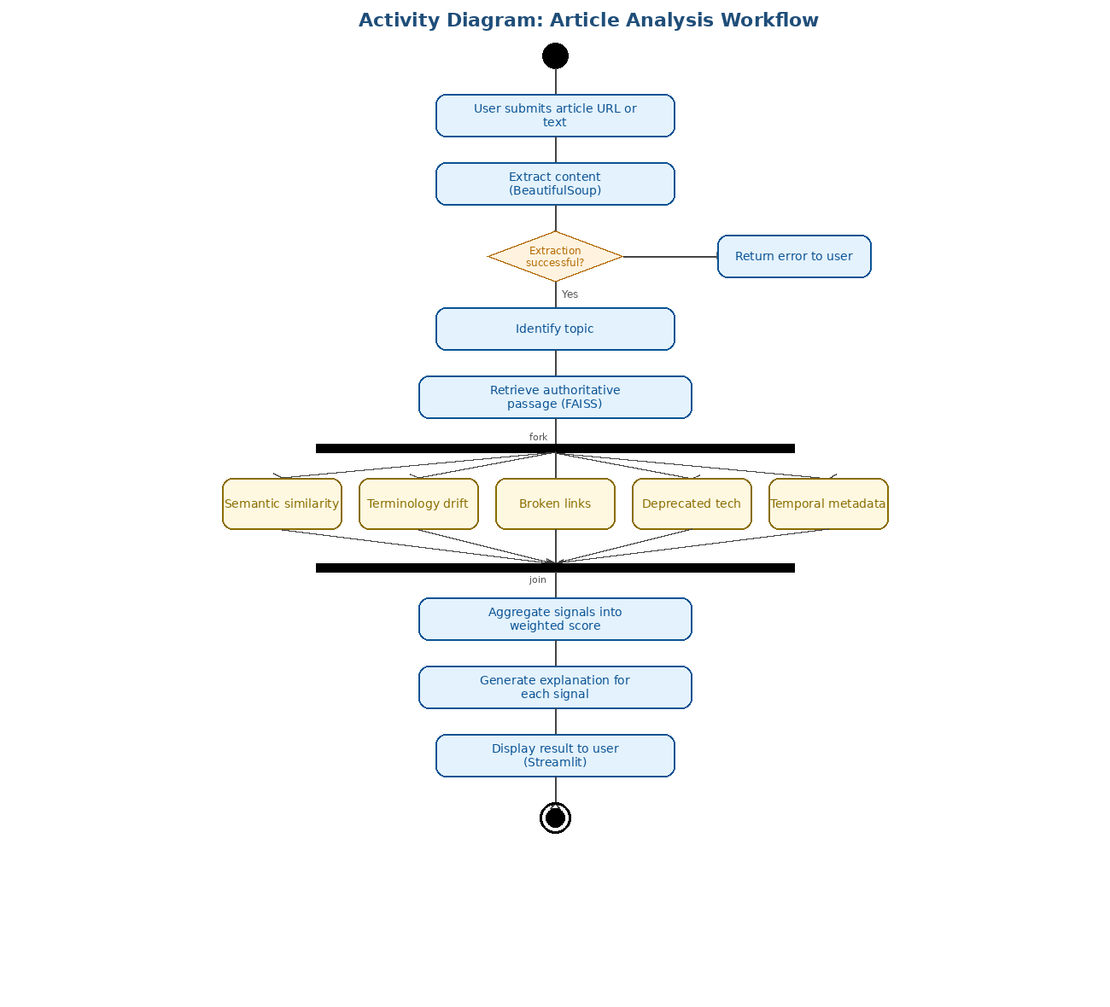
Figure 4.4: Activity diagram - article analysis workflow
4.8 Sequence Diagram
Figure 4.5 presents the sequence of interactions between the system's principal components for the "Submit Article for Analysis" use case, corresponding to the specification in Table 4.2. This is the single most significant sequence in the system and is therefore presented in full here, consistent with the guidance to limit sequence diagrams in the main chapter to the most important cases.
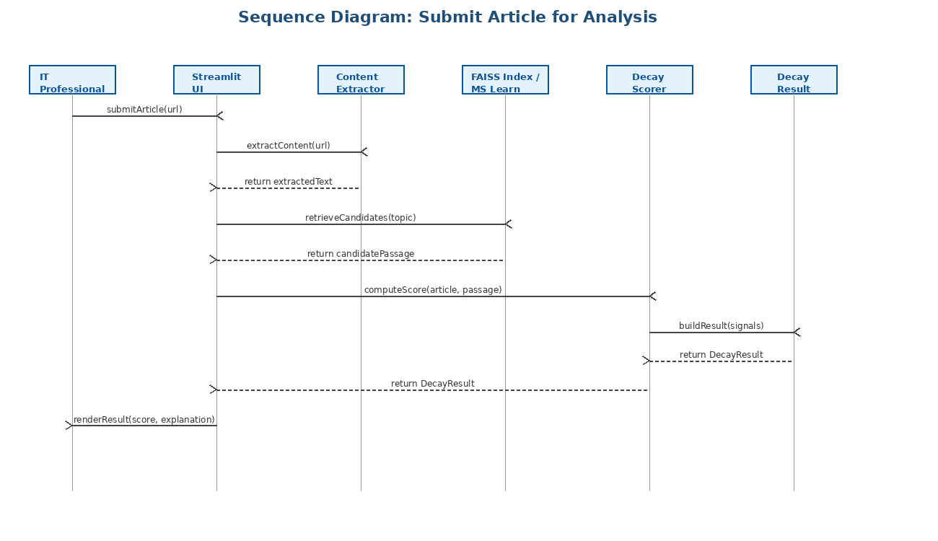
Figure 4.5: Sequence diagram - Submit Article for Analysis
4.9 State and Deployment Considerations
A separate state chart or deployment diagram was considered but judged unnecessary for this system. The framework does not have entities with sufficiently complex internal state transitions to justify a dedicated state chart beyond what the activity diagram in Figure 4.4 already captures, and the deployment topology, a single Streamlit application running against a local or Azure-hosted environment, is straightforward enough to be adequately described in prose in Section 1.9 (Resource Requirements) rather than requiring a separate diagram.
4.10 Proposed System Architecture
Figure 4.6 presents the proposed system architecture as a layered diagram, showing how the presentation, application and data/retrieval layers relate to each other and to the external sources the system depends on.
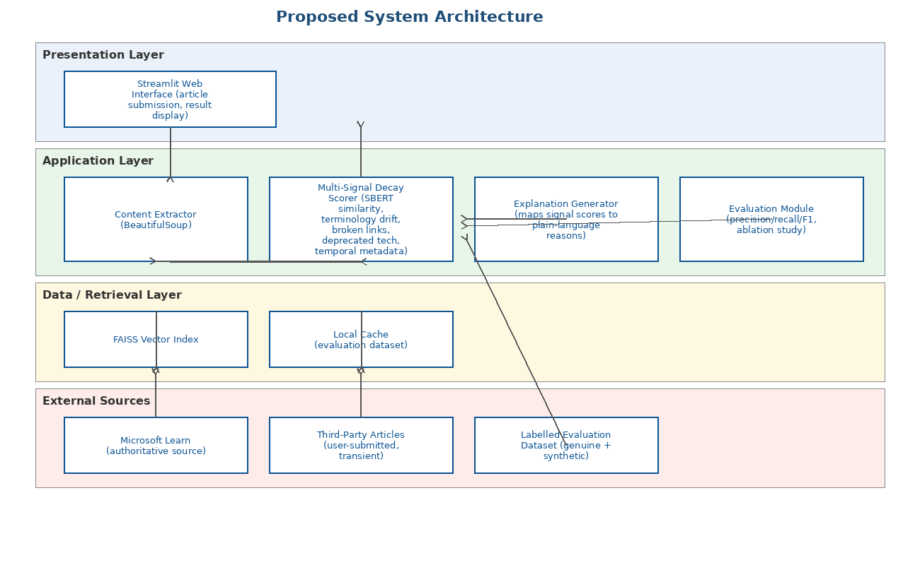
Figure 4.6: Proposed system architecture
4.11 Functional and Non-Functional Requirements
Table 4.4: Functional requirements
ID | Requirement
FR1 | The system shall accept a third-party article as either a URL or pasted text.
FR2 | The system shall extract the readable textual content from a submitted URL, excluding navigation, adverts and other non-article content.
FR3 | The system shall retrieve the most relevant corresponding passage from the Microsoft Learn authoritative corpus.
FR4 | The system shall compute a semantic similarity score between the submitted article and the retrieved authoritative passage.
FR5 | The system shall detect terminology drift by comparing product and feature names in the article against a maintained glossary of superseded terms.
FR6 | The system shall check all hyperlinks in the submitted article and identify any that are broken.
FR7 | The system shall check article content against a maintained list of deprecated technologies and features.
FR8 | The system shall combine all computed signals into a single weighted Knowledge Decay Score.
FR9 | The system shall present the score together with a plain-language explanation of the signals that contributed to it.
FR10 | The system shall not persist the content of an article submitted through the live interface beyond the current session.

Table 4.5: Non-functional requirements
ID | Category | Requirement
NFR1 | Performance | The system shall return a Knowledge Decay Score for a single submitted article within a reasonable interactive time frame on local hardware.
NFR2 | Usability | The system shall present results through a simple, single-page interface usable without developer-level technical knowledge.
NFR3 | Explainability | The system shall never present a Knowledge Decay Score without at least one accompanying, specific, human-readable reason.
NFR4 | Reliability | The system shall handle extraction failures gracefully, returning a clear error rather than an incorrect score.
NFR5 | Security/Privacy | The system shall not transmit or store submitted article content beyond what is required to compute and display a result.
NFR6 | Maintainability | Each decay signal shall be implemented as an independently testable component, consistent with the class design in Figure 4.3.

4.12 Chapter Summary
This chapter has translated the problem and methodology established in earlier chapters into a concrete system requirement specification. It identified the system's stakeholders using an onion model, explained how requirements were derived and validated in the absence of participant-based data collection, and presented the system's behaviour and structure through a use case diagram with detailed specifications for its two most significant use cases, a class diagram, an activity diagram, a sequence diagram and a proposed system architecture. It concluded with a consolidated set of functional and non-functional requirements that the implementation described in the next chapter is designed to satisfy.

