01.

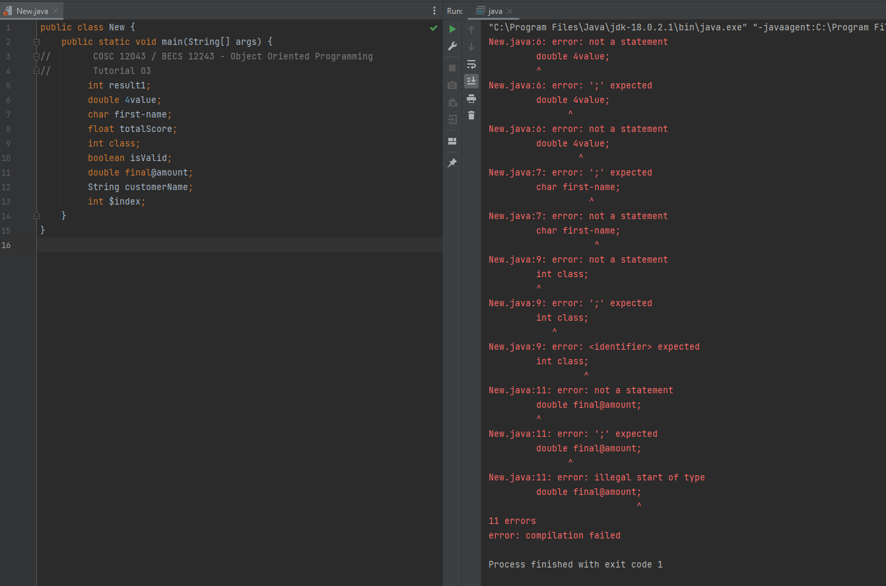

1. Ok
2. 1st character is a number
3. Unsupported characters for identifier( dash sign - )
4. Ok
5. ‘class’ is a Reserved keyword
6. Ok
7. Invalid character ‘@’
8. Ok
9. Ok

2.

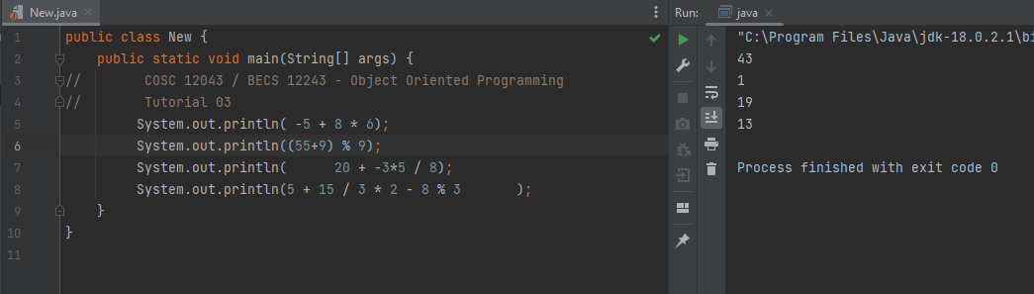

3.

i.

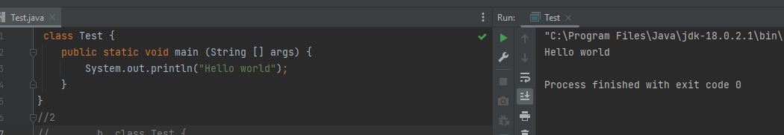

ii.

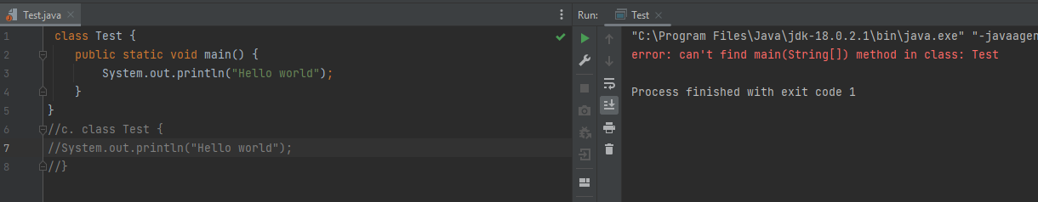

Unable to find Programme String Arguments Array

iii.

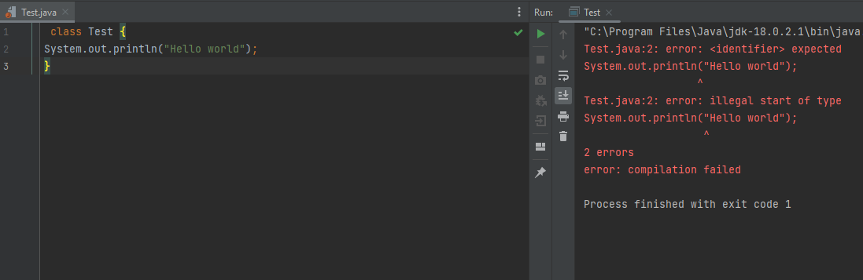

Doesn’t have main method.

4.

i). Return type of main method not mentioned

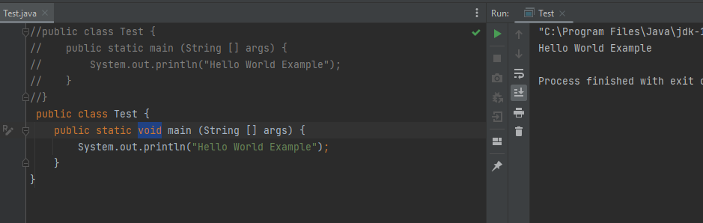

ii).

Arithmetic Exception

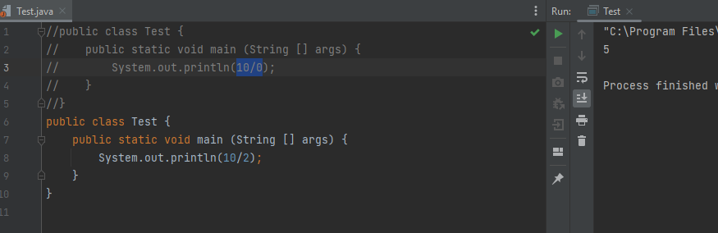

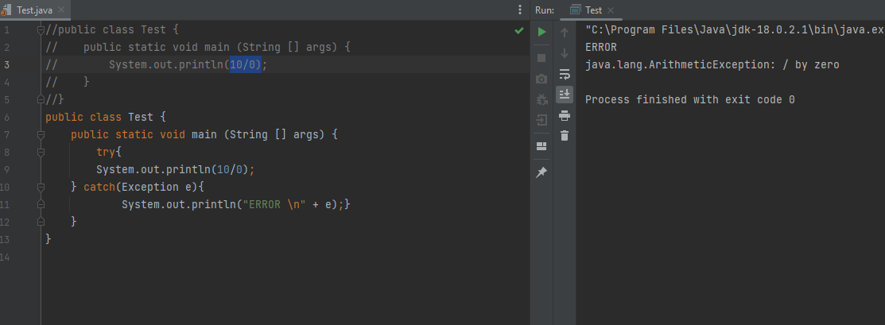

iii).

Logical Error

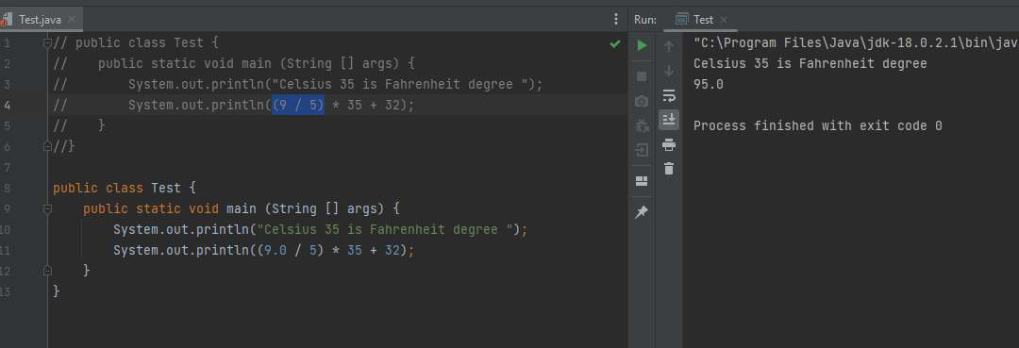

5.

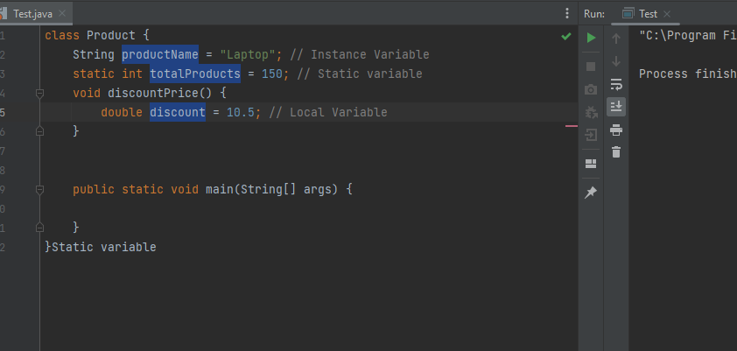

.

.

6.

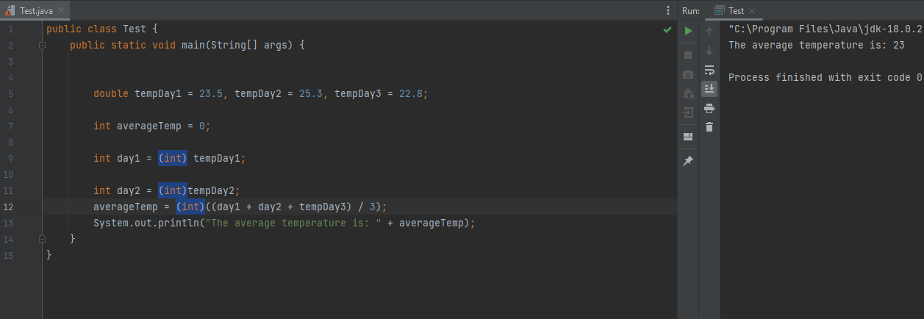

7.

a).

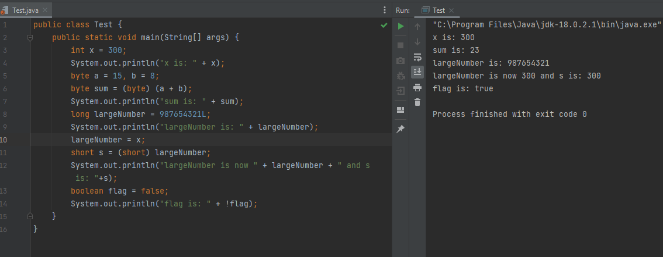

b).

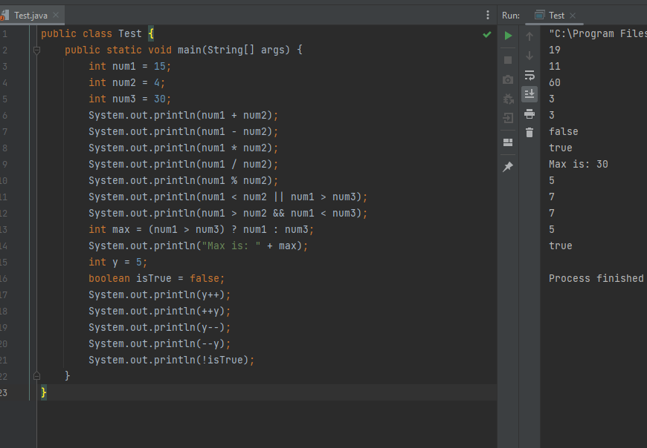

8).

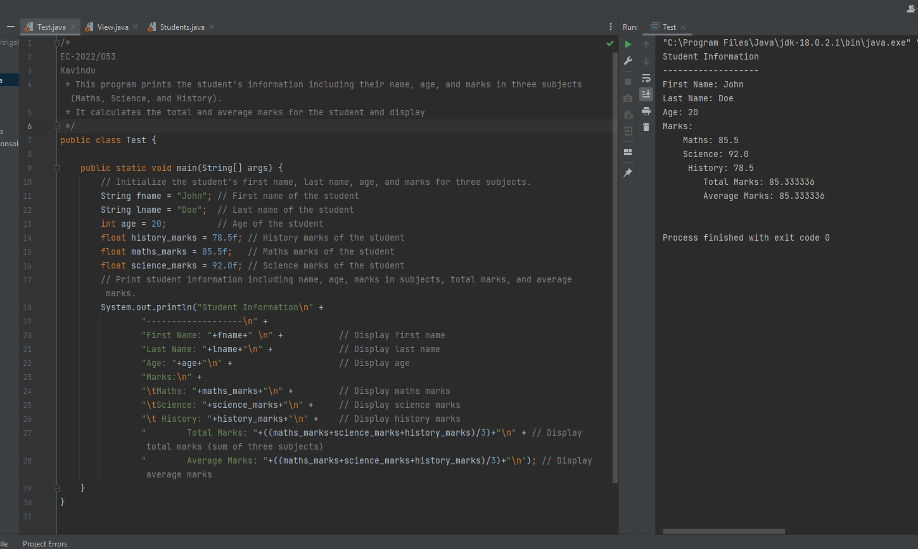

9.

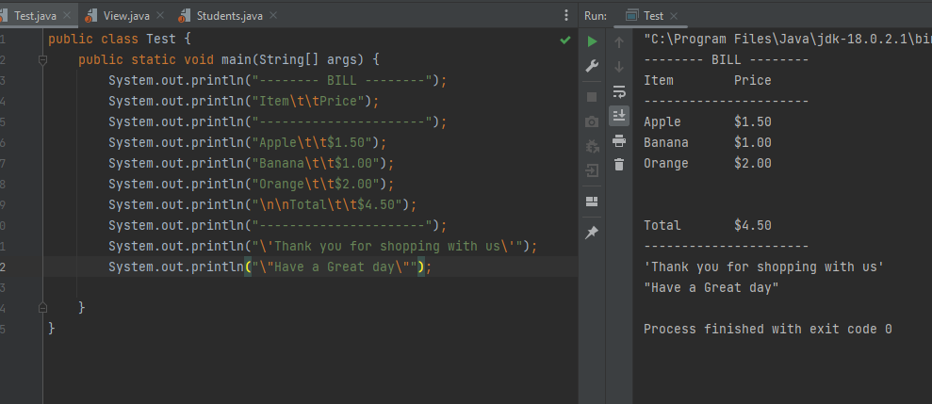

10.

