package SmartHomeDeviceManagmentSystem;

public class **SmartHomeManager** {

public static void main(String[] args) {

SmartDevice livingRoomLight = new Light("Living Room Light", 60, 5);

SmartDevice bedroomThermostat = new Thermostat("Bedroom Thermostat", 8, 1.5);

SmartDevice outdoorCamera = new SecurityCamera("Outdoor Camera", 4, 12);

livingRoomLight.calculateEnergyConsumption();

bedroomThermostat.calculateEnergyConsumption();

outdoorCamera.calculateEnergyConsumption();

System.out.println();

// To String Method is not nessesary

System.out.println(livingRoomLight.toString());

System.out.println(bedroomThermostat.toString());

System.out.println(outdoorCamera.toString());

System.out.println("\nOptimizing energy usage...");

((Thermostat) bedroomThermostat).optimizeEnergyUsage();

// Cast from type SmartDevice to type Thermostat to use //optimizeEnergyUsage()

((SecurityCamera) outdoorCamera).optimizeEnergyUsage();

//Cast from type SmartDevice to type SecurityCamera to use //optimizeEnergyUsage()

System.out.println();

System.out.println(livingRoomLight.toString());

System.out.println(bedroomThermostat.toString());

System.out.println(outdoorCamera.toString()); }

}

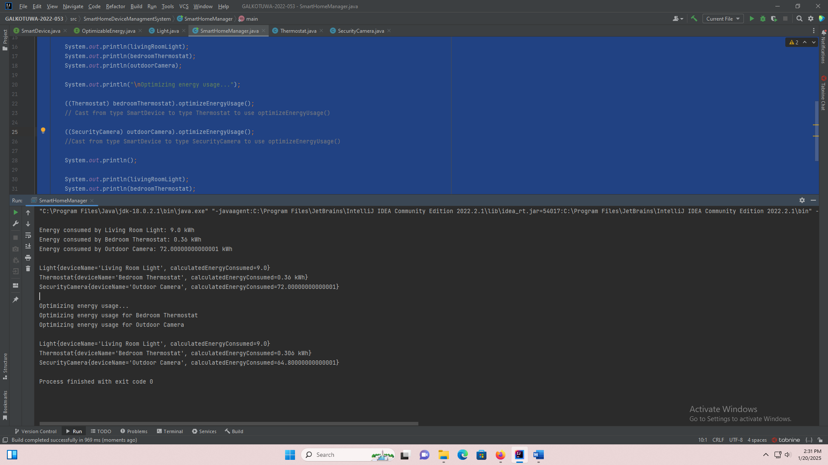

package SmartHomeDeviceManagmentSystem;

public interface **SmartDevice** {

void calculateEnergyConsumption();

}

package SmartHomeDeviceManagmentSystem;

public interface **OptimizableEnergy** {

void optimizeEnergyUsage();

}

package SmartHomeDeviceManagmentSystem;

public class **Light** implements SmartDevice{

private String deviceName;

private double wattage;

private double dailyUsageHours;

private double calculatedEnergyConsumed;

public Light(String deviceName, double wattage, double dailyUsageHours) {

this.deviceName = deviceName;

this.wattage = wattage;

this.dailyUsageHours = dailyUsageHours;

}

@Override

public String toString() {

return "Light{" +

"deviceName='" + deviceName + '\'' +

", calculatedEnergyConsumed=" + calculatedEnergyConsumed +

'}';

}

@Override

public void calculateEnergyConsumption() {

this.calculatedEnergyConsumed = (wattage*dailyUsageHours*30) / 1000;

System.out.println("\nEnergy consumed by " + deviceName + ": " + calculatedEnergyConsumed + " kWh");

}

package SmartHomeDeviceManagmentSystem;

public class **Thermostat** implements SmartDevice, OptimizableEnergy{

private String deviceName;

private double averageRuntimeHoursPerDay;

private double powerRating;

private double calculatedEnergyConsumed;

public Thermostat(String deviceName, double averageRuntimeHoursPerDay, double powerRating) {

this.deviceName = deviceName;

this.averageRuntimeHoursPerDay = averageRuntimeHoursPerDay;

this.powerRating = powerRating;

}

@Override

public String toString() {

return "Thermostat{" +

"deviceName='" + deviceName + '\'' +

", calculatedEnergyConsumed=" + this.calculatedEnergyConsumed +

" kWh}";

}

@Override

public void optimizeEnergyUsage() {

System.out.println("Optimizing energy usage for " + deviceName);

this.averageRuntimeHoursPerDay *= 0.85;

this.calculatedEnergyConsumed = (powerRating*averageRuntimeHoursPerDay*30) / 1000;

}

@Override

public void calculateEnergyConsumption() {

this.calculatedEnergyConsumed = (powerRating*averageRuntimeHoursPerDay*30) / 1000;

System.out.println("Energy consumed by " + deviceName + ": " + calculatedEnergyConsumed + " kWh");

}

}

package SmartHomeDeviceManagmentSystem;

public class **SecurityCamera** implements SmartDevice,OptimizableEnergy{

private String deviceName;

private final double typicalEnergyUsagePerMegapixelHour = 0.05;

private double resolutionInMegaPixels;

private double hoursOfOperationPerDay;

private double calculatedEnergyConsumed;

public SecurityCamera(String deviceName, double resolutionInMegaPixels, double hoursOfOperationPerDay) {

this.deviceName = deviceName;

this.resolutionInMegaPixels = resolutionInMegaPixels;

this.hoursOfOperationPerDay = hoursOfOperationPerDay;

}

@Override

public String toString() {

return "SecurityCamera{" +

"deviceName='" + deviceName + '\'' +

", calculatedEnergyConsumed=" + calculatedEnergyConsumed + '}';

}

@Override

public void optimizeEnergyUsage() {

System.out.println("Optimizing energy usage for " + deviceName);

this.resolutionInMegaPixels *= 0.9;

this.calculatedEnergyConsumed = (resolutionInMegaPixels*hoursOfOperationPerDay*typicalEnergyUsagePerMegapixelHour*30) ;

}

@Override

public void calculateEnergyConsumption() {

this.calculatedEnergyConsumed = (resolutionInMegaPixels*hoursOfOperationPerDay*typicalEnergyUsagePerMegapixelHour*30) ;

System.out.println("Energy consumed by " + deviceName + ": " + calculatedEnergyConsumed + " kWh");

}

}