## Java Thread States

A Java Thread can be found in 6 different states.

1. New
2. Runnable
3. Blocked
4. Waiting
5. Timed Waiting
6. Terminated

**New** – A thread has created. But it still not active.

**Runnable** – This means an active Thread. It can be either running or possibly running thread. It decides by the CPU.

**Blocked** – This not a permanent stop. When the thread is stopped for a span of time, we call it a blocked thread. This happens because of a synchronized lock. (because of another thread)

**Waiting** – This state is also a temporary stop. If the thread is waiting for something to happen it’s in waiting state.

**Timed Waiting** – Thread is stopped for a specific given time.

**Terminated** – This is the permanent end of the thread. This can happen after completing the execution or after getting an exception.

Initial State 🡪 New

Runnable (Active) 🡪 Ready to Run, Running

Non-Runnable (Inactive) 🡪 Blocked, Waiting, Timed Waiting

End State 🡪 Terminated

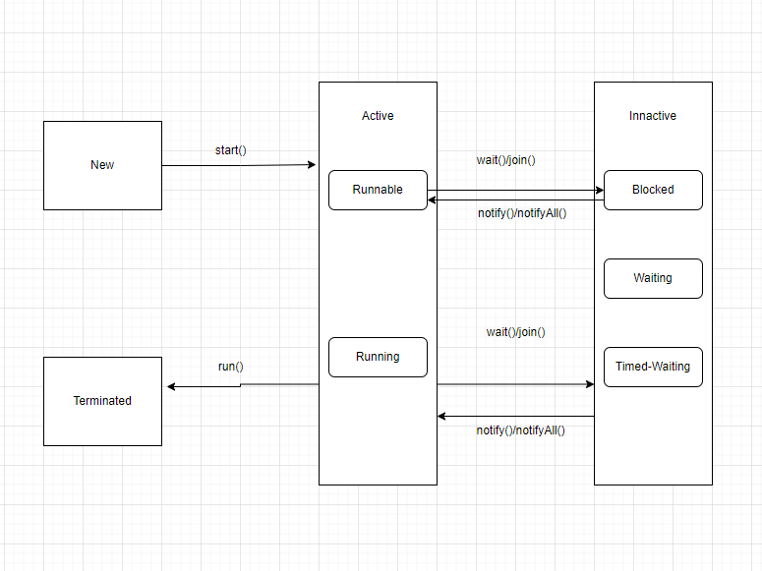

**Code Appendix**

/**

 * Test

 */

class Test implements Runnable {

    public void run()

    {

        // moving thread2 to timed waiting state

        try {

            Thread.sleep(1500);

        }

        catch (InterruptedException e) {

            e.printStackTrace();

        }

        System.out.println("4. thread state: " + MyThreadClass.myThread.getState());

        try {

            Thread.sleep(200);

        }

        catch (InterruptedException e) {

            e.printStackTrace();

        }

    }

}

public class MyThreadClass extends Thread{

    public static Thread myThread;

    public static Test obj;

    // initiating the thread and its in NEW state

    public void run () {

        try {

            Thread.sleep(1000); // Thread is in Timed Waiting state

        } catch (Exception e) {

            e.printStackTrace();

        }

        System.out.println("3. thread state: " + Thread.currentThread().getState());

        try {

            Thread.sleep(200);

        }

        catch (InterruptedException e) {

            e.printStackTrace();

        }

    }

    public static void main(String[] args) throws InterruptedException {

        myThread = new MyThreadClass();

        System.out.println("1. thread state: " + myThread.getState()); //Still the thread is in NEW state

        myThread.start(); // now the thread is in RUNNABLE state

        System.out.println("2. thread state: " + myThread.getState());

        myThread.join();

        System.out.println("4. thread state: " + myThread.getState());

    }

}

**Output:**

