

Data science internship at data glacier

WEEK 4 – MODEL DEPLOYMENT USING FLASK

By Kavinilavan muthukumar



September 27, 2021

KAVINILAVAN MUTHUKUMAR

LISUM13:30

**Model deployment using Flask**

**Introduction**

in this project, I am going to creat a API for machine learning deployment using Python Flask Frameworks. As a demonstration, I am taking the Diabeties dataset which classifying wheather the chances of gettting diabeties or Not. This dataset is already cleaned and ready for model building.

**Dataset Information**

I have taken the diabeties datset which have 8 features and 768 records. The target value is 1 and 0, 1 is person getting high chance of diabeties and 0 is low chance of diabetes. Since, our dataset is already cleaned, there is no null value. The below image showing the datset.

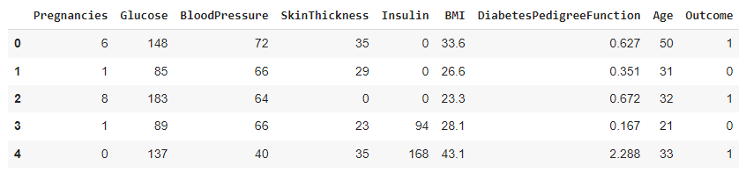

The information of the columns is showing below. It shows the data types of columns, null value counts and shape of the columns.

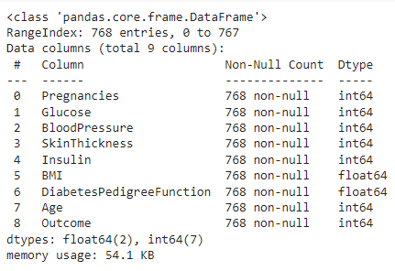

**3 Machine Learning Model Implementation**

**3.1 Data Splitting**

I seperates the data for training and testing purpose. Here, 10% of data for testing and 90% for training. Data splitting is used for compute the metrics of the model and identify the model overfitting.



**3.2 Logistics Regression**

For demonstration, I am using logistics regression for model building, it is more efficient for binary classification and perform well with small amount of data. It estimates the probability of event occuring and not occuring. The target value is bounded between 0 to 1 with threashold of 0.5. if any value lies below 0.5, it considered as negative (low chance of getting diabetes) and above 0.5 considered as positive (high chance of getting diabetes).

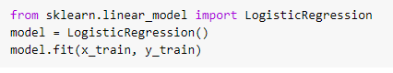

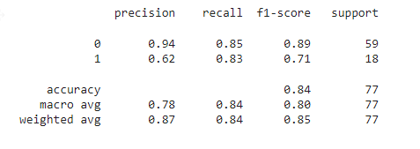

**3.3 Save the model**

After, the model is saved in pickle file for model deployment. For that, I am importing pickle library.

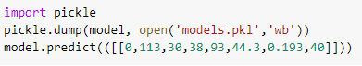

**4 Web Application**

For deploy the model in web application, python flask framework are used. It can allow us to predict the patient has getting chance of diabetes or not with simply typing the data in the field. For that, I am using visual studio code editor. Befor that I had to create a virual environment, then, I made the directory called flask. For model development, we need following files.

app.py

index.html

model.pkl

**4.1 App.py**

App.py is the main file which contains the code for python flask. Here, are we going to create API. Let’s look at the following terminology for python flask.

Flask application instances by passing __name__ as the first argument to the Flask class. To allowing the Flask to get HTML file which is belonging to same directory.

@ app.rout (/) the routing technique is used for users to remember application URLs. It is useful to access the desired page directly without having to navigate from the home page.

Renter template is used to navigates the HTML file in the templates folder. It helps us to collect information from outside file instead of hard coding the html file in app.py.

Debug = True is used for debugging the code and it shows if we have any error.

**4.2 index.html**

It is the html file which contains all the text and fields which we going to type the data for prediction.

**5 Running Code in Local Host**

After, all the above procedure is completed, we can run the code in Local Host. The outcome of the code is shown in the web browser.

Finally, we can type our input data to predict the outcome, let assume we have the new data 0, 113, 30, 38, 93, 44.3, 0.193, 40.

This model shows the prediction of patient has low chance of getting diabetes.