Agentic AI — Catch-Up Study Guide
Days 7, 8 & 9 of the AFDE Prodapt Chennai Program
Foundations recap · Concept walkthroughs · Day 9 Trip Planner assignment
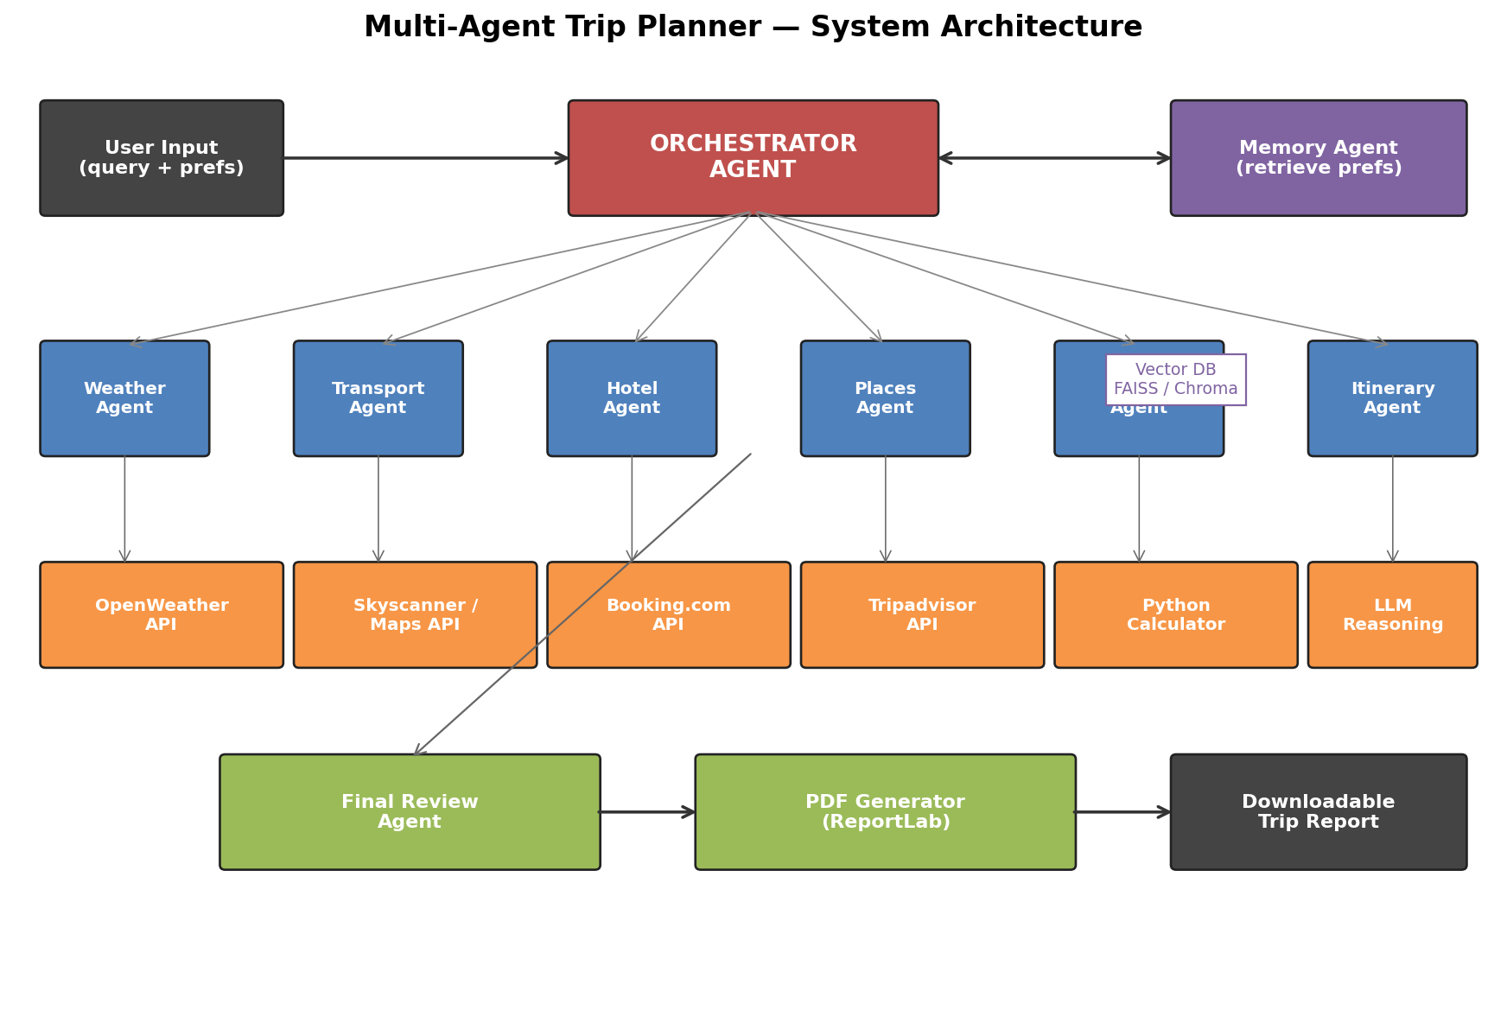
End goal: a production-grade multi-agent system you will build for the Day 9 assignment.

How to use this guide
You have been absent for the last three sessions. This document brings you fully back up to speed:
- Part 0 — Foundations Recap: the minimum you need from Days 1–6 (NLP, embeddings, RAG, LangChain, basic LangGraph).
- Part 1 — Day 7: Agent Foundations (ReAct loop, telecom agent in LangGraph, and CRAG).
- Part 2 — Day 8: LangChain + LangGraph multi-agent + retries + output combination.
- Part 3 — Day 9: Agent patterns, CrewAI, OpenAI Agents SDK.
- Part 4 — The Day 9 Assignment: a complete plan-of-attack for the Multi-Agent Trip Planner.
- Part 5 — Cheat sheet and glossary you can keep open while coding.

Pair this with the notebook: Open Trip_Planner_Assignment.ipynb in the same folder. The code there is fully runnable end-to-end; this guide explains why each piece exists.

Part 0 — Foundations Recap (Days 1–6)
Skim this part if anything sounds unfamiliar. Each subsection is short on purpose — the goal is to give you just enough vocabulary to follow Days 7–9.

0.1 What is a Large Language Model (LLM)?
An LLM is a neural network trained on huge amounts of text. You give it a prompt (some text) and it predicts the most likely next tokens. That is it. Everything else — chat, agents, RAG — is built on top of that single primitive.
Mental model: An LLM is a very smart text-completion engine. It has no memory between calls, no internet, no tools, and no idea what is true. We add all of those by wrapping it with code.

0.2 Embeddings
An embedding is a list of numbers (a vector) that represents the meaning of a piece of text. Texts with similar meaning have vectors that are close together. We use cosine similarity (or dot product) to measure closeness.
Why this matters: when a user asks a question, we embed the question, embed every chunk of our knowledge base, and pick the closest chunks to send to the LLM as context. That is the heart of RAG.

0.3 Retrieval-Augmented Generation (RAG)
RAG is the pattern of (1) retrieving relevant chunks of your own documents and (2) handing those chunks to the LLM as context so it can answer with grounded, fresh, or private information instead of hallucinating from training data.
A minimal RAG pipeline looks like:
docs = load_documents() # PDF, websites, FAQs, etc.
chunks = split(docs, size=500) # 200–800 token chunks
vectors = embed(chunks) # using OpenAI / SBERT / etc.
index = VectorDB.from(vectors) # FAISS / Chroma / Pinecone
# at query time:
top_chunks = index.search(embed(query), k=4)
answer = llm(prompt=f"Use context:{top_chunks}\nQ: {query}")
Day 4 add-ons you should know: Hybrid search = BM25 (keyword) + vector (semantic), then re-rank. Re-ranking with a cross-encoder model dramatically improves precision.

0.4 LangChain in one page
LangChain is a Python framework that bundles together the boring plumbing of LLM apps: prompt templates, model wrappers, retrievers, tool definitions, output parsers, and memory.
The four objects you will see constantly:
Object | What it does
ChatOpenAI / ChatAnthropic | A thin wrapper around the LLM API that supports messages, streaming, and tool-calling.
PromptTemplate | A string with named placeholders that you .format() at runtime.
Retriever | Anything that takes a query string and returns a list of Documents (Chroma, FAISS, BM25, etc.).
Tool | A Python function with a name + description + JSON schema. The LLM can choose to call it during reasoning.

0.5 LangGraph in one page
LangGraph is a sibling library to LangChain. It lets you express an agentic workflow as an explicit state machine — a graph of nodes and edges with a shared state object that every node can read and write.
Why graphs and not chains? Because real agents need loops, branching, retries, and human-in-the-loop pauses. A linear chain cannot express "if the budget is exceeded, go back to the hotel node."
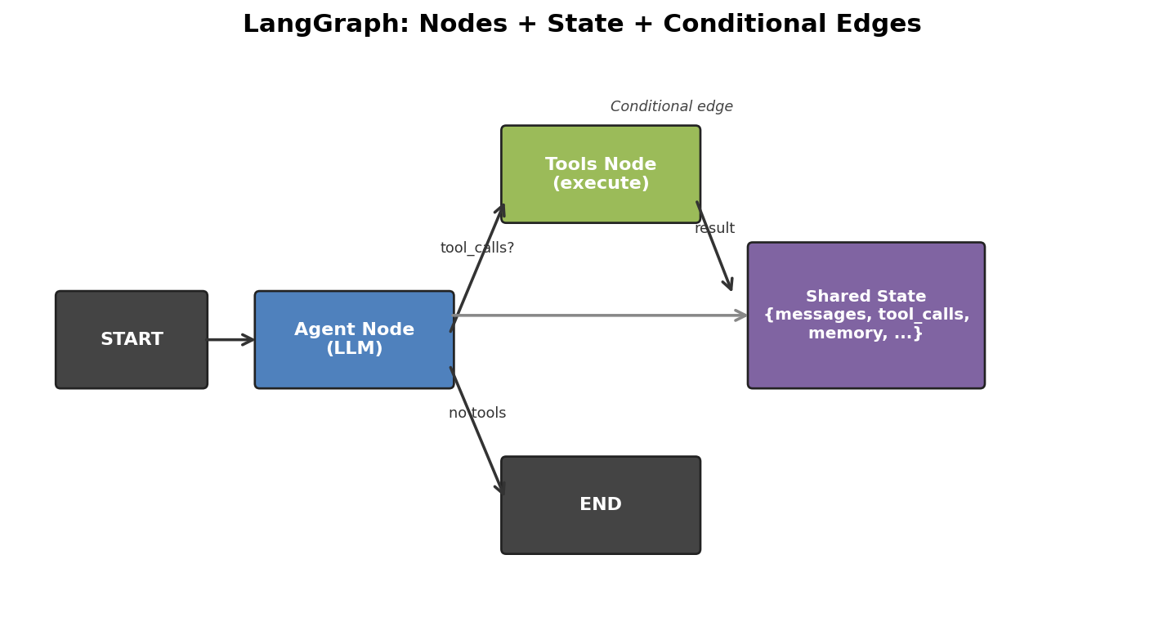
LangGraph: agent and tool nodes share a typed state and route via conditional edges.
The four building blocks:
- State: a TypedDict / Pydantic model that flows between nodes.
- Node: a Python function (state) -> state-update. It can call an LLM, run a tool, or anything else.
- Edge: a connection from one node to another. Edges can be conditional (a function that returns the next node name).
- Checkpointer: a backing store (memory, SQLite, Postgres, Redis) that persists state across runs so the graph is resumable.
Day 6 introduced LangGraph with checkpoints and human-in-the-loop (HITL). Days 7–9 build heavily on this — make sure those four primitives feel solid.

Part 1 — Day 7: Agent Foundations
Day 7 has two notebooks. The Telecom Agent introduces the agent loop, planning, memory, and tool use in LangGraph. The CRAG notebook upgrades a plain RAG into a self-correcting agent. Both are essential building blocks for the assignment.

1.1 The agent loop (ReAct)
An agent is an LLM that runs in a loop: it thinks about what to do, picks an action, observes the result, and decides whether it is done. This is called ReAct (Reason + Act).
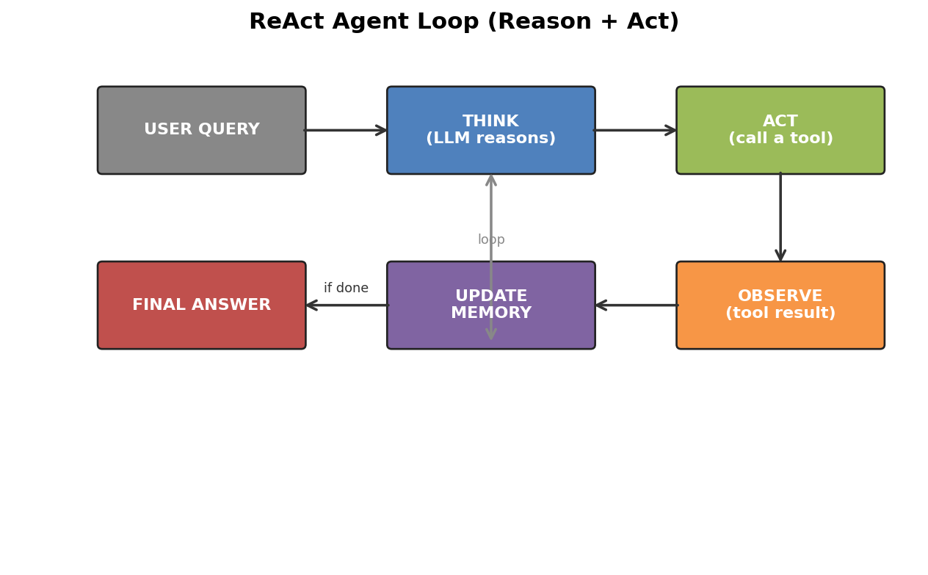
Each iteration: think → pick a tool → observe → update state → repeat or finish.
In LangGraph the loop is implemented as two nodes plus one conditional edge:
def agent_node(state):
msg = llm_with_tools.invoke(state["messages"])
return {"messages": [msg]}
def tools_node(state):
last = state["messages"][-1]
results = [run_tool(c) for c in last.tool_calls]
return {"messages": results}
def should_continue(state):
last = state["messages"][-1]
return "tools" if last.tool_calls else END
graph.add_node("agent", agent_node)
graph.add_node("tools", tools_node)
graph.add_conditional_edges("agent", should_continue)
graph.add_edge("tools", "agent") # loop back
Key insight: The LLM does not run the tools itself. It outputs a structured request ("call get_weather with city='Goa'") and your Python code actually runs it. The loop continues until the LLM stops requesting tools.

1.2 Telecom Agent — the worked example
The Day 7 telecom_agent.ipynb wires up a customer-support bot for a fictional telecom provider. It covers all four agent fundamentals at once:
Concept | How the notebook demonstrates it
Planning | An intent-classification step routes the query to billing, network, plan-change, or technical-support branches before the main agent runs.
Tool use | Four @tool functions: get_account_info, check_data_usage, raise_complaint, change_plan. The LLM picks which to call.
Memory | ConversationBufferMemory holds the chat history; the state TypedDict additionally tracks tickets, intent, and the resolved-flag for cross-session continuity.
Loop control | should_continue inspects the last message: if it has tool_calls go to tools, else END.
Action you should take: open the notebook, run the cells, and read the printed state after each turn. Notice how the state evolves — that is what your trip planner will do too, just with travel-specific keys.

1.3 Corrective RAG (CRAG)
Plain RAG has a famous failure mode: if the retriever returns garbage, the LLM happily generates a confident garbage answer. CRAG fixes this by adding a grading step and a web-search fallback.
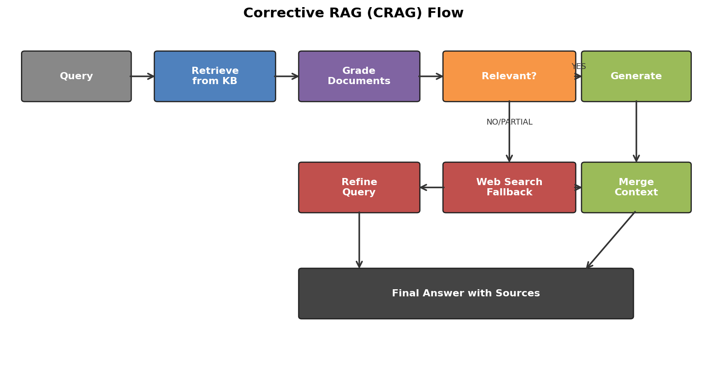
CRAG flow: retrieve → grade → either generate, refine the query, or fall back to web search.
Step by step:
- Retrieve the top-k chunks from your vector store as in normal RAG.
- Grade each chunk for relevance using a small LLM call that returns YES / NO / PARTIAL.
- If YES across the board → generate directly.
- If PARTIAL → refine the query (LLM rewrites it more specifically) and retry.
- If NO → fall back to a web search tool, merge those results with whatever local context survived, and only then generate.
Why this matters for the assignment: Your Trip Planner will face the same problem when an API returns no flights or the weather API is down. The CRAG pattern — grade → retry → fall back — is exactly what the Orchestrator Agent does, just at the agent level instead of the document level.

Part 2 — Day 8: LangChain + LangGraph end-to-end
Day 8 puts everything together in three notebooks: a complete LangChain guide (RAG, agents, LangGraph, LangSmith), a multi-agent LangGraph telecom system, and a notebook on retries and combining multiple agent outputs. We unpack the ideas you most need.

2.1 Building real tools (@tool decorator)
In production every "agent" is just an LLM + a list of well-described tools. The decorator turns a typed Python function into something the LLM can call:
from langchain_core.tools import tool
@tool
def get_weather(city: str, date: str) -> dict:
"""Return the daily weather forecast for a city on a given date.
Args:
city: City name, e.g. 'Goa'
date: ISO date string, e.g. '2026-06-10'
"""
return openweather_api(city, date)
llm_with_tools = llm.bind_tools([get_weather, find_hotels, search_flights])
Docstring = contract: The function's docstring and type hints are sent to the LLM verbatim — that is how it knows what the tool does and what arguments to pass. Write them as if you were writing API documentation for a colleague.

2.2 Memory: short-term, session, long-term
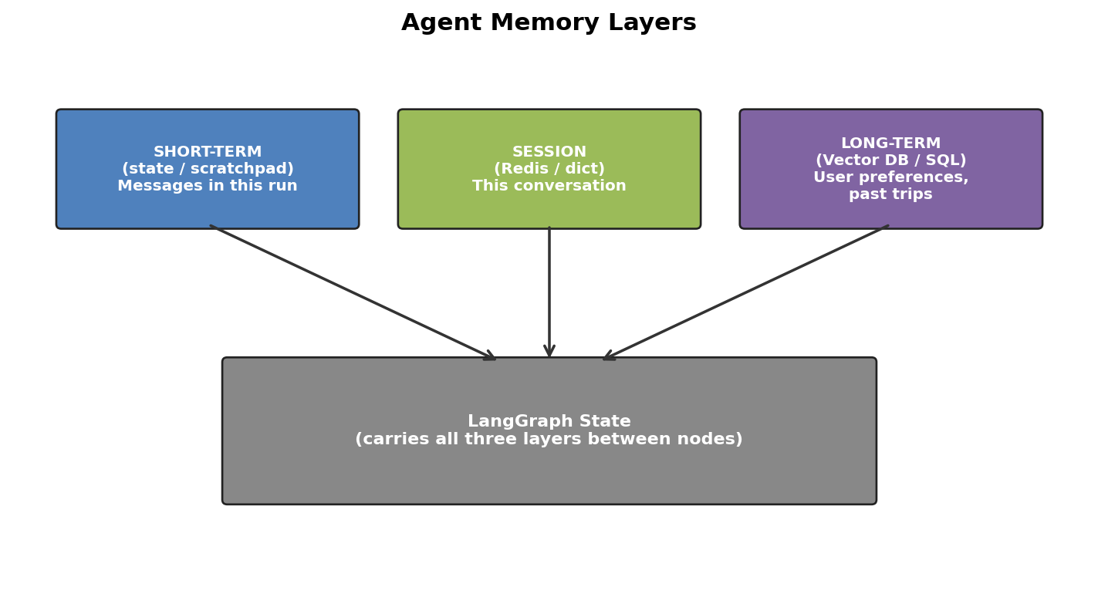
Three layers of memory; the LangGraph state is what threads them through the run.
Day 8 makes a key distinction:
- Short-term (per-turn) — list of messages inside one invocation. Lives in state["messages"]. Cleared when the run ends.
- Session — persists across multiple turns of the same conversation. Day 8 uses a simple dict keyed by user_id; production uses Redis.
- Long-term — facts and preferences you want to remember forever: user's allergies, past trips, budget tier. Stored in a vector DB (FAISS / Chroma) with semantic search, or a relational DB for structured fields.
Your assignment's Memory Agent uses all three. The state schema you will define in the notebook has slots for each.

2.3 Multi-agent in LangGraph
A single LLM with a dozen tools quickly becomes unreliable — the prompt gets huge, the LLM forgets older instructions, and one bad tool spoils everything. The fix: split into specialists, each with a focused prompt and 1–3 tools.
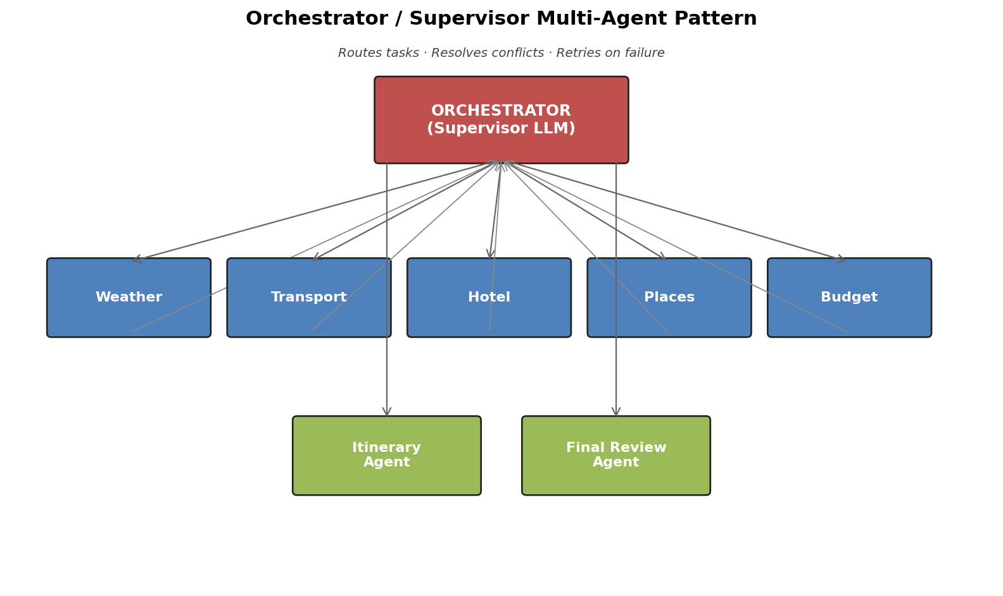
Supervisor (Orchestrator) routes to specialists; each specialist owns its domain and tools.
The Day 8 telecom multi-agent notebook implements exactly this with three specialists and a supervisor. The supervisor:
- Reads the latest user message and the conversation state.
- Decides which specialist to call next, or whether the user query is fully answered (route to END).
- Optionally rewrites the message to add context that the specialist needs.
In code it is just another node whose output names the next node:
def supervisor(state):
decision = supervisor_llm.invoke(SUPERVISOR_PROMPT.format(
history=state["messages"],
available=["weather", "hotel", "transport", "budget", "FINISH"]
))
return {"next": decision.next_agent}
graph.add_conditional_edges("supervisor",
lambda s: s["next"],
{"weather": "weather", "hotel": "hotel", "budget": "budget", "FINISH": END})

2.4 Retries and combining agent output
In a multi-agent system any specialist can fail (API down, rate limit, returned empty). The Day 8 retries notebook shows two essential patterns:

Retry with exponential backoff
from tenacity import retry, stop_after_attempt, wait_exponential
@retry(stop=stop_after_attempt(3),
wait=wait_exponential(multiplier=1, min=1, max=10))
def call_flight_api(origin, dest, date):
return requests.get(FLIGHTS_URL, params=..., timeout=5).json()

Combining outputs ("fan-in")
When several specialists run in parallel — weather + hotel + transport + places all working on the same trip — you need to fan their results back into a single state. LangGraph does this by having each node return a dict that is merged into the shared state. Use Annotated[List[…], operator.add] for lists you want to concatenate rather than overwrite:
from typing import TypedDict, Annotated, List
import operator
class TripState(TypedDict):
user_profile: dict
messages: Annotated[List[BaseMessage], operator.add] # accumulates
weather_data: dict
hotel_data: dict
# …
Trap to avoid: If you do NOT mark the list with operator.add, parallel nodes overwrite each other and you lose data. This is the single most common bug when writing your first multi-agent LangGraph.

Part 3 — Day 9: Patterns, CrewAI, and the OpenAI Agents SDK
Day 9 widens the lens. Instead of one tool, you see four ways to wire multi-agent systems and three competing frameworks. You do not need to master all of them for the assignment — pick LangGraph (recommended) — but you should know what the alternatives look like.

3.1 The four agentic patterns
The Different_Agent_Patterns notebook compares four architectures, ordered from least to most agentic:
Pattern | How it works | When to use
Parallel multi-agent | All specialists run at once, then an aggregator merges. No supervisor. | Independent sub-tasks (e.g. signal + billing + device diagnostics).
Hierarchical supervisor | Supervisor LLM routes one specialist at a time; can loop. | Workflows with dependencies ("need weather before places").
Dynamic / autonomous | Each agent can call any other agent; routing emerges from the LLM. | Open-ended research tasks; harder to debug.
Hybrid (recommended for the assignment) | Supervisor + parallel fan-out for independent work + serial steps for dependent work. | Real products like the trip planner.

3.2 CrewAI in 60 seconds
CrewAI is a higher-level framework where you declare three things and it runs the multi-agent loop for you:
Concept | Definition
Agent | A persona (role + goal + backstory) bound to a list of tools.
Task | A specific job description with expected_output, assigned to one agent.
Crew | A list of agents + a list of tasks + a process: sequential or hierarchical.
Tiny example:
from crewai import Agent, Task, Crew, Process
weather_agent = Agent(role="Weather Specialist",
goal="Give accurate forecasts",
backstory="20 years meteorology experience",
tools=[openweather_tool])
task1 = Task(description="Forecast for Goa June 10–15",
expected_output="JSON with daily highs/lows",
agent=weather_agent)
crew = Crew(agents=[weather_agent, hotel_agent],
tasks=[task1, task2],
process=Process.hierarchical)
crew.kickoff()
Trade-off vs LangGraph: CrewAI is faster to write but harder to debug. You give up the explicit state machine. Pick LangGraph when you need transparency (graded assignments, production systems); pick CrewAI for fast prototypes.

3.3 OpenAI Agents SDK
OpenAI's own agent framework. The core abstraction is an Agent that has instructions and tools, plus the function-calling machinery built in. Multi-agent is done via handoffs — one agent can hand the conversation to another.
from agents import Agent, Runner
flight_agent = Agent(name="Flight",
instructions="Find the cheapest flights.",
tools=[search_flights])
orchestrator = Agent(name="Orchestrator",
instructions="Coordinate trip planning. Hand off to specialists.",
handoffs=[flight_agent, hotel_agent, weather_agent])
Runner.run_sync(orchestrator, "Plan a 5-day Goa trip")
Why bother learning it: tracing and evals are first-class, and it composes with OpenAI's hosted tools (web search, file search). Use it when you are OpenAI-only and want the absolute minimum boilerplate.

Part 4 — Day 9 Assignment: Multi-Agent Trip Planner
This is the deliverable that ties everything together. The companion notebook in this folder, Trip_Planner_Assignment.ipynb, is a complete working solution you can run, modify, and submit. This section explains the design decisions so you can speak to them in a viva or interview.

4.1 What you are building
A LangGraph multi-agent system that takes a free-text trip request plus structured preferences and returns a downloadable PDF travel plan. An Orchestrator Agent decides which specialist to invoke, retries on failures, and only triggers PDF generation when all data is consistent.

Eleven agents in total: 1 Orchestrator, 1 Memory, 8 specialists, 1 PDF Generator.

4.2 Workflow
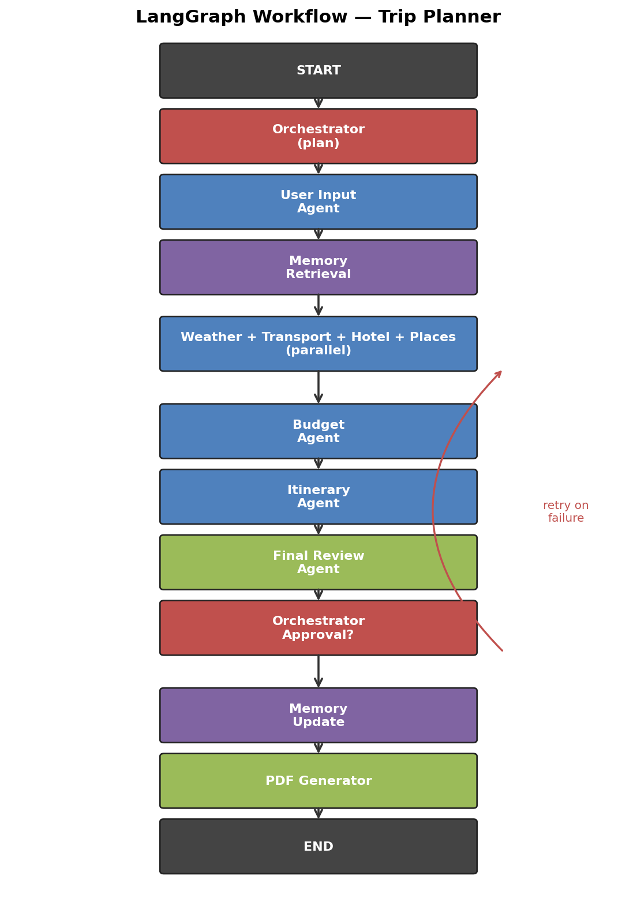
The LangGraph workflow your assignment must implement.
Plain-English walkthrough:
- Start with a user query and optional structured preferences.
- Orchestrator plans the run (which specialists, in what order).
- User Input Agent normalizes the structured fields (parses dates, currency, etc.).
- Memory Retrieval Agent looks up the user's past trips and known preferences from the vector DB.
- Weather + Transport + Hotel + Places agents run in parallel — they do not depend on each other's outputs.
- Budget Agent runs after them: it has all the costs and can optimize.
- Itinerary Agent assembles a day-by-day plan.
- Final Review Agent checks completeness and consistency (no hotel-budget mismatch, no rain-day at an outdoor venue, etc.).
- Orchestrator approves OR routes back to a failed specialist (this is the retry edge).
- Once approved → Memory Update Agent writes the new preferences → PDF Generator Agent produces the report → END.

4.3 State schema
The state is the single most important design artifact. Get it right and the rest follows naturally. Use a TypedDict so the editor and LangGraph can type-check fields.
from typing import TypedDict, List, Dict, Optional, Annotated
from operator import add
from langchain_core.messages import BaseMessage
class TripState(TypedDict):
user_id: str
messages: Annotated[List[BaseMessage], add]
user_profile: dict # name, prefs, allergies, past trips
trip_preferences: dict # source, dest, dates, budget, travelers
weather_data: dict
transport_data: dict
hotel_data: dict
places_data: dict
budget_summary: dict
itinerary: dict
review_status: dict # {"approved": bool, "issues": [...] }
pdf_status: dict # {"path": "...", "generated_at": "..."}
orchestrator_decision: dict # last routing decision + reason
retry_count: int

4.4 Orchestrator logic
The Orchestrator is just an LLM with a structured-output prompt that returns the next node to run plus a short reason. Its decision rules:
Condition | Action
trip_preferences empty / missing required fields | Route to user_input
user_profile empty | Route to memory
weather_data and hotel_data both empty | Route to parallel_specialists (fan-out)
budget_summary empty but specialist outputs present | Route to budget
budget exceeds user budget | Route back to hotel (cheaper) with retry_count++
weather = heavy rain | Route back to places (indoor alternatives)
review_status.approved == True | Route to memory_update then pdf
retry_count > 3 | Route to END with partial result + error in PDF

4.5 Tools and APIs
You can use real APIs (with keys) or the mock implementations provided in the notebook. The notebook ships with mocks so it runs without any credentials; swap the @tool bodies to call the real services when you have keys.
Agent | Tool / API in the notebook
Weather | OpenWeatherMap → fall back to deterministic mock by month/region
Transport | Skyscanner / Amadeus → mock returns 3 priced options
Hotel | Booking.com → mock returns 5 hotels filtered by budget
Places | Google Places / Tripadvisor → mock returns top attractions for city
Budget | Pure-Python calculator (no API)
Memory | Chroma (local, no server) with sentence-transformers embeddings
PDF | ReportLab

4.6 PDF report sections
Your final PDF must have these sections (graders look for them):
- Cover page — trip title, dates, traveler count, generated-on date.
- Section 1 — Flights / transfers, with prices and provider.
- Section 2 — Hotel details, with photos placeholder, address, total cost.
- Section 3 — Day-wise itinerary table (Day · Morning · Afternoon · Evening).
- Section 4 — Budget breakdown table and final total.
- Section 5 — Packing checklist (auto-generated from weather + activities).
- Section 6 — Emergency contacts (consulate, local emergency numbers).

4.7 How to run the companion notebook
Steps to reproduce the assignment from scratch:
- Open Trip_Planner_Assignment.ipynb in Jupyter / VS Code / Colab.
- Run the install cell once. No API keys are required for the mock run.
- Run all cells top-to-bottom. The last cell triggers a sample query (Bangalore → Goa, 5 days, ₹30k) and writes trip_report.pdf next to the notebook.
- Inspect the rendered LangGraph PNG in the notebook to confirm your graph matches the architecture diagram above.
- Swap mocks for real APIs by editing the four functions marked # TODO: real API in the tools section.
Submission checklist (matches the assignment PDF's "Final Deliverables" list):
- Architecture diagram — use the PNG in /diagrams/06_trip_planner_architecture.png.
- LangGraph workflow image — auto-generated in the notebook (graph.get_graph().draw_png()).
- Agent design — Markdown cells in the notebook for each specialist.
- Orchestrator logic — the orchestrator_node function plus the table in §4.4.
- Tool design, memory system, PDF module — corresponding cells in the notebook.
- State schema — the TripState TypedDict.
- Working demo — the final cell's PDF output.
- GitHub repository — push the notebook plus this guide plus a README.

Part 5 — Cheat Sheet & Glossary

5.1 LangGraph cheat sheet
from langgraph.graph import StateGraph, START, END
g = StateGraph(TripState)
g.add_node("orchestrator", orchestrator_node)
g.add_node("weather", weather_node)
g.add_edge(START, "orchestrator")
g.add_conditional_edges("orchestrator", route, {
"weather": "weather", "hotel": "hotel", "FINISH": END
})
g.add_edge("weather", "orchestrator") # back to supervisor
app = g.compile(checkpointer=MemorySaver())
# Run with a thread_id so memory persists across turns
app.invoke({"messages": [HumanMessage("…")]},
config={"configurable": {"thread_id": "user-42"}})

5.2 Common bugs and how to fix them
Symptom | Fix
Parallel nodes overwrite each other's data | Mark list fields with Annotated[List, operator.add] in the state.
Agent loops forever calling the same tool | Add a max_iters counter to state and END when exceeded.
LLM never calls the tool you wrote | Improve the tool's docstring — it must read like API docs, not like a comment.
KeyError on a state field | Initialize the field in the entry node; TypedDict does not auto-fill defaults.
The supervisor picks the wrong specialist | Print the supervisor prompt; usually the list of options is too vague. Add a one-line description per option.
PDF generation hangs | ReportLab is synchronous; do not call it from inside an async node without await asyncio.to_thread().

5.3 Glossary
Term | Meaning
Agent | An LLM + tools running in a loop (think → act → observe).
Tool | A Python function the LLM can choose to call. Defined with @tool.
ReAct | The Reason + Act pattern; the foundational agent loop.
CRAG | Corrective RAG — grade retrieval, refine query, fall back to web search.
LangChain | Plumbing library: prompts, models, retrievers, tools, memory.
LangGraph | Sibling library: explicit state-machine graphs for agentic apps.
State | A TypedDict / Pydantic object passed between graph nodes.
Checkpointer | Backing store (memory, SQLite, Redis) that persists graph state.
Orchestrator / Supervisor | An LLM whose only job is to pick the next specialist to run.
Handoff | OpenAI Agents SDK term for one agent transferring control to another.
Crew (CrewAI) | Top-level container holding agents, tasks, and a process.
Fan-out / fan-in | Running specialists in parallel (fan-out) and merging their state (fan-in).
HITL | Human-in-the-loop — pausing the graph for a human to approve a step.
Good luck — you have got this.

