
FIRESAFEX NEXGEN
Complete Website
Content Document
Exact content currently implemented in the seven-section website experience
CLIENT REVIEW COPY • 01 SEPTEMBER 2026

Document purpose
This document records the complete customer-facing website copy, calls to action, media labels, footer proof content, and booking-form text. Items awaiting final client approval are clearly marked in the final review section.

Website Content Overview
BRAND
FireSafeX NexGen
PAGE TITLE
Anywhere. Any Place. Anytime. | FireSafeX NexGen
META DESCRIPTION / PRODUCT DESCRIPTION
FireSafeX is an end-to-end mixed-reality fire safety training system. It combines a physical smart extinguisher, AI guidance, realistic fire scenarios, one-click assessments, and verified digital certificates in one portable solution.
PRIMARY NAVIGATION
01 Home | 02 Why FireSafeX | 03 How It Works | 04 Ecosystem
05 Smart Training | 06 Enterprise | 07 Book a Demo
Content structure
The website contains seven story sections. Navigation, section order, theme, and layout are treated as fixed unless separately approved.

01 / 07 | HOME  Anywhere. Any Place. Anytime.

SUBTITLE
FireSafeX NexGen — Train. Feel It’s Real. Respond With Confidence.
BODY
FireSafeX is an end-to-end mixed-reality fire safety training system. It combines a physical smart extinguisher, AI guidance, realistic fire scenarios, one-click assessments, and verified digital certificates in one portable solution.
CALLS TO ACTION
Primary: Book a Live Demo | Secondary: Download Brochure
DISPLAYED MEDIA
FireSafeX smart training system — product image.

02 / 07 | WHY FIRESAFEX  Why FireSafeX?

SUBTITLE
Carry Anywhere. Scale Everywhere. Train for Up to 11 Days.
COMPARISON CARDS
Traditional Training Method  Comparison card title | VR Fire Safety Training  Comparison card title
Our Solution: FireSafeX
Comparison card title
Display rule
The website presents these as three comparison cards. Only the approved card titles are customer-facing; no additional feature claims appear inside the cards.

03 / 07 | HOW IT WORKS  Train. Practice. Evaluate. Certify.

SUBTITLE
One guided journey. Four clear steps.
GUIDED JOURNEY
01 | Train — Learn in your preferred language with AI guidance.
02 | Practice — Use the physical smart extinguisher inside mixed-reality fire scenarios.
03 | Evaluate — Create an assessment in one click and capture response actions.
04 | Certify — Issue a verified digital certificate linked to the completed assessment record.
DISPLAYED MEDIA
- FireSafeX smart handle and display assembly.
- Close view of the FireSafeX connected handle.
- FireSafeX integrated display detail.

04 / 07 | ECOSYSTEM  FireSafeX Ecosystem

SUBTITLE
One connected system. Every user. Every device.
BODY
From device connection to full rollout, FireSafeX gives your organization one supported ecosystem that is quick to configure, easy to understand, and adaptable to your training needs.
HIGHLIGHTED SELLING POINTS
About 5 minutes  Connect and begin | Easy to set up  Guided configuration
Easy to understand  Clear training flows | End-to-end onboarding  Supported rollout
Customizable content  Built for each team | Within 1 business day  Complete setup
DISPLAYED MEDIA
- FireSafeX product with P.A.S.S. training guide.
- Two FireSafeX product configurations.
Claim definitions
“About 5 minutes” refers to connecting supported devices and the training platform. “Within 1 business day” refers to complete organizational setup and onboarding when required access and content are ready.

05 / 07 | SMART TRAINING  Smart Training

SUBTITLE
Learn with AI. Practice in VR. Prove with Assessment.
BODY
Learn with the multilingual AI Safety Trainer, run immersive scenarios through Meta Quest, create an assessment in one click, and issue a verified digital certificate linked to the trainee’s completed assessment record.
DISPLAYED MEDIA
- FireSafeX mixed-reality fire safety training demonstration — playable demo video.
- FireSafeX mixed-reality scenario projected during training — supporting event image.
Feature meaning
One-click assessment creation is a FireSafeX product capability presented as marketing content. It is not an assessment-builder feature provided by the marketing website.

06 / 07 | ENTERPRISE  One Team. Every Site. One Standard.

SUBTITLE
Train at scale. Track in one place. Stay ready everywhere.
BODY
Roll out consistent training across roles, regions, and facilities. FireSafeX supports custom content, centralized users and sessions, progress tracking, assessments, certificates, and end-to-end onboarding for every site.
DISPLAYED MEDIA
- Workplace team attending FireSafeX training.
- Workplace team observing a FireSafeX mixed-reality session.
- FireSafeX enterprise training session for a full team.

07 / 07 | BOOK A DEMO  Ready to Train for Real?

SUBTITLE
Bring FireSafeX to your workplace. See it. Feel it. Trust it.
BODY
See the complete FireSafeX experience—from fast setup and custom content to mixed-reality practice, one-click assessments, and verified certification.
CALLS TO ACTION
Primary: Book a Live Demo | Secondary: Download Brochure
DISPLAYED MEDIA
FireSafeX deployment with a workplace training team.
Certificate wording
The approved website wording is “verified digital certificate linked to the completed assessment record” or “verified certification.” No numerical certificate-accuracy percentage is claimed.

Footer and Field Proof Content
SECTION HEADING
FireSafeX in the Field
SUPPORTING LINE
Selected training visits and demonstrations.
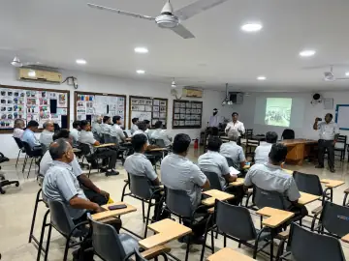  Organization 01  FireSafeX workplace training visit with an organization team. | 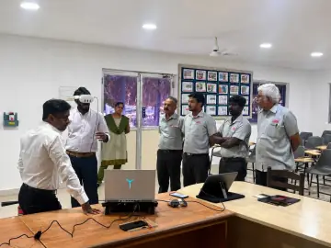  Organization 02  Organization team observing a FireSafeX mixed-reality demonstration.
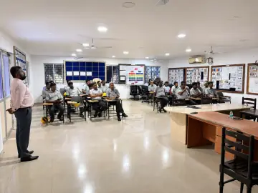  Organization 03  FireSafeX enterprise training session during a company visit. | 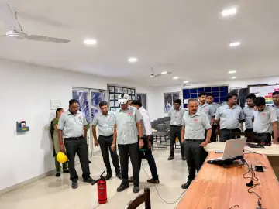  Organization 04  FireSafeX deployment demonstration with a workplace team.
FOOTER NAVIGATION
Home | How It Works | 07 / 07 Ready to Train for Real?
COPYRIGHT
© 2026 FireSafeX
Approval required
Organization 01–04 are temporary placeholders. Replace them with approved company names and approved visit images before production approval. No numerical company-visit count is currently displayed.

Book a Live Demo — Form Content
MODAL INTRODUCTION
Ready to Train for Real?
Bring FireSafeX to your workplace. See it. Feel it. Trust it.
See the complete FireSafeX experience—from fast setup and custom content to mixed-reality practice, one-click assessments, and verified certification.
REQUIRED FORM FIELDS
Field label | Placeholder / instruction
Full Name | Enter your full name
Company / Organization Name | Enter your company or organization
Email Address | Enter your email address
Phone Number | Enter your phone number
Number of Participants | Enter expected participants
Preferred Training Date | Date selection
Message / Requirements | Tell us about your training goals, locations, or program requirements
SUBMIT BUTTON
Book a Live Demo
SUCCESS MESSAGE
Your demo request has been sent. Our team will contact you shortly.
ERROR MESSAGE
We could not send your request. Please try again or email hello@firesafex.ai.

Content Approval and Production Register
Item | Current website status | Required action
Website structure | Seven sections implemented | No change requested
Ecosystem highlights | Six selling points displayed | Confirm commercial claims
Demo video | Optimized video integrated | Approve final video
Brochure | Draft PDF download integrated | Replace with final approved brochure
Certificate wording | Verified-certificate wording only | Provide evidence before adding any numerical accuracy claim
Company visits | Four images with placeholder organization names | Provide approved company names, images and count
Demo booking | Form and backend submission implemented | Verify production Convex deployment variables
Source of truth
Customer-facing wording in this document is taken from the current website content configuration. Review notes are separated from displayed copy and should not be published as marketing text.

