TABLE OF CONTENTS
CHAPTER NO | TITLE | PAGE NO
1 | INTRODUCTION | 6
2 | MODULES AND MODULES DESCRIPTION | 7
3 | CSV FILE EXPLANATION | 8
4 | EXisting system | 9
5 | PROPOSED SYSTEM | 10
6 | DOMAIN EXPLANATION | 11
7 | SOFTWARE AND HARDWARE REQUIREMENTS | 12
8 | ARCHITECTURE DIAGRAM | 13
9 | SOURCE CODE | 14
10 | OUTPUT & SCREENSHOTS | 15
11 | SYSTEM TESTING EXPLANATION | 18
12 | USER MANUAL | 19
13 | CONCLUSION | 20
14 | REFERENCES | 21
15 | PUBLICATIONS | 22

CHAPTER 1 – INTRODUCTION
In the digital era, a vast amount of information is stored in document formats such as PDF files. Extracting relevant information from lengthy documents manually is time-consuming and inefficient. Traditional keyword-based search methods often fail to provide context-aware and accurate answers, especially when dealing with large and unstructured documents.
To address this challenge, this project proposes an AI-powered PDF Question Answering System that enables users to upload PDF documents and interact with them through a chatbot interface. The system leverages Retrieval-Augmented Generation (RAG) and a Local Large Language Model (LLM) to understand user queries, retrieve relevant document context, and generate meaningful answers in real time.
The application uses modern AI technologies including vector embeddings, semantic similarity search, and local language models to provide intelligent, context-aware responses from uploaded PDF documents. By integrating these technologies into a user-friendly chatbot interface, the proposed system improves accessibility, reduces information retrieval time, and enhances the user experience.
This project demonstrates how advanced natural language processing and retrieval systems can be applied to build practical AI solutions for document understanding and question answering.

CHAPTER 2 – MODULES AND MODULE DESCRIPTION
The AI-Powered PDF Question Answering System is divided into multiple functional modules, each responsible for a specific stage of the workflow. These modules collectively enable intelligent document-based question answering.

1. PDF Upload Module
This module allows the user to upload PDF documents through the Streamlit-based web interface. It validates the uploaded file format and forwards the document for processing.

2. PDF Text Extraction Module
This module extracts textual content from the uploaded PDF using the pypdf library. It reads all pages of the document and combines the extracted text into a unified format for further processing.

3. Text Chunking Module
Since large documents cannot be processed efficiently as a single block, this module divides the extracted text into smaller chunks while preserving contextual overlap. This improves retrieval performance and answer accuracy.

4. Embedding Generation Module
This module converts text chunks into vector embeddings using Sentence Transformers. These embeddings numerically represent the semantic meaning of the text.

CHAPTER 3- CSV FILE / DATA FILE EXPLANATION
The proposed AI-Powered PDF Question Answering System does not rely on a traditional CSV dataset for training or processing. Instead, the system operates on user-uploaded PDF documents, which serve as the primary input data source for the application.
The uploaded PDF files may contain academic notes, technical manuals, reports, research papers, or any textual document relevant to the user’s query. These PDF documents are dynamically processed at runtime and converted into machine-readable text for semantic retrieval and question answering.
The extracted text is further divided into smaller chunks and transformed into vector embeddings, which are stored in a FAISS vector database for efficient semantic search.
Thus, instead of a static CSV dataset, the system uses dynamic document-based input data, allowing flexible interaction with any uploaded PDF file.

CHAPTER 4 – EXISTING SYSTEM
Existing document retrieval systems primarily rely on manual reading, keyword-based search, or simple text-matching mechanisms to locate information within PDF documents. These conventional methods require users to know exact keywords or phrases present in the document, limiting their effectiveness when the query is phrased differently from the source text.
Many current systems lack semantic understanding and contextual reasoning, making them unable to provide intelligent responses to natural language questions. Additionally, most advanced AI-powered document assistants available today depend on cloud-based APIs, which introduce concerns related to internet dependency, latency, cost, and data privacy.
Traditional keyword-search chatbots also fail to handle large and complex documents efficiently, often returning irrelevant or incomplete results. Their inability to understand the meaning behind user queries reduces the overall user experience and limits their usefulness in real-world applications.
Therefore, there is a need for an improved system that combines intelligent retrieval mechanisms with language understanding capabilities to deliver more accurate, context-aware, and privacy-preserving document question answering.

CHAPTER 5 – PROPOSED SYSTEM
The proposed system is an AI-Powered PDF Question Answering System designed to provide intelligent and context-aware responses to user queries from uploaded PDF documents. Unlike traditional keyword-based systems, the proposed approach utilizes Retrieval-Augmented Generation (RAG) along with a Local Large Language Model (LLM) to enhance answer accuracy and contextual understanding.
In this system, the uploaded PDF document is first processed to extract textual content. The extracted text is then divided into smaller chunks and converted into vector embeddings using embedding models. These embeddings are stored in a vector database to enable efficient semantic similarity search.
When a user submits a query, the system retrieves the most relevant text chunks from the vector database based on semantic similarity. The retrieved context, along with the user’s question, is then passed to the local LLM, which generates a meaningful and context-aware response.
The proposed system provides several advantages, including improved answer relevance, offline/local execution for better privacy, reduced dependency on external APIs, and an interactive chatbot-based user interface for enhanced usability.

CHAPTER 6 – DOMAIN EXPLANATION
The proposed project belongs to the domain of Artificial Intelligence (AI), specifically under the fields of Natural Language Processing (NLP), Information Retrieval, and Large Language Model Applications. This domain focuses on enabling machines to understand, process, and generate human language in a meaningful way.
Natural Language Processing plays a critical role in the project by allowing the system to interpret user questions posed in natural language and understand their semantic meaning. Information Retrieval techniques are used to search and retrieve the most relevant portions of text from the uploaded PDF document based on semantic similarity rather than exact keyword matching.
The project also falls under the emerging area of Retrieval-Augmented Generation (RAG), which combines retrieval systems with generative AI models to improve answer accuracy and contextual relevance. Additionally, the use of Local Large Language Models (LLMs) places the project within the domain of Offline AI Systems, emphasizing privacy-preserving and self-hosted AI applications.
This domain is highly relevant in modern AI research and industry applications, including document assistants, enterprise knowledge retrieval systems, educational tools, legal document analyzers, and intelligent virtual assistants.

CHAPTER 7 – SOFTWARE AND HARDWARE REQUIREMENTS

Software Requirements
- Operating System: Windows 10 / Windows 11
- Programming Language: Python
- Development Environment: Visual Studio Code / Jupyter Notebook / Anaconda Prompt
- User Interface Framework: Streamlit
- AI Runtime: Ollama
- Large Language Model: Phi / LLaMA 3
- AI Framework: LangChain
- PDF Processing Library: pypdf
- Embedding Model Library: Sentence Transformers
- Vector Database: FAISS

Hardware Requirements
- Processor: Intel Core i5 / i7 or equivalent
- RAM: Minimum 8 GB (Recommended 16 GB for better performance)
- Storage: Minimum 10 GB free disk space
- GPU: Optional (CPU supported; GPU recommended for faster inference)
- Internet Connection: Required only for initial model/package download
The above hardware and software requirements ensure smooth execution of the AI-powered PDF question answering system and efficient local processing of large language models.

CHAPTER 8 – ARCHITECTURE DIAGRAM
The architecture of the proposed AI-Powered PDF Question Answering System consists of multiple interconnected components that work together to process PDF documents and generate intelligent answers. The workflow begins with the user uploading a PDF document through the Streamlit-based user interface.
The uploaded PDF is then processed using the PDF parser to extract textual content from the document. The extracted text is divided into smaller chunks and converted into vector embeddings using an embedding model. These embeddings are stored in a FAISS vector database for efficient semantic retrieval.
When the user enters a query, the system performs semantic similarity search on the vector database to retrieve the most relevant document chunks. The retrieved context, along with the user’s query, is passed to the Local Large Language Model (LLM) running through Ollama. The LLM generates a context-aware answer, which is then displayed back to the user through the chatbot interface.

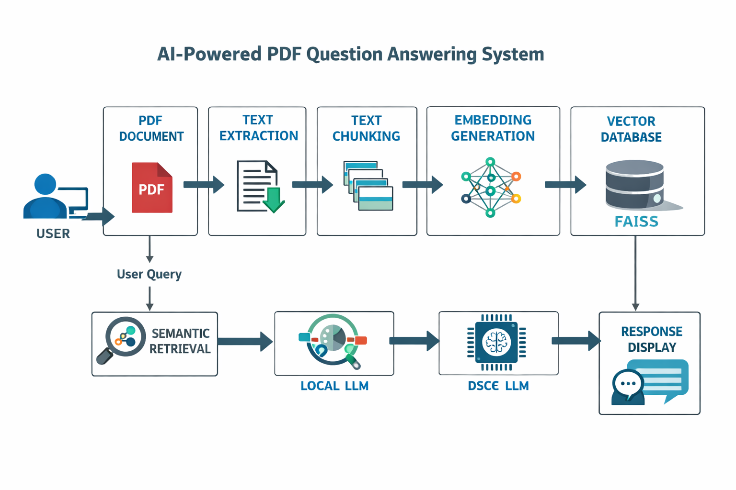

CHAPTER 9 – SOURCE CODE
The implementation of the proposed AI-Powered PDF Question Answering System is carried out using Python and modern AI frameworks. The system is developed as a web-based chatbot application using Streamlit for the user interface. The implementation consists of several functional modules that collectively perform document processing, semantic retrieval, and intelligent response generation.
The PDF processing module uses the pypdf library to extract text from uploaded PDF documents. The extracted text is then segmented into smaller chunks using text splitting techniques to preserve contextual relevance and improve retrieval efficiency.
Each text chunk is converted into vector embeddings using a sentence transformer embedding model. These embeddings are stored in a FAISS vector database, enabling fast semantic similarity search during query processing.
When the user enters a query, the system retrieves relevant text chunks from the vector database and forwards them, along with the query, to the local Large Language Model running via Ollama. The model generates a context-aware response, which is displayed through the chatbot interface.
The implementation is optimized using caching techniques to reduce repeated processing time and improve system responsiveness.

CHAPTER 10 – OUTPUT & SCREENSHOTS
The developed AI-Powered PDF Question Answering System was successfully implemented and tested using multiple PDF documents containing academic and technical content. The system allows users to upload PDF files through the chatbot interface and ask natural language questions related to the document content.
Upon processing the uploaded PDF, the system extracts text, converts it into vector embeddings, stores the embeddings in a FAISS vector database, and retrieves contextually relevant chunks during query processing. The local Large Language Model then generates intelligent responses based on the retrieved context.
The experimental results demonstrate that the system can provide accurate and context-aware answers for most document-related queries. Compared to traditional keyword-based approaches, the proposed system offers improved semantic understanding and better answer relevance.
The chatbot interface provides an interactive and user-friendly experience, allowing users to communicate naturally with the document. The use of a lightweight local LLM ensures offline operation and improved privacy while maintaining acceptable performance.
Overall, the developed system successfully meets the project objectives by delivering intelligent PDF-based question answering through an AI-powered conversational interface.
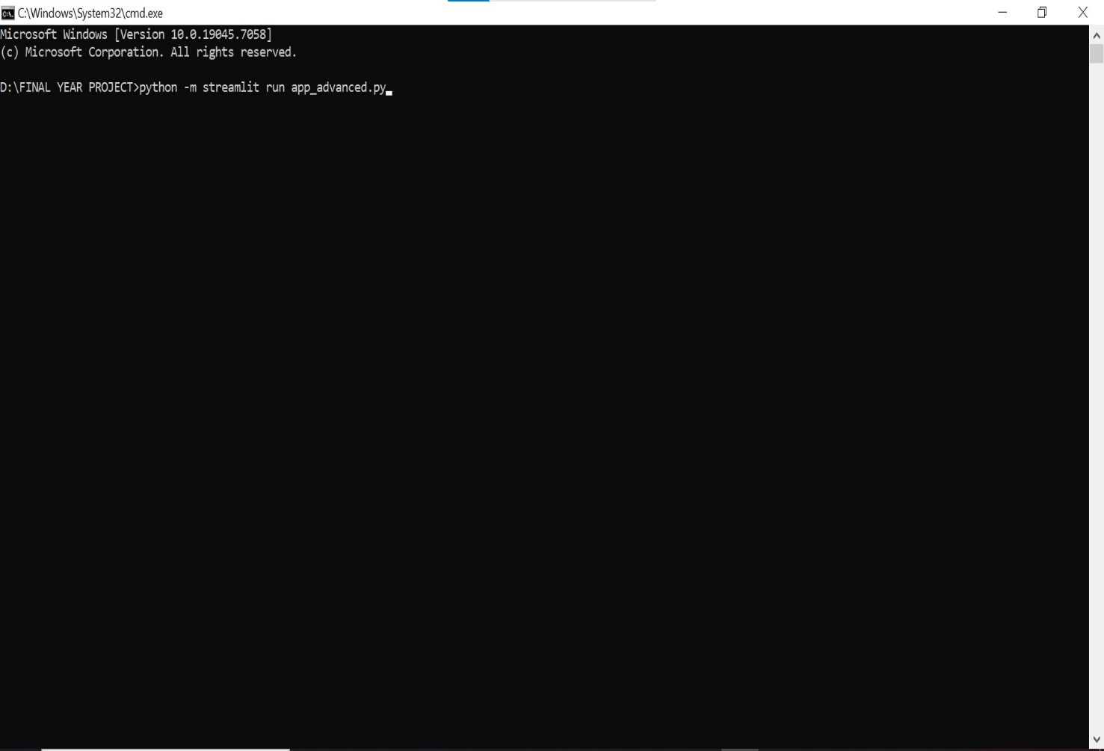
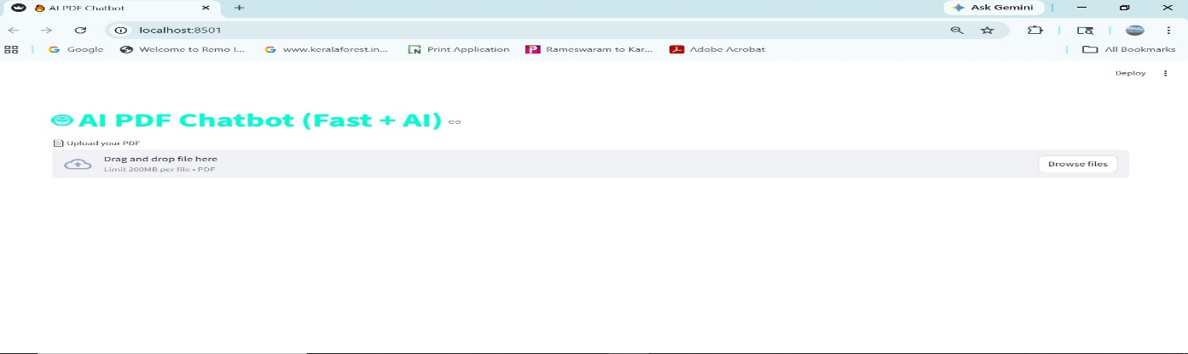
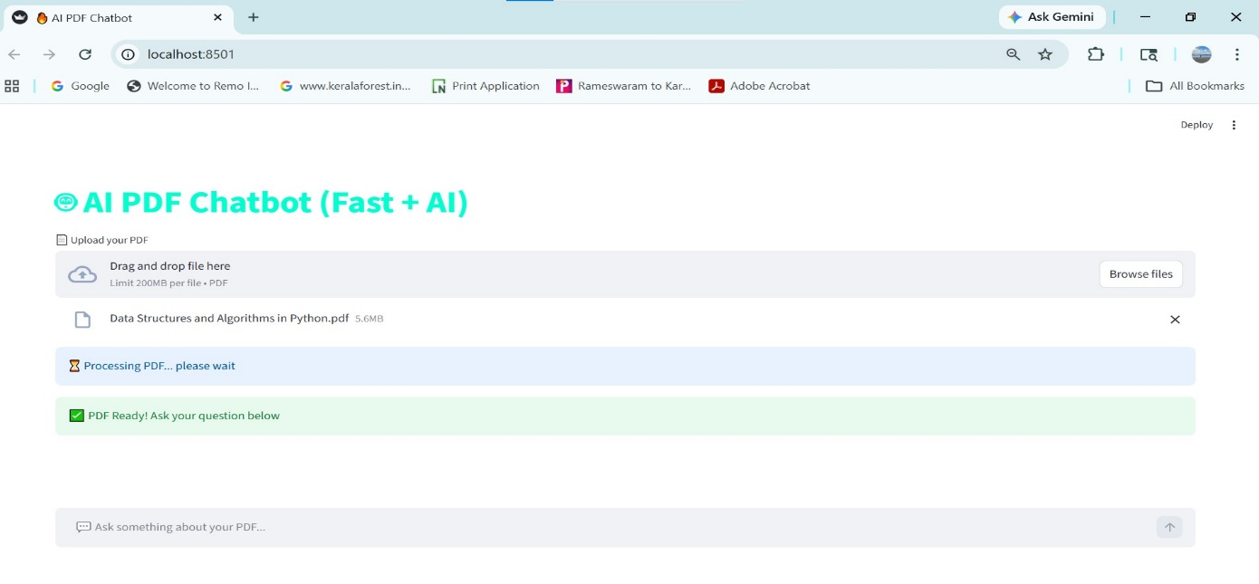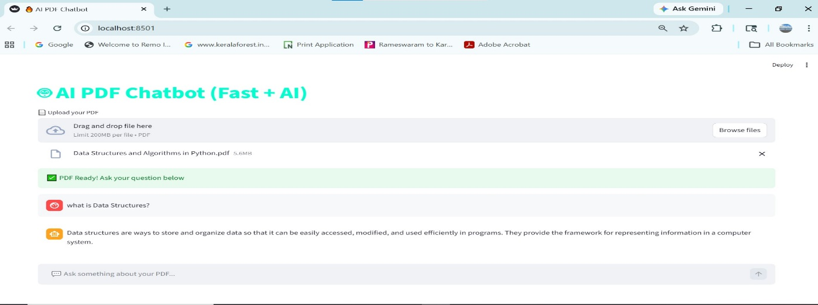
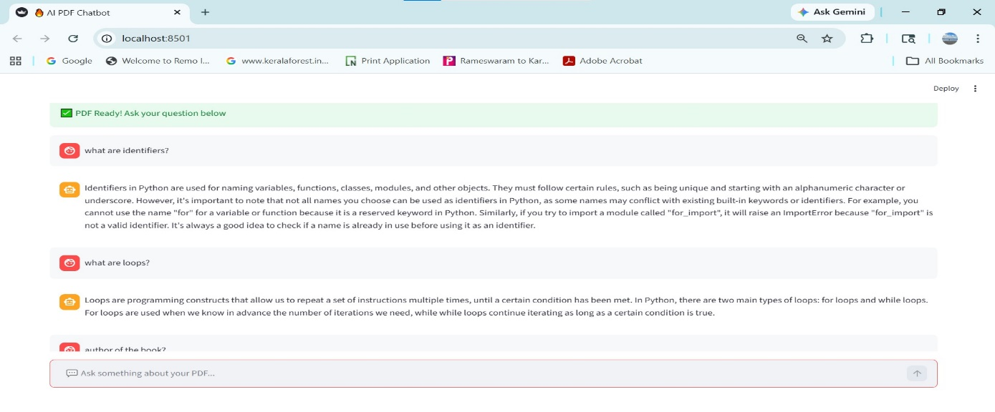
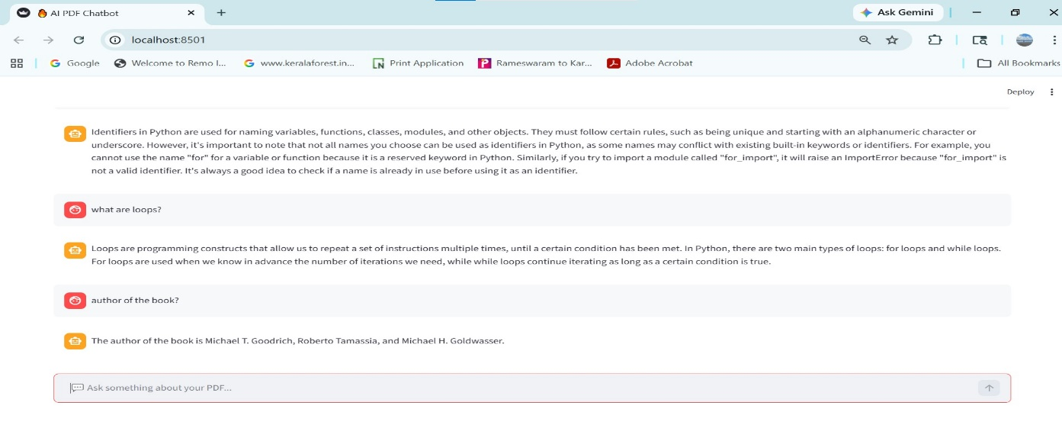

CHAPTER 11 – SYSTEM TESTING EXPLANATION
System testing was performed to evaluate the functionality, accuracy, and performance of the AI-Powered PDF Question Answering System. Multiple PDF documents containing academic and technical content were uploaded and tested with various natural language queries to verify system behavior under different scenarios.
Functional testing confirmed that the system successfully uploads PDF documents, extracts text content, generates embeddings, stores vectors in the FAISS database, retrieves relevant context, and produces AI-generated responses through the local language model. The chatbot interface was also tested to ensure proper display of user queries and generated answers.
Accuracy testing was conducted by comparing the generated responses against the actual content present in the uploaded documents. The system demonstrated good contextual understanding and produced relevant answers for most queries when the requested information existed within the document.
Performance testing indicated that response speed depends on PDF size, system hardware, and the selected local language model. Optimization techniques such as caching and lightweight models improved the system’s responsiveness.
The testing results confirm that the proposed system operates reliably and fulfills the intended functionality of intelligent PDF-based question answering.

CHAPTER 12 – USER MANUAL
The AI-Powered PDF Question Answering System provides a simple and user-friendly interface that allows users to upload PDF documents and interact with them through a chatbot.

Step 1: Launch the Application
Run the application using the Streamlit command in the terminal:
python -m streamlit run app_advanced.py

Step 2: Open the Interface
The application opens in the web browser through the local Streamlit URL.

Step 3: Upload PDF
Click the “Upload PDF” button and select the desired PDF document from the system.

Step 4: Wait for Processing
The system extracts text, generates embeddings, and prepares the document for question answering.

Step 5: Ask Questions
Enter a natural language question related to the uploaded PDF in the chatbot input box.

Step 6: View Response
The system retrieves relevant document context and displays the AI-generated answer in the chat interface.

Step 7: Continue Interaction
Users can ask multiple questions related to the same PDF without re-uploading the document.

CHAPTER 13 – CONCLUSION
The AI-Powered PDF Question Answering System using Retrieval-Augmented Generation and Local Large Language Models was successfully designed and implemented. The developed system enables users to upload PDF documents and interact with them through a chatbot interface to obtain context-aware answers for natural language queries.
By integrating PDF text extraction, text chunking, embedding generation, vector database retrieval, and local LLM-based response generation, the proposed system overcomes the limitations of traditional keyword-based document search methods. It provides improved semantic understanding, enhanced answer relevance, and an intuitive user experience.
The system operates locally using Ollama, ensuring data privacy and reducing dependency on external cloud-based AI services. Experimental results demonstrate that the system effectively retrieves and generates relevant answers from uploaded PDF documents while maintaining acceptable performance.
Overall, the project successfully achieves its objective of building an intelligent and efficient PDF-based question answering assistant using modern AI technologies.

CHAPTER 14 – REFERENCES
- Lewis, P., Perez, E., Piktus, A., et al., “Retrieval-Augmented Generation for Knowledge-Intensive NLP Tasks,” Advances in Neural Information Processing Systems (NeurIPS), 2020.
- Vaswani, A., Shazeer, N., Parmar, N., et al., “Attention Is All You Need,” Advances in Neural Information Processing Systems (NeurIPS), 2017.
- LangChain Documentation, Available: https://python.langchain.com/
- Ollama Documentation, Available: https://ollama.com/
- Streamlit Documentation, Available: https://docs.streamlit.io/
- FAISS Documentation, Facebook AI Similarity Search, Available: https://faiss.ai/
- Sentence Transformers Documentation, Available: https://www.sbert.net/
- pypdf Documentation, Available: https://pypdf.readthedocs.io/

CHAPTER 15 – PUBLICATION
The developed project titled “AI-Powered PDF Question Answering System Using Retrieval-Augmented Generation and Local LLM” demonstrates significant potential for academic and industrial research publication in the fields of Artificial Intelligence, Natural Language Processing, and Intelligent Information Retrieval.
Although the current work has not yet been formally published in any journal or conference, the implemented system presents a practical application of Retrieval-Augmented Generation (RAG), semantic vector search, and local Large Language Model deployment for document-based question answering.
The project can be further extended and refined for future publication in academic conferences or journals by incorporating enhanced evaluation metrics, comparative performance analysis, larger benchmark datasets, and enterprise-scale deployment scenarios.
Potential publication domains include:
- Artificial Intelligence Applications
- Natural Language Processing
- Retrieval-Augmented Generation Systems
- Intelligent Document Analysis
- Conversational AI Systems
This project establishes a strong foundation for future research contributions in AI-powered knowledge retrieval and document understanding systems.

THANK YOU

