Devops Learning
Linux Basics
Pwd
Print working directory
Shows the full absolute path of the directory you are currently working in.

Cd / etc
Navigate to /etc where Linux system configuration files are stored.
Example
vvdn_8422@8422--CLD--POY:~$ cd /etc
vvdn_8422@8422--CLD--POY:/$ cd /etc
Folder create Then list the content inside:
vvdn_8422@8422--CLD--POY:/etc$ ls
acpi hdparm.conf pnm2ppa.conf
adduser.conf host.conf polkit-1
alsa hostid popularity-contest.conf
alternatives hostname ppp
anacrontab hosts printcap

Ls -l
Detailed listing with

Permissions
Owner
Group
File type
Modification date
Example
vvdn_8422@8422--CLD--POY:/etc$ ls -l
total 1156
drwxr-xr-x 3 root root 4096 Mar 16 2023 acpi
-rw-r--r-- 1 root root 3028 Mar 16 2023 adduser.conf
drwxr-xr-x 3 root root 4096 Mar 16 2023 alsa
drwxr-xr-x 2 root root 4096 Jun 4 16:12 alternatives
-rw-r--r-- 1 root root 401 Jul 17 2019 anacrontab
-rw-r--r-- 1 root root 433 Oct 2 2017 apg.conf

Cd /var
Change to /var
Navigate to /var stores logs and runtime data.
Example
vvdn_8422@8422--CLD--POY:~$ cd /var
Directory change to list the files
vvdn_8422@8422--CLD--POY:/var$ ls
backups crash local log metrics ossec snap tmp
Cache lib lock mail opt run spool

/etc/ssh
just enters the directory
It doesn’t open the SSH config files; it just moves you into the folder where those files are stored.
Example
vvdn_8422@8422--CLD--POY:~$ cd /etc
vvdn_8422@8422--CLD--POY:/etc$ cd /etc/ssh
List the files
vvdn_8422@8422--CLD--POY:/etc/ssh$ ls -a
. ssh_config.d ssh_host_ecdsa_key.pub ssh_host_rsa_key.pub
.. sshd_config ssh_host_ed25519_key ssh_import_id
moduli sshd_config.d ssh_host_ed25519_key.pub
ssh_config ssh_host_ecdsa_key ssh_host_rsa_key
Cd ..
Previous go up 1 level
Example
vvdn_8422@8422--CLD--POY:/etc/ssh$ cd ..

Cd~
Go to your home directory.
vvdn_8422@8422--CLD--POY:/etc$ cd ~
vvdn_8422@8422--CLD--POY:~$

Cd /home
Using the directories
vvdn_8422@8422--CLD--POY:/home$ ls
Administrator lost+found Quarantine vvdn_8422 vvsa
vvdn_8422@8422--CLD--POY:/home$
Var log
Store log files for the OS, services, and applications.
Logs here help monitor system health, debug issues, and track security events.
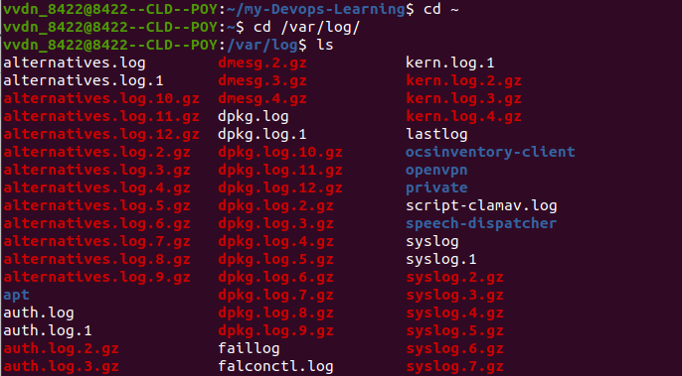
Ls-lh
