ULPAD32: Design and Proof-of-Concept Validation of a Modular Ultra-Low-Power 32-bit MCU Platform
Boopathikumar S, Chandraprakash S, Kavinkumar M, Boopalakrishnan P
Final Year, Department of Electronics and Communication Engineering
Bachelor of Engineering (B.E)
Jai Shriram Engineering College,Tirupur,TamilNadu, India
Email: boopathikumar0012@gmail.com, chandraprakashh139@gmail.com,
kavinmayil123@gmail.com, boopalakrishnan264@gmail.com
Under the Guidance of
Mr. T. Mani
Assistant Professor (Sr.G)
Department of Electronics and Communication Engineering
Email: mani.chip@gmail.com

Abstract—This paper presents ULPAD32, a modular 32-bit microcontroller platform designed for ultra-low-power operation and flexible system integration. The proposed platform is based on the ESP32-S3 processor and incorporates an attach–detach modular architecture to support scalable embedded applications. A wide-range power management subsystem utilizing a buck–boost converter and supercapacitor-based energy storage is employed to ensure stable and efficient operation under varying input conditions. A proof-of-concept prototype was implemented using a dot-PCB hardware setup and validated through functional testing. The design emphasizes compactness, reusability, and cost-effectiveness, making it suitable for rapid prototyping and academic research. The proposed platform demonstrates potential applicability in IoT, robotics, and smart agriculture systems. Future enhancements will focus on optimized power-stage design and custom PCB implementation to further improve efficiency and reliability
Keywords— Ultra-low power MCU, ESP32-S3, Modular embedded systems, Power management, Proof-of-concept prototype

I. INTRODUCTION
The rapid growth of embedded systems in applications such as the Internet of Things (IoT), robotics, and smart agriculture has increased the demand for platforms that offer efficient processing, low power consumption, and modular adaptability. Conventional microcontroller-based systems often suffer from limitations including fixed operating voltage ranges, limited modularity, and reduced reusability, which restrict their applicability across diverse use cases.
To address these challenges, this work presents ULPAD32, an Ultra-Low-Power Attach–Detach 32-bit microcontroller platform designed to support flexible integration and scalable system development. The proposed platform is based on the ESP32-S3 processor, which provides integrated wireless connectivity through Wi-Fi and Bluetooth, along with MicroSD card support for data storage and logging applications.
The system incorporates a wide-range power management architecture utilizing a buck–boost converter and supercapacitor-based energy storage to support operation under varying input conditions. A proof-of-concept hardware prototype was implemented to validate the feasibility of the proposed design. The modular and reusable nature of ULPAD32 makes it suitable for rapid prototyping and academic research, with potential applications in low-power embedded and IoT-based systems.
The main objectives of the proposed ULPAD32 platform are as follows:
• To design a modular attach–detach 32-bit MCU system based on the ESP32-S3 for flexible system integration.
• To implement a wide-range power management architecture using buck–boost converters and supercapacitor-based energy storage.
• To achieve reliable processing performance within a compact and scalable hardware design.
• To promote reusability and adaptability of the platform for applications in IoT, robotics, smart agriculture, and engineering education.
• To provide a low-cost and practical embedded development platform suitable for students and academic research.
II. RELATED WORK
Several studies have explored low-power processing architectures, modular embedded system design, and energy-efficient power management techniques relevant to the development of ultra-low-power microcontroller platforms. Prior research on RISC-V–based clusters and fully depleted silicon-on-insulator (FD-SOI) microcontrollers has demonstrated scalable low-power computation for edge and embedded applications. Although these solutions offer significant energy efficiency, their higher cost and fabrication complexity limit widespread adoption in academic and prototyping environments. These works influenced the power-optimization strategy adopted in the ULPAD32 platform using a commercially available MCU.
Modular embedded system design has also been widely investigated, with several platforms emphasizing standardized interfaces and plug-and-play architectures to improve flexibility and reusability. Such approaches highlight the benefits of detachable modules for rapid system integration and application-specific customization.
Power management remains a critical aspect of low-power embedded platforms. Existing studies on buck–boost power converters, hybrid energy storage, and supercapacitor-based backup systems demonstrate effective methods for maintaining stable operation under varying input conditions. These techniques inspired the power management architecture of ULPAD32, which combines buck–boost conversion with supercapacitor-based energy storage to enhance system reliability and operational flexibility.
III. EXISTING EMBEDDED PLATFORMS
Several commercially available microcontroller platforms are widely used for embedded and IoT applications; however, each presents specific limitations when evaluated in terms of modularity, power flexibility, and scalability.
The NodeMCU platform based on the ESP8266 microcontroller offers a cost-effective solution with integrated Wi-Fi connectivity, making it suitable for basic IoT applications. Nevertheless, it operates at a fixed supply voltage of 3.3 V, provides a limited number of GPIO pins, and offers lower processing performance compared to more recent 32-bit microcontrollers.
Arduino-based development boards are widely adopted for educational purposes due to their simplicity and extensive community support. Despite these advantages, such platforms generally lack modular hardware architectures, have limited onboard memory resources, and provide minimal support for flexible power input management, restricting their use in advanced low-power and scalable systems.
ESP32-based platforms improve upon earlier solutions by offering enhanced processing capability along with integrated Wi-Fi and Bluetooth connectivity. However, most existing ESP32 development boards do not incorporate attach–detach modular architectures or wide-range power management features, limiting their adaptability for reusable and application-specific system configurations.
IV. SYSTEM ARCHITECTURE
The overall architecture of the proposed ULPAD32 platform is designed to achieve modularity, power efficiency, and scalability for low-power embedded applications. The system follows a block-based architecture consisting of a processing unit, power management subsystem, modular interface layer, and peripheral support modules.
At the core of the architecture is the ESP32-S3 microcontroller, which serves as the primary processing and control unit. The MCU provides 32-bit processing capability along with integrated Wi-Fi and Bluetooth connectivity, enabling wireless communication for IoT-based applications. A MicroSD card interface is included to support local data storage, logging, and offline operation.
The power management subsystem is designed to support operation under varying input conditions. It incorporates a buck–boost power converter to regulate the input supply and a supercapacitor-based energy storage element to provide short-term backup and improve system reliability during transient power variations. This architecture allows the platform to adapt to different power sources such as batteries, adapters, and energy-harvesting modules.
A key feature of the ULPAD32 platform is its attach–detach modular interface, which enables peripheral modules to be connected or removed based on application requirements. This modular approach enhances reusability, simplifies system customization, and supports rapid prototyping. The overall architecture was validated through a proof-of-concept hardware implementation using a dot-PCB setup to demonstrate functional feasibility.
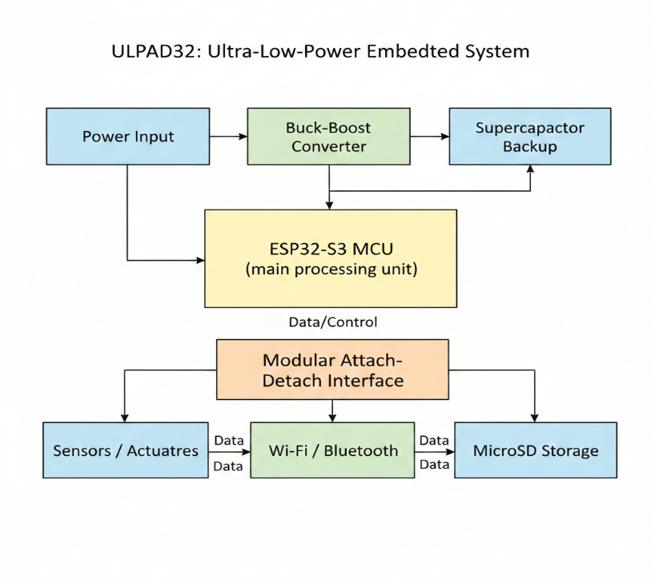
Fig. 1.ULPAD Block Diagram
V. HARDWARE DESIGN AND IMPLEMENTATION
Component | Part / Module | Purpose in ULPAD32
Microcontroller Unit | ESP32-S3 | Acts as the main 32-bit processing unit with integrated Wi-Fi and Bluetooth connectivity
Power Converter | Buck–Boost Converter IC | Regulates input voltage to provide stable supply under varying input conditions
Energy Storage | Supercapacitor | Provides short-term backup power and improves reliability during voltage fluctuations
Storage Interface | MicroSD Card Module | Enables local data storage and logging for offline operation
Voltage Regulation | LDO / Regulator | Ensures stable voltage rails for sensitive components
Modular Connectors | Pin Headers / Connectors | Implements the attach–detach modular interface for peripheral expansion
Passive Components | Resistors, Capacitors | Used for filtering, stabilization, and signal conditioning
The hardware design of the ULPAD32 platform was realized through careful selection of commercially available components to balance performance, power efficiency, and cost. The ESP32-S3 microcontroller was chosen as the core processing unit due to its 32-bit architecture and integrated wireless communication capabilities. A buck–boost power conversion stage was incorporated to support operation under varying input conditions, while a supercapacitor was employed to enhance power stability during transient interruptions. Modular connectors were introduced to enable the attach–detach architecture, allowing peripheral modules to be added or removed based on application requirements. The overall design was implemented as a proof-of-concept prototype to validate functional feasibility
VI. POWER MANAGEMENT ARCHITECTURE.
A. Power Input and Regulation
The power management architecture of the proposed ULPAD32 platform is designed to support operation under varying input supply conditions while maintaining stable voltage levels for the microcontroller and peripheral modules. The system accepts power from multiple sources such as batteries, external adapters, or experimental energy-harvesting units.
A buck–boost DC–DC converter is employed as the primary regulation stage, allowing the system to maintain a constant regulated output despite fluctuations in the input supply. This approach enables seamless operation when the input voltage is either above or below the required system voltage. The regulated output is distributed to the ESP32-S3 microcontroller and associated peripheral circuits through dedicated power rails.
B. Energy Storage and Power Stability
To improve power stability and provide short-duration backup during transient interruptions, a supercapacitor-based energy storage element is integrated into the power subsystem. Unlike conventional battery-only designs, the use of a supercapacitor enables rapid charge–discharge cycles, high reliability, and reduced maintenance requirements.
The supercapacitor assists in smoothing voltage fluctuations caused by sudden load changes and supports uninterrupted operation during brief power drops. This design choice enhances system robustness, particularly in portable and experimental embedded applications.
C. Power Efficiency Considerations
Power efficiency in the ULPAD32 platform is addressed through a combination of hardware-level regulation and system-level design choices. Efficient DC–DC conversion reduces power dissipation, while careful component selection minimizes quiescent current consumption. The ESP32-S3 microcontroller supports multiple low-power operating modes, which can be utilized at the firmware level to further reduce overall energy consumption.
The presented power management architecture was validated through a proof-of-concept prototype to confirm functional stability under practical operating conditions.
η = (Pout / Pin) × 100%
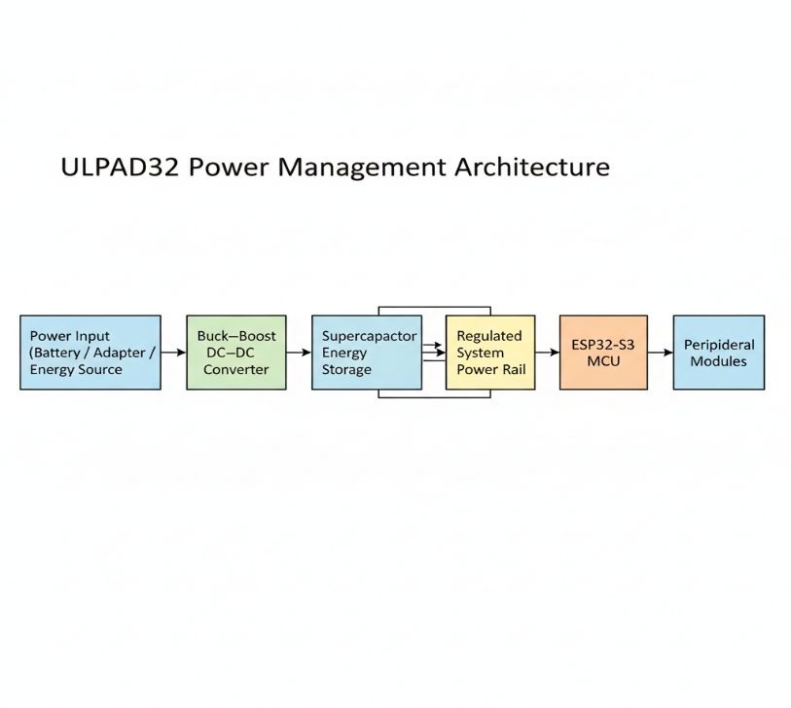
Fig. 2. Power management architecture of the proposed ULPAD32 platform.
VII. PROTOTYPE IMPLEMENTATION AND PoC VALIDATION
The proposed ULPAD32 platform was implemented as a proof-of-concept hardware prototype to validate the feasibility of the system architecture and power management design. The prototype was developed using a dot-PCB and modular connectors, allowing rapid assembly and flexible modification during the development process.
The schematic and layout design were created using the EasyEDA design environment, enabling systematic integration of the ESP32-S3 microcontroller, power regulation circuitry, modular interfaces, and peripheral components. Standard soldering techniques were employed to assemble the prototype, ensuring reliable electrical connections and structural stability.
Functional validation was performed by powering the system under practical operating conditions and verifying successful microcontroller boot-up, stable voltage regulation, and basic peripheral communication. The attach–detach modular interface was tested by connecting and disconnecting peripheral modules to confirm reliable operation and signal continuity.
The proof-of-concept prototype demonstrated consistent functional performance, confirming the validity of the proposed hardware architecture. Although the prototype does not represent a final production-ready system, it effectively validates the core design concepts of modularity, power stability, and system integration proposed in this work.
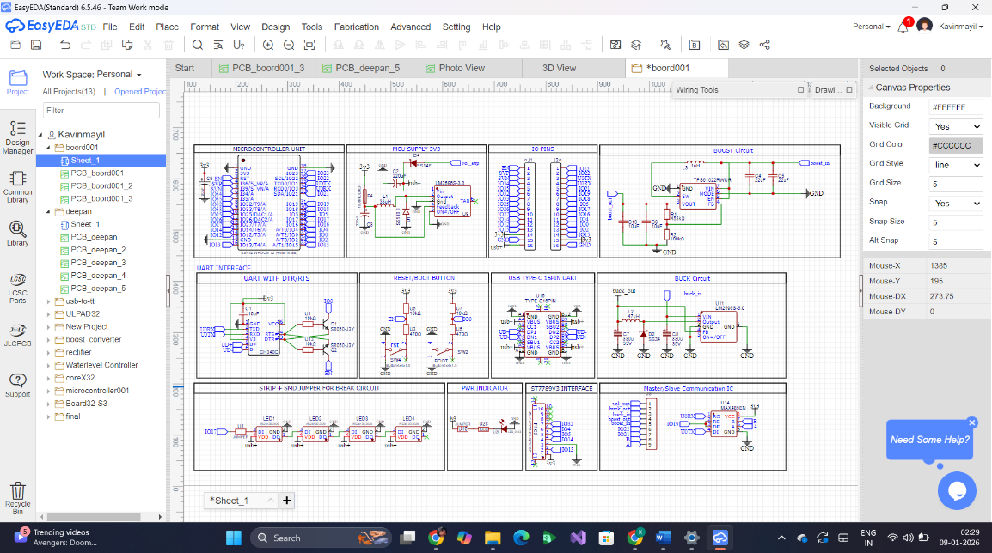
Fig. 3. EasyEDA Circuit Diagram
Following schematic validation, the PCB layout and 3D board representation were designed in EasyEDA, emphasizing optimal component placement, power routing, and modular connectivity
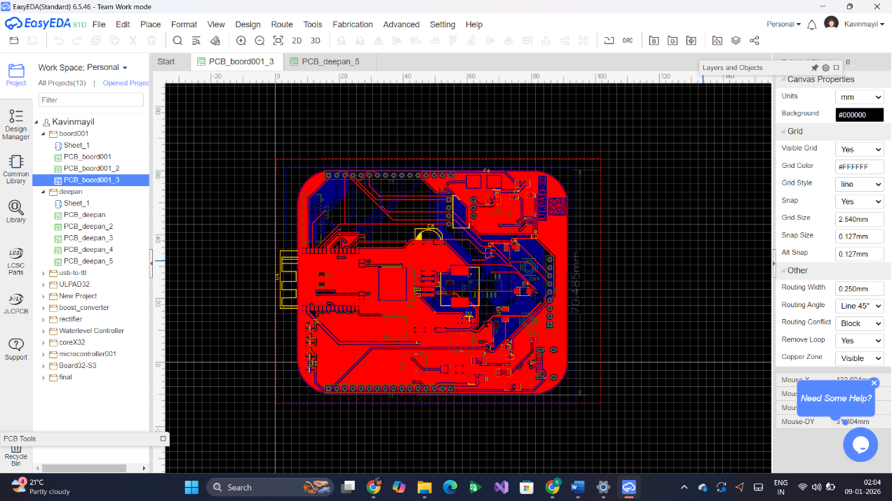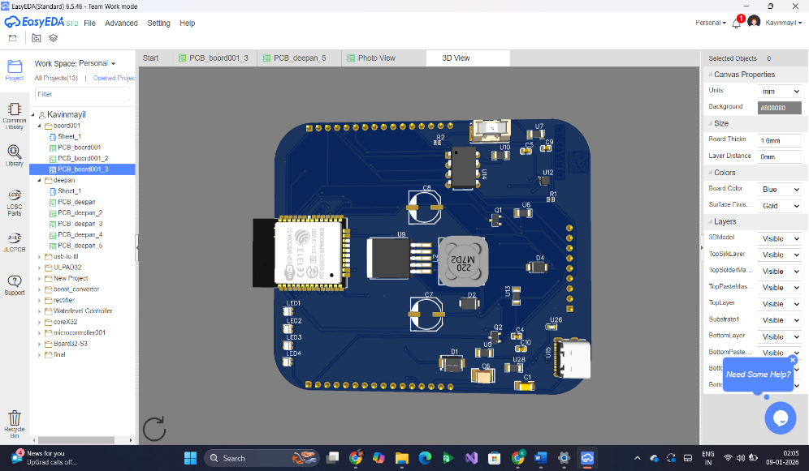
Fig. 4. Prototype PCB layout implemented for ULPAD32 validation.
VIII. RESULTS AND DISCUSSION
The ULPAD32 prototype was successfully designed and assembled to validate the proposed modular ultra-low power microcontroller platform. The developed PCB integrates the ESP32-S3, power management circuitry, attach–detach interfaces, and communication modules as presented in the system architecture.

A. Prototype Validation
The prototype was powered using multiple input sources within the range of 1.5 V to 12 V, and stable voltage regulation was observed at the required operating levels. Although the design targets ultra-low-voltage operation, reliable functionality was achieved from 1.5 V onwards, which is sufficient for practical embedded and IoT applications.
The ESP32-S3 successfully booted and executed test firmware, confirming correct power sequencing, clock stability, and reset behavior. GPIO pins, UART communication, and USB-Type-C interface were verified through functional testing.

B. Power Management Performance
The buck–boost power management architecture ensured consistent output voltage under varying input conditions. The use of supercapacitors improved transient response and provided short-term backup during input fluctuations. This validates the suitability of ULPAD32 for portable and energy-harvesting-based systems.
Compared with conventional development boards, the proposed design demonstrates improved voltage adaptability and modular reusability, making it suitable for both battery-powered and fixed-supply environments.

C. Modular and Hardware Reusability Analysis
The attach–detach modular architecture allowed easy interfacing of peripherals without redesigning the core MCU board. This significantly reduces development time and hardware redundancy. The PCB layout and 3D implementation further confirmed the compactness and manufacturability of the design.

D. Discussion
The experimental results confirm that ULPAD32 meets its design objectives in terms of modularity, power efficiency, and scalability. While the current prototype serves as a Proof of Concept (PoC), future improvements can focus on achieving reliable operation below 1.5 V and optimizing power consumption through firmware-level enhancements.
IX. CONCLUSION AND FUTURE WORK
The ULPAD32 platform presented in this paper demonstrates a modular ultra-low-power 32-bit microcontroller architecture designed to support flexible integration and scalable embedded system development. By combining an attach–detach modular interface with a wide-range power management subsystem, the proposed design addresses key limitations observed in conventional microcontroller platforms related to reusability, power adaptability, and system scalability.
A proof-of-concept hardware prototype was successfully implemented using a dot-PCB approach and validated through functional testing. The experimental observations confirm stable microcontroller operation, effective power regulation, and reliable modular connectivity, thereby validating the feasibility of the proposed architecture for embedded and IoT-based applications.
Future work will focus on the development of a custom fabricated PCB to improve form factor and electrical performance, optimization of the power management stage to extend reliable operation toward lower input voltages, and implementation of firmware-level power optimization techniques. Additionally, the platform can be extended to support advanced sensing, edge intelligence, and energy-harvesting applications, further enhancing its applicability in academic research and real-world embedded systems.
X. REFERENCES
[1] E. Lefeuvre, D. Audigier, C. Richard, and D. Guyomar, “Buck–boost converter for sensorless power optimization of piezoelectric energy harvester,” IEEE Transactions on Power Electronics, vol. 22, no. 5, pp. 2018–2025, Oct. 2007.
[2] G. Sharma, T. Soyata, A. Nadeau, and M. Hassanalieragh, “Solar-supercapacitor harvesting system design for energy-aware applications,” in Proceedings of the 27th IEEE International System-on-Chip Conference (SOCC), 2014, pp. 280–285.
[3] J. Kühne, M. Magno, and L. Benini, “Parallelizing optical flow estimation on an ultra-low-power RISC-V cluster for nano-UAV navigation,” arXiv preprint arXiv:2305.13055, 2023.
[4] A. Dettmann, Z. Wang, W. Wenzel, F. Cordes, and F. Kirchner, “Heterogeneous modules with a homogeneous electromechanical interface in multi-module systems for space exploration,” in Proceedings of the IEEE International Conference on Robotics and Automation (ICRA), 2011, pp. 1964–1969.
[5] J. R. Read, L. McElroy, Q. Bolsee, B. Smith, and N. Gershenfeld, “Modular-Things: Plug-and-play with virtualized hardware,” in Proceedings of the 2023 CHI Conference on Human Factors in Computing Systems, 2023, pp. 1–12.
[6] H. Bauer, M. Stolba, S. Scholze, D. Walter, C. Mayr, A. Oefelein, S. Höppner, A. Scharfe, F. Schraut, and H. Eisenreich, “A RISC-V MCU with adaptive reverse body bias and ultra-low-power retention mode in 22 nm FD-SOI,” in Proceedings of the 2023 IEEE International SoC Conference (ISOCC), 2023, pp. 67–68.c
[7] Espressif Systems, “ESP32-S3 Series Datasheet,” Espressif Systems, 2023.
[8] R. W. Erickson and D. Maksimović, Fundamentals of Power Electronics, 2nd ed. New York, NY, USA: Springer, 2001.
[9] M. Magno, D. Boyle, D. Brunelli, B. Moser, and L. Benini, “Extended lifetime for wireless sensor networks through energy harvesting,” IEEE Internet of Things Journal, vol. 1, no. 5, pp. 437–446, Oct. 2014.
[10] Y. K. Ramadass and A. P. Chandrakasan, “A battery-less thermoelectric energy harvesting interface circuit with 35 mV startup voltage,” IEEE Journal of Solid-State Circuits, vol. 46, no. 1, pp. 333–341, Jan. 2011.
[11] P. Simon and Y. Gogotsi, “Materials for electrochemical capacitors,” Nature Materials, vol. 7, pp. 845–854, 2008.
[12] A. Burke, “Ultracapacitors: why, how, and where is the technology,” Journal of Power Sources, vol. 91, no. 1, pp. 37–50, 2000.
[13] J. Beutel, M. Dyer, M. Hinz, L. Meier, and L. Thiele, “Scalable and flexible sensor network deployment,” IEEE Transactions on Industrial Informatics, vol. 5, no. 3, pp. 234–245, Aug. 2009.
[14] K. Whitehouse, J. Liu, J. Reich, P. Cheung, F. Zhao, and J. Liu, “MacroLab: A vector-based macroprogramming framework for cyber-physical systems,” IEEE Internet Computing, vol. 10, no. 4, pp. 12–19, Jul.–Aug. 2006.
[15] Texas Instruments, “LM2596 Simple Switcher® Buck Converter Datasheet,” Texas Instruments, 2022.

