**ChatBot**

**Introduction**

This is a simple rule-based chatbot implemented in Python. It interacts with users by responding to predefined queries using regular expressions. The chatbot continuously listens to user input and provides appropriate responses based on recognized patterns. The program terminates when the user types "bye," "exit," or "quit." A chatbot is an AI-based software that can simulate a conversation with users. A simple chatbot can be designed using rule-based logic or machine learning models to understand user queries and provide relevant responses. For this project, we will implement a basic chatbot using Python and NLP techniques. The chatbot will handle predefined user inputs and provide relevant responses based on pattern matching or AI-based methods.

**Module Description**

The chatbot is implemented using:

1. **re (Regular Expressions Module):**
   * Used for pattern matching in user input to determine appropriate responses.
2. **Functionality Breakdown:**
   * **Greeting Handling:** Recognizes words like "hello" or "hi."
   * **Well-being Inquiry:** Responds to "how are you?"
   * **Name Inquiry:** Answers when the user asks for the chatbot's name.
   * **Help Command:** Guides the user on what the chatbot can do.
   * **Exit Handling:** The chatbot ends the conversation when the user types "bye," "exit," or "quit."
   * **Fallback Response:** If input doesn't match any pattern, the chatbot states it doesn't understand.
3. **User Interface:**

* Takes input from the user and displays the chatbot's responses. This can be a terminal-based inter face, a web app (Flask/Django), or a GUI app (Tkinter)

1. **Preprocessing Module:** 
   * Cleans and processes user input using NLP techniques (lowercasing, tokenization, stemming, removing stopwords, etc.).
2. **Intent Recognition:**
   * Uses predefined rules or machine learning models (NLTK, spacy, or transformers) to understand the intent of the user.
3. **Response Generation**
   * Matches user input with predefined responses (Rule-based) or generates responses dynamically (ML-based).

**Flow Diagram:**

Here’s a simple representation of how the chatbot processes user input:

Start

│

▼

User Input

│

├───> Matches "bye"/"exit"/"quit"? → Yes → Exit Program

│

├───> Matches "hello"/"hi"? → Yes → Respond with greeting

│

├───> Matches "how are you"? → Yes → Respond with bot's state

│

├───> Matches "your name"? → Yes → Respond with bot's name

│

├───> Matches "help"? → Yes → Provide assistance

│

├───> No match → Default response

│

▼[Repeat until exit command]

**Enhancements:**

To improve the chatbot, you could:

* Add more regex patterns for varied inputs.
* Introduce NLP techniques for better response generation.
* Implement a GUI or deploy it as a web-based chatbot.

**Working Flow of the Chatbot:**

Step-by-Step Process

1. User Input:

* + The user types a message (e.g., "Hello, how are you?").

2. Preprocessing the Input:

* + Convert text to lowercase.
  + Remove stopwords and punctuation.
  + Tokenize the sentence (split it into words).

3. Intent Recognition:

* If rule-based: Match keywords to predefined patterns.
* If ML-based: Use NLP models (e.g., bag-of-words, TF-IDF, deep learning) to classify the intent.

4. Response Generation:

* If a rule-based chatbot, return a predefined response.
* If an AI-based chatbot, generate a response using an NLP model (e.g., GPT, Transformer models).

5. Response Output:

* Display the chatbot’s response to the user.
* Continue the conversation based on new inputs.

**Technologies Used:**

* Programming Language: Python
* Libraries: NLTK, spaCy, TensorFlow/Keras (for ML-based bots)
* Frameworks (Optional): Flask/Django for a web-based chatbot
* API Integration: OpenAI GPT API, weather API, etc. (for advanced features)

**Coding:**

import re

def chatbot():

    print("Hello! I'm a simple chatbot. Type 'bye' to exit.")

    while True:

        user_input = input("You: ").lower()

        if user_input in ['bye', 'exit', 'quit']:

            print("Chatbot: Goodbye! Have a great day!")

            break

        elif re.search(r'hii', user_input):

            print("Chatbot: Hello! How can I help you today?")

        elif re.search(r'how are you', user_input):

            print("Chatbot: I'm just a bot, but I'm doing great! How about you?")

        elif re.search(r'your name', user_input):

            print("Chatbot: I'm a simple chatbot created to assist you!")

        elif re.search(r'can you answer me', user_input):

            print("Chatbot: Sure! I can answer simple questions. Try asking about my name or how I am doing.")

        else:

            print("Chatbot: Sorry, I don't understand that.")

if __name__ == "__main__":

    chatbot()

**Output:**

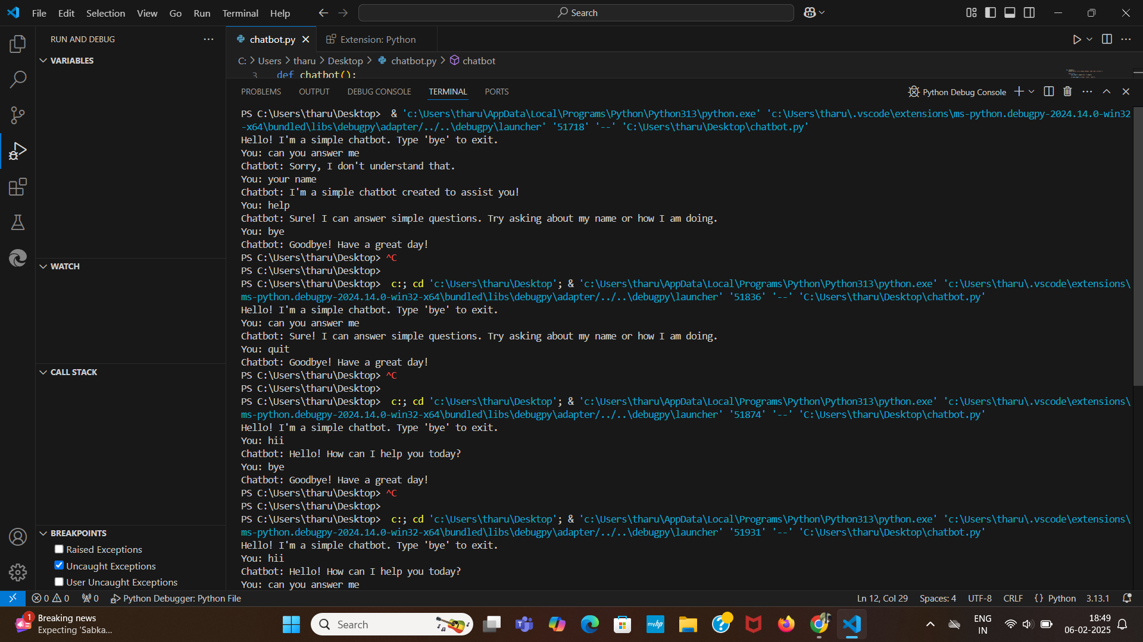

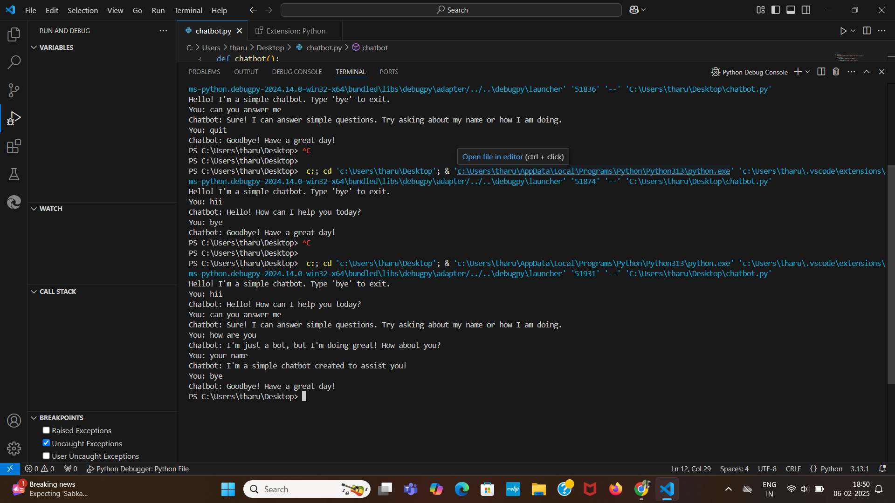

**Conclusion:**

The simple chatbot project demonstrates the fundamental principles of chatbot development, including NLP, response generation, and user interaction. By implementing enhancements and integrating with external APIs, the chatbot can evolve into a more intelligent and dynamic assistant. Future improvements can focus on deep learning techniques, improved conversational abilities, and broader application domains. This project serves as a solid foundation for further advancements in AI-driven communication systems.0