**KALAMINOES**

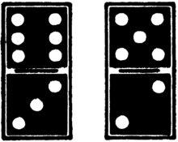**Handbook**

s

Kavin & Pratik

**Table of Contents**

Page 3 --------------------------- How to play

Page 4 --------------------------- Controls

Page 5 --------------------------- Playing the Game

Page 6 --------------------------- Playing the Game

Page 7 --------------------------- Playing the Game

Page 8 --------------------------- Playing the Game



2

**How to Play**

**Setup:** When the game is opened, you will see a main menu to select player names. Depending on the number of players, check off the checkboxes for those players, and type in a username. If less than four players are playing, then a computer player will be made accordingly.

To begin the game, click “Start Game”. The main menu will now disappear, and you will be presented with a domino table.

Each player will receive 7 dominos to start with, and the person with the double six automatically places that domino first.

**Objective of the Game:** To play all the dominos in your hand before anyone else.

3



**Controls**

There are two buttons on the canvas. One says “Left”, and the other says “Right”. These buttons are used to choose whether you want to play on the left side or on the right side. (Refer to Figure 1.0)

The mouse is used to select a domino to be placed. Simply just click on the desired domino.

Figure 1.0

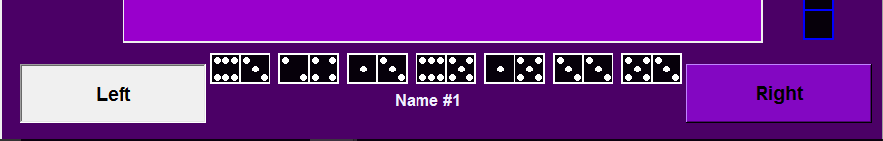

4



**Playing the Game**

When the game is first run, you will see a main menu (Figure 1.1), where you can input names, and select the amount of players. One player is always required, and cannot be unselected.

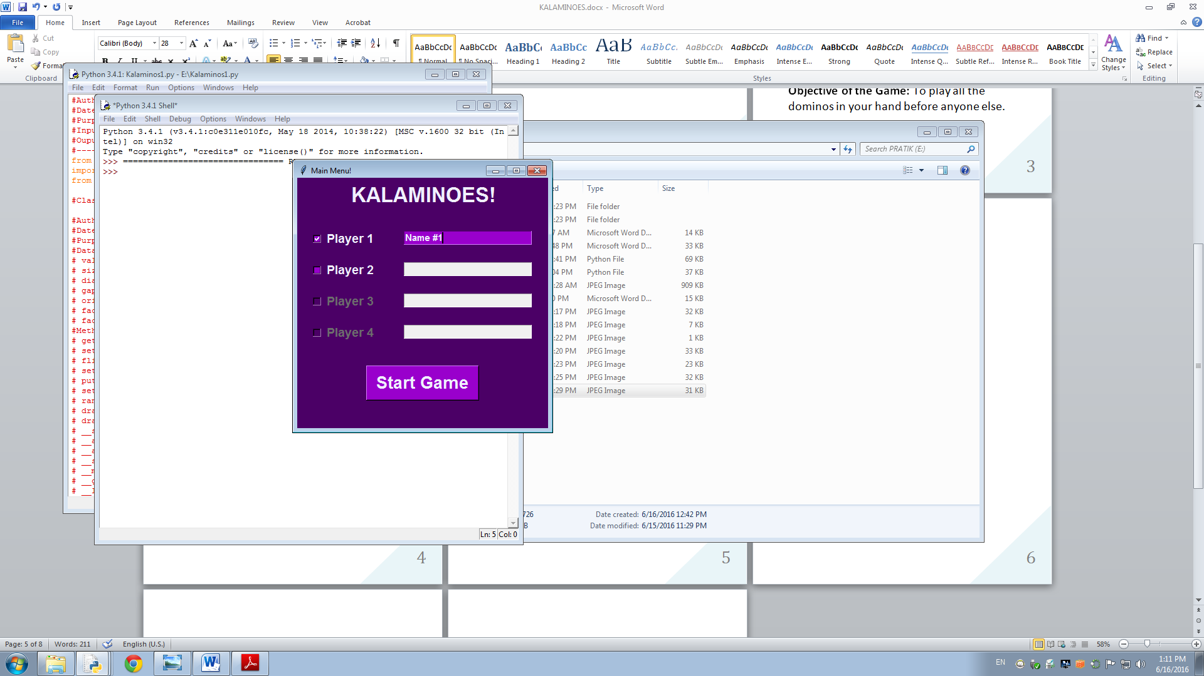Figure 1.1

5



**Playing the Game**

After choosing your names from the main menu, you will be presented with this screen. The person/computer that has the double 6 domino, they will go first. An infobox will pop up to indicate that.

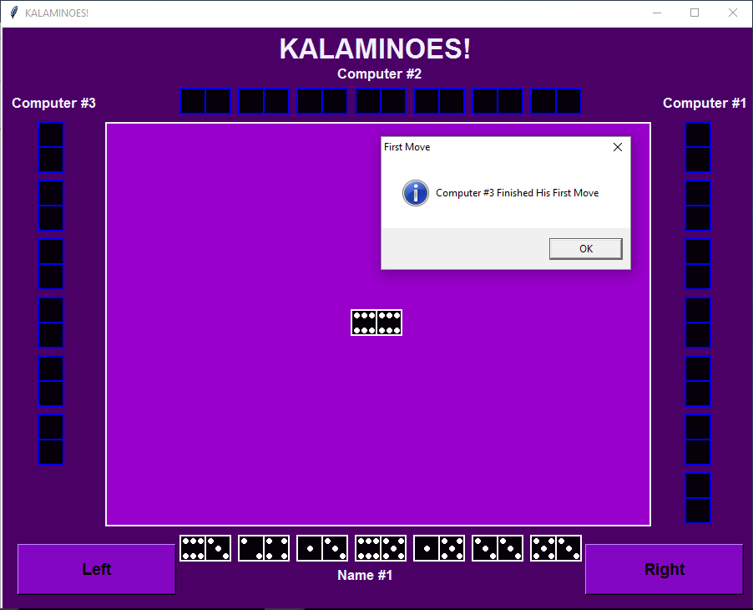

6

**Playing the Game**

Once it is your turn, you must choose a domino to play. In order to play a domino, one of its values must be equal to the right value of the domino on the left side of the table, or the left value of the right side of the table. Depending on which side you want to place on click “Left” or “Right”. If it is not possible to place a domino, then you will automatically pass by clicking anywhere on the game.

Figure 1.2: Demonstration of how dominos connect

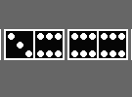

7

**Playing the Game**

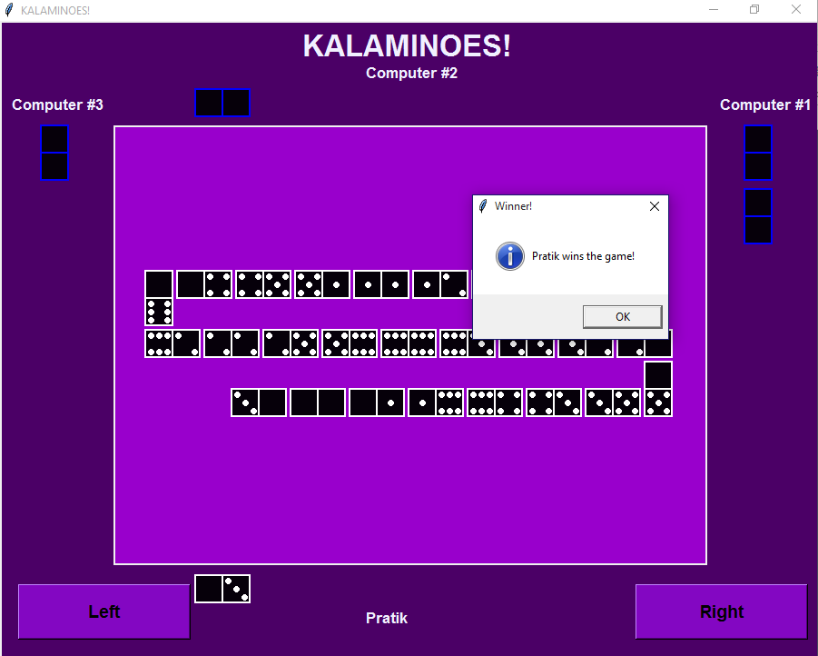As long as each player has dominos, the game continues. Once a player loses all their dominos, that player wins. A message will appear stating the winner (Figure 1.3). By pressing “Ok”, the game will quit automatically.

Figure 1.3



8