10) Creation of VHD on Windows and restoring on

different host

Aim:
To create a VHD on windows and restore the same in different host

Steps:

Create a VHD on Windows

- Press Win + R, type diskmgmt.msc, and press Enter
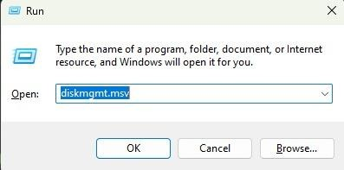

- In Disk Management, go to the Action menu → Create VHD
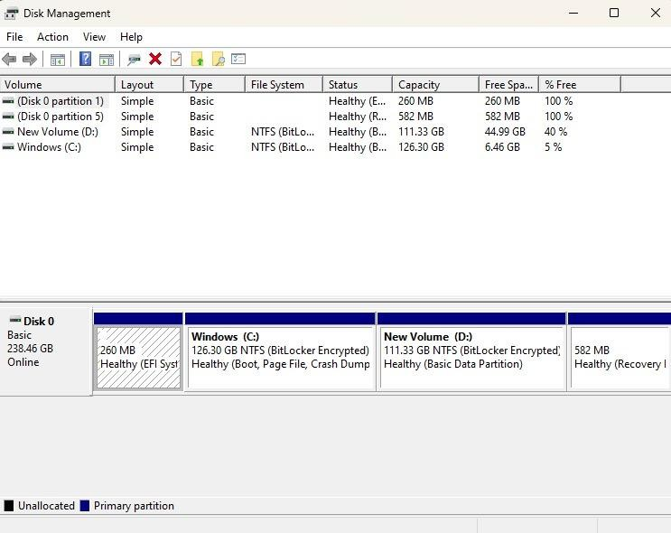

- Location → Browse and select where to save the .vhd or .vhdx file.

- Virtual Hard Disk Size (decide based on what you need).

- VHD format:VHD (compatible with older systems, max 2TB).

- Type: Fixed size → Pre-allocates the full size. Faster runtime, but uses disk space upfront.
- Dynamically expanding → Grows as data is added. Saves space initially.

- Click OK → The VHD will be created and appear in Disk Management as "Not Initialized".
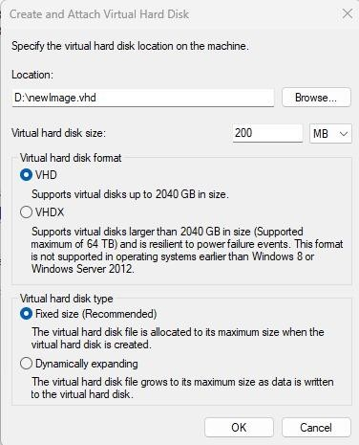
- Right-click the new disk → Initialize Disk.

- Create a new volume: Right-click unallocated space → New Simple Volume
→ Assign a drive letter → Format (NTFS recommended).

- Now you can use it like a normal drive.
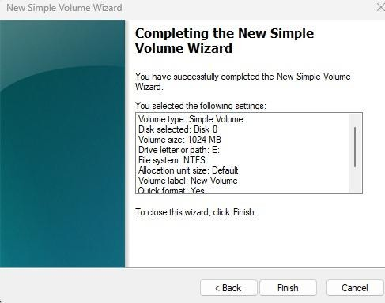

Steps to Use on Another Host

- Copy your .vhd or .vhdx file to the new machine (via external HDD, network, or cloud).
- On the new host:Open Disk Management → Action → Attach VHD.

- Browse to the .vhd file and click OK.
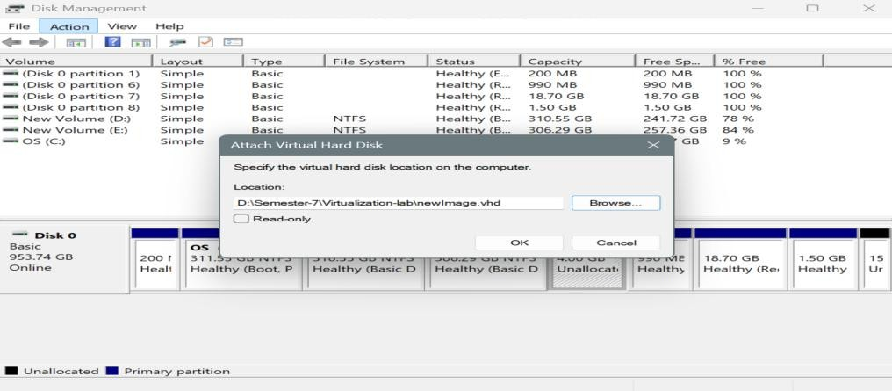

- The VHD will appear as a new drive (with the same partitions/data).
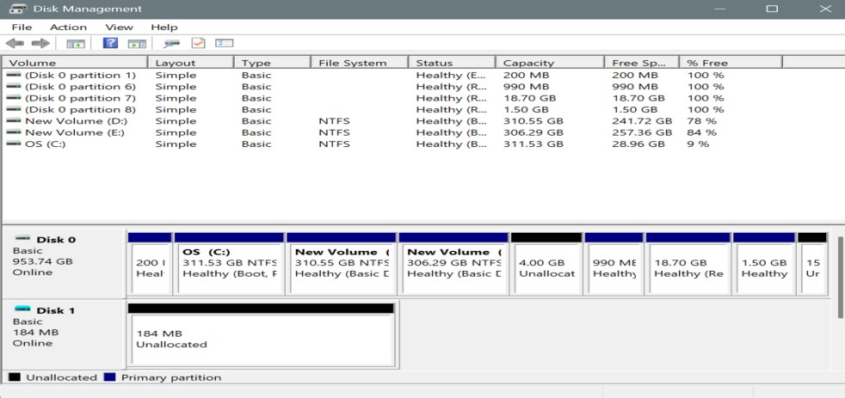

- If needed, assign a drive letter:Right-click the partition → Change Drive Letter and Paths → Assign a letter.
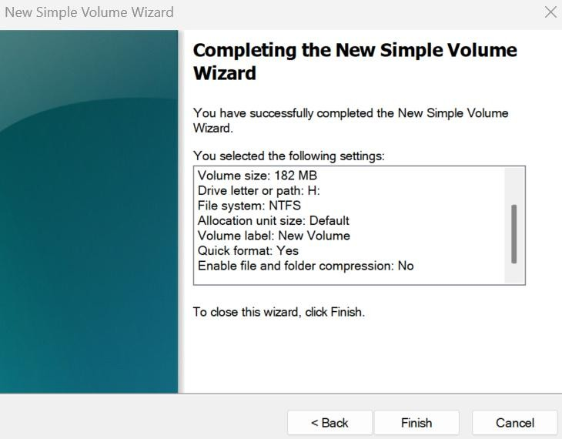

- Now you can access files just like a normal disk.
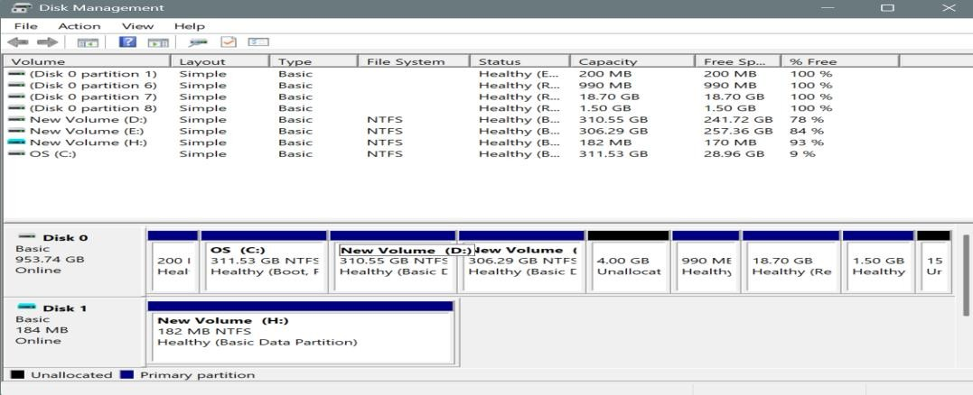

STORAGE VIRTUALIZATION:

Storage Virtualization

Step 1: Create a VM and Add Additional Storage

- Create a Linux VM

  - Open VirtualBox → Click New → Enter VM Name, Type = Linux, Version = ubuntu.
  - Allocate RAM (e.g., 2–4 GB).

  - Hard Disk: Select “Use an existing virtual hard disk file”.

  - Browse and select your VDI file.

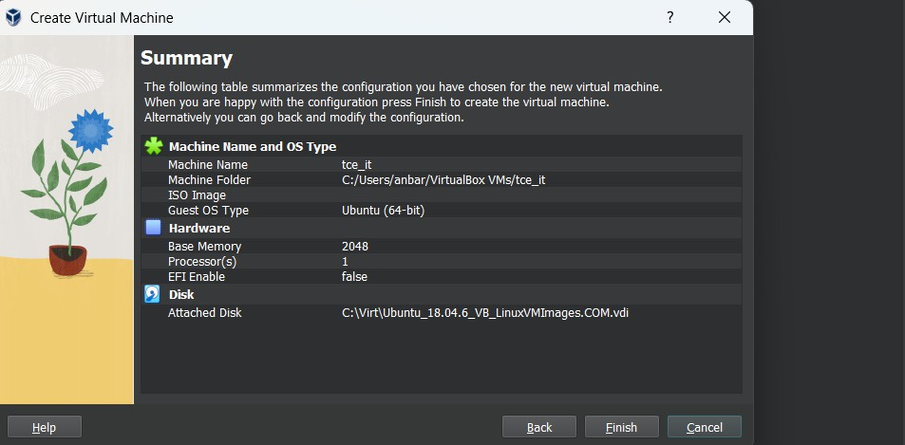
  - Click Finish.

- Add an Additional Virtual Disk

  - This disk will be used for extending storage via LVM.

  - In VirtualBox:

- Select the VM → Settings → Storage.

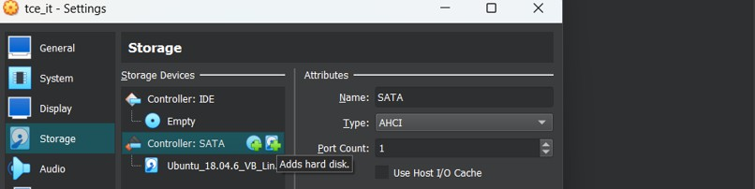

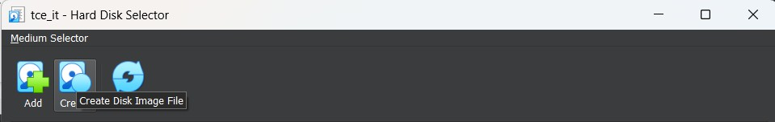
- Click the Controller: SATA → Add Hard Disk → Create New Disk.

- Choose VDI (VirtualBox Disk Image), Dynamically allocated,
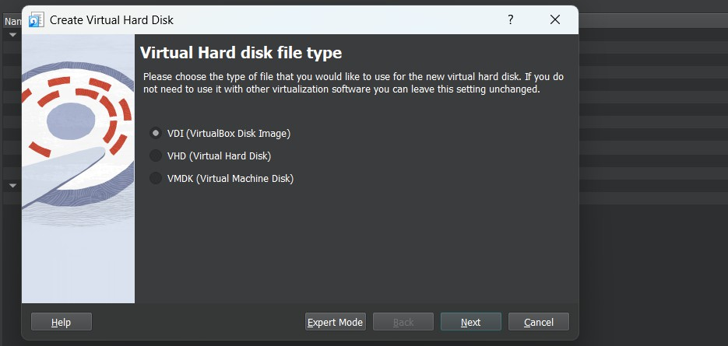
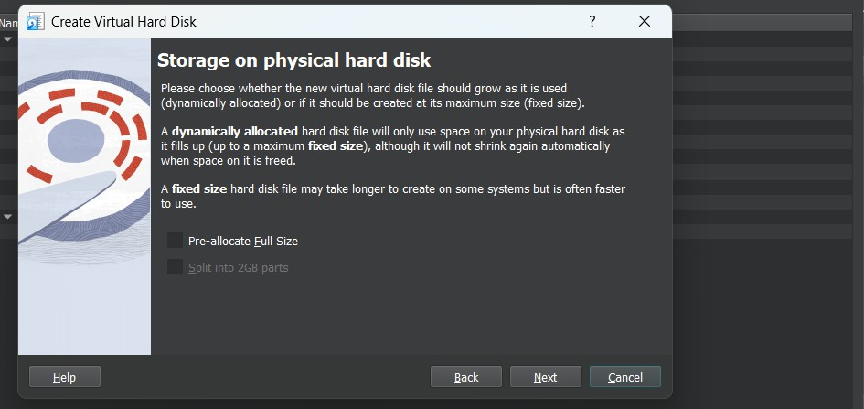

size = 7 GB.

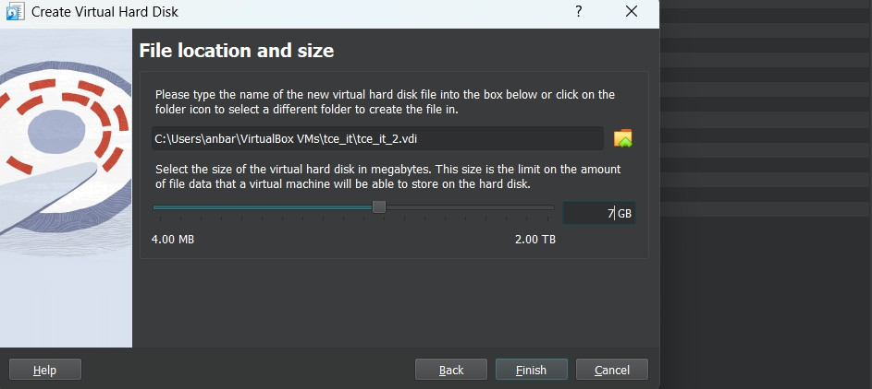
- Click Finish.

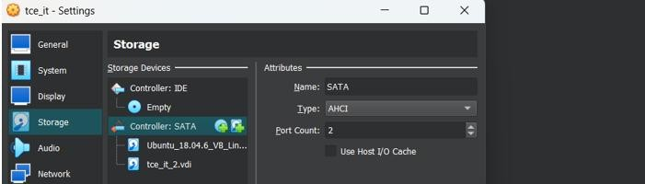

Step 2: Start the VM and Login as Root

Step 3: Check Existing Disks and LVM

# List all disks

fdisk -l

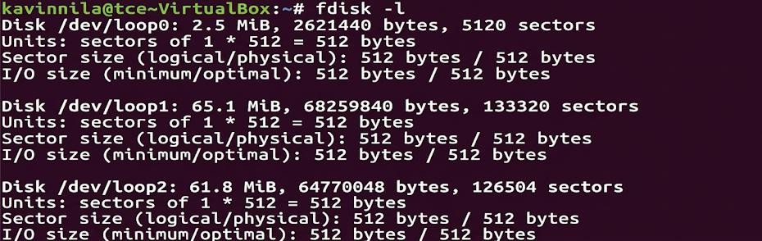
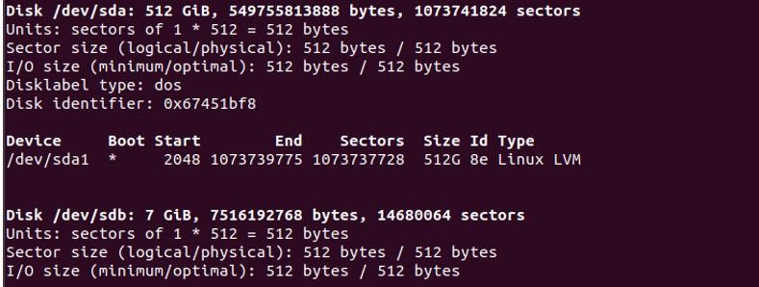

# List physical volumes

pvdisplay
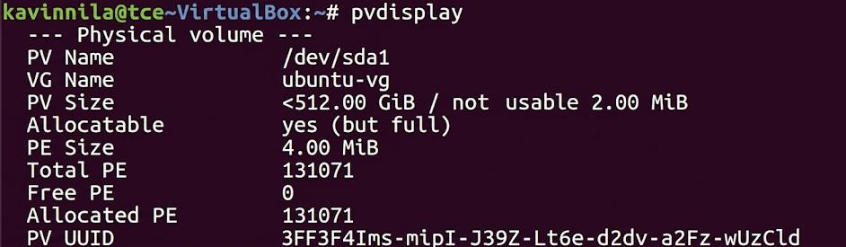

# List volume groups

vgdisplay

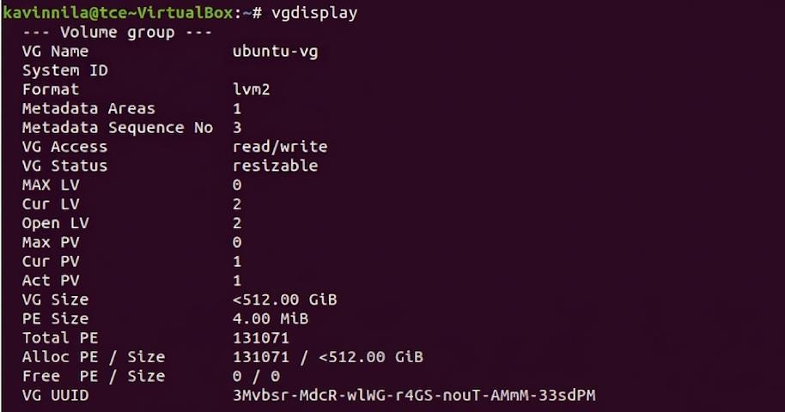
# List logical volumes

lvdisplay
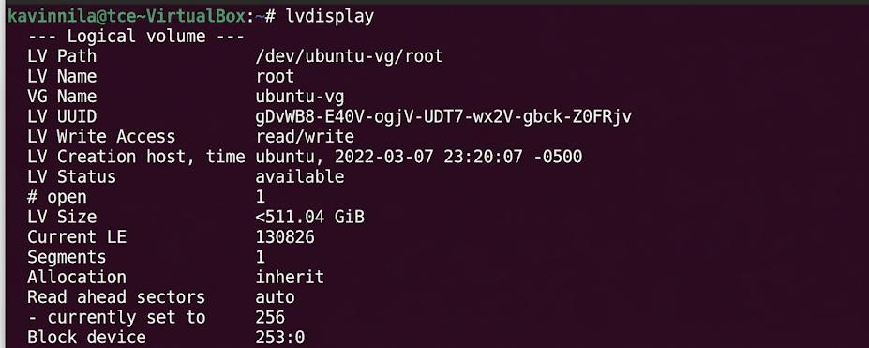
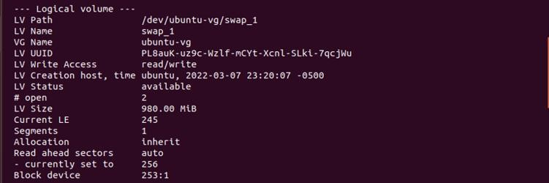

Step 4: Create Physical Volume pvcreate /dev/sdb

Initializes the new disk for LVM. Step 5: Extend the Volume Group vgextend ubuntu-vg /dev/sdb

Replace cloud-vg with your existing Volume Group name. This adds the new PV to your VG.
Step 6: Extend the Logical Volume (Root) lvresize --size +3G /dev/ubuntu-vg/root
• +3G → amount of space to add

- /dev/cloud-vg/root → your logical volume

Alternative:

lvextend -L +3G /dev/ubuntu-vg/root Step 7: Check Current Disk Usage
df -h

Shows current available space on /.
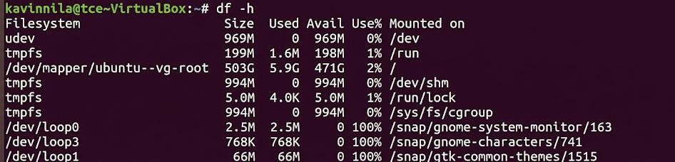

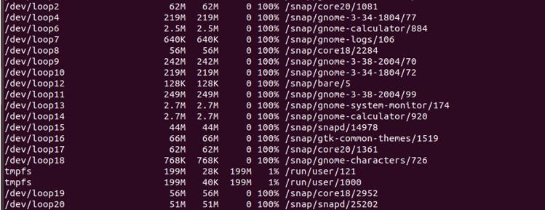

Step 8: Resize the Filesystem

resize2fs /dev/mapper/cloud--vg-root
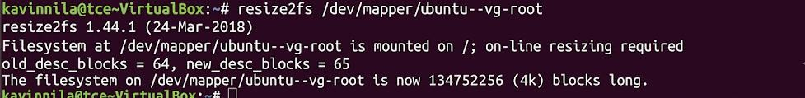

Resizes the filesystem to use the newly added space.

Step 9: Verify Disk Space df -h
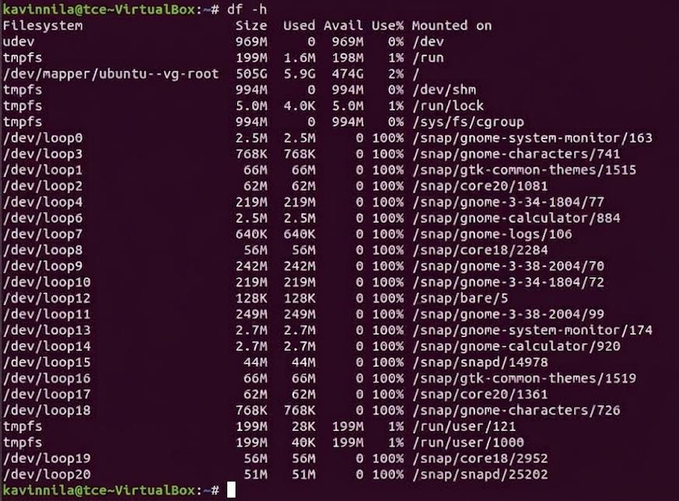
Confirm that the root filesystem now has additional 3 GB. Result:
Thus we have created VHD on windows and restored it on another machine successfully.

