EXERCISE: 10

DATE: 23.11.2020

**AIM:**

To write a Python function that accepts a string and calculate the number of upper-case letters and lower-case letters.

**Program:**

def string_test(s):

d={"UPPER_CASE":0,"LOWER_CASE":0}

for c in s:

if c.isupper():

d["UPPER_CASE"]+=1

elif c.islower():

d["LOWER_CASE"]+=1

else:

pass

print("No. of Upper case characters:",d["UPPER_CASE"])

print("No. of Lower case characters:",d["LOWER_CASE"])

s=input()

string_test(s)

**Output :**

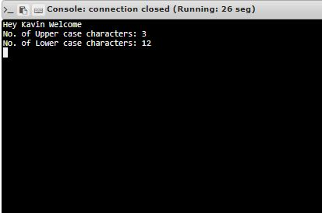

**Link :** [http://103.53.53.18/mod/vpl/forms/edit.php?id=325&userid=1675#](http://103.53.53.18/mod/vpl/forms/edit.php?id=325&userid=1675)

**RESULT:**

Thus**,** The number of upper-case and lower-case is calculated and displayed for the given input.