EXERCISE: 11

DATE: 23.11.2020

**AIM:**

To write a Python program to find the greatest common divisor (GCD) of two integers using recursion.

**Program :**

def gcd(a,b):

if(b==0):

return a

else:

return gcd(b,a%b)

a=int(input("Enter first number:"))

b=int(input("Enter second number:"))

GCD=gcd(a,b)

print("GCD is:")

print(GCD)

Output :

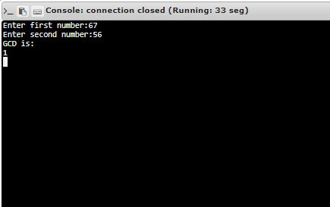

**Link :**

[http://103.53.53.18/mod/vpl/forms/edit.php?id=326&userid=1675#](http://103.53.53.18/mod/vpl/forms/edit.php?id=326&userid=1675)

**RESULT:**

The greatest common divisor (GCD) of two integers using recursion is successfully obtained.