EXERCISE: 14

DATE: 23.11.2020

**AIM:**

To write a Python class to find validity of a string of parentheses, '(', ')', '{', '}', '[' and '].

**Program :**

def areBracketsBalanced(expr):

stack=[]

for c in expr:

if c in ["(","{","["]:

stack.append(c)

else:

if not stack:

return False

current_c=stack.pop()

if current_c=="(":

if c!=")":

return False

if current_c=="{":

if c!="}":

return False

if current_c=="[":

if c!="]":

return False

if stack:

return False

else:

return True

if __name__=="__main__":

expr=input("input:")

if areBracketsBalanced(expr):

print("Output:Valid")

else:

print("Output:Invalid")

**Output :**

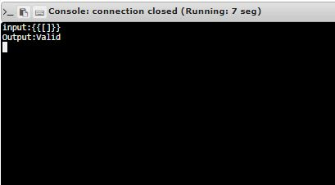

**Link :** [http://103.53.53.18/mod/vpl/forms/edit.php?id=327&userid=1675#](http://103.53.53.18/mod/vpl/forms/edit.php?id=327&userid=1675)

**Result :**

The validity of a string of parentheses is successfully verified.