Exercise No:8

Date:23 .11.2020

**Aim:**

To Write a Python program to get a list of numbers of list and create a list of tuples having first element as the number and second element as the cube of the number.

**Program :**

n=int(input())

lst=[]

for i in range(n):

a=int(input())

lst.append(a)

r=[(j,pow(j,3)) for j in lst]

print(r)

def first(n):

return n[0]

r.sort(key=first)

print(r)

**Output :**

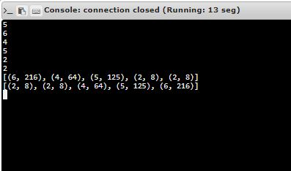

Link : [http://103.53.53.18/mod/vpl/forms/edit.php?id=317&userid=1675#](http://103.53.53.18/mod/vpl/forms/edit.php?id=317&userid=1675)

**Result :**

Thus the Output for the above program is successfully verified.