Software Requirements Specification

for

Hardware Management System

Version 1.4

Prepared by

Group Name: Oshadha Kavintha

|  |  |  |  |  |  |  |
| --- | --- | --- | --- | --- | --- | --- |
| Oshadha Kavintha | | <student #> | kavinthaoshada@gmail.com |  | 0773949221 |  |
|  |
|  |
|  |
|  |

|  |  |
| --- | --- |
| Instructor: | <*place your instructor’s name here>* |
| Course: | Diploma In Software Engineering |
| Batch: | *Zeus* |
| Teaching Assistant: | *<place your TA’s name here>* |
| Date: | 2022-08-01 |

Contents

Introduction 35

Document Purpose 35

Product Scope 35

Definitions, Acronyms and Abbreviations 35

References and Acknowledgments 35

Overall Description 35

Software Perspective 35

Users and Characteristics 36

Operating Environment <Optional> 36

Design and Implementation Constraints <Optional> 36

User Documentation <Optional> 36

Assumptions and Dependencies <Optional> 36

Specific Requirements 37

External Interface Requirements 37

Functional Requirements 37

Behaviour Requirements 37

Other Non-functional Requirements 38

Performance Requirements 38

Safety and Security Requirements 38

Appendix A - Group Log 38

# 

*<In this SRS template of the Java Institute for Advanced Technology, you will find text enclosed by “<>” symbols. This particular text has been presented herein in order to guide you through the template and specify explanations regarding the different sections in this document.*

# Introduction

Dasun Hardware is a business station located in Sandalankawa that sells and lends hardware items. Currently no web application is used and everything is managed by paper writing.

## Document Purpose

## The purpose of this document is to explain the scope of this product and the process.

This application is a desktop application and basically it is managing the stock and rental item management. One of the aims of this document is to clearly describe how the basic processes are carried out by this application and to give the customer a clear understanding about it.

In addition, the profit calculation performed by this application, the sale and purchase quantity calculation is further explained by this document.

## Product Scope

This basically manages the stock. Here the processes of grn preparation, invoice preparation, item return are done. It also shows items expired items, shows items that will expire within a week, shows preset grn, shows preset invoices.

The complete processes here are as follows.

1. User registration.
2. Brand registration.
3. Category registration.
4. Product registration.
5. Company registration.
6. Branch registration.
7. Supplier registration.
8. Rental item registration.
9. Customer registration.
10. Create GRN.
11. Create Invoice.
12. View and advanced search stock.
13. Rental item management.
14. Add return item from stock.
15. Profit calculation.
16. View selling and buying quantity of items.
17. View preset GRN.
18. View preset Invoice.

And create reports as follow.

1. GRN report.
2. Invoice report.
3. Buying and selling quantity of items report.
4. Preset GRN report.
5. Preset Invoice report.
6. Report about stock.
7. Rent report.

## Definitions, Acronyms and Abbreviations

The document is compiled using Microsoft Word and uses the 'Arial' font. The fixed font size used to type this document is 10pt with a spacing of 1.15 lines. It uses bold, 12pt font size and blue foreground properties to edit the subtitle of the document. UML diagrams are created using (draw.io) and visual paradigm tools.

GRN – Good Receive Note.

SRS – Software Requirement Specification.

HMS – Hardware Management System

.

## References and Acknowledgments

<Properly specify any other books, documents, or websites to which this SRS refers. These may include a vision document, scope document, standards, user interface style guides, contracts, system requirements specifications, or use case documents.

# Overall Description

## Software Perspective

## . The HMS is a new self-contained software product developed by the project to avoid problems caused by the current manual system. The newly introduced system provides easy access to the system and includes user-friendly functions with attractive interfaces. The system will provide better options for large-scale physical file system handling problems, computational errors, and other client-specific tasks. The end result of this project will be to increase the efficiency of all the work done in the hardware in a more convenient manner

## Users and Characteristics

Admin - The admin has the privilege of overseeing and authorizing all the work that the system handles. He has access to everything the system does.

Cashier – cashier can’t access user registration, (Income and Expenses cal) and Selling & Buying Qty calculation. But he can access other all functions and generate report.

## Operating Environment <Optional>

## Software:-

1.MySQL must be installed.

2.java JRE

## Hardware:-

## 1.Operating System Supports all known operating systems, such as Windows.

2.RAM – 4gb

3.Processor – i3 5th gen

## 4.A Laser printer will need to be used to print these reports and notes

## Design and Implementation Constraints <Optional>

## We do our best to develop the system. To maintain the reliability and durability of the system, certain design and implementation limitations are applied. The system requires at least 150MB of memory. But having 500MB of memory is recommended. In designing the system interface, we had the ability to work with tools such as (Netbeans 12.2). Considering the client's budget, we decided to design the interface in a simple and realistic way using affordable technology.

## User Documentation <Optional>

The user manual will give the client a clear idea of ​​how to interact with the system being provided. It is written in a language that can be easily understood, hiding the internal complexity of the system.

## Assumptions and Dependencies <Optional>

<List any assumptions that could have an impact on the requirements specified in the SRS. These generally include third-party and commercial components as well as issues pertaining to the development or operating environment. In addition to this, identify any dependencies the project has on external factors, including software components that will be reused from another project.

Provide a brief list or outline of the key assumptions that would have an influential impact on the system design.>

# Specific Requirements

## External Interface Requirements

### User Interfaces

**Splash**

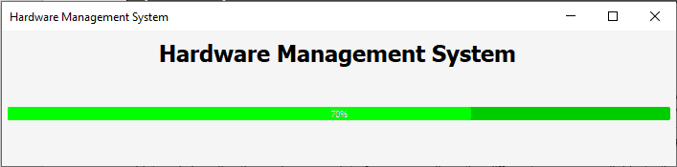

**SignIN**

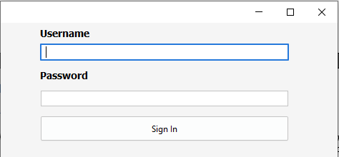

* Admin user or cashier can log by enter user name and password when they are active

Warning 1

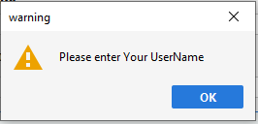

Warning 2

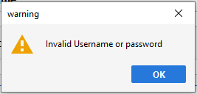

**Home**

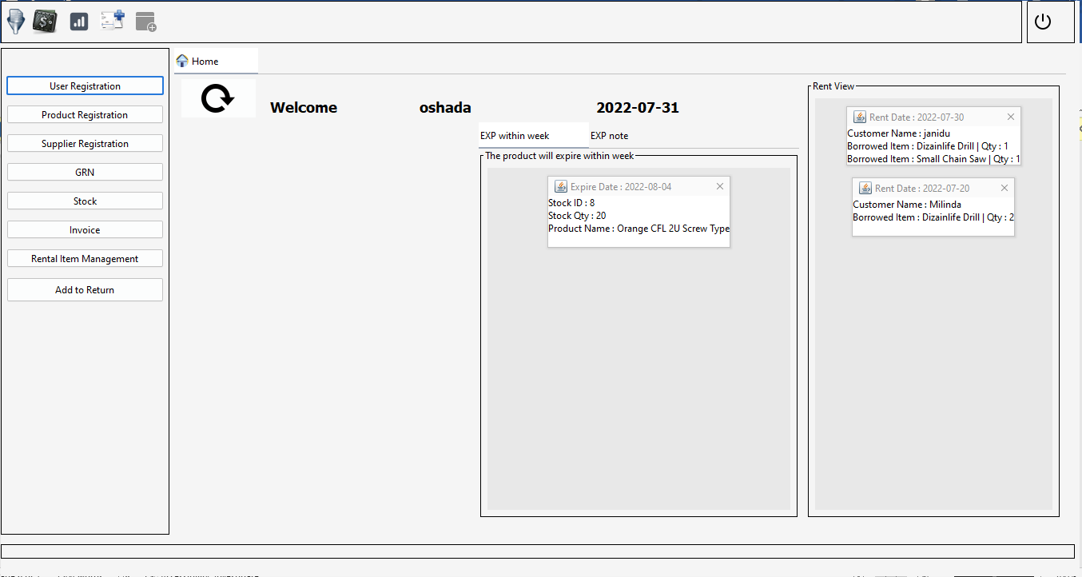

* Admin can use all function in home.
* Cashier can’t access user registration, income and expenses and buying & selling qty
* Both users can logout and view home tab and reset home tab.

Expire product view

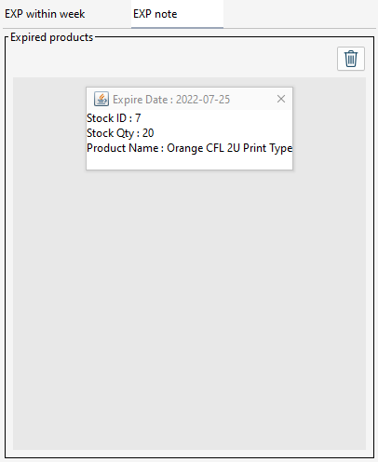

* Expire within week tab shows only items what expire within week.
* Exp note tab shows only products what expire already.

Remove expire product from stock

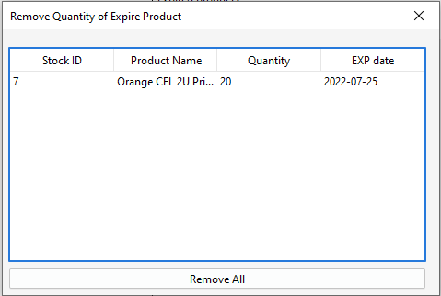

* Can remove items expire already from stock.

**User Registration**

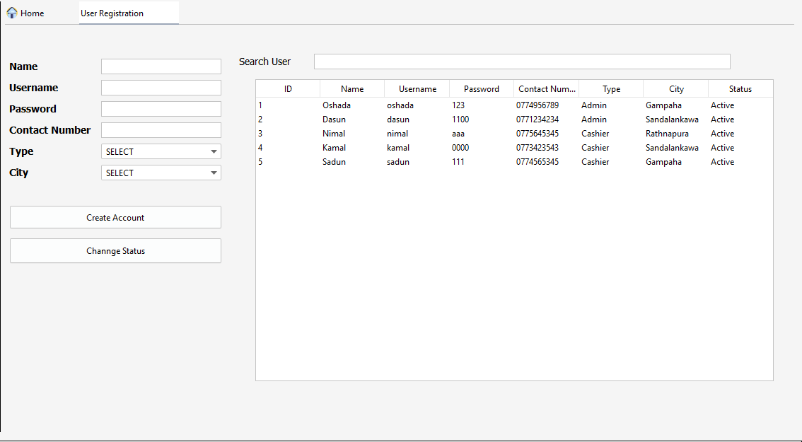

**Product Registration**

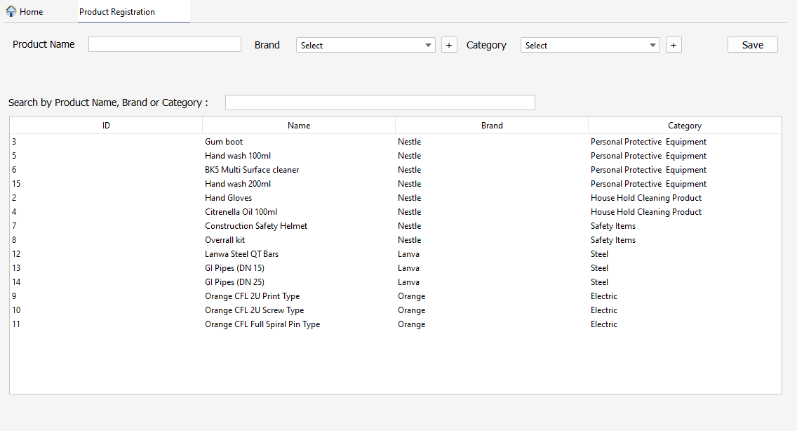

* Can select brand or register brand by click plus mark.
* Can select category or register category by click plus mark.

Brand registration

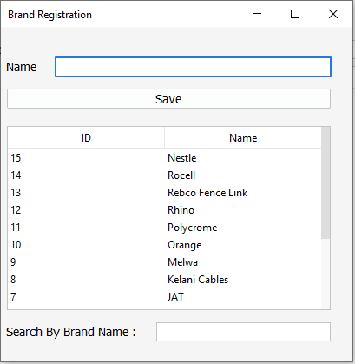

Category registration

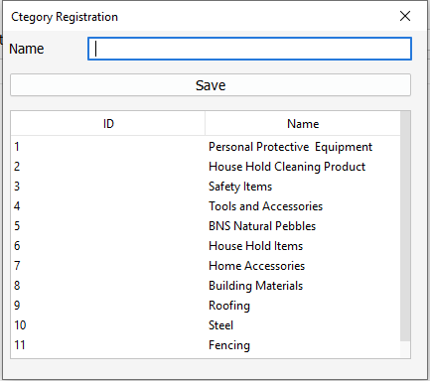

**Supplier registration**

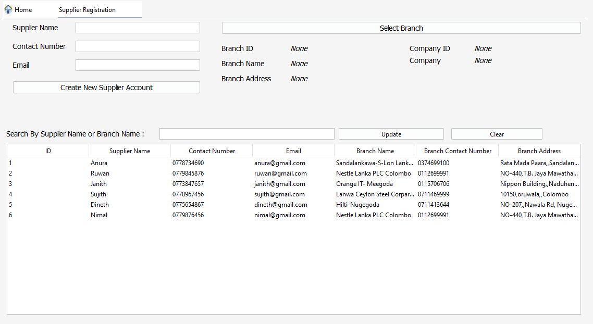

* Can select or register branch by clicking select branch.

Branch registration

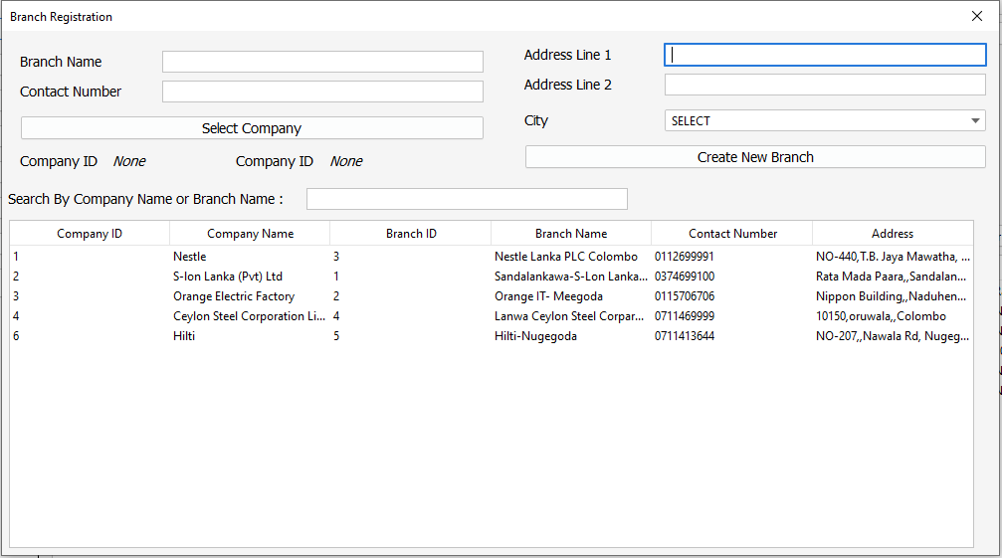

* Can select company or register company by clicking select company.

Company registration

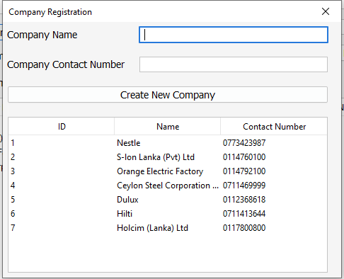

**GRN**

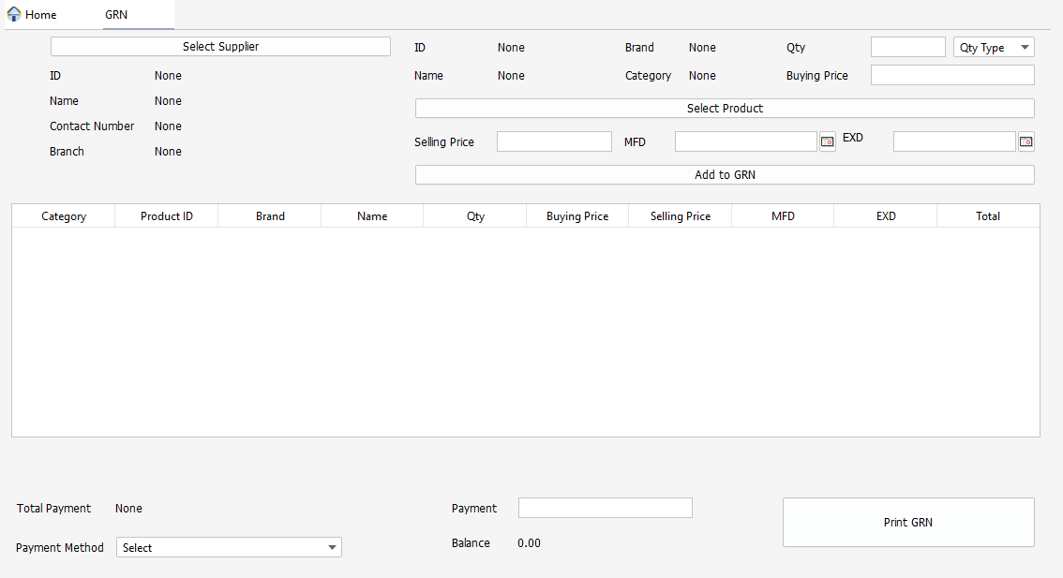

* Can select or register supplier by clicking select supplier.
* Can select or register product by clicking select product.
* If click print GRN button generate report automatically

GRN report

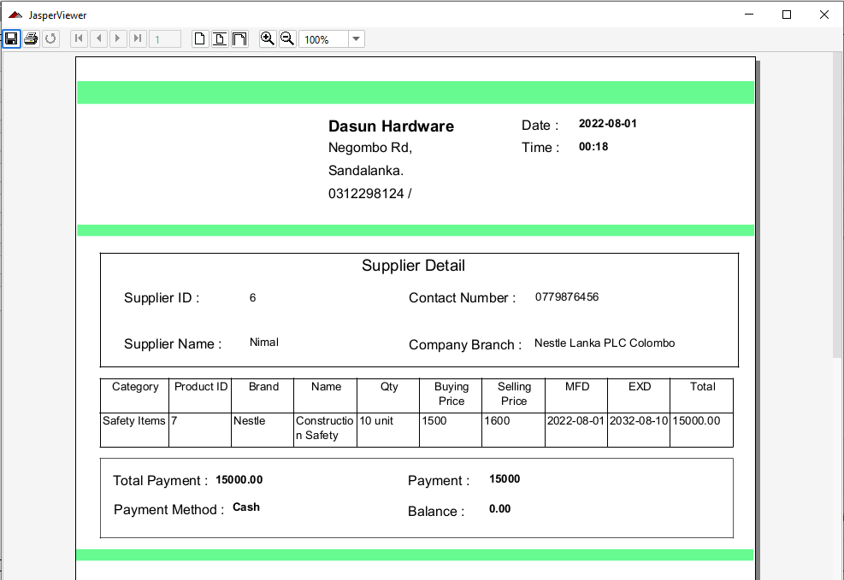

**Invoice**

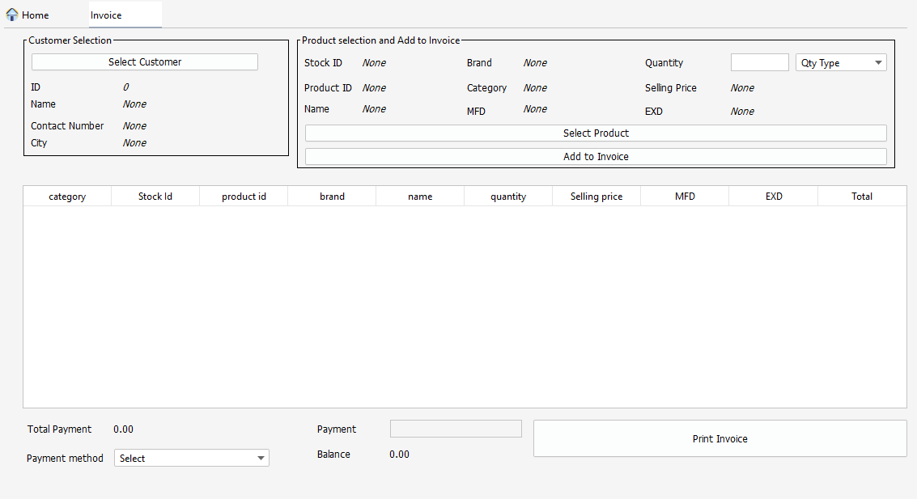

* Can select or register customer by clicking select customer.
* If click print invoice button generate report automatically

Customer registration

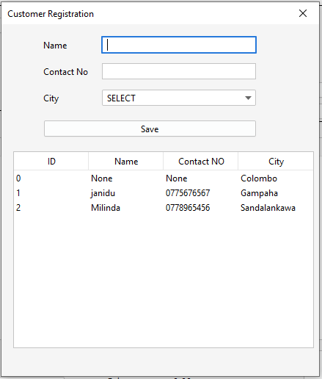

Invoice report

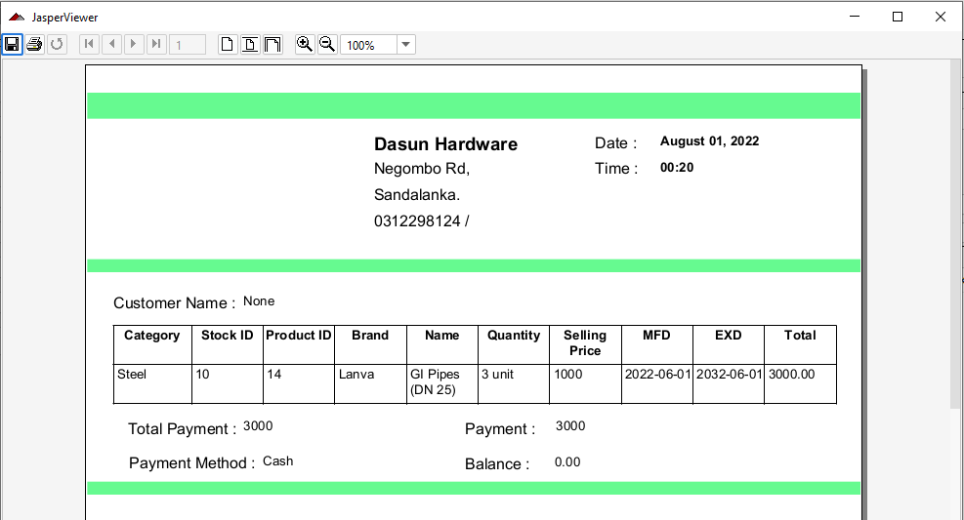

**Stock**

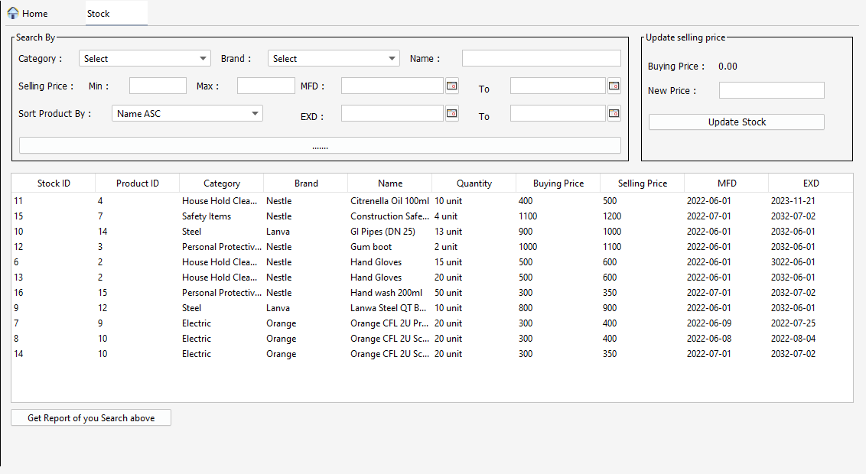

* Can sort or search stock.

Stock report

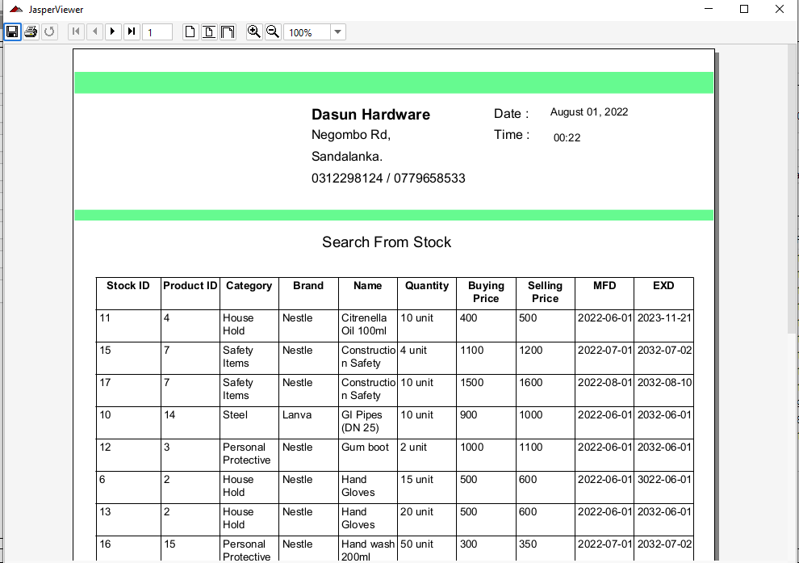

**Rental item management**

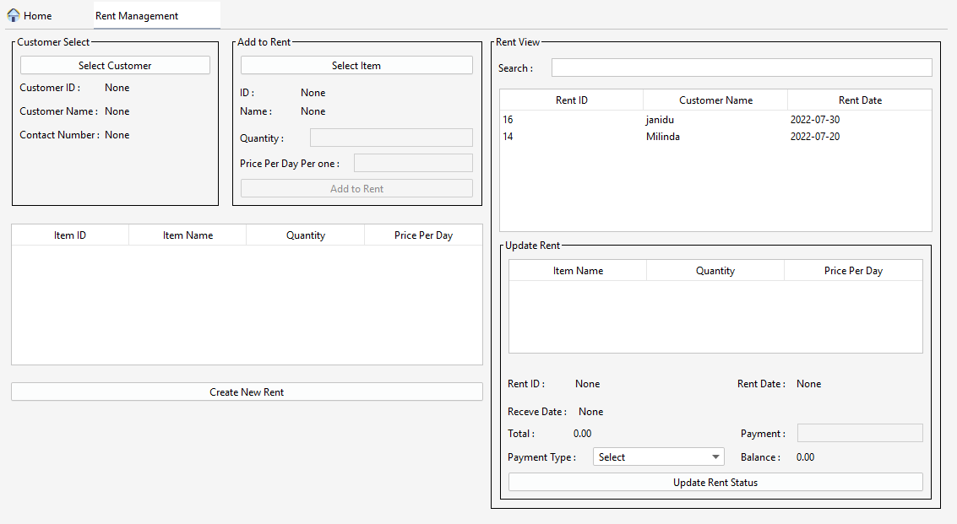

* If create new rent it will be update in table right up corner.
* If click any row in that table will be update table right down corner.
* If click update rent status will be generate report automatically.

Rental item registration

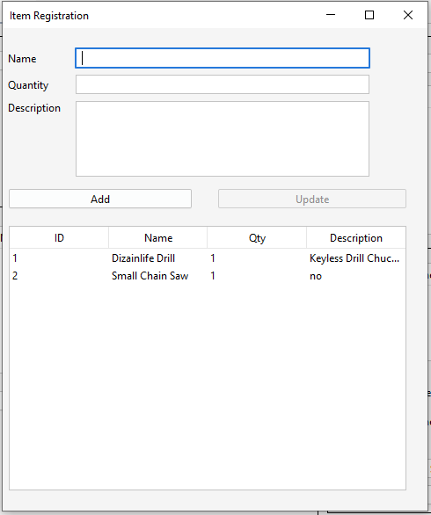

Rent report

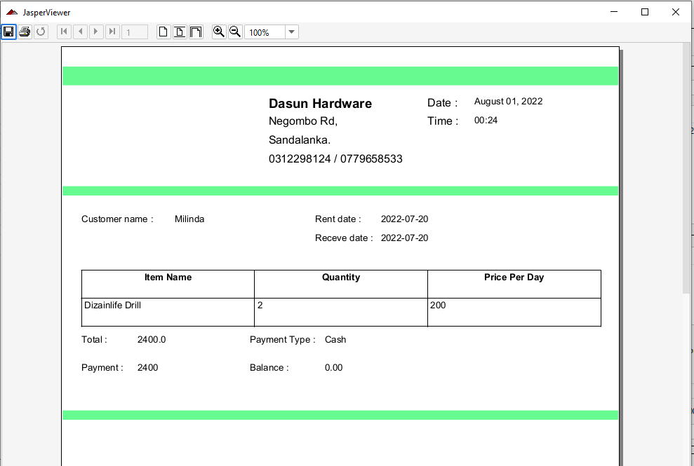

**Return**

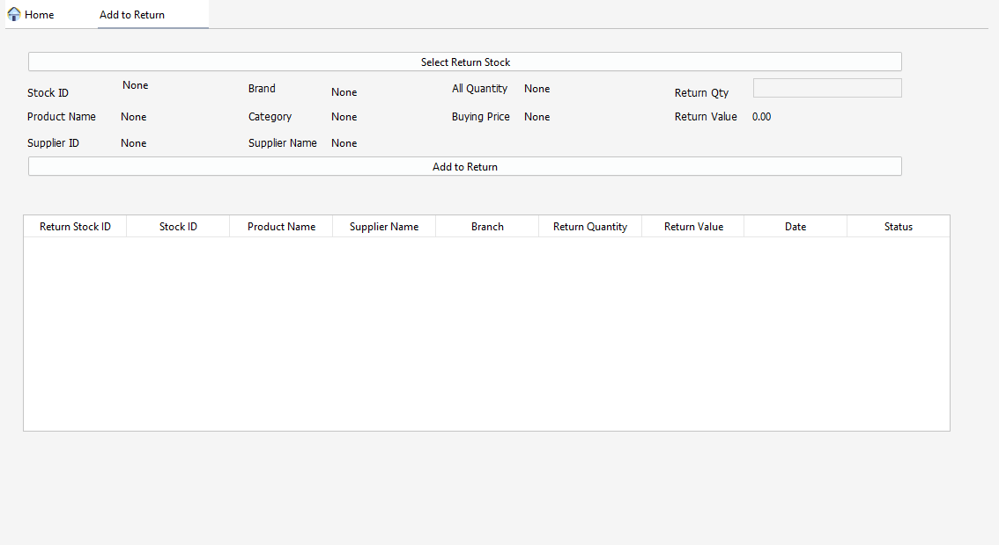

* If add some items for return it will be check GRN for re earn that value from supplier.

**Income and Expenses cal**

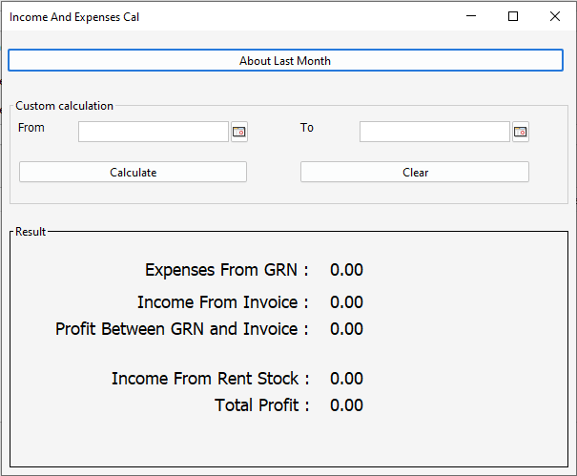

* If didn’t choose date range it will calculate about last month.

**Selling and buying quantity cal**

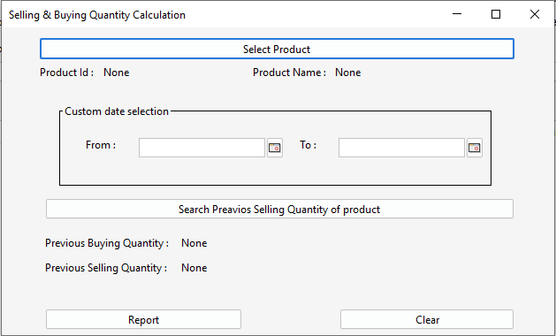

* If didn’t choose date range it will calculate about last month.

Selling and buying qty report

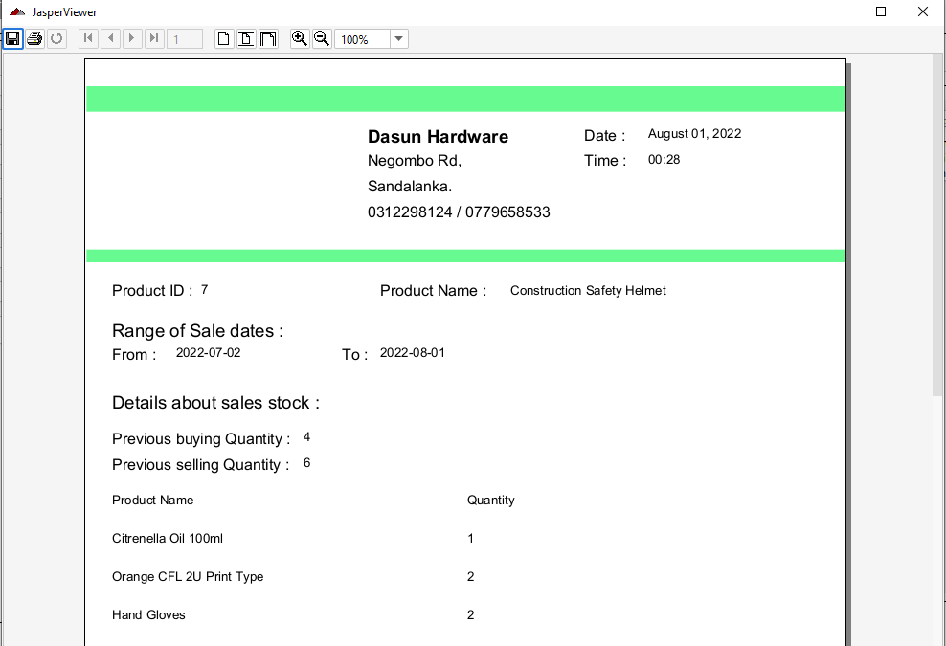

**Preset invoice**

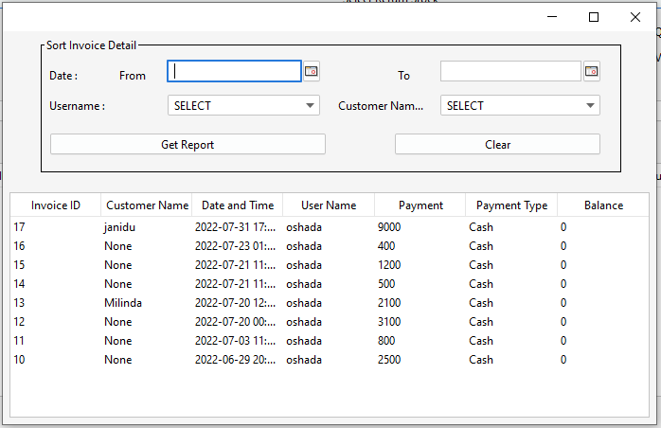

Preset invoice report

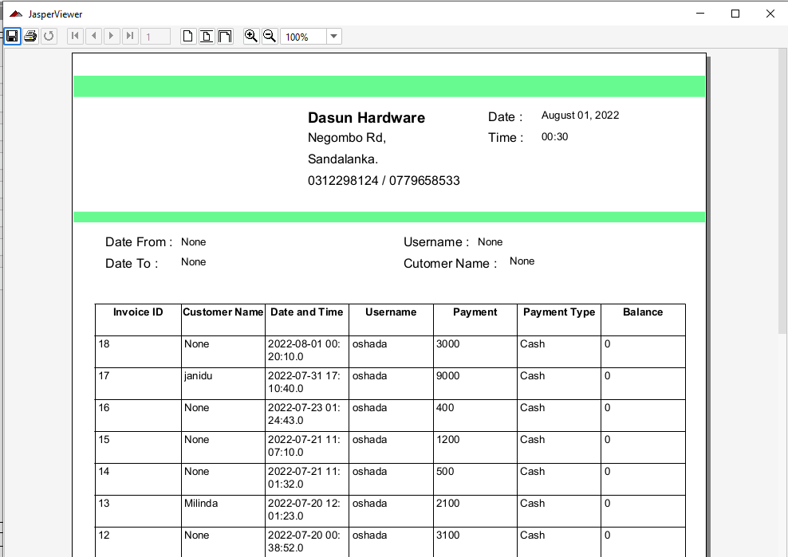

**Preset GRN**

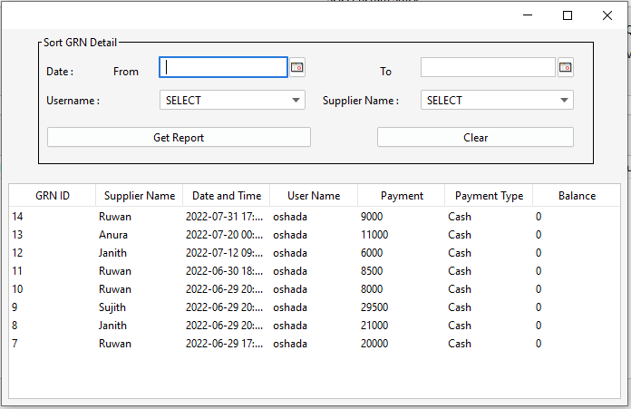

Preset GRN report

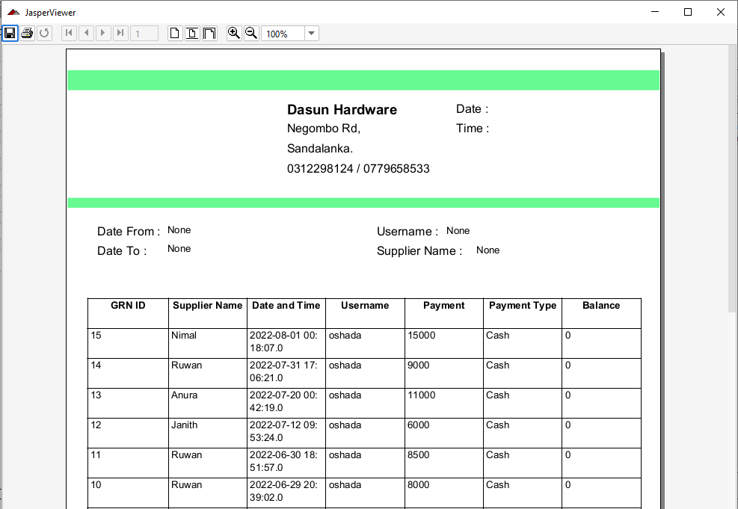

### Hardware Interfaces

Printing several bills and records requires a laser printer.

### Software Interfaces

Must be installed MySQL and java JRE 1.8 or greater.

## Functional Requirements

Login

* Admin or cashier can login by enter username and password if they are active.

Home

* Admin can use all functions and generate report.
* Cashier can’t access user registration, income and expenses and buying and selling qty.
* Can logout and after logout will be auto backup database.

User registration

* Admin can register new admin or cashier.
* Admin can change status active or inactive user.

Product registration

* Can register product
* Can register brand
* Can register category

Supplier registration

* Can register supplier.
* Can register branch.
* Can register company

GRN

* Create GRN
* Generate report

Stock

* Search or sort product in stock.
* Generate report about it

Invoice

* Create Invoice
* Generate report

Rental item management

* Create rent item.
* Update rent status.
* Register rent item.
* Generate report about updated rent.

Add to return

* Can add items to return after return items.

*.*

## Behaviour Requirements

### Use Case View

**Use Case Diagram for HMS**

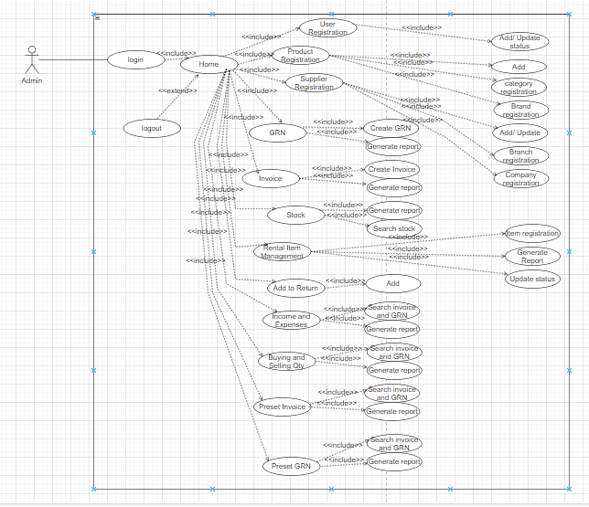

**Activity diagram for GRN**

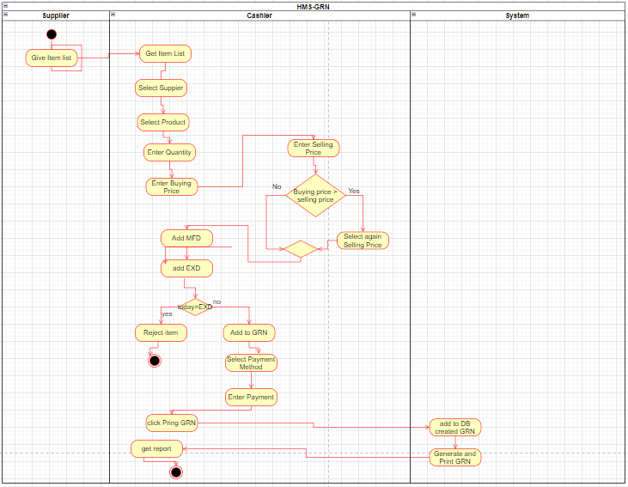

**Activity diagram for invoice**

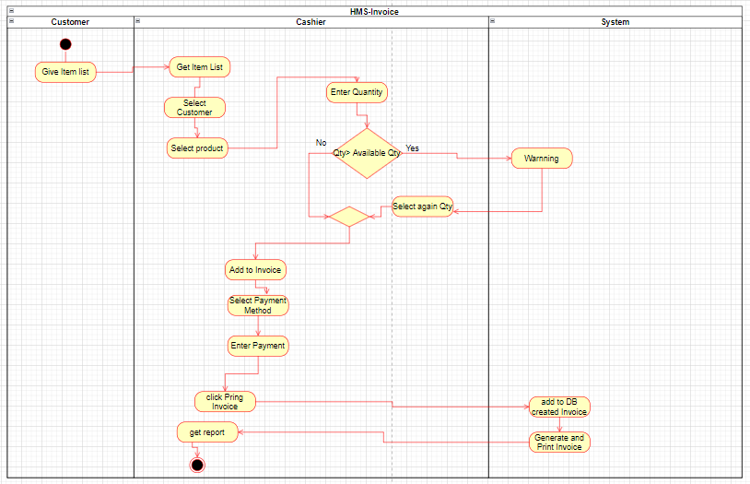

# Other Non-functional Requirements

## Performance Requirements

Performance requirements define the acceptable response time for a system to function. Although the system has been developed to be optimal for minimal system performance, system performance largely depends on the performance of the installation computer's hardware and software components.

## Safety and Security Requirements

HMS has several user levels, and access to various subsystems is protected by a user login screen that requires a username and password. This provides different views and accessible functions at the user level across the system. Backup maintenance ensures the security of the system database. The system can be restored in case of any emergency.

Appendix A - Group Log

<Specify all the group meeting minutes, group activities, and other relevant information that will assist the supervisor to determine the effort put forth to produce this document.>